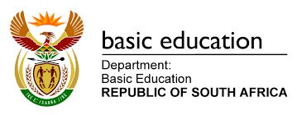

Client | Department of Basic Education | Job # | 001
Product | COVID -19 Vaccination Plan | Date | 18/06/21
Title | COVID-19 Vaccine Registration | Team | CCI
Duration | 60 sec | CD | CCI

Live Read: National DBE COVID -19 Vaccine Roll-out Program
A message from the Department of Basic Education.

Are you a teacher or non-teaching staff employed in the Basic Education sector?

You can now get vaccinated against COVID-19. All teachers and non-teaching staff on PERSAL have been pre-loaded on to the EVDS system. If you are not on PERSAL, you can register on EVDS by sending the word “ register” to 0600123456 on WhatsApp or Dial *134*832#.
You are required to take along your national Identification (ID) as well as their Medical Aid Card (for those on medical aid). Vaccination is either covered by your medical aid or bt Government for those not on medical aid.
For more information visit:
www.sacoronavirus.co.za or www.health.gov.za or www.nicd.ac.za
or call the COVID-19 Hotline on: 0800 029 999

