

# PROVINCIAL MID YEAR EXAMINATIONS

# MID YEAR EXAM

# GRADE 12

# PHYSICAL SCIENCE / FISIESE WETENSKAP (P1/V1)

**MAY/JUNE 2017**

**MEMORANDUM**

**MARKS: 150**

**TIME: 3 hours**

**QUESTION** 1/VRAAG 1

1.1 B √√ (2)

1.2 C √√ (2)

1.3 B √√ (2)

1.4 B √√ (2)

1.5 D √√ (2)

1.6 C √√ (2)

1.7 C √√ (2)

1.8 C √√ (2)

1.9 C√√ (2)

1.10 A √√ (2)

[20]

QUESTION/ VRAAG 2

2.1 An object will remain in a state of rest or move at a constant velocity, unless an external net (resultant) force works in on it.√√ (2)

*‘n Voorwerp sal in rus verkeer of teen ‘n konstante snelheid bly voorbeweeg,*

*tensy ‘n ongebalanseerde/netto/resulterende krag daarop inwerk.*

2.2

applied force/F/Fpacker√ *toepaste krag/F/Fpakker*

gravitationalforce/Fg/w/weight √ *gravitasiekrag/Fg/w/gewig* (2)

2.3 **Choose upwards as positive.**

Fnet = ma √

Fpacker - w = ma

Fpacker - 

Fpacker  N *opwaarts*

The bag will not tear √ since the force exerted by the packer is smaller than the force that the bag can withstand. / N (5)

*Die sak sal nie skeur nie omdat die krag wat deur die pakker toegepas word kleiner is as wat die sak kan weerstaan. /*

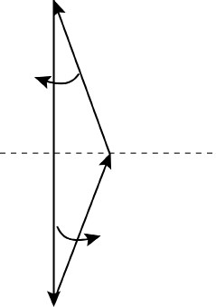

F

packer

F

packer

10

°

10

°

w = (10,5)(9,8)

= 102,9 N

√

√

√

2.4

sin 10⁰√ = sin 160⁰√

Fpacker w

Fpacker = sin 10⁰ ∙ 102,9 √

sin 160⁰

= 52,24N√

**OR**

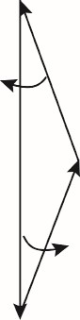Scale 10 mm/1cm : 10 N.✓ Skaal: 10mm:10N

10⁰ Fpacker = 5,2 cm = 52 mm✓

✓

✓Fpacker = 52 N

w = 10,29cm✓ ✓

w = 102,9 N Fpacker = 5,2 cm = 52 mm✓

10⁰ Fpacker = 52N (7) **[16]**

**QUESTION / VRAAG 3**

3.1 The object had an upward velocity when it was released.  (1)

*Die voorwerp het ’n opwaartse snelheid toe dit losgelaat is.*

**OR/ *OF***

The object continues with its state of motion in a straight line.

*Die voorwerp beweeg voort in dieselfde rigting van beweging in ’n reguit lyn.*

**OR/ *OF***

The object has inertia.

D*ie voorwerp het traagheid.*

3.2.1 Upwards  (1)

*Opwaarts*

3.2.2 Downwards  (1)

*Afwaarts*

3.3.1

|  |  |
| --- | --- |
| **Upward positive / opwaarts positief**  vf = vi + a∆ t   0 = 110 - 9,8Δt  ∆ t = 11,22 s   | **Downward positive/ *afwaarts positief***  vf = vi + a∆ t   0 = - 110 + 9,8Δt∆ t = 11,22 s   |

(3)

3.3.2 **OPTION 1**

|  |  |
| --- | --- |
| **Upward positive / *opwaarts positief***  Δy = viΔt +a∆t 22   -550  = 110Δt + ½(-9 ,8)Δt  4,9Δt2 -110 Δt – 550 = 0  ∆t =−(−110)± (−110)2 − 4(4,9)(−550)  2(4,9)  Δt = 26,66 s or – 4,21 s  Δt = 26,66 s  | **Upward negative / *opwaarts negatief***  Δy = viΔt +a∆t 22   550  = -110Δt + ½(9,8)Δt 4,9Δt2 -110 Δt – 550 = 0  Δt = 26,66 s or – 4,21 s  Δt = 26,66 s  |

(4)

**OPTION 2**

**POSITIVE MARKING FROM QUESTION 3.3.1 / POSITIEWE NASIEN VAN VRAAG 3.3.1.**

|  |  |
| --- | --- |
| Time(point **Q** to **R)**: 11,22 s  Time(point **R** to **Q)**: 11,22 s Time(point Q to ground):  **Upward positive / *opwaarts positief***  Δy = viΔt +a∆t 2   -550 = (-110)Δt + ½(-9,8)Δt  4,9 Δt2 + 110 Δt – 550 = 0  -110 ± (110)2 − 4(4,9)(−550)  ∆t =  2(4,9)  Δt = 4,21 s  Total time = 11,22 + 11,22 + 4,21  = 26,65 s  | Time(point **Q** to **R)**: 11,22 s  Time(point **R** to **Q)**: 11,22 s Time(point Q to ground):  **Upward negative / *opwaarts negatief***  Δy = viΔt +a∆t 2 2   550  = (110)Δt + ½(9,8)Δt 4,9 Δt2 +110 Δt – 550 = 0  -110 ± (110)2 − 4(4,9)(−550)  ∆t = 2(4,9)  Δt = 4,21 s  Total time = 11,22 + 11,22 + 4,21 = 26,65 s  |

**OPTION 3**

**POSITIVE MAKING FROM *QUESTION 3.3.1 / POSITIEWE NASIEN VAN VRAAG***

|  |  |
| --- | --- |
| **Upward positive / *opwaarts positief***  Height reached above point Q: vf2 = vi2+ 2a∆y2  (0)2 = (110)2 + 2(-9,8)∆y2  ∴∆y= 617,35 m  Displacement from point **R** to ground:  ∆y= 550 + 617,35 = 1 167,35 m  Δy = viΔt +a∆t 2    -1 167,35  = (0)Δt + ½(-9 ,8)Δt2  Δt = 15,435 s  Total time = 11,22 + 15,435  = 26,66 s  | **Upward negative / Opwaarts negatief**  Height reached above point Q:  vf2 = vi2+ 2a∆y2  (0)2 = (-110)2 + 2(9,8)∆y2  ∴∆y= 617,35 m  Displacement from point **R** to ground:  ∆y= 550 + 617,35 = 1 167,35 m  Δy = viΔt +a∆t 2   1 167,35 = (0)Δt + ½(9,8)Δt2  Δt = 15,435 s  Total time = 11,22 + 15,435  = 26,66 s   |

3.4 **POSITIVE MARKING FROM *QUESTION 3.3 / POSITIEWE NASIEN VAN***

***VRAAG* 3.3.**

**Downward as positive / *afwaarts as positief*:**

**Upward as positive**

**/**

***opwaarts as positief***

**:**

0

11

,

22

,66

26



t(s)

*v (*

m·s

-

1

)

-

110

|  |  |
| --- | --- |
| **Marking criteria/*nasienriglyne*** |  |
| Positive slope */ positiewe helling* |   |
| Graph starts at v = -110 m·s -1 *Grafiek begin by v = -110* m·s-1 |  |
| Graph intercepts x axis at 11,22 s *Grafiek sny x axis by 11,22 s* |  |
| Graph ends at 26,66 s  *Grafiek eindig by 26,66 s* |  |







|  |  |
| --- | --- |
| **Marking criteria** |  |
| Negative slope / *negatiewe helling* |   |
| Graph starts at v = 110 m·s -1 *Grafiek begin by v = 110* m·s-1 |  |
| Graph intercepts x axis at 11,22 s *Grafiek sny x axis by 11,22 s* |  |
| Graph ends at 26,66 s  *Grafiek eindig by 26,66 s* |  |



(

4

)

**[1**

**4**

**]**

110

*v (*

m

·

s

-

1

)

0

,

11

22

,66

26



t(s)





**QUESTION 4**

4.1 The total linear momentum √of an isolated (closed) system remains constant √ (is conserved). **OR**

In an isolated systemthe total linear momentum before collision equals the total linear moment after collision. (2)

*Die totale liniêre momentum in ‘n geslote sisteem bly konstant.****OF***

*In ‘n geslote sisteem is die totale liniêre momentum voor die botsing gelyk aan die totale liniêre momentum na die botsing.*

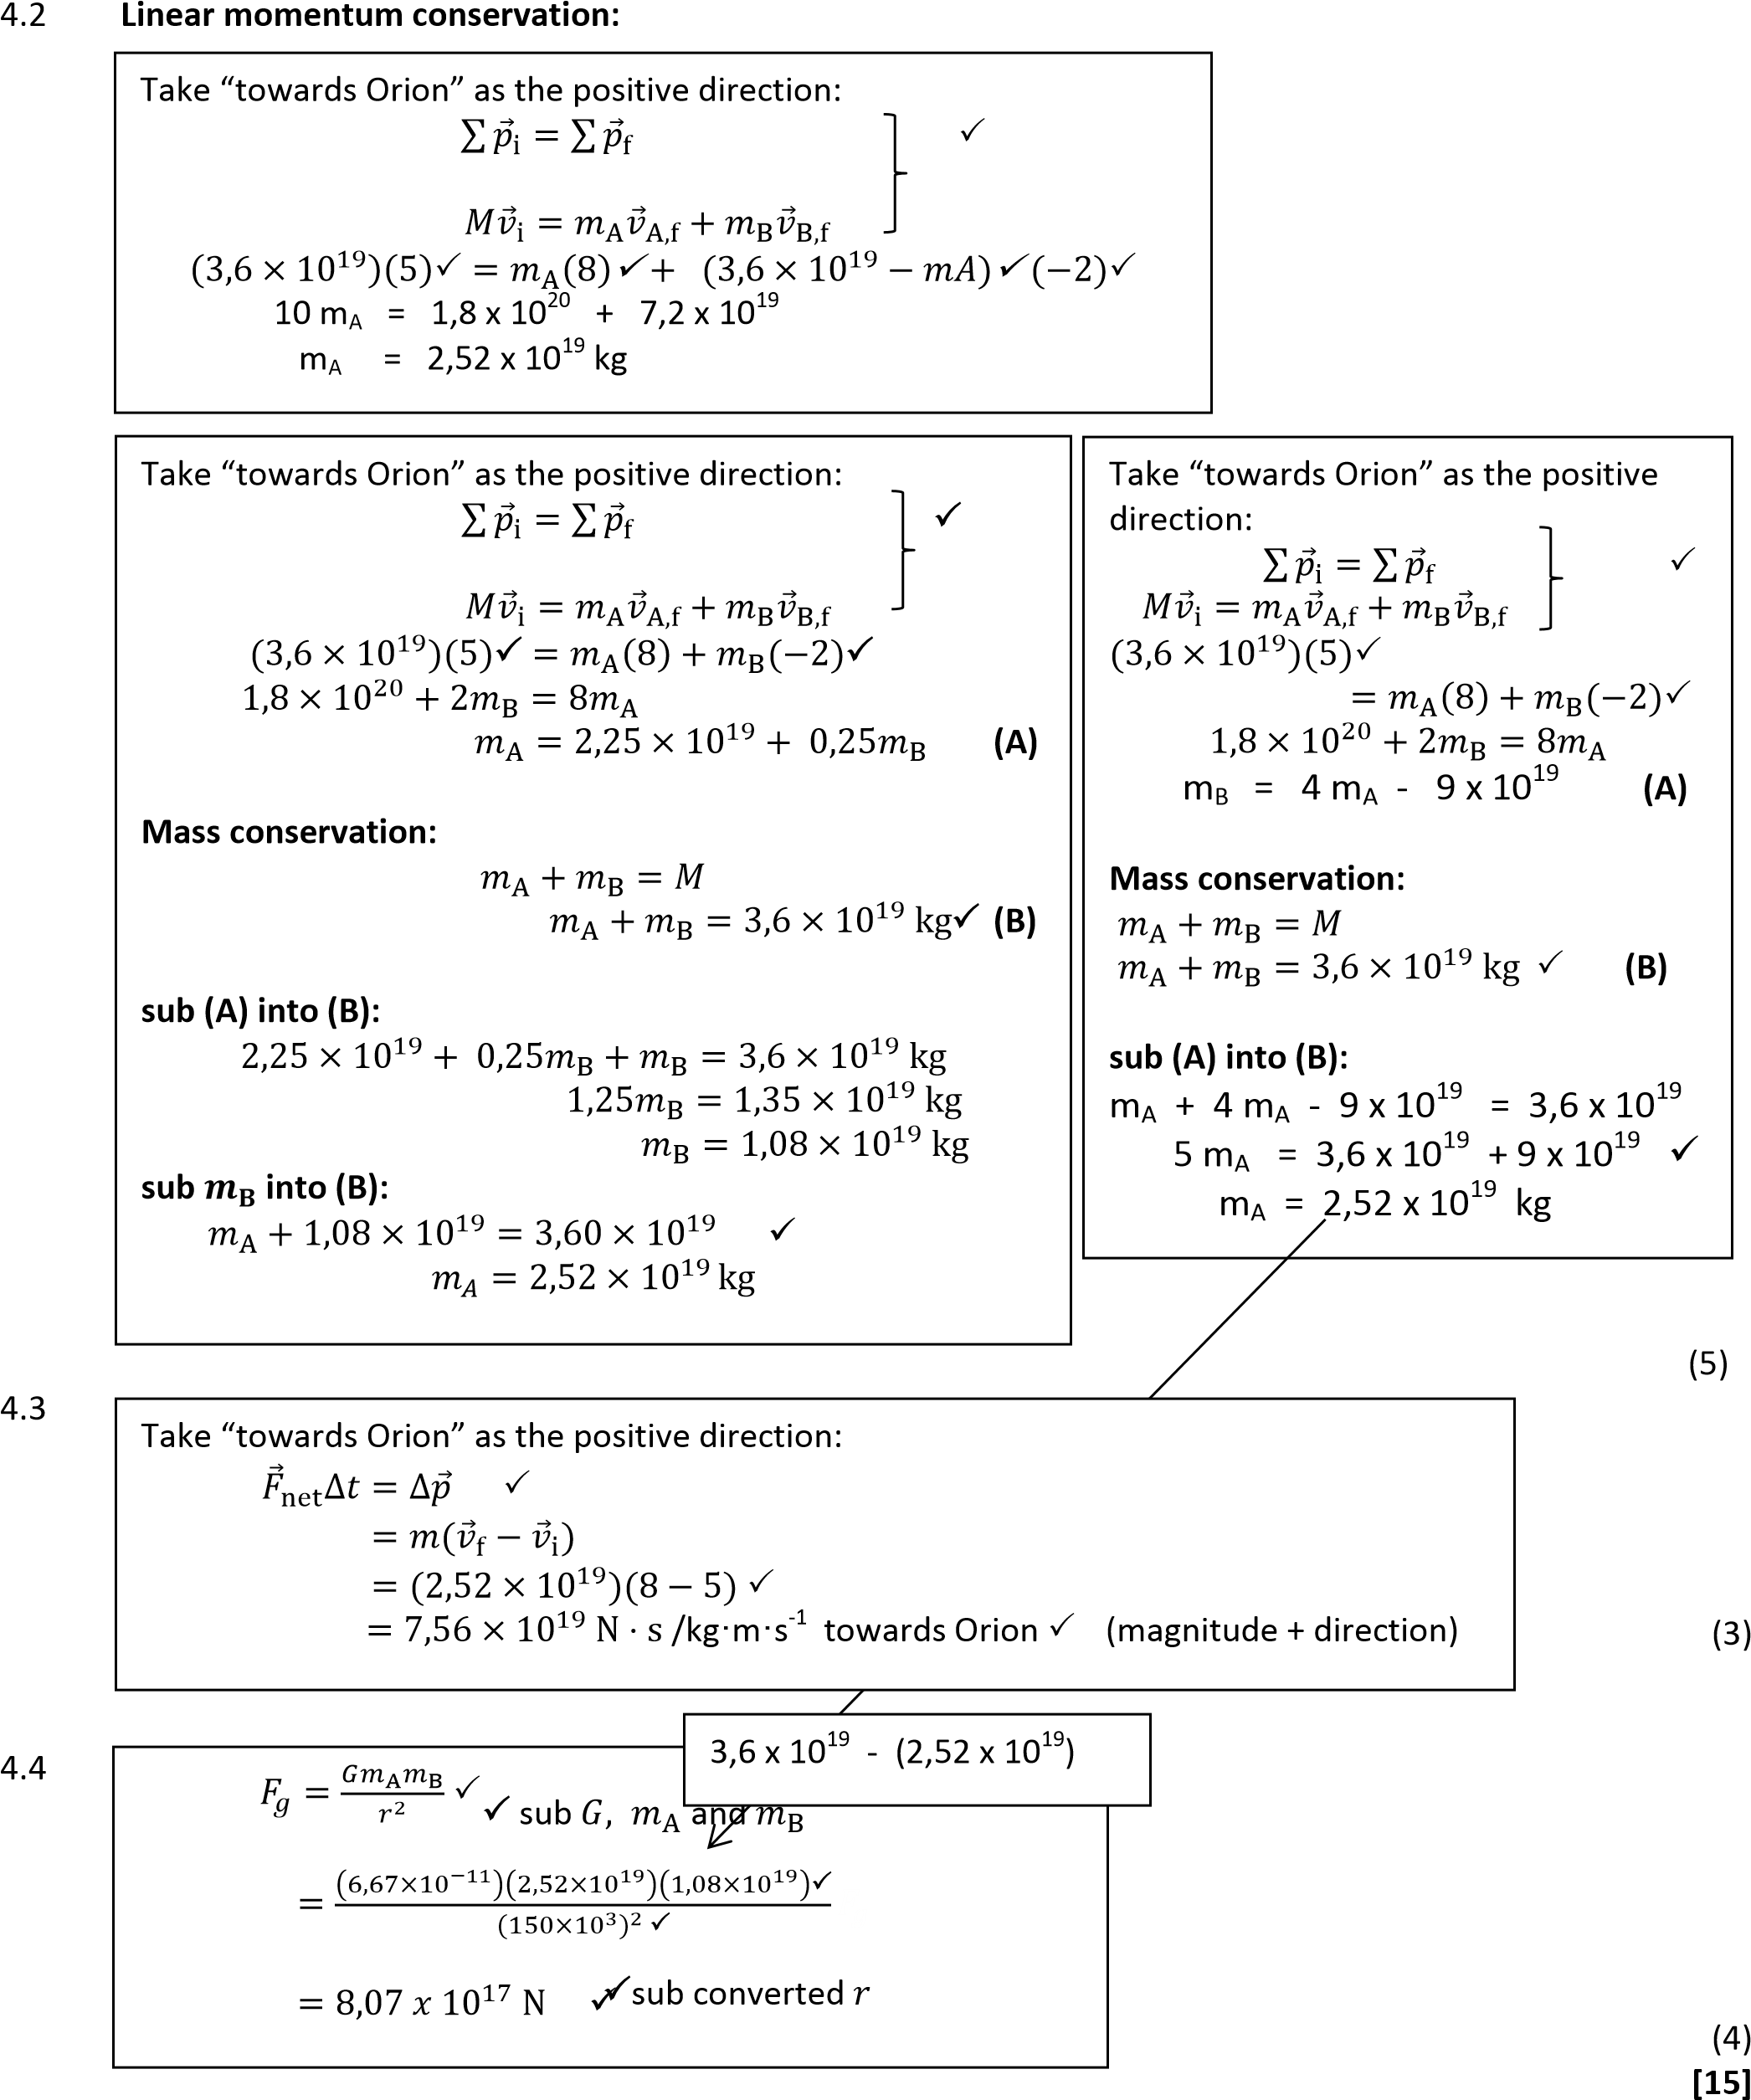

√

QUESTION / VRAAG 5

5.1 N/FN/normal force √

F/Fapplied/applied force√/(components)

f/friction√

w/Fg/gravitational force√

                       ✓ = relative size of arrows correct. (5)

* 1. Friction ✓       (1)

*Wrywing*

* 1. The net/total work done on an object√is equal to the change in the object's

kinetic energy√**OR**

the work done on an object by a resultant/net force is equal to the change in the object's kinetic energy. (2)

*Die netto/totale arbeid wat op ‘n voorwerp verrig word is gelyk aan die verandering*

*in die voorwerp se kinetiese energie.*

*Die arbeid wat op ‘n voorwerp verrig word deur die netto/resulterende krag is*

*gelyk aan die verandering in die voorwerp se kinetiese energie.*

5.4

|  |
| --- |
| **OPTION 1/*OPSIE 1***  Wnet = ΔEk✓  Fapp||Δxcosθ + fΔxcosθ = ½ m(vf2 – vi2)  (45) cos300✓(3,5)cos00✓+ f(3,5)cos1800✓= ½ (25)(10,82 – 122)✓  f = 136,69 N ✓ |
| **OPTION 2/*OPSIE 2***  Wnet = ΔEk✓  FappliedΔxcosθ + fΔxcosθ = ½ m(vf2 – vi2)  (45)✓(3,5)cos300✓+ f(3,5)cos1800✓= ½ (25)(10,82 – 122)✓  f = 136,69 N ✓ |
| **OPTION 3/*OPSIE 3***  Wnc = ΔEk + ΔEp✓  fΔxcosθ + Fapp||Δxcosθ = ½ m(vf2 – vi2) + mg(hf – hi)  f(3,5)cos1800✓+ (45)cos300(3,5)cos00✓= ½ (25)(10,82 – 122)✓ + 0✓  f = 136,69 N ✓ |

(6)

**[12]**

## **QUESTION 6 / VRAAG 6**

6.1 The air molecules form compressions and rarefactions that vibrate backwards and forwards(move closer and further apart). √ √ (2)

*Die lugmolekules vorm verdigtings en verdunnings wat heen en weer vibreer.*

6.2.1 Remains the same. √ (1)

Bly dieselfde

6.2.2 Increases. √ (1)

Toeneem

6.2.3 Decreases. √ (1)

Afneem

6.3 2m √√ (2)

v

√

335

√

f

=

λ

=

2

=

167,50 Hz

6.4

√ (3)

* 1. The Doppler Effect is the change in the observed frequency (or pitch) of the

sound detected by a listener because the sound source and the listener have different velocities relative to the medium of sound propagation. √√ (2)

*Die Doppler effek is die verandering in die waargenome frekwensie/ toonhoogte/ klank waargeneem deur die luisteraar omdat die klankbron en die luisteraar verskillende snelhede het relatief tot die medium van klank voortplanting*

**OR/ OF**

The change in the (observed) frequency when there is relative motion between the source and the observer.

*Die verandering in die waargenome frekwensie wanneer daar relatiewe beweging is tussen die bron en die waarnemer*

6.6 v = d =12 = 3m∙s-1 √

∆t 4

v ± vL

fL  = v ± vS ∙ fs √

= (335 + 3) √

335√ ∙ 167,50 √

= 169Hz√ (6)

**[18]**

QUESTION / VRAAG 7

7.1 The force of attraction or repulsion between two charges is directly proportional

to the product oftheir charges√ and inversely proportional to the square of the

distance between them/ their centres√ (2)

*Die elektrostaties aantrekkingskrag tussen twee ladings is direk eweredig aan*

*die produk van die ladings en omgekeerde eweredig aan die kwadraat van die*

*afstand tussen hul middelpunte.*

7.2 FJ ON K = k QJ QK √

r2

= (9 x 109)(4 x 10-6)(2 x 10-6) √

(0,05)2 √

= 28,80N attraction√ (4)

7.3 FL ON K

α

FNET FJ ON K

7.4 **MAGNITUDE**: FR2 = FJ ON K 2 + FL ON K 2 √

*GROOTTE:* FR = √ 28,82  + (½ x 28,8)2 √

= 32,12 N √

**DIRECTION:** tan α = 28,8 √

*RIGTING* 14,4

α = 63,43⁰ √ (OR Any other method) Bearing= 206,57⁰ (5)

7.5 E = F√

Q

= 32,12 √

2 x 10-6

= 1,61 x 107 N∙C-1√ (3)

**[17]**

**QUESTION / VRAAG 8**

8.1 The resistance of a battery √ that opposes the flow of charge through the battery. √ **OR**

The resistance of a battery that causes a drop in the reading on a voltmeter connected over the battery (p.d) if the switch is closed. (2)

*Die weerstand in ‘n battery wat die vloei van lading teenstaan deur die battery.*

*Die weerstand in ‘n battery wat veroorsaak dat die lesing van die voltmeter afneem wat oor die battery gekoppel is as die skakelaar gesluit is.*



8.2

* Voltmeter in parallel over battery and ammeter in series √

*Voltmeter is parallel oor die battery en die ammeter in serie.*

* Rest of components connected so that circuit will work √ (2)

*Ander komponente gekoppel sodat stroombaan werk.*

* 1. EMF √ (1)

*EMK*

8.4 If I increases then Vi will increase (Vi = Ir)√ as ε will remain constant√

therefore Ve will decrease ( ε= Vi + Ve)√ (3)

*As I toeneem sal Vi toeneem (Vi = Ir) as ε konstant bly*

*dus sal Ve afneem. ( ε= Vi + Ve)*

* 1. Group 1 √

The gradient represents the internal resistance and the gradient is steeper. √ (2)

*Groep 1*

*Die gradient stel die interne weerstand voor en die helling is steiler.*

**[10]**

**QUESTION / VRAAG 9**

* 1. Yes. √ No current in the circuit / no energy usein the circuit / V2 is effectively

across the battery. (2)

Ja. Daar is geen stroom in die stroombaan/ geen energie verbruik in die stroombaan nie

* 1. .1 Zero or 0 V √ (1)

9.2.2

**OPTION 1**

V1Ω = ITR √

= (2,5)(1)

= 2,5V √

V‖ = 7,5 - 2,5 = 5 V √

V‖  5

R‖ = IT = 2,5 = 2Ω √

*111*

*Rp = R1 + R2 √*

*111*

*2 = 6 + R √*

*R = 3Ω √*

**OPTION 2**

V√ 5

I6Ω = R= 6√ = 0,833 A √

IR = 2,5 - 0.833 √ = 1,667 A √

V 5√

R= I= 1,667 = 2,999 Ω / 3Ω √

(7)

9.2.3

**OPTION 2**

VT√ 10

RT = IT = 2,5 = 4Ω√

r = RT - Rext

= 4 - (1 + 2)

= 1Ω √

**OPTION 1**

Vlost = Vtot - V1= 10 - 7,5 = 2,5 V √

Vlost= Ir √

r = 2,5

2,5

= 1Ω √

**OPTION 3**

emf = IT (R +r) √

10 = 2,5(3 + r) √

r = 1 Ω √

(3)

9.3 Decrease √ (1)

*Afneem*

**[14]**

**QUESTION / VRAAG 10**

10.1 DC Generator √

Mechanical energy converted into electrical energy √ (2)

*GS Generator*

*Meganiese energie word omgesit in elektriese energie.*

10.2 To make the direction of the (induced) current to be the same in every half

cycle/turn. √√ **OR**To keep the (induced) current unidirectional. (2)

*Om die (geïnduseerde) stroom se rigting dieselfde te hou tydens elke half-*

*siklus/rotasie.* ***OF****Om die (geïnduseerde) stroom in een rigting te laat vloei.*

10.3 Graph A. √

DC Generator becomes a AC Generator. √

Voltage is alternating/changing polarity every half cycle. √ (3)

*Grafiek A*

*GS Generator verander na WS Generator*

*Potensiaalverkil wissel / verander polariteit elke halwe siklus.*

10.4

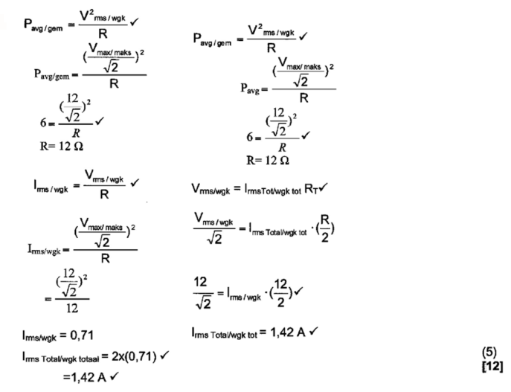

GRAND TOTAL/ GROOT TOTAAL: [150]