**LEARNER TERM 1 REVISION**

**HISTORY**

**TERM1**

**GRADE 12**

**2020**

**LEARNER ACTIVITY BOOKLET**

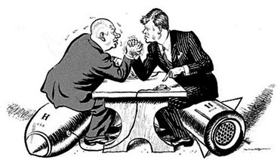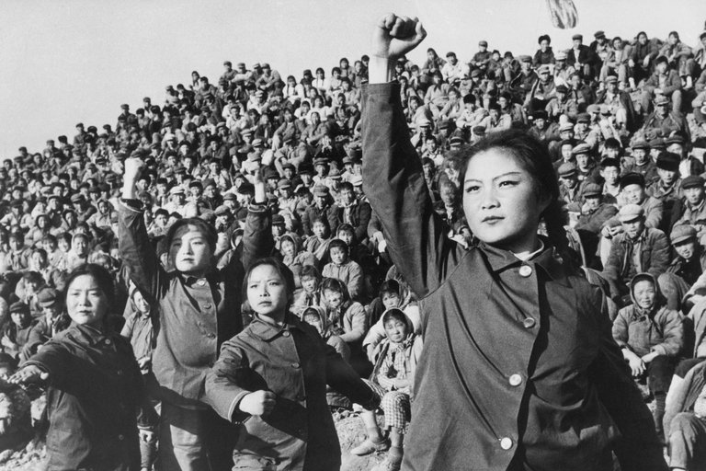

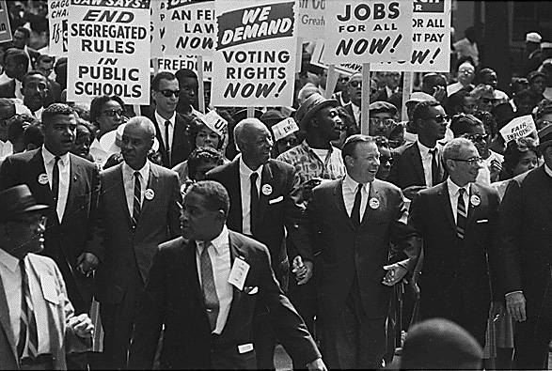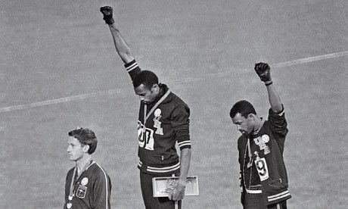

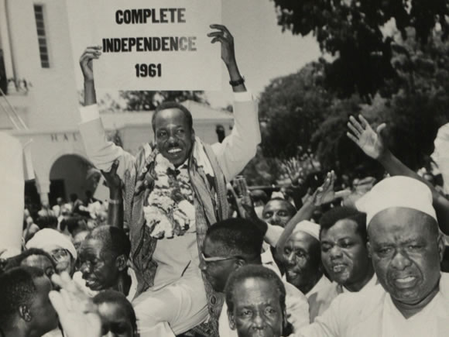

**INSTRUCTIONS AND INFORMATION**

Read the following instructions carefully before answering the questions:

1. This question paper consists of **TWO** Sections:

**SECTION A: SOURCE-BASED QUESTIONS**

Question 1: Cold War: The Cuban Missile Crisis

Question 2: Independent Africa: Case Study Angola

Question 3: Civil Society Protest in the USA from the 1950s to the 1970s: The Black Power Movement

**SECTION B: ESSAY QUESTIONS**

Question 4: The Cold War – Case Study: China

Question 5: Africa Comparative Study: Tanzania and Congo

Question 6: Civil Society Protest in the USA from the 1950s to the 1970s: The Civil Rights Movement

1. The structure of the examination paper is as follows:

* SECTION A consists of THREE (3) source-based questions. Candidates need to answer **ONE SOURCE-BASED** question which counts 50 marks.
* SECTION B consists of THREE (3) essay questions. Candidates need to answer **ONE ESSAY** question which counts 50 marks.
* A candidate needs to answer **TWO** questions:
  + ONE (1) source-based question and ONE (1) essay question.
  + The total mark for the paper is 100.

3. Learners may answer two questions on the same topic.

4. When candidates answer questions, they are required to demonstrate application of knowledge, skills and insight.

5. Rewriting of the sources as answers will be to the disadvantage of candidates.

6. Write neatly and legibly.

**SECTION A – SOURCE-BASED SECTION (50 MARKS)**

**ANSWER ONE OF THE QUESTIONS**

**_________________________________________________________________________**

**QUESTION 1 EXTENSION OF THE COLD WAR**

**QUESTION FOCUS: THE CUBAN MISSILE CRISIS**

**HOW DID CONTAINMENT AND BRINKMANSHIP DOMINATE THE CUBAN MISSILE CRISIS IN 1962?**

**Refer to sources 1A, 1B and 1C and answer the questions that follow:**

* 1. **Refer to Source 1A**

1.1.1 Define the term “brinkmanship” in the context of the Cold War. (1 x 2) (2)

1.1.2 Quote evidence from the source that supports the USA’s domino theory. (1 x 2) (2)

1.1.3 What, according to the source, was the main reason for Russia’s decision to place missiles in Cuba? (1 x 2) (2)

1.1.4 Explain the conditions laid down by USSR to remove missiles planted in Cuba. (2 x 2) (4)

1.1.5 How did the Americans respond to USSR’s demands? (1 x 2) (2)

1.1.6 What is implied (suggested) by the following: ” each with its fingers on the button”? (2 x 2) (4)

* 1. **Refer to Source 1B**

1.2.1 Identify the THREE Presidents shown in the source. (3 x 1) (3)

1.2.2 Do you think that the stance, as supported in the source by the

USA President, was an aggressive one?

Use the source to support your answer. (2 x 2) (4)

1.2.3 Explain why the Russian President rides a horse whilst the

Cuban President rides a donkey in the context of the Cold War. (2 x 2) (4)

1.2.4 How reliable is this source to a historian studying the Cuban Missile

Crisis? (2 x 2) (4)

**1.3** How does Source 1B complement Source 1A with regard to the Cuban

Missile Crisis? (2 x 2) (4)

**1.4 Study Source 1C**

1.4.1. Name, according to the source, one USA city that could have been attacked by the missiles. (1 x 1) (1)

1.4.2 What steps did the American President take to protect his country? (2 x 1) (2)

1.4.3 What is the reference to the “unmistakable evidence” that is

referred to by the American President? (2 x 2) (4)

**1.5** Use the sources and your own knowledge to write 80 words (8 lines)

on how brinkmanship and containment dominated the

Cuban Missile Crisis in 1962. (8)

**[50]**

**QUESTION 2: INDEPENDENT AFRICA**

**QUESTION FOCUS: CASE STUDY ANGOLA**

**WHY DID THE CIVIL WAR IN ANGOLA BECOME AN INTERNATIONAL CONFLICT?**

**Study Sources 2A, 2B and 2C and answer the questions that follow:**

**2.1 Refer to Source 2A – Viewpoint 1**

2.1.1 What was the position of Geldenhuys in the SADF? (1 x 1) (1)

2.1.2 Give a reason for his unhappiness about the presence of

The Soviet Union & Cuba in Angola. (1 x 1) (1)

2.1.3 Explain how he defended South Africa’s presence in Angola? (2 x 2) (4)

2.1.4 What, according to the source, is his reaction to those who questioned South Africa’s presence in Angola? (1 x 2) (2)

**2.2 Refer to Source 2A – Viewpoint 2**

2.2.1 Define the term “African socialism”. (1 x 2) (2)

2.2.2 List two reasons, given by Kolomin, for the USSR’s

Involvement in Angola. (2 x 1) (2)

2.2.3 Explain the reference, “global confrontation with the USA”

in the context of the Cold War. (2 x 2) (4)

2.2.4 How useful is the source to a historian studying the USSR’s

involvement in Angola? (2 x 2) (4)

**2.3.** Compare and contrast the view of Geldenhuys in Source 2A

to that of Kolomin, in Source 2B, regarding the presence

of the USSR in Angola. (2 x 2) (4)

**2.4 Refer to Source 2B**

2.4.1 Identify the two symbols which link the USSR and Cuba to

Angola. (2 x 1) (2)

2.4.2 How does the use of symbols in 2.3.1 enrich our

understanding of events in Angola? (2 x 2) (4)

2.4.3 What message is being conveyed in Source 2C? (2 x 2) (4)

2.4.4 What natural resource has attracted foreign powers to Angola?

(1 x 2) (2)

**2.5. Refer to Source 2C**

2.5.1 What is the name of the person referred to in the source as a,

“Chinese –trained guerrilla”? (1 x 2) (2)

2.5.2 Explain why the USA supported the “Chinese- trained guerilla”, mentioned in question 2.5.1? (2 x 2) (4)

**2.6.** Using all sources and your own knowledge, write a paragraph of

8 lines (80 words), on the involvement of the USA, USSR, South

Africa and Cuba in the Angolan conflict. (8)

**[50]**

**QUESTION 3 CIVIL SOCIETY PROTESTS FROM THE**

**1950s TO THE 1970s**

**QUESTION FOCUS: THE BLACK POWER MOVEMENT**

**WHAT WERE THE REASONS FOR THE FORMATION OF THE BLACK POWER**

**MOVEMENT?**

**Study Sources 3A, 3B and 3C and answer the following questions:**

**3.1 Study Source 3A**

3.1.1 Define the concept, *Black Power.* (1 x 2) (2)

3.1.2 Whose death, according to the source, sparked the protest march? (1 x 1) (1)

3.1.3 What, according to the source, was the response of the police?

to the protest march? (2 x 1) (2)

3.1.4 Explain why Carmichael, McKissick and Malcolm X rejected

‘integration as a short term goal’. (2 x 2) (4)

3.1.5 Why, in your opinion, would Dr. Martin Luther King jr. have rejected Black Power as a form of resistance? (2 x 2) (4)

3.1.6 Comment on the impact of the slogan, ‘*Black is Beautiful’,* as described in the source. (2 x 2) (4)

**3.2 Refer to Source 3B**

3.2.1 Name three concerns of black people with regard to the attitude of the police. (3 x 1) (3)

3.2.2 How useful is the source to historians understanding police

brutality? (2 x 2) (4)

**3.3** How does Source 3B support Source 3A with regard to police indifference (lack of concern)? (2 x 2) (4)

**3.4 Study Source 3C**

**Source 3C - 1**

3.4.1 Which movement was supported by both Malcolm X and Carmichael? (1 x 1) (1)

3.4.2 Name the city where King launched his campaign. (1 x 1) (1)

3.4.3 Why, according to the source, was Malcolm X willing to dispatch brothers to organise self – defense units’? (2 x 1) (2)

3.4.4 Explain why the ‘self – defense units’ were important to Malcolm X

and the Black Power Movement in their fight against white racism. (2 x 2) (4)

**Source 3C - 2**

3.4.5 How, according to the source (Source 3C – 2), did the actions of black people go against the principles of the Black Power Movement? (1 x 2) (2)

3.4.6 Explain why Carmichael wanted Barnett and Clark ‘out of our way’? (2 x 2) (4)

**3.5** Use your own knowledge and the sources and write a paragraph of 8 lines

(80 words) in which you explain the reasons for the formation of the

Black Power Movement. (8)

**[50]**

**TOTAL SECTION A: 50**

**SECTION B – ESSAY SECTION (50 MARKS)**

**ANSWER ONE OF THE QUESTIONS**

**_________________________________________________________________________**

**QUESTION 4 (A): THE COLD WAR: CASE STUDY CHINA**

In a form of an essay: e.g.: Explain whether the Great Leap Forward was able to transform (change) China to become a world power.

**QUESTION 5:** **INDEPENDENT AFRICA**

*“*The economic models adopted by the Congo and Tanzania were different. The

Congo choosing capitalism and Tanzania socialism, yet both adopted a one-party,

centralised political model.”

Compare the political and economic successes and challenges faced by these two

nations after independence.

[50]

**QUESTION 6: CIVIL SOCIETY PROTESTS: THE USA CIVIL RIGHTS MOVEMENT**

The Civil Rights Movement successfully protested through non – violent means to force the American authorities to grant civil rights to African Americans.

Do you agree with the above statement? Support your argument with relevant evidence while paying attention to the events between the 1950s and 1960s in the United States.

[50]

**TOTAL SECTION B: 50**

**TOTAL MARK: 100**

**ADDENDUM**

**QUESTION 1 EXTENSION OF THE COLD WAR**

**QUESTION FOCUS: CUBAN MISSILE CRISIS**

**KEY QUESTION: HOW DID CONTAINMENT AND BRINKMANSHIP DOMINATE THE CUBAN MISSILE CRISIS?**

**SOURCE 1A**

An extract from H. Khrushchev memoirs in which he recalls the Cuban Missile Crisis

I will explain what the Caribbean crisis (Cuban Missile crisis) of October 1962 was all about….. After Castro’s crushing victory over counter – revolutionaries. We intensified our military aid to Cuba ….

We were quite convinced that the Americans would never reconcile themselves to the existence of Castro’s Cuba. They feared as much as we hoped, that socialist Cuba might become a magnet that would lead other Latin American countries to socialism….. The fate of Cuba and the maintenance of Soviet prestige in that part of the world preoccupied me.

We had to establish a tangible and an effective deterrent to American interference in Cuba…. I had the idea of installing missiles with nuclear warheads in Cuba without letting the USA find out they were there until it was too late…. We had no desire to start a war.

We sent a note to the Americans saying that we agree to remove our missiles and bombers on condition that the President gave us the assurance there would be no invasion of Cuba. Finally Kennedy gave in…..

The two most powerful nations of the world had squared off against each other, each with its finger on the button

From. Khrushchev Remembers 1964

**SOURCE 1B**

An editorial cartoon depicting a western – style showdown between cowboys:

Left: USA president; Right: The Cuban president riding on a donkey and the Soviet leader riding on a horse; Illustration by Leslie Illingworth from the Daily Mail (London) Courtesy of the Library of Congress

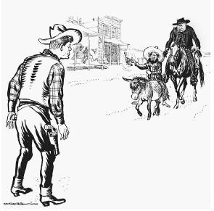

http://ic.galegroup.com/ic/uhic/ReferenceDetailsPage2

**SOURCE 1C**

John. F. Kennedy’s Speech on Radio and Television (an extract)

October 22, 1962

Good Evening, My Fellow Citizens:

This government, as promised, has maintained the closest surveillance of the Soviet military build-up on the island of Cuba. Within the past week, unmistakable evidence has established the fact that a series of offensive missile sites is now in preparation on that imprisoned island. The purpose of these bases can be none other than to provide a nuclear strike capability against the Western Hemisphere…

The characteristics of these new missile sites indicate two distinct types of installations. Several of them include medium range ballistic missiles, capable of carrying a nuclear warhead for a distance of more than 1,000 nautical miles. Each of these missiles, in short, is capable of striking Washington D.C., the Panama Canal, Cape Canaveral, Mexico City, or any other city in the south eastern part of the United States, in Central America or in the Caribbean area.

Acting, therefore, in the defence of our own security and of the entire Western Hemisphere, and under the authority entrusted to me by the Constitution as endorsed by the resolution of the Congress, I have directed that the following initial steps be taken immediately:

First: To halt this offensive build-up, a strict quarantine on all offensive military equipment under shipment to Cuba is being initiated. All ships of any kind bound for Cuba from whatever nation and port will, if found to contain cargoes of offensive weapons, be turned back. This quarantine will be extended, if needed, to other types of cargo and carriers. We are not at this time, however, denying the necessities of life as the Soviets attempted to do in their Berlin blockade of 1948…

Third: It shall be the policy of this nation to regard any nuclear missile launched from Cuba against any nation in the Western Hemisphere as an attack on the United States, requiring a full retaliatory response upon the Soviet Union…

Thank you and good night.

<http://www.historywiz.com/primarysources/kennedyspeechcuba.html\>

**QUESTION TWO INDEPENDENT AFRICA**

**QUESTION FOCUS: CASE STUDY ANGOLA**

**WHY DID THE CIVIL WAR IN ANGOLA BECOME AN INTERNATIONAL CONFLICT?**

**SOURCE 2A – VIEWPOINT 1**

An extract from I Filatova and A Davidson, *The Hidden Thread. Russia and South Africa in the Soviet Era.*  Johannesburg: Jonathan Ball Publishers, 2013, pp. 273-4.

But what were the South Africans doing there (in Angola) in the first place? . . . General Jannie Geldenhuys, commander of the South West African Territorial Force – an auxiliary force of the SADF which had been created to combat Namibian guerrillas – and later chief of the SADF, explained:

In 2011 some arrogant and malicious critics still pose the question: whatever did South Africa have to do with the situation in Angola during the 1970s and 1980s? Now: the Soviet Union mainland is only 70 miles . . . from the United States (Alaska); Cuba’s littoral (shoreline) is only 90 miles away from the United States . . . the Soviet Union at a distance of 3800 miles as the crow flies from Angola – over the Mediterranean and eight European and African countries! On the other hand, at the time of the war in Angola, SWA/Namibia was still legally in international terms under the administration of South Africa; and Namibia has common borders with Angola and South Africa. Obviously, any decent person would ask the much more valid question: What did the island of Cuba and the Soviet Union have to do with Angola?

**SOURCE 2A – VIEWPOINT 2**

An extract from I Filatova and A Davidson, *The Hidden Thread. Russia and South Africa in the Soviet Era.*  Johannesburg: Jonathan Ball Publishers, 2013, pp. 275-6

A (USSR) veteran of the Angolan war, Sergei Kolomin, wrote: . . . What were we doing in this far-off African country, what values were we defending? Officially Soviet military advisers and specialists were fulfilling their ‘international duty’, defending the values of socialism and assisting friendly Angola in building its national army and repulsing (turning away) external aggression. But the then Soviet leadership had other motives for sending thousands of Soviet citizens to take part in a bloody civil war. Maybe they thought of further economic cooperation? Yes, several economic projects were being realised. But the main goals were political. To spread their influence into Angola . . . and in future into Namibia, illegally occupied by South Africa, and finally into South Africa itself. Moreover, Angola was an object of interest for the leadership of the Soviet armed forces in terms of the global confrontation with the USA.

**SOURCE 2B**

A cartoon drawn by a South African, Fred Mouton, and published in Die Burger, 1976. Die Burger was widely associated with the National Party government in South Africa at the time. The cartoon shows a large hand knocking ash from a cigar into an ashtray.



<http://coldwarafrica.tumblr.com/>

**SOURCE 2C**

Dan Wasserman’s cartoon, *Angola in the News* from The Boston Globe.

<http://havanaluanda.files.wordpress.com/2013/07/bissonnette-brian-the-angolan-proxy-war.pdf> Accessed 24 March 2014.

 *The text in the cartoon above reads:*

*Top images, left to right*: Angola in the news → Ronald Reagan wants to give aid …. To a Chinese-trained guerrilla…. Who is bankrolled by South Africa…

*Bottom images, left to right*: To make attacks on US-owned oil refineries …. Which are guarded by Cuban troops… At the request of the Marxist Angolan government. The White House wants the support of the U.S. people.

**QUESTION 3 CIVIL SOCIETY PROTESTS FROM THE 1950s TO THE 1970s**

**QUESTION FOCUS: THE BLACK POWER MOVEMENT**

**WHAT WERE THE REASONS FOR THE FORMATION OF THE BLACK POWER**

**MOVEMENT?**

**SOURCE 3A**

**Black Power: A New Civil Rights Movement**

On June 5, 1966, JAMES MEREDITH was shot in an ambush as he attempted to complete a peaceful march from Memphis, Tennessee, to Jackson, Mississippi. Meredith had already made national headlines in 1962 by becoming the first African American to enrol at the University of Mississippi.

Civil rights leaders such as Martin Luther King Jr., Floyd Mcissick of CORE, and Stokely Carmichael of SNCC rushed to Meredith's hospital bed. They determined that his march must be completed. As Carmichael and McKissick walked through Mississippi, they observed that little had changed despite federal legislation. Local white townspeople harassed the marchers while the police turned a blind eye or arrested the activists as troublemakers.

At a mass rally, Carmichael uttered the simple statement: "What we need is black power." Crowds chanted the phrase as a slogan, and a movement began to flower.

Carmichael and McKissick were heavily influenced by the words of Malcolm X, and rejected integration as a short-term goal. Carmichael felt that blacks needed to feel a sense of racial pride and self-respect before any meaningful gains could be achieved. He encouraged the strengthening of African American communities without the help of whites.

The Black Power movement turned popular fashion and aesthetics on end. In the 1930s, skin lighteners and hair straighteners were used by fashionable black women in an effort to look whiter. By the end of the 1960s, being proud of the African heritage dictated that afros and dark skin were desirable.

Chapters of SNCC and CORE — both integrated organizations — began to reject white membership as Carmichael abandoned peaceful resistance. Martin Luther King Jr. and the NAACP denounced black power as the proper forward path. But black power was a powerful message in the streets of urban America, where resentment boiled and tempers flared.

Soon, African American students began to celebrate African American culture boldly and publicly. Colleges teemed with young blacks wearing traditional African colors and clothes. Soul singer JAMES BROWN had his audience chanting "Say it loud, I'm black and I'm proud." Hairstyles unique to African Americans became popular and youths proclaimed, "BLACK IS BEAUTIFUL!"

<http://www.ushistory.org/us/54i.asp>, accessed on 26 April 2017

**SOURCE 3B**

**Portlands: Historical footage of protest marches calling for police oversight in the 1960s and 1970s**

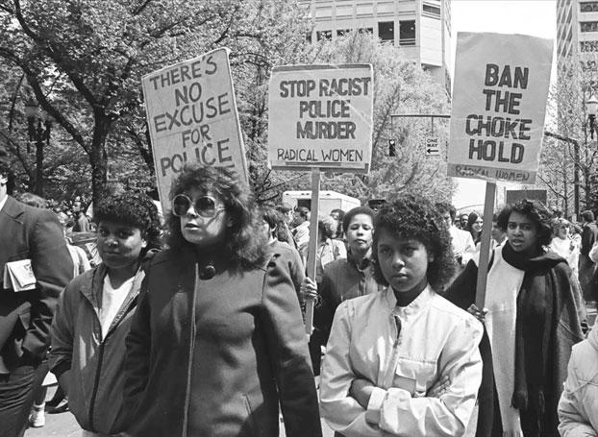

<https://www.bitchmedia.org/post/documenting-the-history-of-police-brutality-in-one-city-arresting-power-film-interview>, accessed in April 2017

**There’s no excuse for police violence**

1. Racist: discrimination
2. Choke: obstruct or block
3. Radical: militant or activist

**SOURCE 3C**

LEADERS OF THE BLACK POWER MOVEMENT EXPRESSED THEIR VALUES AND PRINCIPLES

**SOURCE 3C – 1**

**Malcolm X on Self – Defence Units**

Soon after meeting King in Washington, Malcolm **X** wired King to offer his support for the campaign in St. Augustine, Florida.

Western Union Telegram, 30 June 1964, Dr Martin Luther King, St Augustine, Florida

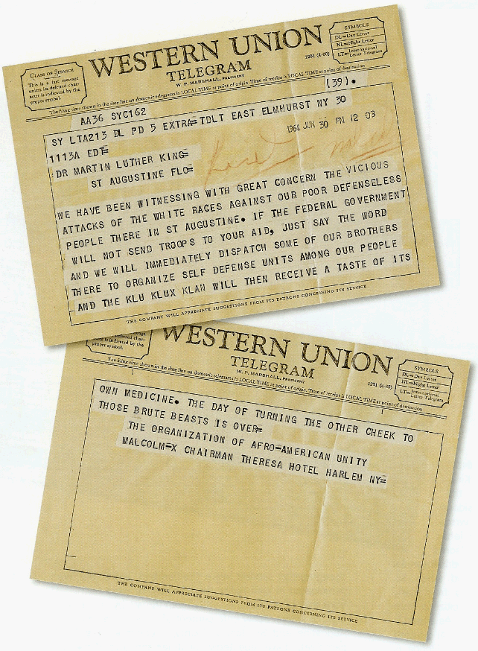

<http://kingencyclopedia.stanford.edu//primarydocuments/Telegram-from-MalcolmX-to-M.gif>

“We have been witnessing with great concern the vicious attacks of the white races against our poor defenceless people there in St Augustine. If the Federal Government will not send troops to your aid, just say the word and we will immediately dispatch some of our brothers there to organise self defense units among people and the Klu Klux Klan will then receive of its own medicine. The day of turning the other cheek to those brute beasts is over.”

The Organisation of Afro – American Unity

**Malcolm X …**

**SOURCE 3C – 2**

**Carmichael on non - violence**

“This country has been feeding us a thalidomide drug (medication to treat a certain cancer) of integration; and some Negroes have been walking down a dream street talking about sitting next to white people. And [that] does not begin to solve the problem. That when we went to Mississippi, we did not go to sit next to Ross Barnett. Ross Barnett was the Governor of Mississippi from 1960 to 1964. He was a prominent member of the Dixiecrats, Southern Democrats who supported racial segregation.

We did not go to sit next to Jim Clark. Jim Clark was sheriff of Selma, and vocally opposed to racial integration ... We went to get them out of our way. And [-] people ought’a understand that. That we were never fighting for the right to integrate; we were fighting against white supremacy.” ~ Carmichael, 1966

<http://breakingbrown.com/2015/06/3-times-kwame-ture-stokely-carmichael-explained-why-forgiveness-nonviolence-and-integration-wont-save-black-america/>