GRADE 11 REVISION MATERIAL

TOPOGRAPHY ASSOCIATED WITH HORIZONTALLY LAYERED ROCKS
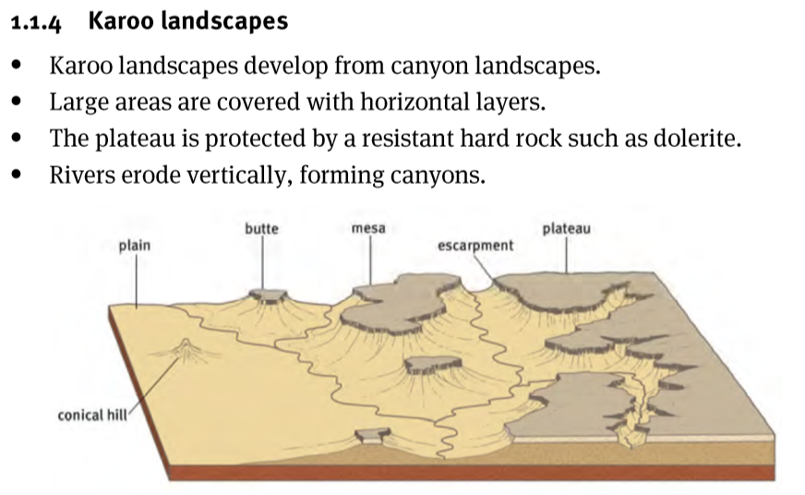
Explain Scarp Retreat
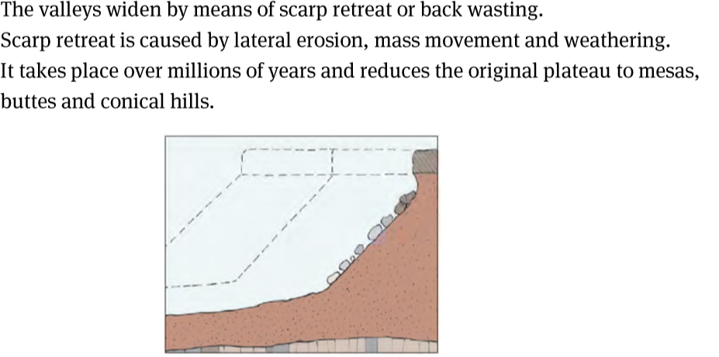

Differentiate between Mesa and Conical Hill
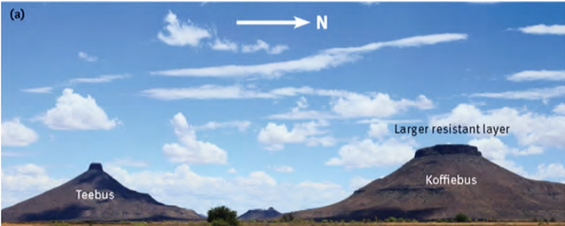
Show differences between a Mesa and a Conical Hill on a Topographical Map
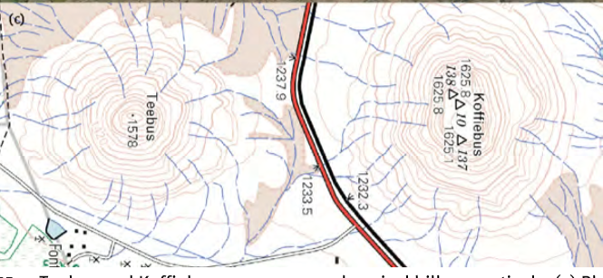

TOPOGRAPHY ASSOCIATED WITH MASSIVE IGNEOUS ROCKS
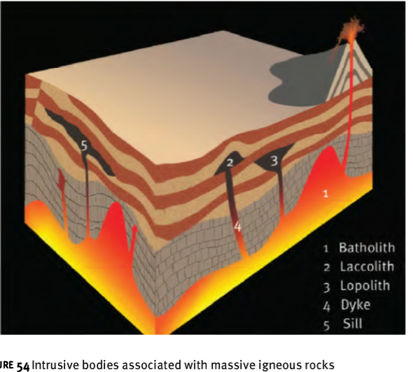
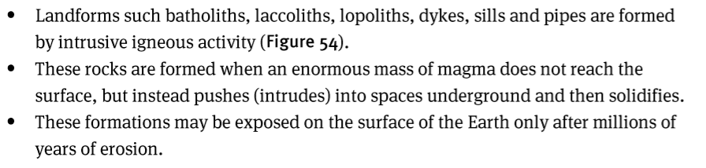
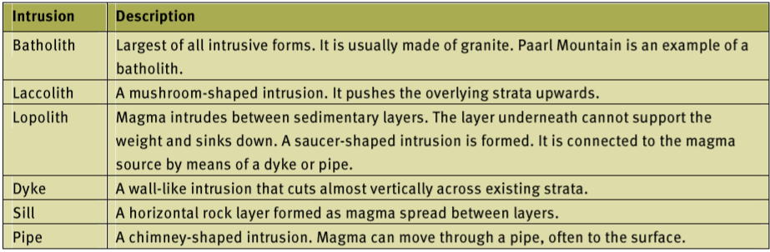

TOPOGRAPHY ASSOCIATED WITH INCLINED/TILTED ROCK STRATA
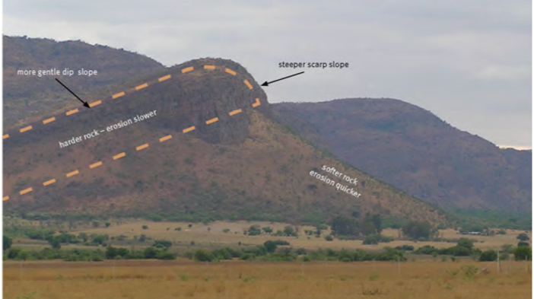
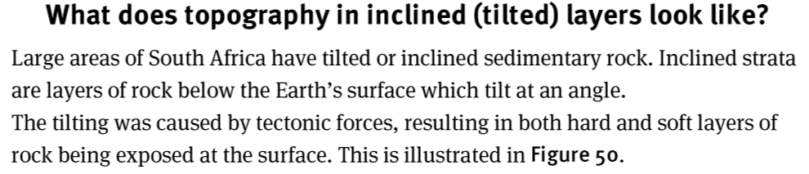
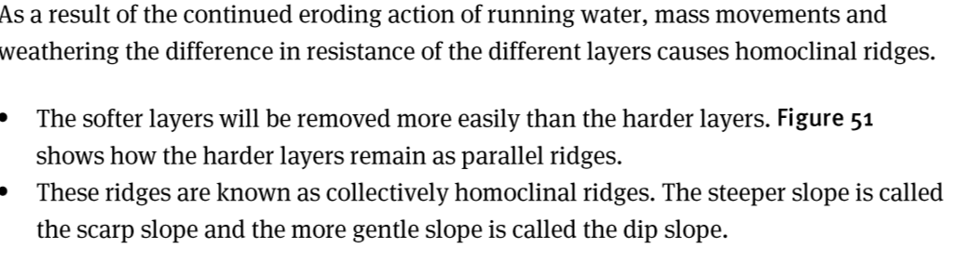
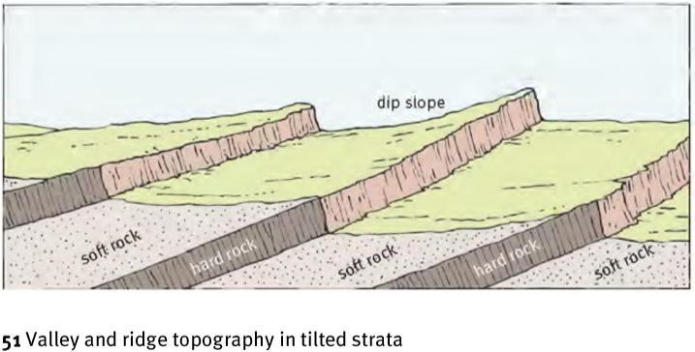
Explain the angles of the Three Homoclinal Ridges
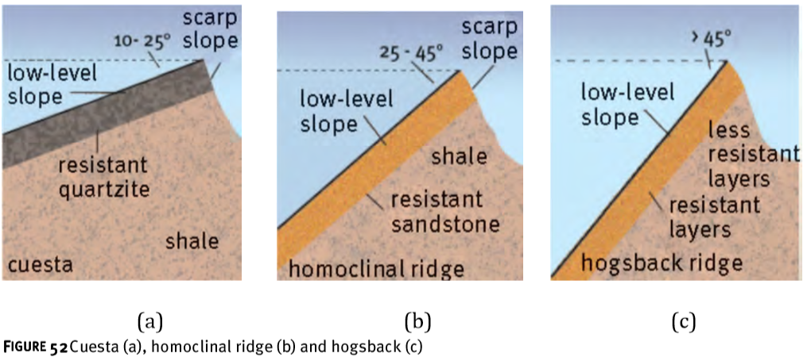
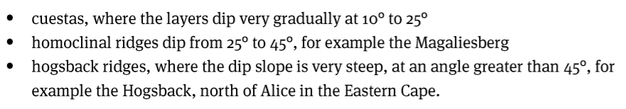

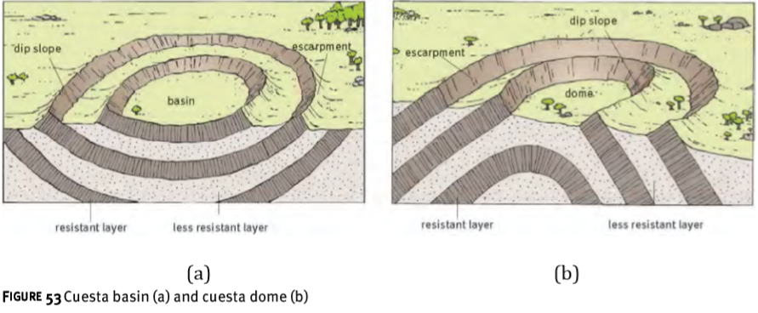
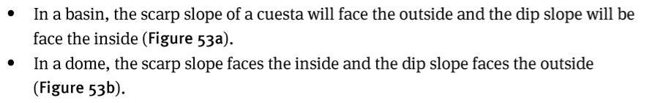
What are the importance of Cuestas to humans?
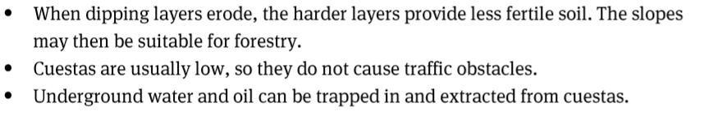
TORS
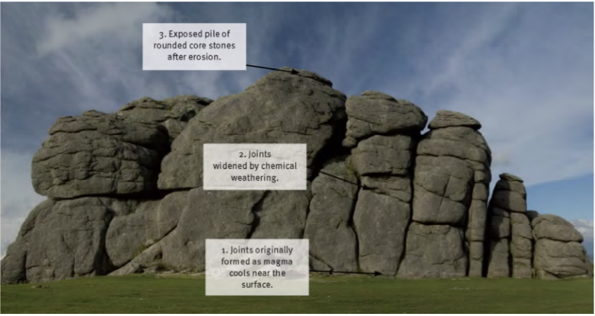

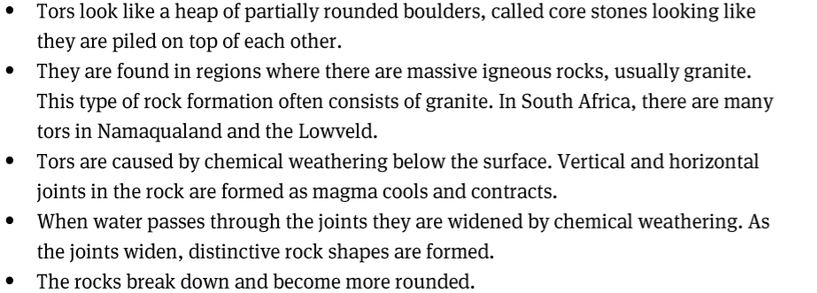
SLOPES
MASS MOVEMENTS AND HUMAN RESPONSES
South Africa's FIVE Physiological Regions
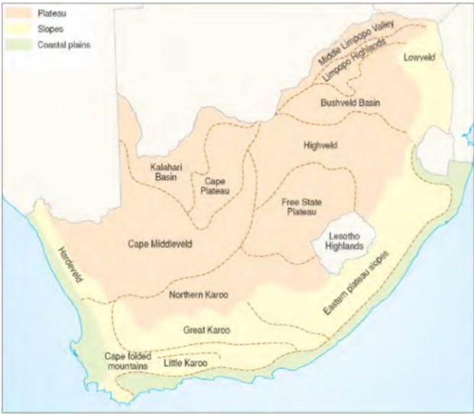

Types of slopes
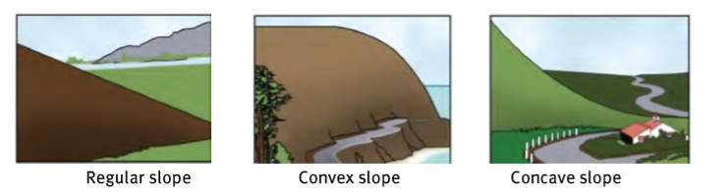
Four Slope Elements
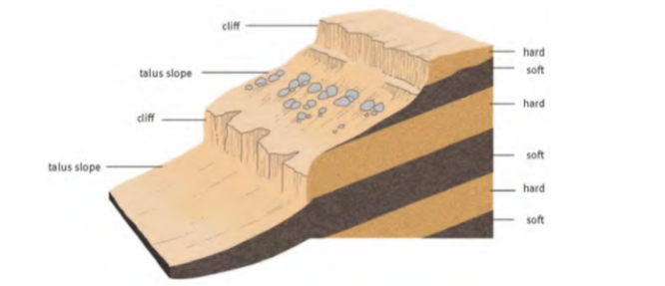
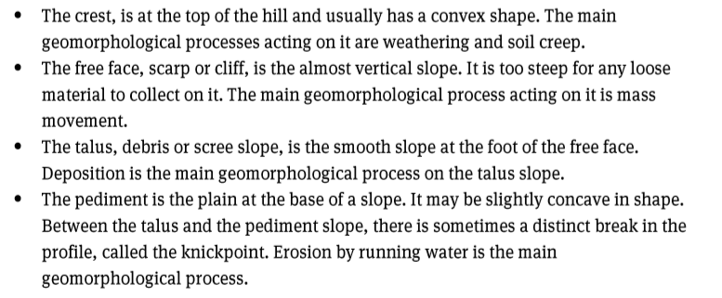

KINDS OF MASS MOVEMENTS

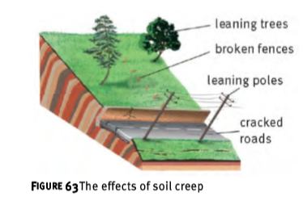 | 