NW PROVINCE MIDYEAR
EXAMINATIONS

GRADE 12

ENGLISH HOME LANGUAGE P1
JUNE 2017

MARKS: 70

TIME: 2 hours

This question paper consists of 13 pages.
INSTRUCTIONS AND INFORMATION

- This question paper consists of THREE sections, namely:

SECTION A: COMPREHENSION (30 marks)
SECTION B: SUMMARY (10 marks)
SECTION C: LANGUAGE IN CONTEXT (30 marks)

- Answer all the questions

- Start EACH section on a new page

- Rule off after each section

- Number the answers correctly, according to the numbering system used in this question paper.

- Leave a line after each answer.

- Pay special attention to spelling and sentence construction.

- Use the following time frames as a guideline:

SECTION A: 50 minutes
SECTION B : 30 minutes
SECTION C : 40 minutes

- Write neatly and legibly.

SECTION A: COMPREHENSION

QUESTION 1: READ FOR MEANING AND UNDERSTANDING
Read and refer to TEXTS A and B below and answer the set questions.
TEXT A

Why Devra Davis wants the world to hang up and take notice
 | American scientist Devra Davis has an impressive record in public health, helping to expose the dangers of tobacco, asbestos and passive smoking. Next on her list? The always-on, every-present mobile phone.
 |  | 3
 | Though the science in her 2010 book, Disconnect: the Truth About Mobile-Phone Radiation, has been questioned, even pilloried, by some experts in the field, Davis is not an ill-informed fraud shouting her way around the world. In fact, she has a long and distinguished career in science behind her, including 10 years as a board director at the US National Academy of Sciences. There, she oversaw the evaluation of the evidence on the likes of tobacco and asbestos. "While we waited and continued to evaluate the issues, millions of people were exposed," she says.
 |  | 10
 | Mobile phones, Davis says, are like tobacco in that they are widely used. "But, unlike tobacco, mobile phones play very valuable roles in society. They have transformed our ability to respond to emergencies and for us to communicate with each other at any time, from anywhere.
 |  | 14
 | Though Davis missed the fact that the CSIRO here invented Wi-Fi ("Really? Did they?"), she is aware we led the world in making the wearing of seatbelts compulsory in cars. "So why don't you give everyone the right to know what's buried in every mobile phone?"
 |  | 18
 | Good point. And one that she claims some success in achieving. Following the publication of her book, she says mobile-phone manufacturers worldwide started to include information on radiation. With the tone of a conjurer, Davis asks me to take out my iPhone and follow the path Settings/General/About/Legal/RF Exposure. While it is hard to verify her claim of being instrumental in having this mandated, the information appears on my iPhone. In black and white. The lengthy screed includes the following:"To reduce exposure to RF energy, use a hands-free option, such as the built-in speaker phone, the supplied headphones or other similar accessories. Carry iPhone at least 5mm away from your body to ensure exposure levels remain at or below the as-tested levels”.
 |  | 28
 | Did you know you were supposed to carry your mobile away from your body? Hands up if you press your iPhone to your face while speaking? If, as Davis's many detractors say, the radiation admitted by the two-way microwave radios in mobile phones is so inert and harmless, why would these warnings exist?
 |  | 32
 | Davis waves away such criticism. She says she is prepared to accept that the carcinogenic properties of mobile phone radiation are a bit of sideshow, a distraction. "I do think mobile phone radiation causes cancer and I do think there will be a tsunami of it, but I'll be dead by the time it is upon us," she says, pointing to the fact that after the dropping of nuclear bombs on Japanese cities during World War II, it took 40 years for brain cancers to appear in great numbers in exposed populations. More pressing, more urgent, and perhaps more obvious are the effects of mobile phone use on male fertility, on children and on unborn babies in the womb.
 |  | 41
 | Why don't you give everyone the right to know what's buried in every mobile phone? Davis is particularly horrified by the enrolment of infants in their parents' gadgets. "There is no reason whatsoever that anybody should be giving a cell phone to an infant in the crib, yet there are thousands of apps for babies in cribs," she observes."If you must give a cell phone to a toddler, at least make sure it is in flight mode”.
 |  | 47
 | Though an ardent user of technology herself, Davis is concerned about the adverse physical effects of its overuse among the young. She points to recent studies indicating that prolonged exposure to the LED screens in iPhones and iPads can cause irreversible damage to the retina. As she regards me with her deep brown eyes, Davis adds that there is something dehumanising about spending nine hours a day looking at a screen rather than looking people in the eye. Davis is horrified by what she calls "e-zombies": parents who take their children to fancy restaurants where everyone gets out an iPad and they don't talk or even look at each other.
 |  | 56
10 | So what makes a woman with such a distinguished career behind her want to devote the rest of her life to these issues? "I now have five grandchildren," she says. "That two-year-old is going to be getting married in two months – that's what it feels like for me. You only get one shot, and they grow so fast. I don't want to see my grandchildren become evidence in somebody's research project”.
 |  | 61
(http://www.sinh.com.au/good-weekend/why-devra-davis-wants-the-world-to-hang-up-and-and-take- notice2015)

AND
TEXT B
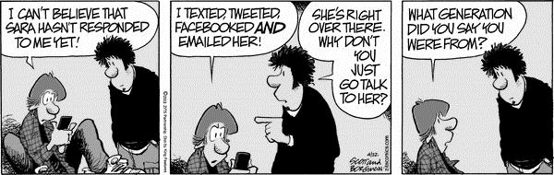

FRAME 1 FRAME 2 FRAME 3
[Source: https://arnoldzwicky.org/category/these-modern-times/page/3/]

QUESTIONS :
TEXT A
 | Why does the writer mention the list of dangerous substances that Devra has exposed in the first paragraph? | (2)
 | Quote one word from paragraph 2 that suggests Devra has endured agony. | (1)
 | Discuss the implications for the use of the inverted commas around ‘while we waited and continued to evaluate the issues millions of people were exposed’ in paragraph 2. | (2)
 | Refer to paragraph 3  Debra has been trying to discourage smoking, and the overuse of a mobile phone. Which one you think is most harmful? Justify your response. | (2)
 | Refer to paragraph 5; choose the best option to describe the tone:
A | humorous and informal
B | factual and conversational
C | formal and humorous
D | patriotic and formal | (1)
 | Refer to paragraph 5  According to the writer there are preventive /pre emptive actions to reduce over exposure to the harmful effects of radiation. List any TWO. | (2)
 | Refer to paragraph 7  State, in your own words what the writer conveys about ‘mobile phone radiation’. | (2)
 | What are the questions in paragraph 8 called and what purpose do they serve in this context? | (2)
 | Refer to paragraph 9. State whether the following statement is TRUE or FALSE. Substantiate your answer.  The writer believes that we should completely abstain from technology. | (2)
 | Comment on the style of the passage. | (2)
 | What do you think is the writer’s intention in paragraph10? Consider the overall purpose of the passage. | (2)
QUESTIONS: TEXT B
 | What is the gadget the boy is looking at in frame 1 | (1)
 | Name any two of the methods the boy used to try and communicate with the girl | (2)
 | Identify the words that imply that the father was born before social networks? | (2)
QUESTION: TEXT A AND B
 | Texts A and B both convey information about technology. Which of the two texts does so more effectively? Substantiate your answer by comparing the two texts. | (2)
 | In your view, does TEXT B support or contradict TEXT A? Justify your answer. | (3)
TOTAL SECTION A: 30

SECTION B: SUMMARY

QUESTION 2: SUMMARISING IN YOUR OWN WORDS
The article below is based on Practical Advice to Limit Exposure to Electromagnetic Radiation Emitted from Cell Phones
Read TEXT C : A FLUENT PARAGRAPH ONLY (containing seven different points) on Practical Advice to Limit Exposure to Electromagnetic Radiation Emitted from Cell Phones and Summarise.
.
- You must use your OWN words, as far as possible.
- Your summary should include 7 points and NOT exceed 90 words.
- Do not volunteer your own information.
- You must write in FULL sentences.
- You need not supply a heading.
- State the correct number of words used, at the end of your summary.

______________________________________________________________________

Practical Advice to Limit Exposure to Electromagnetic Radiation Emitted from Cell Phones
Do not allow children to use a cell phone, except for emergencies. The developing organs of a foetus or child are the most likely to be sensitive to any possible effects of exposure to electromagnetic fields. Avoid using your cell phone in places, like a bus, where you can passively expose others to your phone’s electromagnetic fields.
Avoid carrying your cell phone on your body at all times. Do not keep it near your body at night such as under the pillow or on a bedside table, particularly if pregnant. You can also put it on “flight” or “off-line” mode, which stops electromagnetic emissions. Only use your cell phone to establish contact or for conversations lasting a few minutes, as the biological effects are directly related to the duration of exposure. For longer conversations, use a land line with a corded phone, not a cordless phone, which uses electromagnetic emitting technology similar to that of cell phones.
Switch sides regularly while communicating on your cell phone to spread out your exposure. Before putting your cell phone to the ear, wait until your correspondent has picked up.
This limits the power of the electromagnetic field emitted near your ear and the duration of your exposure. Avoid using your cell phone when the signal is weak or when moving at high speed, such as in a car or train, as this automatically increases power to a maximum as the phone repeatedly attempts to connect to a new relay antenna.
When possible, communicate via text messaging rather than making a call, limiting the duration of exposure and the proximity to the body. Choose a device with the lowest SAR possible (SAR = Specific Absorption Rate, which is a measure of the strength of the magnetic field absorbed by the body). SAR ratings of contemporary phones by different manufacturers are available by searching for “sar ratings cell phones” on the internet.
[source:https://groups.google.com/forum/#!topic/avanthicse/bKCF_5pbow]
TOTAL SECTION B: [10]

SECTION C: LANGUAGE STRUCTURES AND CONVENTIONS
QUESTION 3: ANALSING ADVERTISING
Study the advertisement (TEXT D) below and answer the set questions.
TEXT D

(Source: http://www.christianitytodayads.com/2012/09/25/the-advantages-of-ipad-advertising/)

QUESTIONS :
 | What visual indications are there that the advertisement featured here is old? | (2)
 | Carefully describe the target audience of this advertisement. | (2)
 | What do you think is the significance of the statement: “up to 64 Gigabytes Gee whizz”? | (3)
 | Critically discuss how the image is intended to influence the reader. | (3)
[10]

TEXT E and F: CARTOON
QUESTION 4: UNDERSTANDING OTHER ASPECTS OF THE MEDIA
Study TEXT E and F; Analyse the Cartoons below and Answer the Questions that follow
TEXT E: CARTOON
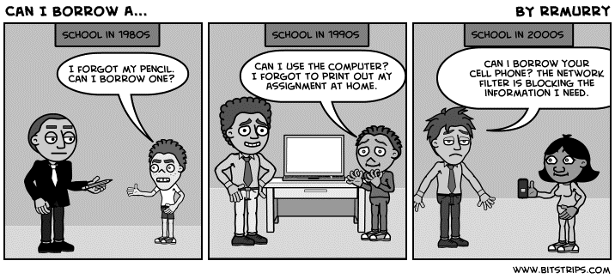
Frame 1 Frame 2 Frame 3

[http://kelewis.blogspot.co.za/2011/12/non-print-source-response.html?m=1]
QUESTIONS: TEXT E
 | Define and account for the teacher’s body language and facial expression. |  |  | (2)
 | Discuss how humour is created in this cartoon? |  |  | (3)

TEXT F: CARTOON
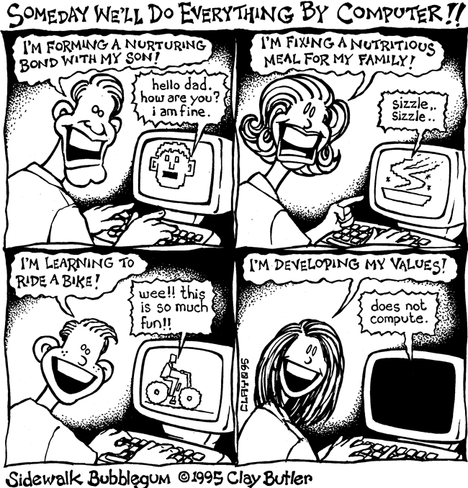
Frame 1 Frame 2

Frame 3 Frame 4

[http://www.sidewalkbubblegum.com/category/comics-about-science-technology]
QUESTIONS: TEXT F
 | Explain the irony in Frame 4. | (2)
 | Refer to Frames 1, 2, 3 and 4.  Discuss any TWO techniques used by the cartoonist to comment on the people’s character. | (3)
[10]

QUESTION 5: USING LANGUAGE CORRECTLY

Study the following text, which contains a deliberate mistake, and answer all the questions:
TEXT G
 | Children Shouldn’t Use Cell Phones...  Cell phone safety is one of the fastest growing and strongest global industries in the world today and is even stronger than the pharmaceutical industry. As a multi-trillion dollar industry that funds media around the world today they are capable of making sizeble political donations and persistent lobbying efforts that dictate government policies. | 5
 | So while cell phone dangers will one day likely be as well known as tobacco dangers, there’s going to be a window when people are extremely vulnerable. And that window is right now. Children are especially vulnerable to damage from cell phone radiation, and should not use them at all (or only for very limited amounts). Men and women who want to have healthy children need to take special precaution to protect their reproductive organs and should not keep phones in their front pockets or close to their abdomens—just as fine print warnings advise. | 13
 | If you DO give a child or a toddler a cell phone to play with, be sure it is at least set to “Airplane Mode” so that the wireless connections are disabled. Dr. Davis is hopeful that a safer technology is underway. | 16
 | [source:http://articles.mercola.com/sites/articles/archive/2012/10/07/devra-davis-on-cell-phone-dangers.aspx]
QUESTIONS: TEXT G
 | What is the function of the hyphen in line 3? | (1)
 | Identify and correct spelling error in paragraph 1. | (1)
 | Provide the noun form of ‘pharmaceutical’ (line 3). | (1)
 | Provide the adverbial form of ‘vulnerable’ (line8). | (1)
 | Justify the use of the brackets/parentheses in line 11. | (2)
 | What part of speech is ‘their’ in the following sentence:  ‘Men and women who want to have healthy children need to take special precaution to protect their reproductive organs’. | (1)
 | Rewrite the following clause in the passive voice:  ‘Men and women who want to have healthy children need to take special precaution’. | (2)
 | Account for the use of the dash in line 14? | (1)
[10]
TOTAL SECTION C: 30
GRAND TOTAL: 70

