NW PROVINCE MID-YEAR

EXAMINATIONS

GRADE 10

ENGLISH FIRST ADDITIONAL LANGUAGE

PAPER 1

JUNE 2017

MARKS: 80
TIME: 2 HOURS

This Question Paper consists of 13 pages

INSTRUCTIONS AND INFORMATION

1. This question paper consists of THREE sections:
SECTION A: Comprehension (30)
SECTION B: Summary (10)
SECTION C: Language (40)
2. | Answer all questions.
3. | Read ALL the instructions carefully.
4. | Start EACH section on a NEW page.
5. | Leave a line between answers.
6. | Number the answers correctly according to the numbering system used in this question paper.
7. | For multiple choice questions, write only the question number and the letter (A-D) of the correct answer.
8. | Pay special attention to spelling and sentence construction.
9. | Write neatly and legibly.

SECTION A: COMPREHENSION
QUESTION 1
Read BOTH TEXT A and TEXT B and answer the set questions.
TEXT A
SNIFFING OUT DRUGS

- Like most mothers, she had dreams that her son would lead a good life and grow up to be a responsible, respected member of society. But Nonhlanhla Mngomezulu*(46) didn’t foresee her son, Mandla*(25), becoming a drug addict at the age of 15.
“My son was living with his father in the Eastern Cape after we got divorced,” she tells us. “His interest in drugs began as a form of peer pressure; then gradually he started taking drugs on a social level. By the time he was an adult he was a full blown addict.
5

- Nonhlanhla believes Mandla had too much freedom as a teenager. “I often had a hunch that my son was taking drugs,” she says. “He’d come to Joburg to visit me and would tell lies about where he was going. Then things started disappearing from the house like my jewellery, power tools and appliances.”
10

- She also noticed changes in his behaviour. “He struggled to sleep, had a lack of appetite, was losing weight and there was no rational thought process behind some of his actions.” Before long, her worst fears were realised. He started to disappear, sometimes for days at a time. “I don’t wish for anyone to go through what I went through,” Nonhlanhla says. “Not knowing whether your child is sleeping under a bridge or whether they’re at the morgue – whether they’re dead or alive.”
15

- Last year things came to a head when Mandla disappeared for four months. She eventually received a call from the police to say he’d been arrested. “I decided not to pay bail because if I did, he’d leave jail and go back to the streets,” she shares. “So I let him stay there until he’d finished his sentence [which was 80 days]. After that, I put him on a bus to Joburg and now he’s in a rehabilitation centre. He’s been clean for 60 days”.
20

- One thing at least has made things a bit easier for this distressed mother: Nonhlanhla has help in a new form of technology, IDenta Touch & know, which she can use to check her son’s room for drugs.
25

- “I can swab his remote control, console games, cupboards, bedside table and cell phone to monitor whether there are any drugs in his room,” she explains. The IDenta Touch & Know was developed in Europe in 2009 by Yaacov Shoham, a retired Chief Superintendent of the Israeli Police with experience in chemistry and forensic. His company, IDenta Corporation, has designed several test kits that are used globally to combat the distribution of illicit drugs and fight terrorism.
30

- This specific kit can test for up to 21 drugs including cocaine, white heroin, marijuana, mandrax, ecstasy, phetamine/methamphetamine, LSD, ketamine, Nyaope and tik.
Russell Hutton, General Manager at Vukani Marketing & Consulting, the company that’s brought the technology to SA, says the test is non-invasive. “Many people, particularly parents, are reluctant to approach a person they suspect is taking drugs for fear this will lead to confrontation, distrust, breaking of relationships and alienation,” he says.
35

- “You can take a swab off any surface. The test kit releases a fluid that can detect whether the substance it has picked up is illegal. It also detects emerging designer drugs, commonly described as spice, bath salts and plant food.
40
The kit can only be used once but it can test several surfaces, Hutton says.
“The test is non-confrontational, as it tests substances and not the person. It provides concerned people with credible information and lets them know what’s happening and seek advice on the best way to deal with the situation,”
45

AUN World Health Report has identified SA as one of the world’s drug capitals.
[Adapted from Drum magazine 3 March 2016]

NOTE:
- Answer all the questions in your OWN WORDS.
- For one-word answers, write only the question number and the word.
- For multiple- choice questions, write only the question number and the letter (A-D) of the correct answer.
1.1.1 | Nonhlahla Mngomezulu didn’t realise in time that her son was becoming a drug addict. What was the reason? |  | (1)
1.1.2 | According to his mother, how did Mandla get into drugs? How far did he go  with his involvement? |  | (2)
1.2  1.2.1 | Refer to Paragraph 2.  “I often had a hunch that my son was taking drugs.”  Explain the expression: ‘had a hunch’ from the extract above. |  | (2)
1.2.2 | In Mandla’s mother’s opinion, why did Mandla fall into drugs so easily? |  | (2)
1.3  1.3.1 | Refer to paragraph 3  Besides stealing and telling lies, what behavioural signs were evident in Mandla? Mention two. |  | (2)
1.3.2 | - In your opinion, why doesn’t Nonhlahla wish for anyone to experience what she experienced herself? |  | (1)
1.3.3 | - Which of the following words is a synonym of the word ‘morgue’?
 | A | Monument
 | B | Mortuary
 | C | Statue
 | D | Church | (1)
1.4 | Refer to paragraph 4.  Explain what is meant by: He’s been clean for 60 days? |  | (1)
1.5 | Quote a word in paragraph 6 which tells us that Mandla’s mother wants to know what Mandla is doing all the time? |  | (1)
1.6 | Refer to line 30 of paragraph 6.  Pick a word which has opposite meaning to: locally. |  | (1)
1.7 | State whether the statement below is TRUE or FALSE. Give a reason for your answer.  The IDenta Touch & Know was invented with drug addicts in mind only. |  | (2)
1.8 | Refer to paragraph 7.  Name the company that brought The IDenta Touch & Know technology to  South Africa. |  | (1)
1.9 | State whether the following statement is a FACT or OPINION.  Parents are reluctant to approach their children suspected of taking drugs for fear of confrontation, distrust or even breaking relationships or alienation. |  | (1)
1.10 | Respond to the question below with a ‘Yes’ or ‘No’ and support your answer with a reason.  Did Mandla’s mother make the right decision not to pay bail when her son was arrested? |  | (2)
1.11 | What is a rehabilitation centre? |  | (2)
1.12 | What do you understand by: SA has been identified as one of the world’s drug capitals? |  | (2) [24]

Study TEXT B below and answer the set questions.
TEXT B

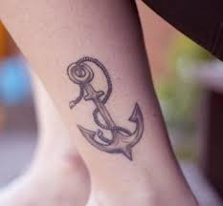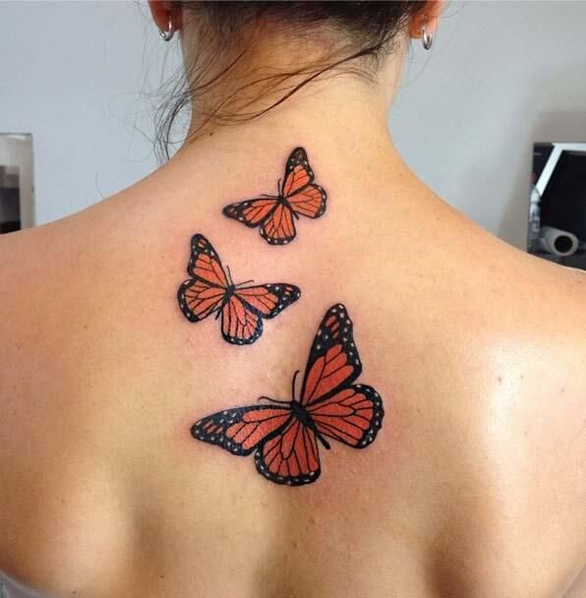
1.13 | What is the body mark on these people called? | (1)
1.14 | State two reasons you think people make those body marks? | (2)
1.15 | What is your opinion about these body marks? Would you make them?  Explain your answer. | (3)  [06]
 | TOTAL SECTION A: | [30]
SECTION B: SUMMARY
QUESTION 2
Read Text below and list SEVEN points that you will include in your article on how to take care of your feet.
INSTRUCTIONS
- Your summary must be written in point form.
- List your SEVEN points in full sentences, using no more than 70 words
- Number your sentences from 1 to 7
- Write only ONE point per sentences
- Use your OWN words as far as possible.
- Indicate the total number of words you have used in brackets at the end of you summary.
TEXT C
CARING FOR YOUR FEET

When you buy shoes, always be super fussy about getting a good fit, and never wear shoes that someone else has bought and rejected. Shoes are bought to fit their original owner’s measurements, and if they have been worn for any length of time, they will have adapted themselves to whatever foot faults their owners may have had- and your feet will be following in their trails.

Your shoes should be 1.5 cm longer than your foot for comfort so that you can wiggle your toes. Shoes should fit comfortably in width, so that your toes aren’t pinched. Always stand up and move around when you are trying on new shoes. Your feet spread when you stand up. If you try on shoes only when sitting down, you are not getting an accurate idea of how the shoes fit.

Don’t constantly wear shoes that don’t allow your feet to breathe. Always give your feet a “shoe break”, too from any kind of shoe fashion during the day. Take them off, flex your feet and walk around for a while in socks. If you have a job that requires constant standing; you need to take special care of your feet. In the evening, if your feet are really tired, bathe them in cold, salted water. A foot refresher spray in useful as a pick-up for tired feet during the day.

Try not to stand constantly in the same position when you work. Move around a little from time to time. When you must stand still, stand up straight, allowing some space between your feet so that weight is evenly distributed between them. Don’t wear the same pair of shoes every day this isn’t good for your feet or for your shoes. You can go barefoot when you can. You need to keep your feet strong by walking or running short distances.
[www.aofas>foot health]
TOTAL SECTION B: 10
SECTION C: LANGUAGE
QUESTION 3: ANALYSING AN ADVERTISEMENT
Study the advertisement (TEXT D) and answer the set questions.
TEXT D

NB: this is the VISUAL and the TEXT at the bottom of advert TEXT D. (In case it is not clear)

Inspired by South Africa’s favourite personal care fragrances - Luscious Tropical Cocoa Butter, Pampering Powder Fresh and Soothing Aloe & Moringa - Clere is proud to introduce a NEW favourites Limited Edition Range of Clere Hand and Body Lotions and Crémes. Your favourite fragrances, combined with all the goodness of Clere will leave your skin feeling and smelling beautiful
3.1. | Give the name of the brand advertised? | (1)
3.2. | Who is the advertisement aimed at? Give a reason for your answer. | (2)
3.3 | How is the slogan “love your beautiful skin” meant to influence the reader? | (2)
3.4 | What is the significance of the heart drawn in the slogan? | (1)
3.5 | Does the advertisement convince you to buy the product? Give a reason for your answer. | (2)
3.6 | Name any two of the products advertised. | (2)  [10]

QUESTION 4: ANALYSING A CARTOON
Read the cartoon (TEXT E) below and answer the set questions.
TEXT E
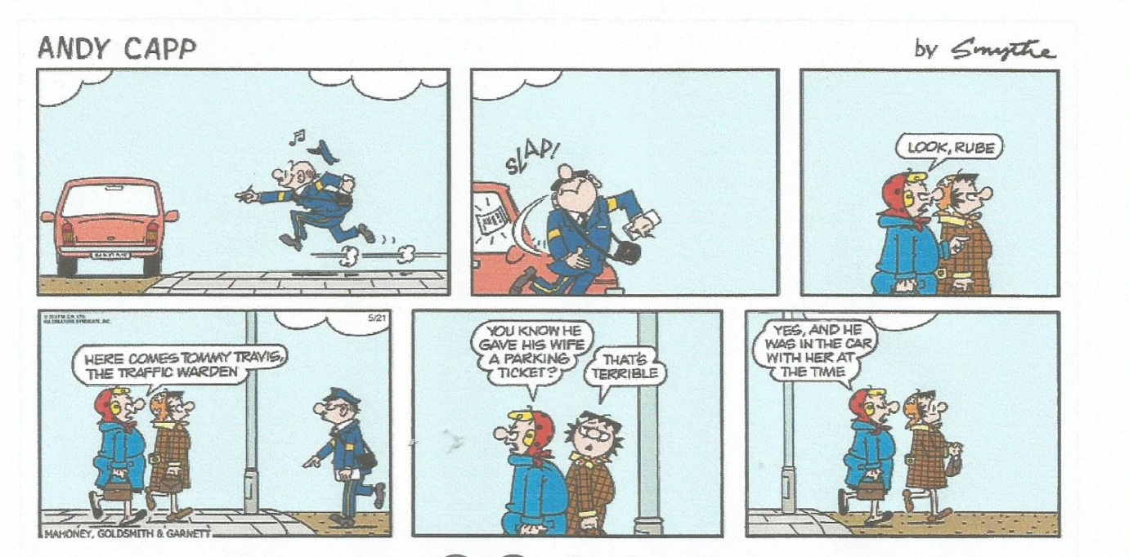
The man in the cartoon is Tommy
Frame 3
Frame 2
Frame 1

Frame 5
Frame 4
Frame 6
http://www.gocomics.com/andycapp
4.1. | Refer frame 1.
4.1.1. | What is Tommy trying to do? |  | (1)
4.1.2. | Mention TWO motion/movement lines that show us that Tommy is hurried? |  | (2)
4.2. | Refer to frame 2  What shows you that Tommy is frustrated and why is he frustrated? |  | (2)
4.3. | Refer to frame 4.  What could be the reason the women talk about Tommy but they do not greet him? |  | (1)
4.4. | Do you agree with Tommy’s attitude to his work? Give a reason for your answer. |  | (2)
4.5. | Comment on the funny side of this cartoon. |  | (2)  [10]
QUESTION 5
LANGUAGE STRUCTURES AND CONVENTION
TEXT E
Read the following text which contains some deliberate errors and answer the questions that follow
KEEP YOUR CHILD SAFE
1. One child go missing every five hours in South Africa, according to figures released be South African Police Service’s (SAPS) Missing Bureau. Missing Children South Africa (MCSA) was established in 2007 in respond to the kidnapping and brutal murders of Sheldean Human, aged seven, from Pretoria and Annestacia Wiese, 12, from Cape Town, in an effect to support families finding themself in similar situations.
2. The organisation also assists the SAPS in finding people and created national awareness. At least 1697 children go missing each year. This is a real dangerous and, as an organisation, we feel it is necessary to ensure that the citizen of South Africa are aware of this threat to the safety of our children.
3. Further to this, Statistics on MCSA, dating from December 2015 to August 2016 show that 142 children were reported missing. This figures are scary but its important to keep a close eye on your little one. The festive season is the busiest time of the year and many mishaps occur. There are ways to prevent your child getting lost and informing them about what to do should anything happen the holidays. [Adapted from TRUELOVE, December 2016]
5.1. | Correct the SINGLE error in each of the following sentences:  (a) One child go missing every five hours in South Africa according to SAPS’ MCSA. |  | (1)
 | (b) The organisation stated that it is a real dangerous to the safety of children. |  | (1)
 | (c) This figures are scary but it’s important to keep a close eye on your little ones. |  | (1)
5.2. | Rewrite the following sentence by changing the underlined words to the singular.  I feel it is necessary to ensure that citizens of South Africa are aware of this threat to children. |  | (3)
5.3. | Add a question tag to the following statement.  MCSA was established in 2007 in response to kidnapping and brutal murder of  children, . . . . . . .? |  | (1)
5.4. | Rewrite the following statement in reported speech (indirect speech).  Mary reports: “At least 1697 children go missing each year.”  Start with: Mary…………………………………………. |  | (3)
5.5. | Rewrite the following sentence in the negative.  The organisation assists SAPS in finding lost people. |  | (1)
5.6. | Combine the following sentences into a single sentence using the word in brackets.  The children go missing. The children are not taken care of (because). |  | (1)
5.7. | Rewrite only the underlined word in the following sentence in full.  You can’t rely on care givers; you need to take care on your little ones. |  | (1)
5.8. | Fill in the correct preposition.  Sheldean Human; aged seven lives……. Pretoria. |  | (1)
5.9. | Correct the underlined adjective in the following sentence.  The festive season is an event time of the year. |  | (1)
5.10. | Give the antonym (opposite) of the word “necessary”.  They feel it is necessary to ensure the safety of their children. |  | (1)
5.11. | Write the following sentence in passive voice.  The organisation assists the SAPS in finding missing persons. |  | (1)
5.12. | Give the homophone of the word ‘hours’ used in the sentence below, write only the word.  Children go missing every five ‘hours’ in South Africa. |  | (1)
5.13. | Choose the correct answer to complete the statement below.  Write down ONLY the question number 5.13 and the letter (A – D) of the correct  answer.  Another word for ‘holidays’ is ................
 | A | Probation
 | B | Excursion
 | C | Vacation
 | D | Tourism | (1)
5.14. | Correct the wrong concord used in the sentence below.  Kidnapping of the two children aged seven and twelve were a painful experience. |  | (1)  [20]
 | TOTAL SECTION C:  GRAND TOTAL: |  | 40  80

