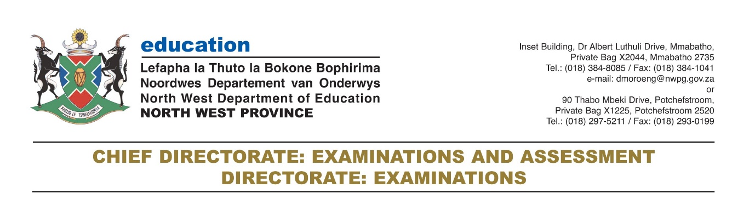

CERTIFICATION SERVICES

A. Applying for a Re-issue of a Certificate: Changes of Particulars

Applying for a Re-issue of a certificate (change of particulars)
For all certificates issued, candidates are allowed a twelve month period from the date of issue for any corrections to be effected. A change to an original certificate will not be considered unless the original certificate (not replacement) is returned.

To change your name on your matric certificate, you must apply to the Department of Basic Education (DBE) or Provincial Education Department (PED) by completing the Re-issues application form.

You must go to the nearest DBE/PED offices in person so that DBE/PED officials can interview you before they make the amendments.

A statement of results may be issued, as an interim record while waiting for the issue of your certificate.

Reasons for re-issue
- Re-issue: Administrative errors
- Within the six-month period after certification (first issue), but not later than a year after the last examination.
- A request for a re-issue will be considered in cases where there is sufficient proof that the mistake on the certificate, either with regard to a subject mark, subject choice or a change in result, or some aspect of the personal details, is incorrect because of a registration error by the school or department.

- Re-issue: Alteration of Sex Description and Sex Status
- In the situation where the Director General of the Department of Home Affairs has granted an application in terms of the Alteration of Sex Description and Sex Status Act, 2003.
- A person’s sex-description has been altered accordingly, the person may, through the Provincial Education Department (PED) or District office or sub-district (SD) office examination section, make application for re-issue with a change of name/personal details (if requested), and a re-assignation of sex description on the Umalusi data-base.

Documentation Required
- Certified copies of the candidate’s old and new Identity Documents
- A detailed sworn statement (affidavit) by the candidate
- The original certificate
- A letter from the Department of Home Affairs confirming that it has, on behalf of the person in question, acted in terms of Section 27(A) of the Births and Death Registration Act, 1992, and that it has altered the sex description (and the names) of that person
- Application form obtainable from the Provincial Education Department (PED) or District office or sub-district (SD) office examination section.
On line application form can be downloaded from the departmental website http://desd.nwpg.gov.za/

What you should do
- Pay the prescribed fee by at the bank (see details attached), cash at Provincial Education Department (PED) or District office or sub-district (SD) office examination section or by cheque.
- Go to the nearest Provincial Education Department (PED) or District office or sub-district (SD) office examination section with the following documents:
    - your original national/ senior certificate and a certified copy
    - Identity document (ID) and a certified copy of your ID
    - an affidavit stating the reasons for alteration (detailed one)
    - confirmation letter from the Department of Home Affairs
    - Birth certificate. If you don’t have a birth certificate you must bring a clinic card, baptismal certificate, or school report that states your name and date of birth.
- Alternatively you can download the form, Application for Change/Correction of Personal Particulars, fill it and Alternatively you can download form, Replacement Certificate: Change of Status, fill it in and email it with the attached documents including the proof of payment receipt to: Nwcertification@nwed.gov.za
- .

How long does it take?
It takes four to six weeks for a Re-Issue certificate

How much does it cost?
- Re-issue certificate (Administrative errors): R130.00
- Statement of results: R50.00
- These fees are valid from 01 April 2020 until 31 March 2021.

B. Applying for Replacement Certificate: Lost or damaged matric certificate

- If you lost or damaged your original matric certificate, you must apply for replacement at the Provincial Education Department (PED) or District office or sub-district office examination section by completing the Replacement application form.
- You can request for the statement of results while waiting for the issue of your certificate. If the certificate is damaged, you must return the damaged certificate to the Provincial Education Department (PED) or District office or sub-district (SD) office examination section.

What should you do?
- Pay the prescribed fee by at the bank (see details attached), cash at Provincial Education Department (PED) or District office or sub-district (SD) office examination section or by cheque.
- Go to the nearest Provincial Education Department (PED) or District office or sub-district (SD) office examination section with the following documents:
  - An affidavit stating what happened to your certificate (i.e. if it is lost or damaged)
  - the original national/ senior certificate (if it is damaged), this is not applicable if it is lost
  - The original identity document (ID) and a certified copy.
- Alternatively you can download form, Application for a Replacement Certificate Std’s 5,6,7,8,9,10 or Grade 12, Alternatively you can download form, Replacement Certificate: Change of Status, fill it in and email it with the attached documents including the proof of payment receipt to Nwcertification@nwed.gov.za

Note: You may apply and pay for the re-issue ONLINE (www.eservices.gov.za).

How long does it take?
It takes between four to six weeks for a Replacement certificate to be issued (for records on the system). You can obtain your statement of results immediately.
For records not on the system, it will take longer as records needs to be retrieved from the Archives and loaded on the system.

How much does it cost?
- Replacement certificate: R130.00
- Statement of results: additional R50.00.
- These fees are valid from 01 April 2020 until 31 March 2021.

B. Applying for Replacement Certificate: Change of Status

If you wrote matric in more than one examination sitting and you want to combine your credits to qualify for a National Certificate, i.e. Senior Certificate (SC) or National Senior Certificate (NSC), you must apply for Replacement certificate: change of status.

The department does not automatically combine your credits, unless you wrote a supplementary examination.

You can apply for confirmation statement of results while waiting for the National Certificate.

What should you do?
- Pay the prescribed fee at the bank (see details attached), cash at Provincial Education Department (PED) or District office or sub-district (SD) office examination section or by cheque.
- Go to the nearest Provincial Education Department (PED) or District office or sub-district (SD) office examination section with the following documents:
    - Your results from all examination sittings
    - The original identity document (ID) and a certified copy.
    - The proof of payment
- Alternatively you can download form, Replacement Certificate: Change of Status, fill it in and email it with the attached documents including the proof of payment receipt to: Nwcertification@nwed.gov.za

How long does it take?
It takes four to six weeks for Replacement certificate: change of status. The combination statement of results is obtainable immediately.

How much does it cost?
It will cost you R130.00 for the Replacement certificate, and if you want a statement of results, it will cost you an additional R50.00. These fees are valid from 01 April 2020 until 31 March 2021.

Banking Details:

Payment Name | NW Education Revenue
Bank Name | FNB
Account Type | Current (Cheque/bond) account
Branch Code | 250655
Account Number | 62811737644
Our Reference | Your Name
Your reference | Examination fees

Any queries should be directed to the following officials:

 | Official | Designation | Contact Number | Email address
Provincial Office | R.D Moroeng | Director: Exams | 0183848095 | dmoroeng@nwpg.gov.za
 | B.F Keetile | Deputy Director | 0183880827 | Bkeetile@nwpg.gov.za
 | T Motlhala | AAA | 0183880865 | Tmotlhala@nwpg.gov.za
 | L Nkotsoe | AAA | 0183880864 | LModukanele@nwpg.gov.za
 | L.C Molefi | AAA | 0183880826 | Lesorom@nwpg.gov.za
 | MJV Lekgetho | AAA | 0183880857 | Jlekgetho@nwpg.gov.za
 | L Mocoencoeng | AAA | 0182975211 | Lmocoencoeng@nwpg.gov.za
 | M Mokoena | AAA | 0182975211 | Mokoenam@nwpg.gov.za
District Offices
Bojanala | D Sebolao | AAA | 0145904800 | DSebolao@nwpg.gov.za
Dr Kenneth Kaunda | J Taje | AAA | 0182998209 | Jtaje@nwpg.gov.za
Dr Ruth Segomotsi Mompati | K.A Motseokae | CEA | 0539287598 | kmotseokae@nwpg.gov.za
Ngaka Modiri Molema | D Semenya | CEA | 0183814565 | Dsemenya@nwpg.gov.za

