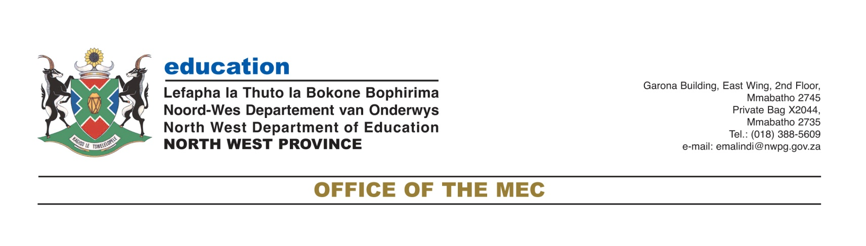

Monday, 20 April 2020
To: All Media houses
For immediate release
MEDIA STATEMENT
NW EDUCATION DISTANCES ITSELF FROM CIRCULATING MESSAGES ABOUT THE REOPENING OF SCHOOLS

The North West Education department is distancing itself from circulating messages on social media and in other communication platforms about schools reopening on 6 May 2020.

The department finds it disturbing that individuals and social media messages purports that schools will be opening on the 06 May 2020 for the Grade 12 and Grade 7 learners. These messages are insinuating that the reopening of schools will happen in different phases for different grades.

On 23 March 2020, the President announced a 21-day nationwide lockdown with effect from midnight of Thursday 26 March 2020 as part of extra ordinary measures to stem the spread and transmission of COVID-19. The COVID-19 lockdown was extended with a further 14 days on 09 April 2020 until the 30 April 2020.

In the first quarter a pronouncement was made for schools to close on the 18 March 2020, before the actual date of the normal Easter recess due to the COVID -19 threat. Since then government has not officially declared the date of the reopening of schools yet.

The North West Education MEC, Mmaphefo Matsemela without any hesitation distanced the department from those circulating dates of the reopening of schools.

“On behalf of the North West Education department I am very much disappointed and amazed on the messages making the rounds that schools will reopen on the 06 May 2020. I need to set the record straight to our parents, guardians, teachers, unions, employees and all our stakeholders that there is no one who has confirmed the date of the reopening of schools yet. I am appealing to all in sundry to wait for our Minister of Education to make the announcement at a right time after consulting with the Provincial MECs of Education and all other stakeholders. These messages circulating are all fake news and there is no truth in them”, said MEC Matsemela.

Matsemela further encouraged parents to continue to support learners when they are home by ensuring that they read for them, open relevant educational websites, watch the education television channels and listens to the radio lessons.

“I would like to further appeal to parents and guardians to ensure that learners stay at home, wash hands and do their school work whilst still at home. I also need to applaud all those teachers who go an extra – mile in teaching our learners through the use of group WhatsApp and other virtual forms of teaching. Thank you once more and continue to be the light of the society in these difficult times”, said MEC Matsemela.

Matsemela further indicated that they have extended the period of broadcasting the radio lessons on the SABC: Motsweding FM from 30 April to 14 May 2020. She said the reason for extension is to provide learners with enough time to understand the content of their subjects.

End.

For more information, please contact:
Mr Elias Malindi
Departmental Spokesperson
Cell: 072 1154 855/072 892 8399

