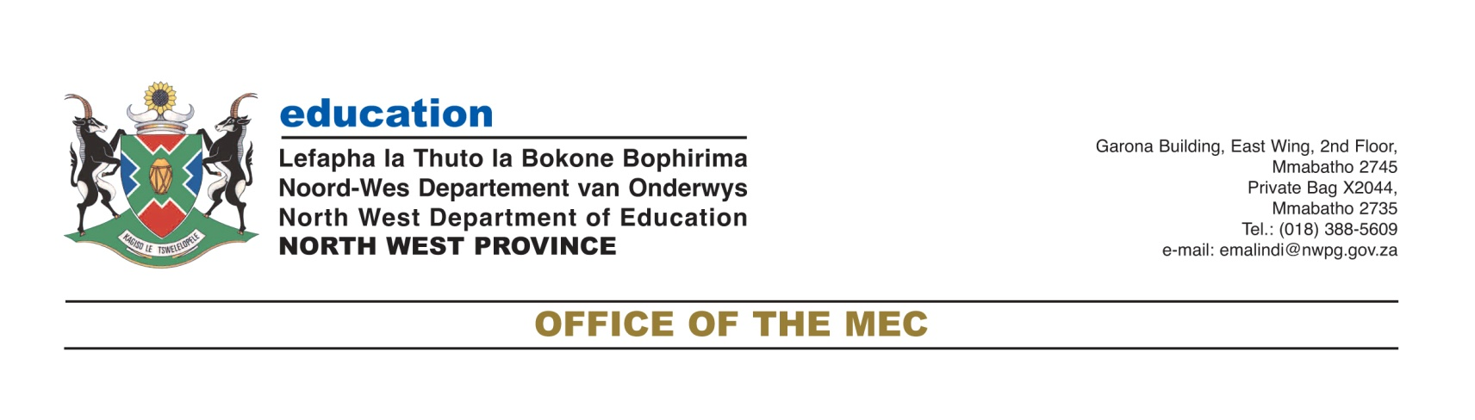

Monday, 30 March 2020
To: All Media houses
For immediate release
MEDIA STATEMENT
NW DEPARTMENTS ASSURES COMMUNITY THAT LEARNERS RECEIVING FOOD AT SCHOOL WILL BE AMONGST FAMILIES IDENTIFIED FOR FOOD PARCELS
Both the North West Education and Social Development departments assured communities that learners who normally receive food at school will be amongst families that will be identified for food parcels.
Different communities have raised serious concerns about learners who come from destitute families and not getting food from school during the lockdown. Following the 21 days of the nationwide lockdown wherein schools have been closed since on Wednesday, 18 March 2020 due to the threat of Covid 19.
The North West Education MEC, Mmaphefo Matsemela assured the communities that departments operate in an integrated approach to deal with feeding of learners.
“As the Department of Education we wish to indicate to our communities that, feeding of learners is only done when they are at school. We do not provide meals to learners when they are not at school because the primary objective for the National School Nutrition Programme is to ensure that learners are taught on a full stomach. When learners are hungry, they do not concentrate in class. As government departments we operate in an integrated manner, there are other departments who take care of these learners when they are out of our schools”, said MEC Matsemela.
MEC Matsemela further encouraged parents to ensure that learners stay at home and listen to the radio lessons and watch other channels aimed at assisting them.
The North West Social Development MEC, Boitumelo Moilwa emphasized that learners are not individuals but they belong to the entire society.
“We want to indicate that learners are not independent individuals but they are part of the entire society. As a department we are doing profiling to identify needy families across the province. Based on the home circumstances we will ensure that, we provide the needy with food parcels and dignitary towels packs during this 21 days of the lockdown. Our Social Workers are part of the Essential Service team and they are working on verifying that needy families are included”, said MEC Boitumelo Moilwa.
The homeless in alternative shelters, Moiloa said are also receiving services from government and other stakeholders.
End.
For further communication, please contact:
Mr Elias Malindi
Departmental Spokesperson
Cell: 072 1154 855/072 8928 399

