GRADE 7
PRACTICAL INVESTIGATION
MATTER AND MATERIAL (PROPERTIES OF THE MATERIALS)
FLEXIBILITY OF THE MATERIAL
- Grade 7 learners wanted to find out which of the two materials that makes the ruler, wooden ruler and Perspex ruler is more flexible than the other? , by measuring the “sag” of each ruler as weight is hanged over the end of each ruler as shown in the diagram below.
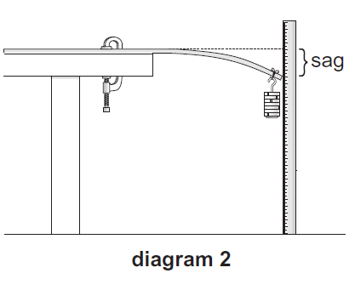
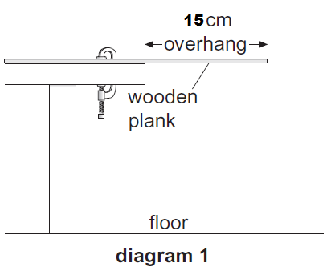
Step 1 step 2

Perform the investigation and write your report under the following headings
- Research/investigative question
- Hypothesis
- Indicate the following variables
- Independent variable
- Dependent variable
- List the material you will need to carry-out the investigation
- Give two variables that you are going to control to make the investigation a fair test
- Collect results
- Draw conclusion

GRADE 7
PRACTICAL INVESTIGATION
MATTER AND MATERIAL
ELECTRICAL CONDUCTIVITY
- Investigate which of the following materials conduct electricity and which do not.
Materials to be tested
Steel wool, tap water, brass, insulated copper wire, sugar solution, salt solution, plastic ruler
Set up your circuit as shown in the picture below. For the solutions immerse/dip the crocodile clips in the solution, make sure that the clips do not touch each other
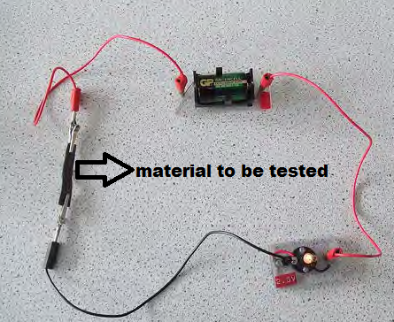
And write a scientific report.
- Investigation question
- Hypothesis/prediction
- Collect results
- Is there any difference in conductivity between sugar solution and salt solution?
- If there is any, find out why is there a difference?
- Brass is a mixture of two metals, which two metal make up Brass?

PRACTICAL INVESTIGATION
MATTER AND MATERIAL (ACID AND BASE)
- Investigate common beverages to determine whether they are acids, bases or neutrals using a red litmus paper
- Beverages to be tested ( tap water , rooibos tea, bleach, vinegar, liquid dish washer, fizzy drink, shampoo, sugar solution )
Write down the report under the following headings

- Investigative question
- Hypothesis
- Collect results
- Conclusion

Grade 7
Practical investigation
Matter and Material
Strength of the material
A grade 7 learner want to investigate which of the following material is stronger (tissue paper, exercise book paper, news paper).
The learner cut the papers in the same dimensions (4cm by 12cm) and punches the single hole at the centre of each paper 1 cm from the bottom and hangs a small container with a paper clip.
He then added the identical marbles one by one till the paper breaks and recorded the number of marble added till the paper breaks for each type of paper
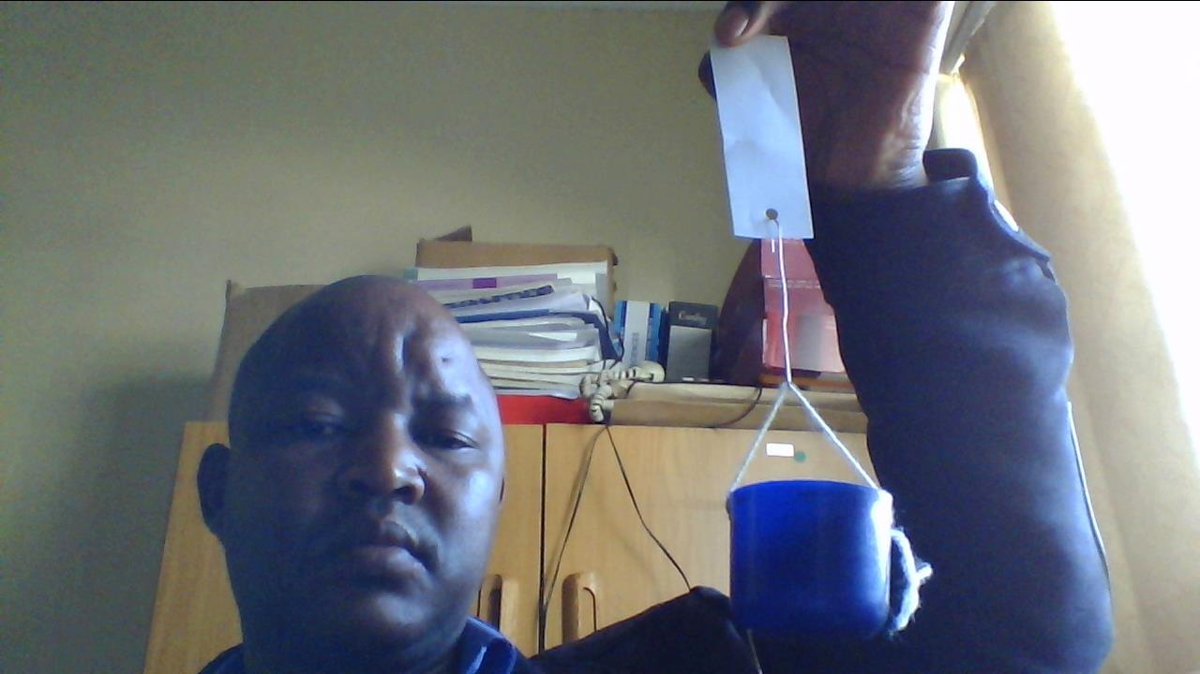

Conduct the investigation and write the scientific report under the following headings
- Research/investigative question
- Hypothesis
- Indicate the following variables
- Independent variable
- Dependent variable
- List the material you will need to carry-out the investigation
- Give two variables that you are going to control to make the investigation a fair test
- Collect results
- Draw conclusion

GRADE 7
PRACTICAL INVESTIGATION
MATER AND MATERIAL (HEAT CONDUCTIVITY)
Learners wanted to investigate which material between BRASS, COPPER AND IRON conduct the heat the fastest. He poured boiled water in the container with the rods of the aforementioned material protruding from the container the apparatus is shown in the picture below. The learners felt the temperature on the far end of each rod by their fingers after a minute.
Precaution (be careful not to burn your fingers, some material may be too much hot)

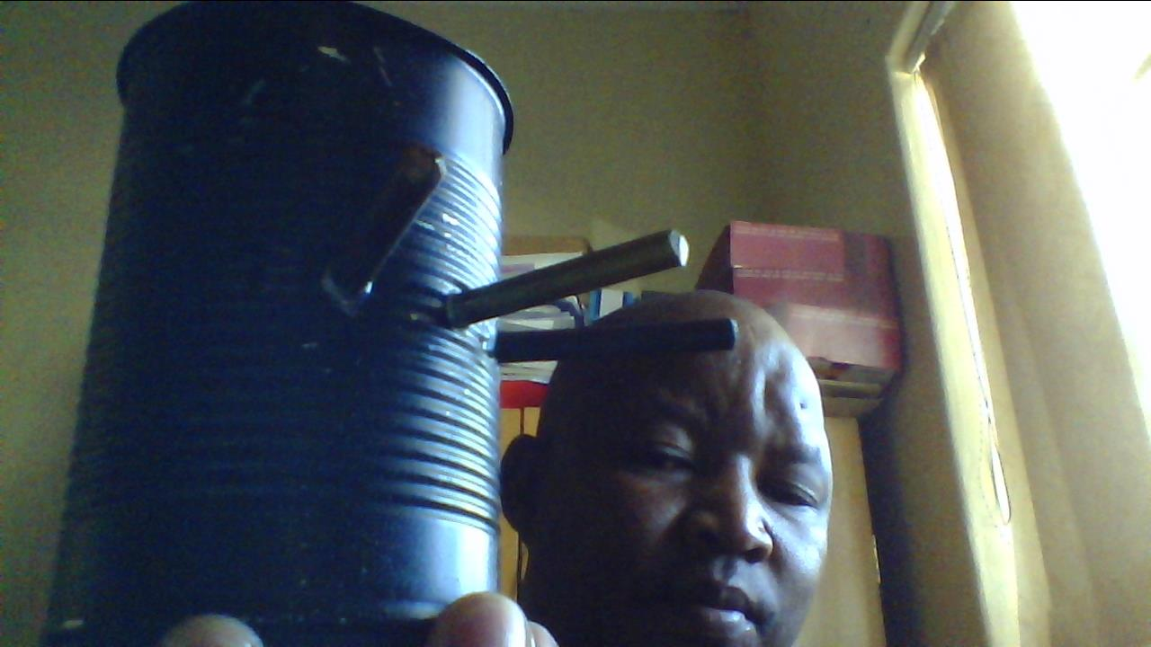
- Research/investigative question
- Hypothesis
- Indicate the following variables
- Independent variable
- Dependent variable
- Collect results
- Draw conclusion

GRADE 7
PRACTICAL INVESTIGATION
TERM 3
A grade 7 learner wanted to investigate how the increase in the potential energy affect the distance the trolley will roll before it stops. He prepared a ramp and inclined by placing a stack of books, by placing two books at a time to increase the height from which the trolley is released as shown in the pictures below
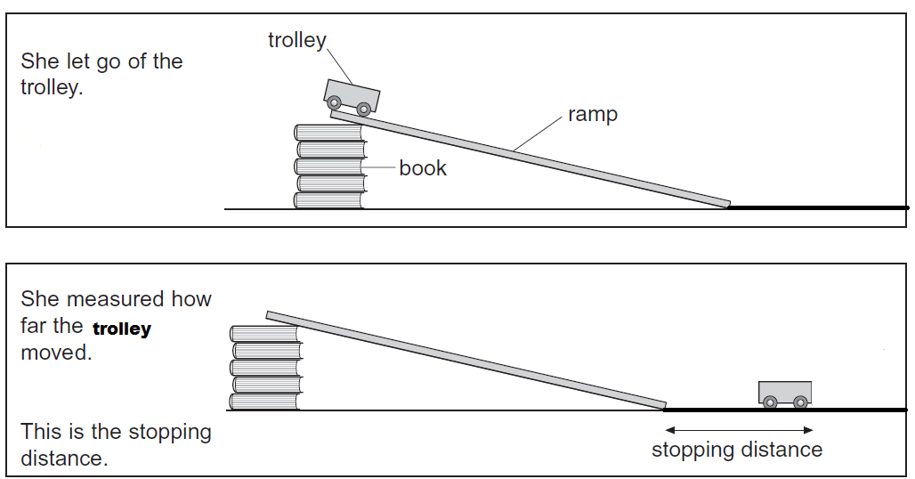
Perform this investigation and report according to the questions below:
Measure the mass of the trolley using a electronic scale/ spring balance ________________Kg
Measure the height of two books at a time and calculate the potential energy by completing the table below
Perform the investigation and write your scientific report by answering the following questions
- What question is the learner investigating?
- What do you think will be the relationship between the potential energy and the stopping distance of the trolley
- Identify the following variables for this investigation
- Independent variable
- Dependant variable
- Which variables must be kept the same for the investigation to be a fair test?
- Measure the height and calculate the potential energy of the trolley and complete the table below
- Release the trolley from the same point every time and measure its stopping distance and complete the table

Number of books | Height in (cm) | Height in (meters) | Potential energy (E_{P} = mgh) | Stopping distance in (meters)
2
4
6
8
10
12
14

- What conclusion can you draw from the results?
- What can you generalise about the potential and kinetic energy of an object?
- Draw a line graph showing the potential energy of an object and the stopping distance of an object

