CIRCULAR FLOW

LEARNER NAME_______________________________________________
GRADE 9

ACTIVITY 1: REVISION OF THE CIRCULAR FLOW

- Define the circular flow.

- Explain why the circular flow is not an accurate reflection of economic reality.

- State what governments consume in the circular flow.

- State what governments produce in the circular flow.

- Who are the participants in the circular flow?

- Explain the role of the markets in the circular flow.

- Why are factors of production important in the circular flow?

- Explain why the circular flow model is circular.

ACTIVITY 2: THE PARTICIPANTS IN A CLOSED ECONOMY

- List the four main participants in a closed economy?

- Indicate which participant makes loans and invests savings.

- Identify the main function of the business sector.

- List two functions of the government sector and describe the additional roles that it plays.

- Explain the meaning of a closed economy.

- Briefly discuss who the household sector consists of. Give your own reasons why this sector is both a consumer and producer.

ACTIVITY 3: MARKETS

- Briefly explain in your own words your understanding of a market?

- Differentiate between a goods and service market and a factor market?

- List at least two examples of a factor market.

- List two examples of a goods and service market.

- List two examples of a goods and service market.
- Supermarket
- Online shopping

ACTIVITY 4: FOLLOW THE FLOW OF GOODS AND SERVICES THROUGH THE MODEL
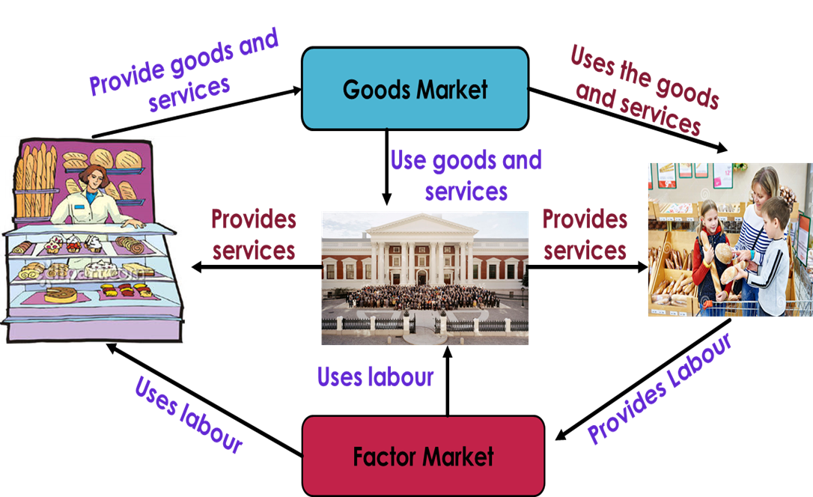

4.1. Identify what we use in order to satisfy needs and wants.

4.2. Provide your own examples of a good and a service that businesses sell to households.

4.3. Study the diagram of the flow of goods and services between businesses and households and identify the main service that is supplied by households to businesses.

4.4. Look at the diagram of the flow of goods and services between businesses, the government and households. what kind of goods and services do you think the government provides to households and businesses? Find your own examples.

ACTIVITY 5: LEARN ABOUT THE FACTORS OF PRODUCTION

- Name the four factors of production

- What is the natural resource used in the production of a block of cheese?
_______________________

- Explain how labour and entrepreneurship are rewarded.

- Create your own labelled sketch of a product and show how the factors of production are used to produce this product.

ACTIVITY 6: PLAN THE ROUTE OF MONEY AROUND THE CIRCULAR FLOW MODEL

- Draw the table below in your workbook. For each point in the left hand-hand column, decide which participant in the circular flow model it falls under. Place a tick in the correct box to indicate your choice. The first point has been completed already.
Flow of income | Households | Businesses | Government | Financial Institutions
Receives taxes from the other participants
Pays company tax
Earns wages from the other participants
Makes loans to households and businesses
Sells goods and services to the other participants
Provides labour to the government and businesses
Pays personal income tax
Receives savings from households and businesses

ACTIVITY 7: SHOW THAT YOU UNDERSTAND THE TERMS

- Complete the following sentences.
- An ______________ is any place where consumers and producers try to do solve the economic problem.
- The economic problem is where people have unlimited needs and wants but _____________ resources to satisfy them.
- the factors of production are owned by __________________.
- Capital, labour, natural resources and entrepreneurship are sold on the _______________ market.
- businesses sell their products on the ______________.
- there are three participants in the circular flow of a closed economy are ______________, ________________ and __________________.
- when there is no trading with foreign countries, we call it a ____________ economy.
- the two flows in the circular flow model are ________________ flows and ________________ flows.

- Draw a circular flow diagram showing the flow of factors of production and goods and services between households, businesses and the government.

ACTIVITY 8: UNDERSTANDING THE CONCEPT CIRCULAR FLOW

8.1Briefly explain in our own words what you understand by the term circular flow?

8.2Differentiate between a closed economy and a open economy.

8.3Identify the five participants who interact in the circular flow model.

MARKING GUIDE
GRADE 9
ANSWERS

  - Define the circular flow.
A model that describes the movement of money through the economy between participant.
  - Explain why the circular flow is not an accurate reflection of economic reality.
The circular flow is just a simple model of how money flows through the economy.
It is based on the following assumptions, which are not a true reflection of economic reality:
                - Households spend all of the income that they earn on goods and services – they do not save any money.
                - Households purchase all of the goods and services that businesses produce.

  - State what governments consume in the circular flow.
Governments purchase factors of production in the form of labour in the factor market, and purchase goods and services from the goods Market.

  - State what governments produce in the circular flow.
Government collects revenue in the form of taxes and provides public goods and services to businesses and households.

  - Who are the participants in the circular flow?
  - Households
  - Businesses
  - Government
  - Financial institutions
  - Foreign sector (Open economy)

10.6Explain the role of the markets in the circular flow.
- The factor market provides factors of production from the households to businesses and the government.
- They act as the middle man between the households, businesses and the government.
- The goods market is where businesses sell their goods so that households can spend their income at the good marke

  - Why are factors of production important in the circular flow?
Without households, the circular flow would not exist, they the anchor of the economy as the economy consist of individuals and these individuals offer their labour, capital, land and entrepreneurial skills to the factor market so that businesses and the government can have used them. Businesses and government need teachers, nurses, engineers, physicists’ architects and a whole lot of households to keep the economy running.
  - Explain why the circular flow model is circular.
The behaviour of the participants in a circular flow is ongoing, meaning it goes on and on and never stop. The participants in the economy are always interacting and they always demanding something from each other.

ANSWERS
ACTIVITY 2: THE PARTICIPANTS IN A CLOSED ECONOMY

- List the four main participants in a closed economy?
- Households
- businesses
- Government
- Financial Institutions

- Indicate which participant makes loans and invests savings.
- Financial Institution

- Identify the main function of the business sector.
- The main function of the business sector is production

- List two functions of the government sector and describe the additional roles that it plays.
- Government passes laws and collects taxes from households and businesses.
- it plays a role as a consumer of goods and services by paying labour and making purchases of goods and services from businesses.
- Explain the meaning of a closed economy.
- A closed economy is an economy that does not trade or interact with other economies at all. There are no exports or imports in a closed economy; it is self –sufficient.
- Briefly discuss who the household sector consists of. Give your own reasons why this sector is both a consumer and producer.
- The household sector consists of consumers
- This sector is responsible for consumption by making expenses and it owns and provides labour, which is one of the factors of production

ANSWERS
ACTIVITY 3: MARKETS

3.1Briefly explain in your own words your understanding of a market?
- A market is a place where buyers and sellers come together to exchange money for goods.
- Differentiate between a goods and service market and a factor market?
- Goods and services – the market where businesses aell their goods and services and where households buy them.
- Factor market – the market where households sell their factors of production and where businesses buy the factors of production.
- List at least two examples of a factor market.
- Labour market
- Capital market
- Financial market
- Employment agencies
- List two examples of a goods and service market.
- Supermarket
- Online shopping

- Goods and services are things that we use in order to satisfy our needs and wants.
- A bakery (business) bakes bread (good) and consumers (households) buy this bread.
Repair shop (service)
Clothing store
- Factors of production (Labour)
- Public goods and services such as Healthcare, public parks, roads and water and sanitation.

ANSWERS
ACTIVITY 5: LEARN ABOUT THE FACTORS OF PRODUCTION

- Name the four factors of production
- Natural resources
- Labour
- Capital
- Entrepreneurship

- What is the natural resource used in the production of a block of cheese?
- Milk

- Explain how labour and entrepreneurship are rewarded.
- Labour – Wages / Salaries
- Entrepreneurship - Profit

- Create your own labelled sketch of a product and show how the factors of production are used to produce this products

QUESTION 6
Flow of income | Households | Businesses | Government | Financial Institutions
Receives taxes from the other participants
Pays company tax
Earns wages from the other participants
Makes loans to households and businesses
Sells goods and services to the other participants
Provides labour to the government and businesses
Pays personal income tax
Receives savings from households and businesses

ANSWERS
ACTIVITY 7: SHOW THAT YOU UNDERSTAND THE TERMS

- Complete the following sentences.
- An economy is any place where consumers and producers try to solve the economic problem.
- The economic problem is where people have unlimited needs and wants but limited resources to satisfy them.
- The factors of production are owned by households.
- Capital, labour, natural resources and entrepreneurship are sold on the factor market.
- Businesses sell their products on the goods market.
- There are three participants in the circular flow of a closed economy are households, businesses and government.
- When there is no trading with foreign countries, we call it a closed economy.
- The two flows in the circular flow model are real flows and money flows.

- Draw a circular flow diagram showing the flow of factors of production and goods and services between households, businesses and the government.

ANSWERS QUESTION 8

  - Describes the circulation of goods and services and income between producers and consumers’.
- It’s an easy way of seeing how the key parts of the macro economy fit together.
  - Closed economy excludes trade with other countries.
- Open economy included trade with other countries.
- Households
- Businesses
- Government
- Financial institutions
- Foreign sector
  - Circulation
Expenditure
Start- up capital
Participants

