NW PROVINCE MIDYEAR
EXAMINATIONS

GRADE 12

ENGLISH FIRST ADDITIONAL LANGUAGE P1
MAY/JUNE 2017

MARKS: 80
TIME: 2HRS

INSTRUCTIONS AND INFORMATION:

1. This question paper consists of THREE sections:

SECTION A: Comprehension (30)

SECTION B: Summary (10)

SECTION C: Language (40)

2. Answer ALL the questions.

3. Read ALL the instructions carefully.

4. Start EACH section on a NEW page.

5. Rule off after each section.

6. Leave a line between answers.

7. Number the answers correctly according to the numbering system used in this paper.

8. Pay special attention to spelling and sentence construction.

9. Write neatly and legibly.

10. Use the following time frames as a guideline:

SECTION A: 50 minutes

SECTION B: 30 minutes

SECTION C: 40 minutes

QUESTION 1
Read BOTH TEXT A and TEXT B and answer the set questions.
TEXT A
SA’S HUMBLE ART CELEBRITY: ESTHER MAHLANGU
Mabhoko
1 Esther Mahlangu’s colourful geometric artwork is exhibited in galleries around the world, but she remains in her South African Village unfazed by fame and determined to preserve her ethnic Ndebele culture. The 81-year-old painter and mural artist earned an international reputation with her Ndebele motifs at a time when the art scene in her home country was focused on contemporary styles. Now, Johannesburg is hosting a major exhibition for Mahlangu, an elderly black woman who rose to global acclaim using a skill passed down for generations.
2 With just a chicken feather, Mahlangu first painted mud huts and chipboards before moving on to luxury cars, vodka bottles, skateboards and footwear as her intricate patterns became huge commercial hits. At home in a dusty village in Mpumalanga, the sprightly great-grandmother looks nothing like an artist who has exhibited at the Centre Georges Pompidou in Paris, the 5th Biennale in Lyon, France, and London’s British Museum. She goes about her daily chores, sweeping the courtyard in front of her hut and worrying about crying babies. Unlike many locals, she still dresses in the distinctive Ndebele traditional attire, with heavy beaded necklaces and dozens of copper rings around her neck and legs. “Working with famous people has not changed me,” she said. “I am not intimidated by anything and not even once have I changed who I am to fit in with their culture.” The only change she has incorporated into her work is replacing natural pigments of cow dung and soil with acrylic paint.
3 Mahlangu’s first big international break came in 1989, when she was 54. Her ornately decorated house had caught the eye of French researchers, who invited her to the Pompidou Centre. In Paris, she painted a replica of her hut for an exhibition. Mahlangu’s heavily wrinkled face lights up in disbelief when showcasing what she had been doing since she was a child. “I only used chicken feathers, no brushes,” she told AFP, taking a break from her chores. “I am an ordinary Ndebele woman, doing what I was taught by my mother and grandmother,” she chuckled. She said she was amazed by the interest her work attracted, an experience that prompted her to teach the age-old Ndebele skill to youngsters in her village. “My aim is to preserve the Ndebele culture. I don’t want it to get lost with civilisation,” she said.

4 German carmaker BMW has collaborated with Mahlangu on two occasions, when she painted the body of their luxury sedans with her iconic Ndebele shapes. Her first collaboration with the company, in 1991, made her the first woman to be invited to take part in the in the Art Car project, following in the footsteps of Andy Warhol and Roy Lichtenstein. “Painting the car was exciting. I never felt under pressure,” she said. The car has been displayed in major exhibitions around the world and in February, ended a four-month show at the British Museum.
5 South Africa was not quick to recognise Mahlangu’s talent, although she has had solo exhibitions in Cape Town. In 2006 she was given a presidential award. “I had to travel to Pretoria to accept it,” she said. “It made me proud to be seen as doing something for the people.” In her cramped two-room thatched roof hut that doubles as a makeshift gallery stands a wooden cabinet displaying some of her many accolades.
6 The Melrose Gallery in Johannesburg is showing a collection of Mahlangu’s latest work, a series of paintings paying tribute to Nelson Mandela. The paintings were created by embellishing prints of drawings created by Mandela in 2001. At the opening of the exhibition, the painter said she had no intention of slowing down despite her age. “I may no longer have the same energy as I used to, but I can still do everything.
Adapted from The Citizen, (Wednesday 15 March 2017)

- Refer to the title of the passage after reading the whole extract. Say whether the title contains a FACT or an OPINION. (1)

- Quote the TWO words which describe Ester’s art best. (2)

- Why was Ester’s work initially not recognised in her own country? (2)

- Choose the correct answer to complete the following sentence:

Ester “rose to global acclaim” means she…

  - travelled all over the world.
  - became famous all over the world.
  - went up in society.
  - claimed to be an upcoming artist. (1)

- Briefly described how Ester’s art progressed through the years. (2)

- Ester is described as looking “nothing like an artist".
1.6.1 In your opinion, what does the stereotype of an artist look like? (1)
1.6.2 How does Ester look different from this stereotype? (1)

- Say which duties Ester keeps herself busy with at home. (2)

- Say whether the following statement is TRUE or FALSE. Quote three consecutive words to prove your answer.

Many people from Ester’s village wear Ndebele clothes. (1)

- Name the only modern element Ester has started to use in her work. (1)

1.10 Describe how it happened that Ester was invited to the Pompidou Centre in Paris, France. (2)

1.11 Explain why Ester’s face lit “up in disbelief”. (paragraph 3) (2)

1.12 Discuss whether you think it is a good idea of Ester’s to teach young people
how to paint Ndebele art. Motivate your answer. (2)

1.13 What does Ester have in common with the two famous artists, Andy Warhol and Roy Lichtenstein? (2)

1.14 Complete the following sentence by filling in the missing words.
A “solo exhibition” is an exhibition which ________________. (1)

1.15 Provide proof that fame did not go to Ester Mahlangu’s head. (1)

TEXT B
LONGEST-LASTING LANDFILL ITEMS

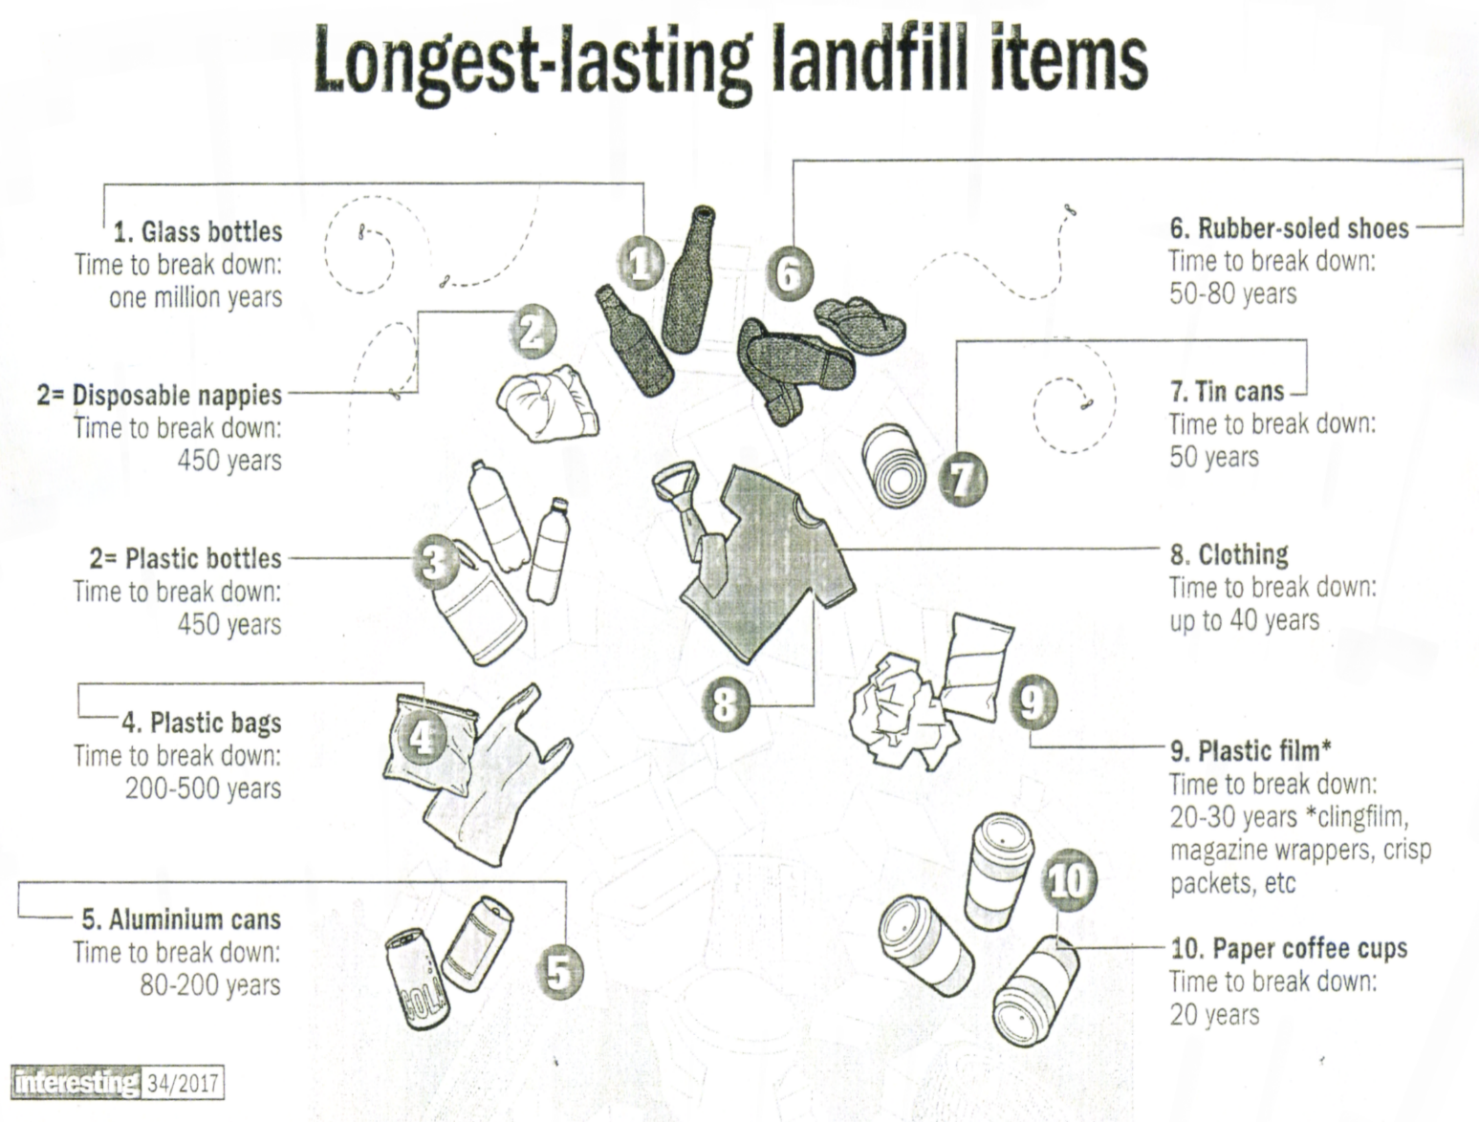

Source: Very interesting (brain entertainment) Issue 34

Refer to the illustration above (TEXT B)
1.16 Comment on the effectiveness of the heading of the text. (2)
1.17 Which of the products is most damaging to the environment?
Motivate your answer. (2)
1.18 Explain the purpose of the text. (2)
TOTAL SECTION A: 30

SECTION B: SUMMARY
QUESTION 2
In 2018 many of the matriculates from 2017 will be looking for employment. With employers on the lookout for the best staff, it is crucial that you are considered among this crowd by nailing a great interview.
Read TEXT C below and list SEVEN tips on how to stand out when you are being interviewed.
INSTRUCTIONS
1. Your summary must be written in point form.
2. List SEVEN points in full sentences using NO MORE than 70 words.
3. Number your sentences from 1 to 7.
4. Write only ONE point per sentence.
5. Use your OWN words as far as possible.
6. Indicate the total number of words you have used in brackets at the end of your summary.

WAYS TO ACE YOUR INTERVIEW
TEXT C
Read the job spec thoroughly, noting the responsibilities that are part of your current role and those that are not. Research the company to be sure of its core business, its size, and how long they have been in business. Check the names and titles of the interviewers, too. Reread your CV so you do not muddle your own job and education history. Make sure there are not any unexplained gaps. Arrive 10 minutes early- it makes a good impression, and means that you will not be flustered from running in at the last minute. Switch off your phone before you enter the interview. Employers want a well-presented candidate (dressed in line with their own dress code) who is able to talk about his/her abilities with knowledge and pride. They also want someone who demonstrates a keenness to learn about the business. Listen carefully to the questions asked, and be sure to structure your responses directly to the question. Do not be tempted to say what you think they want to hear. Rather be honest about yourself, your strengths, and areas for development.
Adapted from Woman & Home (November 2016)

WAYS TO ACE YOUR INTERVIEW

TOTAL SECTION B: 10

SECTION C: LANGUAGE
QUESTION 3: ANALYSING AN ADVERTISEMENT
Study the advertisement (TEXT D) below and answer the set of questions.
TEXT D
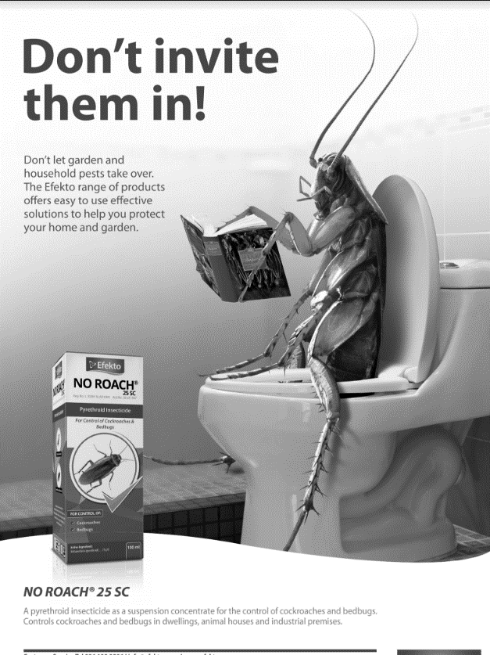

Source: Woman and home (November 2016)

3.1 Which product is being advertised? (1)

3.2 Who is the target audience of this advertisement? (1)

3.3 Explain how the visual of the insect sitting on the toilet, links with the message of the heading. (2)

3.4 Choose the correct answer to complete the following sentence:
Don’t is an example of
A colloquial language.
B slang.
C formal language.
D all of the above. (1)

3.5 Name two places that could possibly be infected by the insects mentioned
in the advertisement. (2)

3.6 3.6.1 How does the picture of the cockroach make you feel? (1)

3.6.2 Explain why the advertiser probably planned on making you feel
this way. (2)

[10]

QUESTION 4

ANALYSING A CARTOON
Read the cartoon (TEXT E) below and answer the set questions. The frames are numbered in the bottom left hand corner.
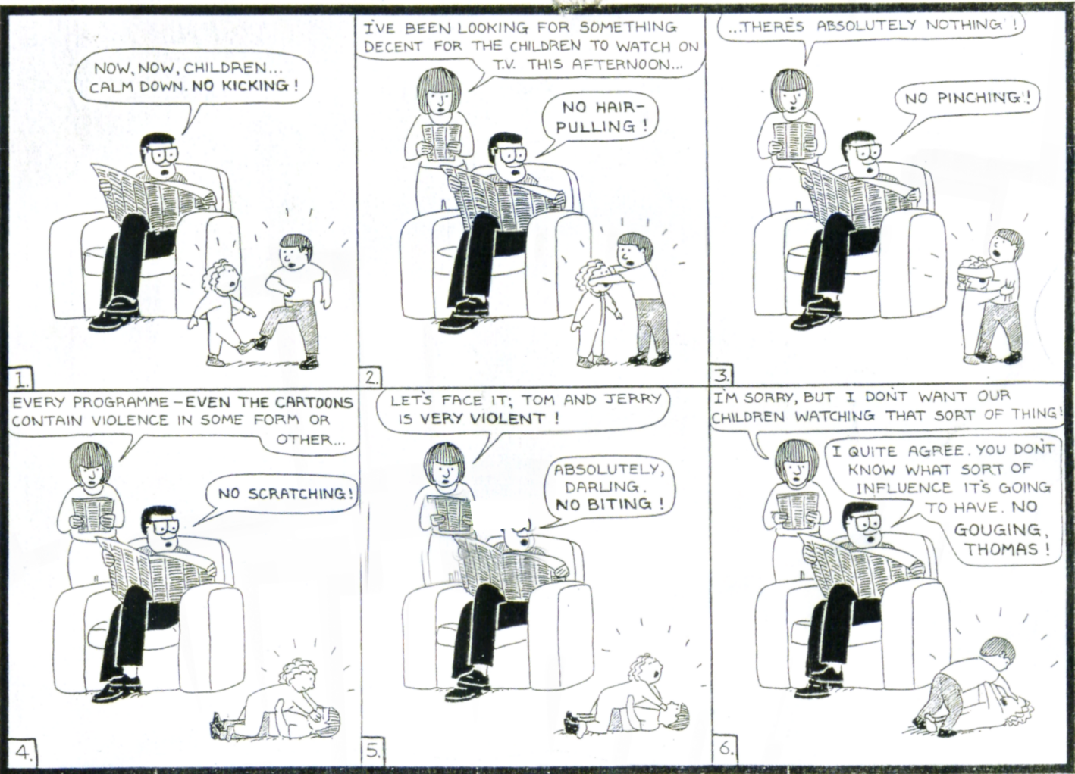
TEXT E

Source: Laughter is the best medicine (Reader’s Digest)
4.1 Refer to FRAME 1.
Why are the words “No kicking!” printed in bold? (1)
4.2 Refer to FRAME 2.
4.2.1 What is the mother reading? (1)
4.2.2 Motivate your answer. (1)
4.3 Explain the use of the ellipsis in the mother’s speech bubble. (1)
4.4 Why do you think the facial expression of the father does not change
throughout the cartoon? (1)

4.5 What is the setting of this cartoon? (1)
4.6 Refer to FRAME 6.
Explain the irony in this cartoon. (2)
4.7 What would you have done in the father’s place to stop the children from
fighting? (2)
[10]

QUESTION 5
LANGUAGE AND EDITING SKILLS
5.1 read the passage (TEXT F) below, which has some deliberate errors, and answer the set questions.
TEXT F
HOLE IN THE OZONE STARTS TO HEAL
1 In 1987, virtually every nation in the world signed the Montreal Protocol. It was a concerted effort to ban the use of CFC’s in order to repair the widening hole in Earth’s ozone layer. Now, almost 30 years later, it appears to have paid of as scientists at MIT have found evidence that the hole in the ozone layer over the Antarctic is closing. The team found that the ozone hole has shrunk by more than four million square kilometres, or about half the area of the United States, since 2000, when ozone depletion was at its peak.
2 “We can now be confident that the things we’ve done have put the planet on a path to heal,” says lead researcher Susan Solomon. “Which is pretty good for us, isn’t it?
3. The ozone hole is first discovered in the 1950s. But concerns began to grow in the mid-1980s when scientists from the British Antarctic Survey noticed it was widening. CFC’s (chlorofluorocarbons), chemical compounds once emitted by dry-cleaning processes, refrigerators and aerosol sprays, were thought to be the main culprit because the chlorine they emit into the atmosphere eats away at ozone. According to Solomon, if levels of chlorine in the atmosphere continue to dissipate at the current rate, the ozone hole could be closed by the middle of the century.
Source: Very interesting (brain entertainment) Issue 34

5.1.1 Correct the SINGLE error in each of the following sentences. Write down ONLY the question numbers and the words you have corrected.

a) The ozone hole is first discovered in 1950. (1)
b) It was a concerted effort to ban the use of CFC’s. (1)
c) Now it appears to have paid of, as the hole in the ozone layer is closing. (1)

5.1.2 Rewrite the following sentence in the passive voice:

Scientists at MIT have found evidence of the closing of the hole in the ozone
layer. (1)

5.1.3 Combine the following two sentences by using “as well as. “

Scientists from MIT noticed the ozone hole was widening.
Scientists from the British Antarctic Survey noticed the ozone hole was
widening. (2)

5.1.4 Rewrite the following sentence in reported speech:

Susan Solomon said, “We can now be confident of healing the planet.” (2)

5.1.5 Rewrite the following sentence in the negative:

Which is pretty good for us, isn’t it? (2)

5.1.6 Provide an antonym for the word “shrunk” in the following sentence:
The hole in the ozone layer has shrunk by more than 400 000 square
kilometres. (1)

5.1.7 Identify the part of speech of the underlined word.

The ozone hole could be closed by the middle of the century. (1)

5.2 Study the text (TEXT G) below and answer the questions.
TEXT G
SKYDIVING WITHOUT A PARACHUTE
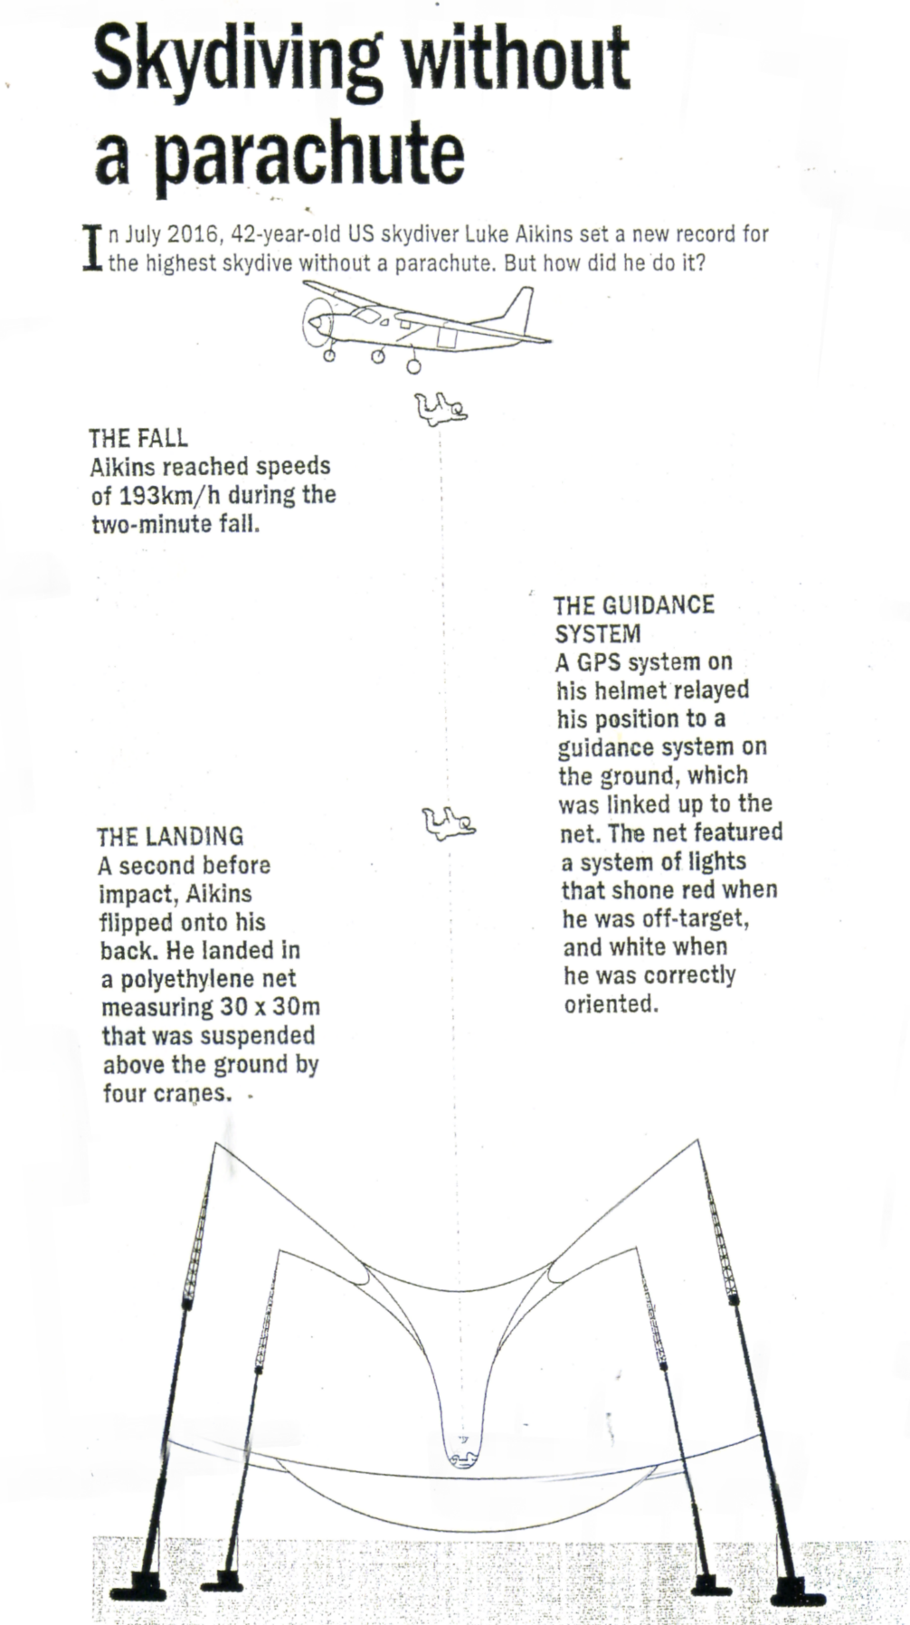

Source: Very interesting (brain entertainment) Issue 34

5.2.1 Complete the following sentence by filling in the missing prepositions. Write only the number and your answer.
Aikins leapt out a)_______ the plane b) ______ a height of 7,620 m (2)

5.2.2 Explain the use of the slash in 193 km/h. (1)
5.2.3 Rewrite the following sentence as a question.
Aikins landed in a polyethylene net. (1)
5.2.4 Write out 30×30 m. (1)
5.2.5 GPS stands for:
A Global Place Searcher.
B General Positioning Service.
C Global Positioning System.
D Garmin Pointing South. (1)
[20]
TOTAL SECTION C: 40
GRAND TOTAL: 80

