SENIO

NW PROVINCE MID- YEAR EXAMINATIONS

GRADE 11

ENGLISH HOME LANGUAGE P1

JUNE 2017

MARKS: 70

TIME: 2 HOURS

This examination paper consists of 12 pages.

INSTRUCTIONS AND INFORMATION
- This question paper consists of THREE sections:
SECTION A: Comprehension [30]
SECTION B: Summary [10]
SECTION C: Language Structures and Conventions [30]

- Read ALL the instructions carefully.

- Answer ALL the questions.

- Start EACH section on a NEW page.

- Rule off after each section.

- Number the answers correctly according to the numbering system used in this question paper.

- Leave a line after each answer.

- Pay special attention to spelling and sentence construction.

- Suggested time allocation:

SECTION A: 50 minutes
SECTION B: 30 minutes
SECTION C: 40 minutes

- Write neatly and legibly.
SECTION A: COMPREHENSION
QUESTION 1: READING FOR MEANING AND UNDERSTANDING

Read TEXTS A AND B below and answer the questions set.
TEXT A
1 | On February 24, 2016, Finance Minister Pravin Gordhan announced that  sugar-sweetened beverages(SSBs) sold in South Africa will be taxed beginning April 2017.SBBs include soft drinks(still and carbonated),fruit juices, energy drinks, vitamin waters, sport drinks, sweetened ice tea, lemonade, cordials and squashes. The stated aim of the tax is to reduce excessive sugar intake | 1  5
2 | Taxes on sugary beverages in other countries have historically been at or below 10%. There is talk of South Africa implementing a 20% tax, which would be one of the highest to be levied anywhere in the world. A 20% tax, while mathematically modelled to reduce obesity, has not yet been tested in practice.
3 | Despite the stated aim of reducing obesity prevalence, this tax is likely being implemented to generate revenue for the country, as part of an effort to shore up major budget shortfalls. There have also been no earmarks on the future profits of the tax, nor are programs being developed to run alongside the tax to help reduce obesity, such as education programs on the harms of SSB consumption. This article will focus on the public health impact of a tax on SSBs, motives side. | 10  15
4 | Sugar taxes, along with taxes on certain foods, tobacco, and alcohol and gambling, are known as “sin taxes.” A sin tax is a tax levied on a product or behaviour viewed as harmful to the public good. These taxes can be implemented to profit from a “sin,” encourage the public to make healthy choices, impact a specific public health outcome, or some combination of the above. | 20
5 | The Department of Health found fiscal measures (including taxes) to be one of the most cost - effective measures to reduce obesity. Fiscal measures generate some of the largest long-term health gains. They add that any one measure alone will not be sufficient to cause a substantial reduction in obesity
6 | This is not South Africa’s first sin tax. Alcohol and tobacco have been taxed since before 1993 [the oldest South African budget the writer can access], with frequent increases rate. Several other countries have implemented some version of a sugar tax, including the U. S., Norway, the U.K., Denmark, France, Finland, Hungary, and Mexico. | 25
7 | According to basic economic theory, an increase in the price of a good (for example from adding a tax) will lead to a decrease in the demand for that good. Studies have found that demand for SSBs is relatively elastic, meaning that people are likely to buy fewer SSBs if their price increases. While this high price elasticity of demand for SSBs is a positive sign for the success of a sugar tax, we must consider the possibility of a substitution effect, where people will avoid buying say, Coca Cola, but will opt instead for a cheaper generic cool drink, effectively consuming the same amount of sugar from a different source. | 30  35
8 | South Africa has the highest obesity rate in the sub-Saharan Africa. According to health sociologist Aviva Tugendhaft, of PRICELESS-SA, more than half of South Africa’s population is overweight or obese. “South Africans consume on average 24 teaspoons of sugar a day, well above the limit of between 6-12 teaspoons,” Tugendhaft says. The National Strategy of the Prevention and Control of Obesity in South Africa has set the goal of reducing obesity prevalence in the country by 10% by 2020. | 40
9 | It is well establish that over-consumption of SSBs contributes to weight gain. The World Health Organization recommends that added sugar should make up less than 10% of a person’s daily calorie consumption in order to reduce the risk of obesity and tooth decay. This works out to approximately 70 grams for men and 50 grams for women. For reference, one can of soda contains about 40 grams, or 10 teaspoons, of sugar. | 45
10 | The negative impacts of excessive sugar consumption do not fall on the individual alone. The costs to the health care system are also impacted, as a result of providing care for those with non-communicable diseases related to the consumption of SBBs. Without a broad approach, a tax on SBBs will not reduce the prevalence of obesity in South Africa.  [Source: Emily Christopher (Adapted)africahealthnews.com 16 April 2016] | 50
 | TEXT B
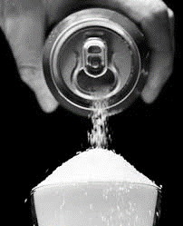

[Source: Creative advertisements]

[Source: Creative advertisements]

 | QUESTIONS: TEXT A
NOTE:
When answering the questions, use your own words as far as possible, unless you are asked for a quotation.
For multiple- choice questions, write only the question number and the letter
(A-of the correct answer.
1.1 | What is the purpose of sugar tax? Use your own words. | (1)
1.2 | Why is there a need for such a tax? State the TWO reasons stated in the text. | (2)
1.3 | Mention how the South African stance on sugar tax is different from other countries. | (1)
1.4 | What is the writer’s intention for stating that the 20% tax is just theory? | (2)
1.5 | Explain the connotation of “sin” in the context of the text | (3)
1.6 | Refer to par 7:  Critically discuss how effective it is to introduce sugar tax as a measure to combat obesity? | (3)
1.7.1 | In your own words describe what “sin tax” entails | (2)
1.7.2 | Do you agree with the view of imposing sin tax on people? Give a reason | (2)
1.8 | Refer to par 6:  “the oldest South African budget the writer can access”  Why do you think records of budgets before 1993 are unattainable? | (2)
1.9 | What is so alarming about South Africa’s obesity statistics? | (2)
1.10 | According to par 9, If you consume a can of soda, how much intake of sugar would be left to consume? | (2)
1.11 | What are non-communicable diseases? (Paragraph10) | (2)
1.12 | Why is it a concern that the national health care system is affected by obesity due to over consumption of sugar? | (2)
 | TEXT A AND B
1.13 | Compare paragraph 8 in Text A and the visual in Text B. justify how the message in the paragraph is complemented by the visual in text B? | (4)
 | TOTAL SECTION A: | [30]

SECTION B

QUESTION 2

Read TEXT C below about “Why sugar is bad for you”, and summarise using your own words and sentences. In ONE fluent paragraph of no more than 90 words.
NOTE:
1. Your summary should include SEVEN points and NOT exceed 90 words.
2. You MUST write one fluent paragraph.
3. You are NOT required to include a title for the summary.
4. Indicate your word count at the end of your summary.

Read the article (Text C) below and list seven points on how to help parents cope with the new setup.

Why too much sugar is bad for you

Sugar-related illnesses (diabetes, heart disease and dementia) are skyrocketing. Yet that doesn’t stop us from sprinkling it over our morning oats, stirring it in our coffee and knocking it back by the tinful on balmy spring days. We know it is bad but we cannot stop.
“Sugar consumption is now an epidemic,” says Dr Mark Hyman, author of The Blood

Sugar Solution 10-day Detox Diet.” The long-term effects will be staggering.”And, no, we’re not just talking cavities. When eaten in such vast quantities, sugar can wreak havoc on the body. And over time, that havoc can lead to diabetes and obesity, Alzheimer’s disease and also breast, endometrial and colon cancers.

One study found that normal-weight people who loaded up on sugar doubled their risk of dying from heart disease. Other research pinpoints excess sugar as cause of non-alcoholic fatty liver disease, which can lead to liver failure.

Research shows that hyper-sweet foods may be as addictive as the hardest-to-quit drugs.

The problem is research suggests that your brain still gets wired by sweets. Bingeing on them can cause a surge of dopamine. Repeated spikes can desensitize the reward centre of the brain, leaving you needing more and more sugar to score a rush.
Not helping matters are your taste buds, which suffer from their own sort of addiction, they become duller.

Eating too much sugar can eat away at your brainpower according to US scientists. It also interfere with insulin’s ability to regulate how cells use and store sugar. It affects our emotions and thoughts too. “What you eat affects how you think”. “Eating a fructose diet over long terms alters your brain’s ability to learn and remember information”, said Gomez-Pinilla. To up your sugar in take for it remains a health hazard.

If you feel all right, your brain is probably not misfiring, though that’s no excuse to up your sugar in take for it remains a health hazard.

“Most people are sugar over eaters but do not know it “says Dr Nicole Avena. That’s because some “healthy foods are loaded with hidden added sugars.

[Gretchen Voss (Adapted) Health 24]

TOTAL SECTION B: 10

SECTION C: LANGUAGE

VISUAL LITERACY

QUESTION 3: ANALYSING AN ADVERTISEMENT

Study the advertisements in TEXTS D & E below carefully and answer the questions below.
TEXT D:
 | Lollipop
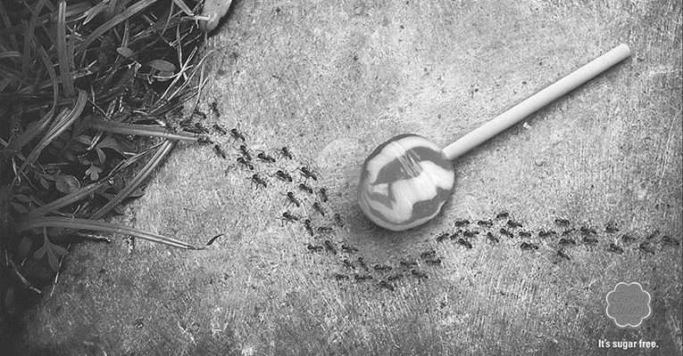
It’s sugar free freefree free
3.1 | What product is advertised? | (1)
3.2 | Account for puzzling behaviour of the ants in the advertisement? | (2)

 | TEXT E
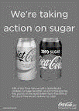
43% of the Coca-Cola we sell in Britain contains no sugar. By 2020, we aim to become the first country in the world where more than 50% of the Coca-Cola we sell contains no sugar
3.4 | What evidence is there in the advert that not all Coca-Cola products are sugar free? | (2)
3.5 | Who is the “we” in the caption: “ We’re taking action against sugar reffering to? | (2)
3.6 | From the visual, quote two words that imply that the drinks are sugar free? | (2)
3.7 | How many years is it going to take the advertising company to reach its goal? | (1)
[TOTAL: 10]

 | QUESTION 4 : ANALYSING A CARTOON
Read the cartoon (TEXT F) below and answer the set questions.
TEXT F
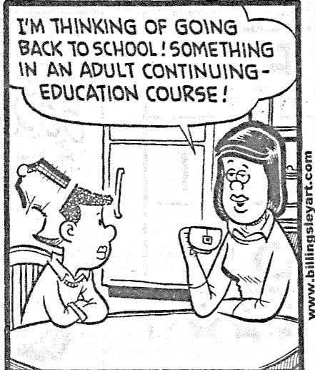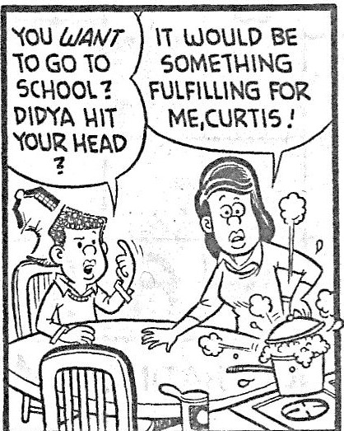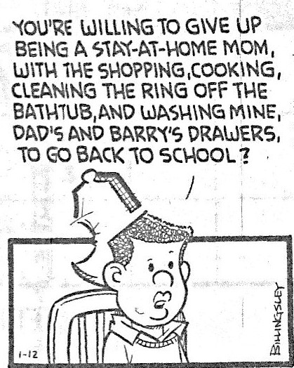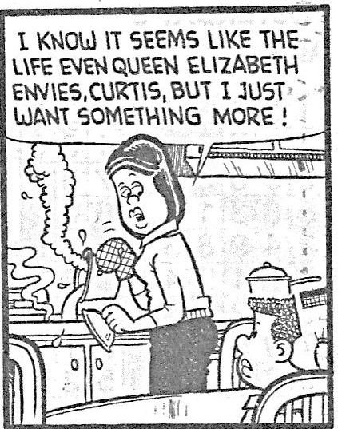

[
Source:
www.shenow.org
]

FRAME 2

FRAME 1

FRAME 4

FRAME 3

4.1 | The woman in frame 2 is clearly not fulfilled. Point out a visual cue that is one of those chores that do not fulfil her? |  | (1)
4.2. | Discuss what the cartoonist conveys about Curtis' attitude in frame 2.  Focus on both his body language and his speech. |  | (4)
4.3 | What the woman says in frame 4, is an example of:
 | a) | Pun
 | b) | Sarcasm
 | c) | Metaphor
 | d) | Amusement | (1)
4.4 | In your own words, describe how a stereotype is portrayed in frame 3? |  | (2)
4.5 | Why is the exclamation mark used in all the frames where the woman speaks? |  | (2)
 | TOTAL 10

QUESTION 5: USING LANGUAGE CORRECTLY

Study the following text, which contains a deliberate mistake, and answer all the questions:
TEXT G

WATCH: JMPD officers arrested after alleged bribery caught on video
Two Johannesburg metro police officers were arrested after they were caught on camera allegedly taking a bribe on Albertina Sisulu Road in Bez valley.
Chief Superintendent Wayne Minnaar said a case of extortion was opened at the Jeppe police station.
Minnaar said the case will be handed over to the senior public prosecutor for prosecution.
The Johannesburg Metro Police Department (JMPD) appealed to the person who took the footage to contact JMPD on 011 490 1797 or visit their internal affairs office at the corner of Village Road and Love day Street during office hours to give a statement which will help secure this case.
In the video two men can be seen emptying their pockets to hand over the money over to the officers.
The video, captured on a cell phone, were send to the JMPD.
Johannesburg safety MMC Michael Sun said JMPD internal affairs worked hard on case.
“The two officers involved were arrested yesterday morning,” Sun said.
He said they would appear in the Johannesburg Magistrate’s Court on Monday.
“The two officers also face internal disciplinary processes and will be dismissed if found guilty,” said Sun.
[Source: Iavan Pijoos 20 March 2017 News 24]

 | Note: For one word answers, write only the question number and the word.
5.1. | Provide a synonym for “allegedly” in paragraph 1 | (1)
5.2. | Write paragraph 3 in the direct speech | (2)
5.3. | The sentence in paragraph 4 is an example of a…………..  A. simple sentence  B. complex sentence  C. compound sentence  D. compound- complex sentence | (2)
5.4 | Correct the concord error in paragraph 6 (rewrite the sentence correctly) | (1)
5.5 | Account for the use of the apostrophe in paragraph 9 | (2)
5.6 | Refer to par 9:  Rewrite the sentence below wherein the word “appear” is used as a noun  They would appear in the Johannesburg Magistrate’s Court on Monday. | (2)
 |  | (10)
 | TOTAL SECTION C: | 30
 | GRAND TOTAL: | 70

