NW PROVINCE MID_YEAR EXAMINATIONS

GRADE 10

ENGLISH HOME LANGUAGE P1

JUNE 2017

MARKS: 70

TIME: 2HOURS

This examination paper consists of 10 pages.
INSTRUCTIONS AND INFORMATION

- This question paper consists of THREE sections:
SECTION A: Comprehension [30]
SECTION B: Summary [10]
SECTION C: Language Structures and Conventions [30]

- Read ALL the instructions carefully.

- Answer ALL the questions.

- Start EACH section on a NEW page.

- Rule off after each section.

- Number the answers correctly according to the numbering system used in this question paper.

- Leave a line after EACH answer.

- Pay special attention to spelling and sentence construction.

- Suggested time allocation:
SECTION A: 50 minutes
SECTION B: 30 minutes
SECTION C: 40 minutes

- Write neatly and legibly.

SECTION A: COMPREHENSION

QUESTION 1: READING FOR MEANING AND UNDERSTAND

Read both TEXT A and TEXT B below and answer the set questions:

TEXT A

KFC

 | Kentucky Fried Chicken, more commonly known by its initials KFC, is an American fast food restaurant chain that specializes in fried chicken. Headquartered in Louisville, Kentucky, it is the world’s second-largest restaurant chain (as measured by sales) after McDonald’s, with almost 20,000 locations globally in 123 countries and territories of Yum! Brands, a restaurant company that also owns the Pizza Hut and Taco Bell chains,  KFC was founded by Colonel Harland Sanders, an entrepreneur who began selling fried chicken from his roadside restaurant in Corbin, Kentucky, during the Great Depression. Sanders identified the potential of the restaurant franchising concept, and the first “Kentucky Fried Chicken” franchise opened in Utah in 1952. KFC popularized chicken in the fast food industry, diversifying the market by challenging the established dominance of the hamburger. By branding himself as “Colonel Sanders”, Harland became a prominent figure of American cultural history, and his image remains widely used in KFC advertising. However, the company’s rapid expansion overwhelmed the aging Sanders and he sold it to a group of investors led by John T Brown, Jr. and Jack C. Massey in 1964.  KFC was one of the first American fast food chains KFC was one of the first American fast food chains to expand internationally, opening outlets in Canada, the United Kingdom, Mexico, and Jamaica by the mid-1960s. Throughout the 1970s and 1980s, it experienced mixed fortunes domestically, as it went through a series of changes in corporate ownership with little or no experience in the restaurant business. In the early-1970s, KFC was sold to the spirits distributor Heublein, which was taken over by the R.J. Reynolds food and tobacco conglomerate; that company sold the chain to PepsiCo. The chain continued to expand overseas, however, and in 1987, it became the first Western restaurant chain to open in China. It has since expanded rapidly in China, which is now the company's single largest market. PepsiCo spun off its restaurants division as Tricon Global Restaurants, which later changed its name to Yum! Brands.  KFC's original product is pressure fried chicken pieces, seasoned with Sanders' recipe of 11 herbs and spices. The constituents of the recipe represent a notable trade secret. Larger portions of fried chicken are served in a cardboard "bucket", which has become a well-known feature of the chain since it was first introduced by franchisee Pete Harman in 1957. Since the early 1990s, KFC has expanded its menu to offer other chicken products such as chicken fillet burgers and wraps, as well as salads and side dishes, such as French fries and coleslaw, desserts, and soft drinks, the latter often supplied by PepsiCo. KFC is known for its former and current slogan "Finger Lickin' Good", which was replaced by "Nobody does chicken like KFC" and "So good" in the interim.  Source: “ Wikipedia, the free encyclopaedia” | 6  16  28  38

TEXT B

A documentary tonight shows the birds living amid their excrement in conditions activists say are ‘oppressive’ – but the farmer in charge claims it’s ‘a very good life’.
Footage to be screened this evening on BBC1 focuses on one farm where about 34,000 chickens are penned into a shed with few windows.

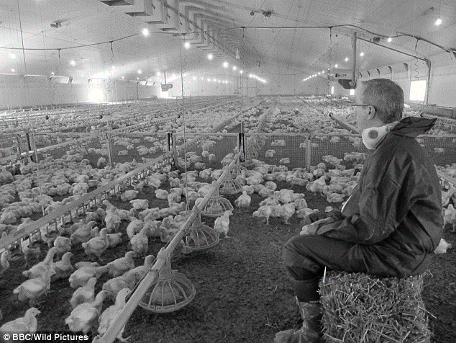
Picture 1

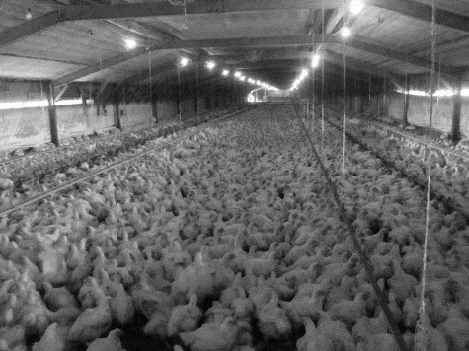
Yesterday animal rights campaigners claimed the lives of the KFC chickens were ‘oppressive’.
Andrew Tyler, director of Animal Aid, said: ‘These birds have no meaningful life. They endure a wretched existence in giant windowless sheds stinking with ammonia.
Picture 2

Picture 3

QUESTIONS: TEXT A
 | KFC experienced mixed fortunes domestically during the 1980’s? True or False? | (1) | 3
 | Why do you think the recipe is a notable trade secret? Substantiate your answer. | (2) | 3
 | “Nobody does chicken like KFC” – comment on the figure of speech. | (2) | 5
 | What image remains widely used in KFC advertising? Do you think it would be wise to change it after he sold the fast food chain? | (2) | 3
 | Refer to Paragraph 1. In your own words explain “The chain is a subsidiary of Yum”. | (2) | 3
 | Quote from the text provided, how do we know that KFC is the world’s second-largest Restaurant chain? | (2) | 1
 | Which other word can be effectively replaced with the word ‘bucket’. Why is “bucket” a good word choice? | (2) | 1
 | In your opinion, can the ‘side dishes’ be sold on their own, without accompanied meals? Substantiate your answer. | (2) | 4
 | Explain in your own words the meaning of the words ‘founded and founder’. | (2) | 3
 | What is the meaning of the word ‘franchise’ and how do you know that KFC is a part of the franchising concept? | (2) | 3
 | Comment on the style of the passage. | (2) | 5
 | Choose the best option to describe the tone of the passage:  A humorous and informal  B factual and conversational  C formal and humorous  D patriotic and formal | (1) | 3
QUESTIONS: TEXT B

 | Why do you think it is important to layer the chicken sheds with sawdust.  (picture 1) | (2) | 4
 | Why would a documentary highlighting the living conditions of the KFC chickens in picture 2 have a negative impact on the sales? | (2) | 5
 | Give the definitions of the words “logo” and “slogan” in meaningful sentences. | (2) | 3
QUESTIONS: TEXT A AND B

 | Texts A and B both convey information about Chickens. Which of the two texts does so more effectively? Substantiate your answer by comparing the two texts. | (2) | 4
Total: 30

SECTION B : SUMMARY

QUESTION 2 : SUMMARISING IN YOUR OWN WORDS

Read TEXT C below about How KFC founder Colonel Sanders achieved success in his 60’s. Using your own words and sentences, summarise, How KFC founder Colonel Sanders achieved success in his 60’s, in ONE fluent paragraph of no more than 90 words.

NOTE:
- Your summary should include SEVEN points and NOT exceed 90 words.
- You MUST write one fluent paragraph.
- You are NOT required to include a title for the summary.
- Indicate your word count at the end of your summary.
HOW KFC FOUNDER COLONEL SANDERS ACHIEVED SUCCESS IN HIS 60’S – Business Insider
In 1952, he made a deal with his restaurateur friend, Pete Harman, to sell his chicken dish as "Kentucky Fried Chicken" in exchange for a 4-cent royalty on every piece sold. After it became a top-selling item, Sanders made the same deal with several other local restaurants.
Things were going great, but when a new interstate bypassed Sanders' restaurant, it spelled doom.
He sold the location at a loss in 1956, leaving his $105 monthly Social Security check as his only income.
Since he'd closed his restaurant, the Colonel decided to dedicate himself fully to the franchising side project he'd started four years earlier.
He hit the road with his wife. He would enter a restaurant, offer to cook his chicken, and then make a deal if the owner liked what they tasted.
By 1963, had more than 600 restaurants across the US and Canada selling Kentucky Fried Chicken. That October, he was approached by John Y, Brown, Jr. and Jack C. Massey who wanted to buy the franchise rights.
Sanders was initially reluctant, but after weeks of persuasion, he agreed to sell his rights for $2 million ($15.1 million in 2015 dollars) in January 1965.
Under the contract, the company Kentucky Fried Chicken would establish its own restaurants around the world and would not compromise the chicken recipe. Sanders was to have a lifetime salary of $40,000 (later upped to $75,000), a seat on the board, majority ownership of KFC's Canadian franchises, and would serve as the company's brand ambassador.
Sanders' pursuit was never about becoming rich, but rather about becoming renowned. That's why he constantly grumbled and swore about the more profitable but lower quality gravy that the corporate KFC began producing.
"If you were a franchisee turning out perfect gravy but making very little money for the company and I was a franchisee making lots of money for the company but serving gravy that was merely excellent, the Colonel would think that you were great and I was a bum,. "With the Colonel, it isn't money that counts, it's artistic talent."
Total 10

SECTION C : LANGUAGE STRUCTURE AND CONVENTIONS
QUESTION 3 : ANALYSING ADVERTISING
Study the advertisements TEXT D and answer the set questions that follow:
TEXT D
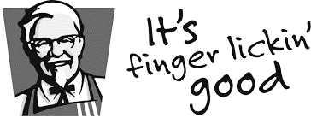

- INTRODUCING THE –

STREETWISE

VALUE BOX
R24.90

This January, we’ve got your back. Go to your nearest KFC
and get the value Box for only R24.90. That’s a Snack Burger,
2 Zinger Wings, Chips and R5 free airtime. It’s the ultimate
and tastiest plan to keep your January on track

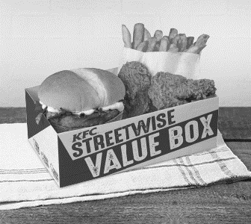

QUESTIONS: ADVERT
 | Discuss how the images (the box with goodies) on the advertisement may have the impact on potential buyers? | (2) | 4
 | List two things one will get when buying this value box? | (2) | 1
 | What is the “buy-line/ slogan” of KFC? | (1) | 1
 | In your own words what does the writer mean by “It’s the ultimate and tastiest plan to keep your January on track” | (1) | 4
 | Why are the words, “INTRODUCING THE –STREETWISE VALUE BOX” capitalized? | (2) | 3
 | Is this advertisement effective? Substantiate your answer. | (2) | 4
Total 10

QUESTION 4 : CARTOONS

Study TEXT F below and answer the set questions.

Frame 2
Frame 3
Frame 4
Frame 1
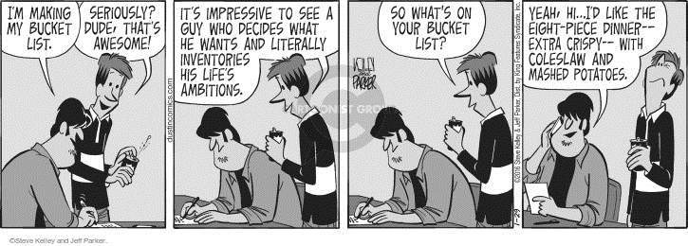
Source:
 |  | Comment on the cartoonist’s choice of diction portraying KFC favourite meals. |  |  | (3) | 3
 |  | Which word in frame 1 indicates that the friend is inspired by what “Dude” is doing? |  |  | (2) | 1
 |  | How does the cartoonist use facial expression and diction to reveal the humour in the cartoon? (frame 4) |  |  | (3) | 3
 |  | In your opinion, do you think that the message the cartoonist is portraying, is effective? |  |  | (2) | 3
Total 10
QUESTION 5 : USING LANGUAGE CORRECTLY
Read TEXT H which contains some deliberate errors and answer the set questions.
1  2  3 | History: The Harland Sanders Café and Museum in Corbin, Kentucky  Harland Sanders was born in 1890 and raised on a farm outside Henryville, Indiana (near Louisville, Kentucky).^{[4]} After he reached seven years of age, his mother taught him how to cook.^{[4]} In 1930, he took over a Shell filing station on “US Route 25” just outside North Corbin, Kentucky, a small town on the edge of the Appalachian Mountains.^{[7]} It was here that he first served to travelers the recipes that he has learned as a child: fried chicken and other dishes such as steaks and country ham.^{[7]} After four years of serving from his own dining room table, Sanders purchased the larger filing station on the other side of the road and expanded to six tables.^{[8]} By 1936, this had proven successful enough for Sanders to be given the honorary title of Kentucky colonel by Governor Ruby Laffoon.^{[9]} In 1937 he expanded his restaurant to 142 seats, and added a motel he purchased across the street naming it Sanders Court & Café.^{[10]}  Sanders was unhappy with the 35 minutes it took to prepare his chicken in an iron frying pan, but he refused to deep fry the chicken, which he believed lowered the quality of the product.^{[11]} In 1939, the first commercial pressure cookers were released onto the market, mostly designed for steaming vegetables.^{[12]} Sanders bought one, and modified it into a pressure fryer, which he then used to fry chicken.^{[13]}  In July 1940, Sanders finalised what came to be known as his "Original Recipe" of 11 herbs and spices.^{[14]} Although he never publicly revealed the recipe, he admitted to the use of salt and pepper, and claimed that the ingredients "stand on everybody's shelf".^{[15]}  Source: |  |  |  |  |  |  | 12  18  22
QUESTIONS
 |  |  | Identify the correct concord errors in paragraph 1. | (1) |  |  | 1
 |  |  | Write out the abbreviation ‘US ROUTE 25’ in full. | (1) |  |  | 2
 |  |  | Comment on the use of the colon in Paragraph 1. | (1) |  |  | 1
 |  |  | Provide a synonym for the word ‘purchased’ | (1) |  |  | 3
 |  |  | Identify the function of the apostrophe in the last line. | (1) |  |  | 1
 |  |  | Identify and correct the tense error in line 11. Write down the incorrect word as well as the correct word. | (2) |  |  | 1
 |  |  | Provide the noun form of the word ‘production’. | (1) |  |  | 1
 |  |  | There is a comma missing in paragraph 1. Identify and correct the error. | (1) |  |  | 1
 |  |  | Comment on the use of the inverted comma in “Original Recipe”. | (1) |  |  | 1
TOTAL :10
GRAND TOTAL = 70]

