

CHIEF MARKER'S / MODERATOR'S/ SUBJECT ANALYST’S REPORT FOR PUBLISHING

SUBJECT: PHYSICAL SCIENCES PAPER: 2

INTRODUCTORY COMMENTS (How the paper was received; Papers too long/short/
balance)

- This report gives an overview of the learner performance question by question, the common errors and misconceptions that made the candidates to lose the marks as well as the possible suggestions for improving the teaching and learning of chemistry.
- The paper was well received by most of the candidates. The fact that candidates managed to answer all the questions on time, indicates that the time allocated was sufficient for an average candidate to complete the paper.
- The paper covered the entire syllabus that is examinable for grade 12 as prescribed by the SAG. That is an indication that the paper was balanced. It also highlighted the importance of revising the work that was done in grade 10 & 11.
- Questions addressed all the cognitive levels with a fair spread of LO’s and AS’s.
- Most of the candidates made an effort to answer all the questions, even if some were found to be difficult by some candidates.

SECTION 1

(General overview of Learner Performance in the question paper as a whole)

- Generally the candidates performance has improved as compared to the previous years, particularly on the question that used to be the most challenging; Q.7 on chemical equilibrium.
- The paper was of a good standard that it allowed an average learner to get enough marks to pass.
- Candidates who were well prepared performed well. It is evident from the graph that Q. 6 on rate of reaction was the most poorly performed one.
- Most of the candidates lost a lot of marks not because they do not know the answers but due to some common errors that have been highlighted in the previous reports.
SECTION 2

(Comments on candidates’ performance in the five individual sub questions (a) – (e) will be provided below. Comments will be provided for each question on a separate sheet).

QUESTION 1

(a) General comments on the performance of learners in the specific question.

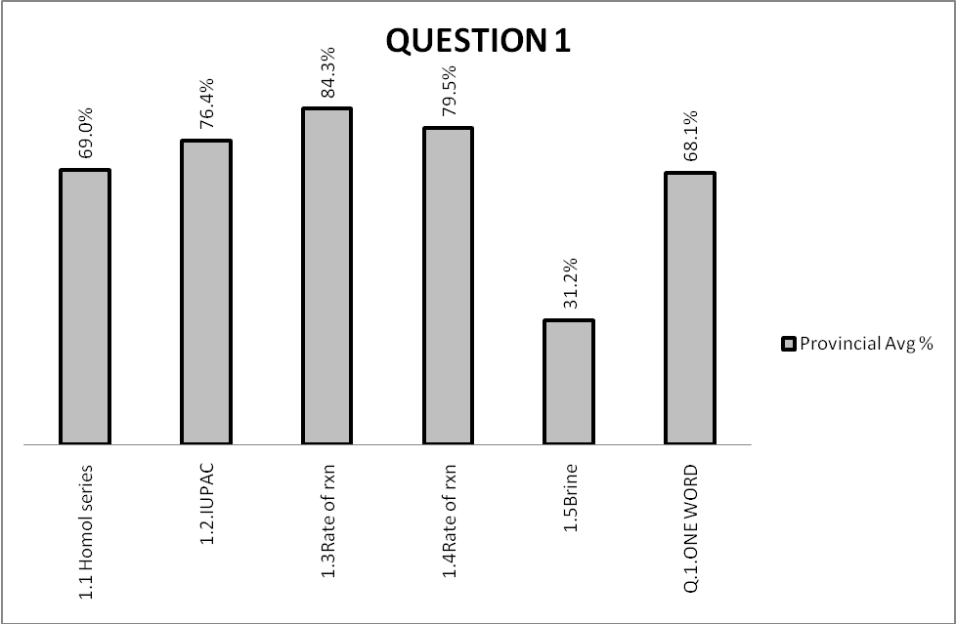

(b) Reasons why the question was poorly answered. Specific examples, common errors
and misconceptions are indicated.
(c) Suggestions for improvement in relation to teaching and learning.

Q. 1.1.
- Some candidates failed to give the homologous series to which propan-2-one belongs. Different homologous series were given, aldehyde, alkene, haloalkane etc.

SUGGESTIONS:
- A table of homologous series should be given to the learners.
- Questions on homologous series should be included in all the informal tasks.

Q. 1.2
- Some candidates tried to illustrate the position of the double bond. e.g. Eth-1-ene, 1- ethene.

SUGGESTIONS:
- Learners need to be drilled on naming of compounds.

Q. 1.3
- Some candidates confused the activated complex with the activation energy.

SUGGESTIONS:
- The correct terminology should always be used.
- Educators are advised to revise the grade 11 work with the learners, especially the energy graphs.

Q. 1.4
- Only few candidates could not remember a catalyst.

SUGGESTIONS:
- Learners should revise all the chemistry terminology.

Q 1.5
- Most of the candidates gave the chemical formula instead of the name.
- Sodium hydroxide was also given as the answer.

SUGGESTIONS:

- Candidates should be able to differentiate between the name and the formula.

(d) Other specific observations relating to responses of learners.
- The fact that most of the learners failed to get Q. 1.5 correct, might be because of the section not being taught at all or the lack of sufficient time allocated to the topic.
- It seems as if most of the candidates did not know the term brine.

(e) Any other comments useful to teachers, subject advisors, teacher development, etc.
- Educators should give a summary of terms at the end of each chapter.
- Subject advisors should develop a glossary for educators.

QUESTION 2

(a) General comment on the performance of learners in the specific question.

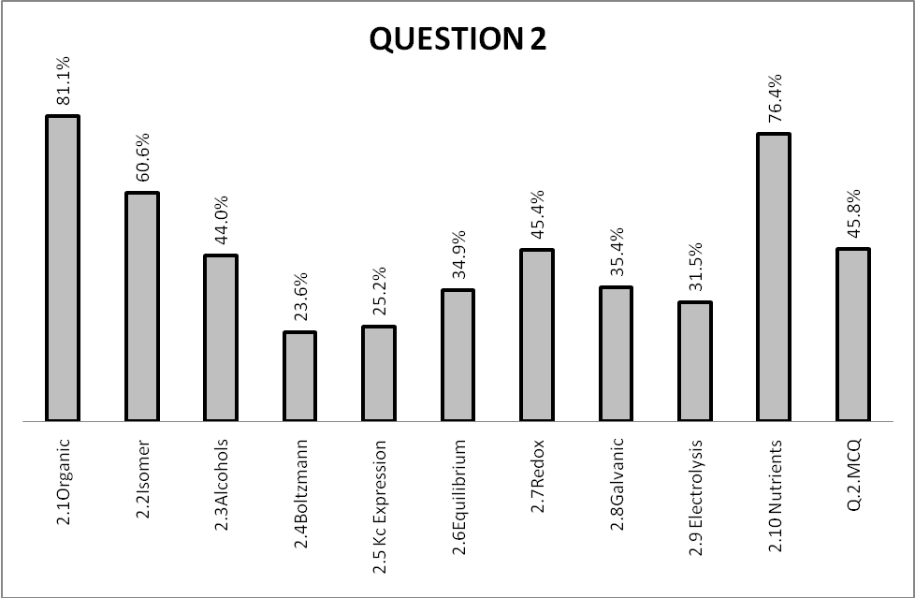

(b) Reasons why the question was poorly answered. Specific examples, common errors
and misconceptions are indicated.
(c) Suggestions for improvement in relation to teaching and learning.

Q. 2.1.
- Candidates who missed the answer might have not known the difference between saturated and unsaturated compounds.

SUGGESTIONS:
- Learners must memorise the definitions well.

Q. 2.2
- Some candidates failed to identify the isomers.

SUGGESTIONS:
- Learners should be given more questions on structural isomers.

Q. 2.3
- Candidates might have forgotten the difference between the physical and the chemical properties.

SUGGESTIONS:
- Educators should explain the difference between the physical and the chemical properties.

Q. 2.4
- Some candidates failed to interpret the Boltzman distribution curve.

SUGGESTIONS:
- Interpretation of graphs should be a priority.

Q. 2.5
- The writing of the K_{c} expression was a challenge for some candidates.
- Candidates might have not been aware that only the gaseous and aqueous phases take part.

SUGGESTIONS:
- Learners need to practice writing the K_{c} expression.

Q. 2.6
- Candidates find it difficult to apply the Le Chatelier’s principle.
- Some candidates failed to understand the link of the Le Chatelier’s principle to exothermic reaction.

SUGGESTIONS:
- A lot of exercises are recommended for improvement.

Q. 2.7.
- Some candidates still confuse oxidation and reduction.

SUGGESTIONS:
- Acronyms like GER, LEO, OIL and RIG might be used to allow learners to remember the definitions.
Q. 2.8.
- The movement of the electrons in a galvanic cell was confused with the electrolytic cell one.
- Candidates might have confused the external circuit and the salt bridge.

SUGGESTIONS:
- In answering the questions on the galvanic cell, sketches might help.
- Teaching the electrolytic and galvanic cells simultaneously would be a good idea.

Q. 2.9.
- Most of the candidates seem to have not known the function of the cryolite during the extraction process.

SUGGESTIONS:

- The extraction process needs to be explained in detail.

(d) Other specific observations relating to responses of learners.

- It seems as if some learners did not read the questions and the responses thoroughly before they could answer.
- Some textbooks are not clear on the use of cryolite.

(e) Any other comments useful to teachers, subject advisors, teacher development, etc.
- Educators should give learners guidance on how to select the correct answer from the choices given.

QUESTION 3

(a) General comments on the performance of learners in the specific question.

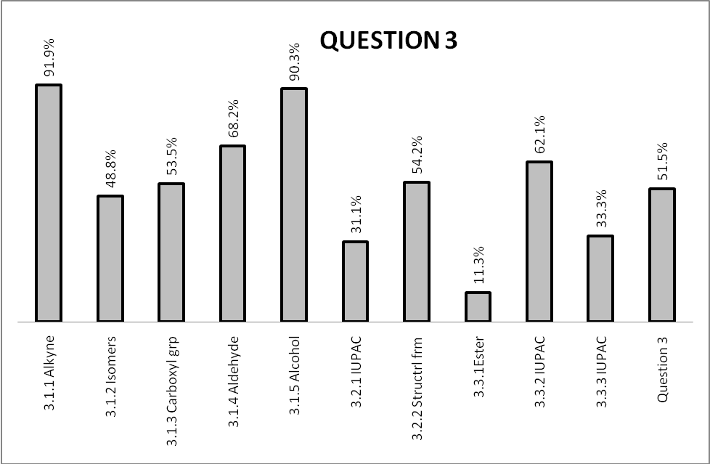

(b) Reasons why the question was poorly answered. Specific examples, common errors
and misconceptions are indicated.
(c) Suggestions for improvement in relation to teaching and learning.

Q. 3.1.1
- Some candidates failed to use the functional group to identify an alkyne.

SUGGESTIONS:
- Learners must memorise all the functional groups.

Q. 3.1.2
- Candidates fail to identify compounds that are isomers of each other.
- This becomes more difficult when compounds have different functional groups.

SUGGESTIONS:
- Learners must be exposed to isomers of compounds with different functional groups.

Q. 3.1.3
- Candidates confused the carbonyl and carboxyl group

SUGGESTIONS:
- Educators should give a clear distinction between a carbonyl and carboxyl groups.

Q. 3.1.4
- Some candidates could not distinguish between the aldehyde and the ketone.

SUGGESTIONS:
- Educators should show learners how to identify different functional groups especially those that have similar atoms. e.g. aldehyde, carboxylic acid and ketone

Q. 3.1.5
- Some candidates failed to use the functional group to identify an alcohol.

SUGGESTIONS:
- Learners must memorise all the functional groups

Q. 3.2.1
- In giving the IUPAC name, candidates could not identify the longest chain and also ignored the position of the double bond.

SUGGESTIONS:
- Learners should be given more exercise to apply the rules for naming of compounds.

Q. 3.2.2
- Some candidates failed to write the correct functional group in the structural formula.
- The carboxylic acid functional group was written wrongly, e.g.

O O O

C H C OH C HO

H

SUGGESTIONS:
- More practice is needed for the structural formulae.

Q. 3.3.1
- Most of the candidates gave water as the answer since it is one of the products.

SUGGESTIONS:
- Learners must memorise all the functional groups

Q. 3.3.2
- Some candidates failed to recognise the alcohol from the structural formula, as a result they gave any alcohol.

SUGGESTIONS:
- Learners should be taught that in an ester, alcohol forms an alkyl or the first part of the name is an alcohol.

Q. 3.3.3
- Candidates swapped the names of the compounds making an ester, i.e. an alcohol with the carboxylic acid.

SUGGESTIONS:
- More exercises on naming of compounds should be given.

(d) Other specific observations relating to responses of learners.
- Organic molecules were taught in schools, but learners still cannot apply the knowledge well to answer the questions.
- Learners need to be drilled thoroughly on the topic as it carries more weight.

(e) Any other comments useful to teachers, subject advisors, teacher development, etc.

- It is recommended that the organic molecules are emphasized towards the end of the 1st term PSF.

QUESTION 4

(a) General comments on the performance of learners in the specific question.

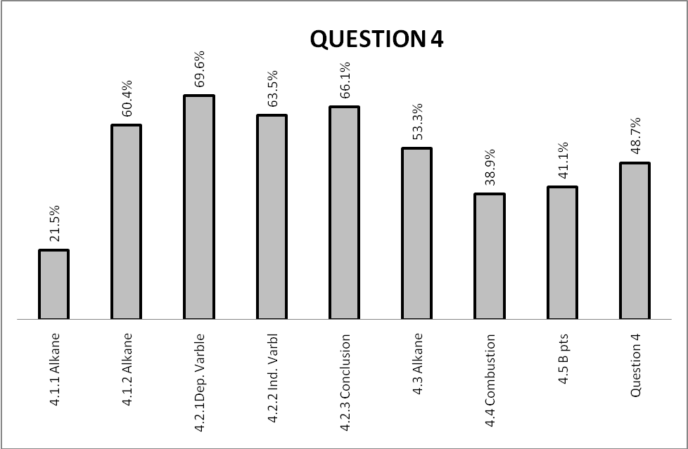

(b) Reasons why the question was poorly answered. Specific examples, common errors
and misconceptions are indicated.
(c) Suggestions for improvement in relation to teaching and learning.

Q. 4.1.1
- The question was answered as an investigative question.
- Candidates’ responses concentrated on the table.

SUGGESTIONS:
- Educators should relate the alkanes to daily life when teaching. The uses must be done at the start of the lesson.

Q. 4.1.2
- Candidates lost marks due to careless mistakes of forgetting to write 2 as the coefficient of n, writing + n instead of 2.

SUGGESTIONS:
- Learners should memorise the general formulae well.

Q. 4.2.1 & 4.2.2

- Some candidates failed to identify the dependent and indepedent variables.
- In some cases the variables were swapped.

SUGGESTIONS:
- Educators should give more exercises involving the identification of the variables.
- Learners should be taught to interpret information from the data given.
- The knowledge gained in Mathematics should be used to explain the relationships between the variables.

Q. 4.2.3
- Some candidates failed to see the relationship between the molecular formula and the boiling point.
- The language was also a challenge in constructing the answer to some.

SUGGESTIONS:

Q. 4.3
- Candidates failed to use the table to identify the name of an alkane.

SUGGESTIONS:
- In teaching the alkanes, emphasis must be put on the states of the compounds ( liquid, gases and solids).

Q. 4.4
- Some candidates still do not write the chemical formulae correctly. Instead of CO₂ and O₂ some wrote CO and O.
- The products were missed by most of them.
- Not all could balance the equation.

SUGGESTIONS:
- Learners must be taught that the products of combustion are CO₂ and H₂O.
- Learners must be trained to balance the equations all the time.
- They should also use the periodic table to help them write the correct chemical formulae.

Q. 4.5
- Most of the candidates failed to follow the instruction in explaining their answer. i.e. referring to the molecular structure, intermolecular forces and energy needed.
- Some were not clear about the types of bonds and the physical properties.
- The incorrect terminology was used in some cases.
- Some candidates failed to give the comparison .

SUGGESTIONS:
- The correct scientific terminology must be used at all times.
- Comparison of the physical properties should be done for different compounds.

(d) Other specific observations relating to responses of learners.

- Learners seem not to be preparing enough for the examination.

(e) Any other comments useful to teachers, subject advisors, teacher development, etc.

- Educators are advised to conduct extra lessons on organic molecules since a lot need to be covered.

QUESTION 5

(a) General comments on the performance of learners in the specific question.
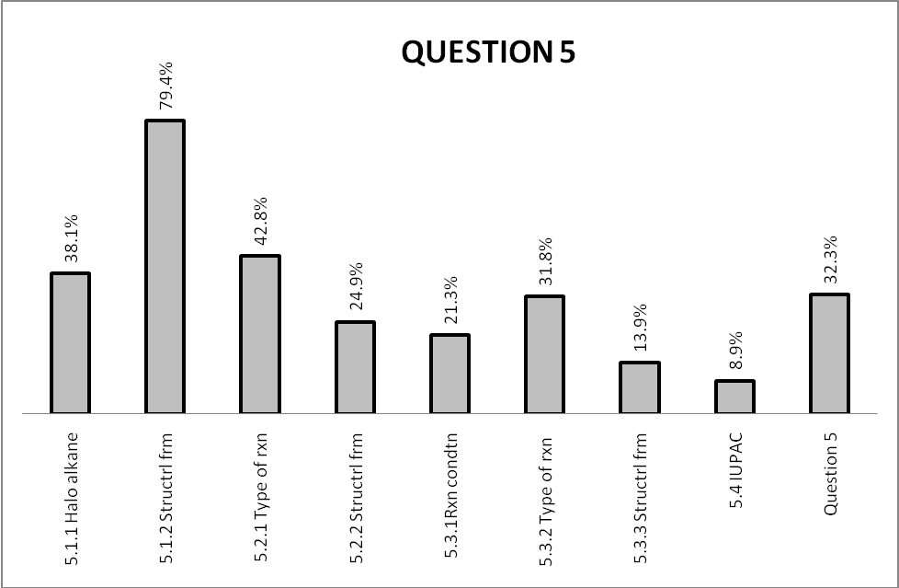

(b) Reasons why the question was poorly answered. Specific examples, common errors
and misconceptions are indicated.
(c) Suggestions for improvement in relation to teaching and learning.

Q. 5.1.1
- Some candidates failed to identify the functional group in the compound.
- Others used the root name to get the homologous series.

SUGGESTIONS:
- Naming of compounds should be given more time.

Q. 5.1.2
- Some of the candidates lost a mark by writing the condensed and molecular formulae instead of the structural.
- In some cases two functional groups were given.

SUGGESTIONS:
- Learners need to practice to draw the structural formulae.

Q. 5.2.1
- Most of the candidates swapped the reactions, elimination instead of substitution and vice versa.

SUGGESTIONS:
- Learners should be exposed to questions on flow diagrams.
- Types of reactions should be done thoroughly with lots of examples.

Q. 5.2.2
- Some of the candidates lost a mark by writing the condensed and molecular formulae instead of the structural.
- Marks were lost when the reaction in the previous question was missed.

SUGGESTIONS:
- Learners need to practice to draw the structural formulae.

Q. 5.3.1.
- Most of the candidates swapped the reactions as in Q. 5.2.1.

SUGGESTIONS:
- Learners should be exposed to questions on flow diagrams.

Q. 5.3.2
- Marks were lost when the reaction in the previous question was missed

SUGGESTIONS:
- Learners need to practice to draw the structural formulae.

Q. 5.3.3.
- Some of the candidates lost a mark by writing the condensed and molecular formulae instead of the structural

Q. 5.4
- Some learners still omit the hyphens.

SUGGESTIONS:
- The rules of naming of compounds should be thoroughly emphasised.

(d) Other specific observations relating to responses of learners.

- Interpreting the flow diagram seemed to be a challenge for most of the learners.
- Learners are confusing the types of reactions.

(e) Any other comments useful to teachers, subject advisors, teacher development, etc.

- The organic molecules should be revisited at all times as learners seem to forget what they have learnt.

QUESTION 6

(a) General comments on the performance of learners in the specific question.

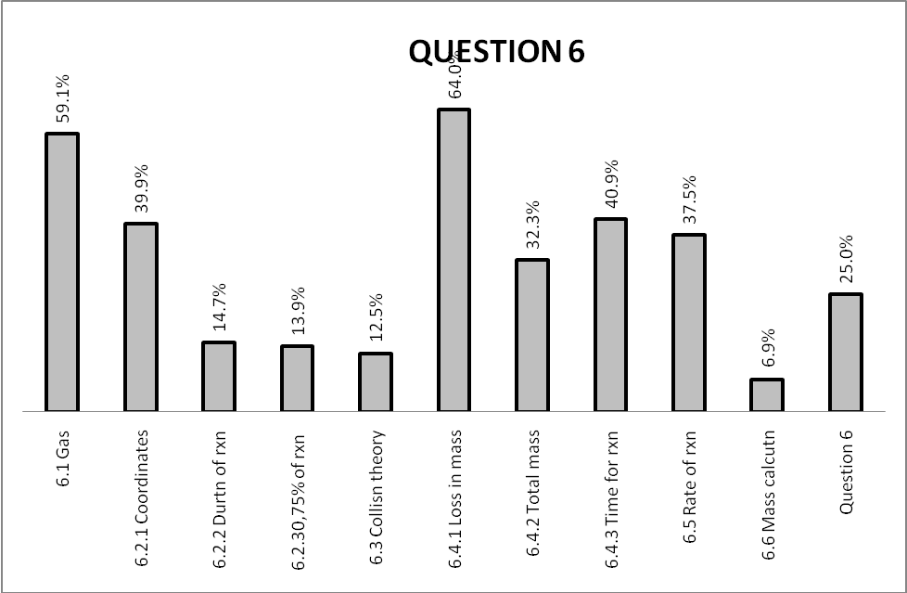

(b) Reasons why the question was poorly answered. Specific examples, common errors
and misconceptions are indicated.
(c) Suggestions for improvement in relation to teaching and learning.

Q. 6.1
- Some candidates lost marks by writing the chemical formula instead of the name.
- Other gases like Hydrogen were also written.
- Responses like evaporation were also given.

SUGGESTIONS:
- There should be a differentiation between the name and the chemical formula during teaching.
- Learners should take words written in capital letters into consideration.
- Learners should be advised to read the chemical equations carefully as answers are sometimes given.

Q.6.2.1
- The wrong coordinates were given by some of the candidates.
- Some failed to write the coordinates as an ordered pair.

SUGGESTIONS:
- Learners should be apply the mathematical skills in Physical Sciences.

Q.6.2.2
- Most of the candidates wrote 16minutes as the duration of the reaction. The last dot was on 16minutes from the graph.

SUGGESTIONS:
- More graph questions should be given to the learners.

Q.6.2.3
- Candidates failed to do the calculation.
- Some calculated 75% of different times, 16minutes because of the last dot ; 12minutes because the reaction lasted for 12minutes.
- Some calculated 75% of the total loss in mass.

SUGGESTIONS:
- Educators should ensure that the grade 11 work that is examinable in grade 12 is revised.
- Educators are encouraged to include the work in the control tests.

Q.6.3
- Most of the candidates confused the collision theory with equilibrium.
- Instead of the concentration, they mentioned other factors that affect the rate of reaction.
- Collisions of momentum were also mentioned.
- Some candidates mentioned effective collision but omitted per unit time.
- Particles were confused with atoms.

SUGGESTIONS:
- Collision theory needs to be thoroughly emphasised, explaining it in terms of the different factors which affect chemical reactions.

Q.6.4.1- Q.6.4.3

- Some of the candidates decided to give one answer for all the 3 questions.

SUGGESTIONS:
- Collision theory needs to be thoroughly emphasised, explaining it in terms of the different factors which affect chemical reactions.

Q.6.5
- Most of the candidates mentioned the other two factors without indicating the changes.
- Some mentioned to remove the cotton wool for the gas to escape, confusing with equilibrium.
- Most of the candidates wrote the catalyst, without mentioning that it must be added.

SUGGESTIONS:
- Educators should conduct practical investigations on all the factors that affect the rate of reaction. This will minimise the confusion with equilibrium.

Q.6.6
- Candidates used the concentration formula since concentration was mentioned in one of the questions.
- Equations of the gas laws were also mentioned.
- Candidates could not calculate the molar masses of the CaCO₃ and CO₂.

SUGGESTIONS:
- Stoichiometry should be thoroughly revised.

(d) Other specific observations relating to responses of learners.

- Some candidates thought that HCℓ was a catalyst.
- Learners might have guessed the answers.
- Some would choose to write the same answer for Q. 6.4.1, Q 6.4.2 and Q.6.4.3

(e) Any other comments useful to teachers, subject advisors, teacher development, etc.

- The PSFs should prioritise the practical investigations and graph interpretations.

QUESTION 7

(a) General comments on the performance of learners in the specific question.

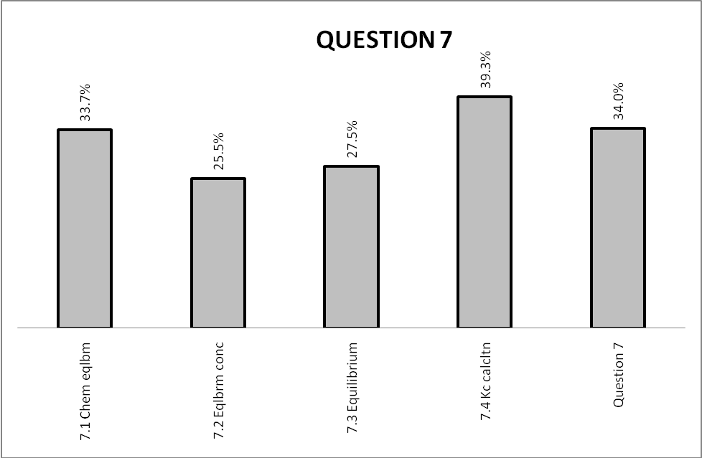

(b) Reasons why the question was poorly answered. Specific examples, common errors
and misconceptions are indicated.
(c) Suggestions for improvement in relation to teaching and learning.

Q. 7.1
- In defining the chemical equilibrium, most of the candidates omitted the word rate.
- Forward reaction equals backward reaction was also given as the answer.
- Some candidates mentioned that the concentrations are equal instead of being constant.

SUGGESTIONS:
- Definitions should be learned properly.
Q 7.2
- Candidates were unable to identify the mole ratio.
- Some were working from the answer 0,4 in their calculation without using the information provided.

SUGGESTIONS:
- Candidates should learn the table method.

Q 7.3
- Candidates were unable to apply the Le Chatelier’s principle. Instead some stated it.
- Where there was an attempt of application, it was done wrongly.
- The collision theory was also used.

SUGGESTIONS:
- Educators should emphasise the application of the principle on all the factors affecting the rate of reaction.
- Learners should be exposed to a lot of questions on the application of Le Chatelier’s principle for practice.

Q 7.4
- The K_{c} expression was written wrongly by some of the candidates.
- The open brackets were used instead of the square ones.
- Products/reactants was written.
- Coefficients as exponents were not written.
- Some candidates used acronyms like RICE in the table that confused them.
- Some candidates did not apply the mole ratio correctly.

SUGGESTIONS:
- Learners should be exposed to a lot of K_{c} calculations using different/past question papers.
- Educators should ensure that they expose learners to calculations that require different variables.

(d) Other specific observations relating to responses of learners.

- K_{c} calculation was taught in schools.
- There was a lot of improvement on the K_{c} calculation question as compared to the previous years, however in some schools it is still a challenge.

(e) Any other comments useful to teachers, subject advisors, teacher development, etc.

- Teacher workshops should be conducted for exposure to the different methods of calculating K_{c}.

QUESTION 8

(a) General comments on the performance of learners in the specific question.

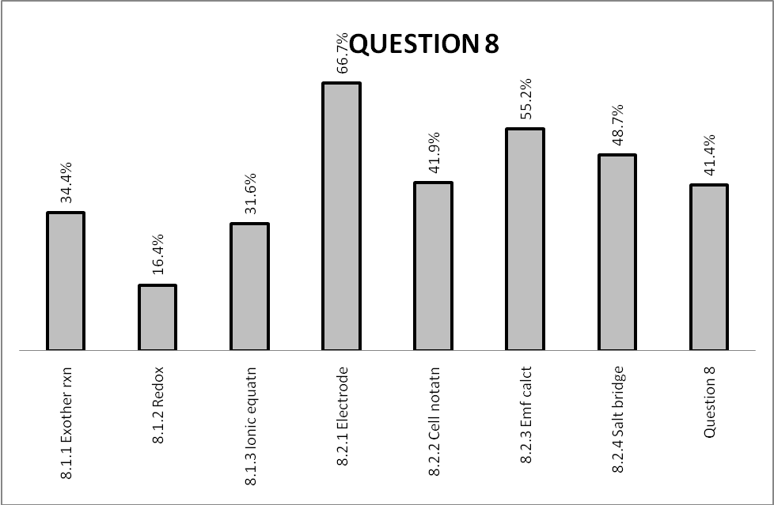

(b) Reasons why the question was poorly answered. Specific examples, common errors
and misconceptions are indicated.
(c) Suggestions for improvement in relation to teaching and learning.

Q. 8.1.1
- Most of the candidates failed to give the reason why the reading on the thermometer increases as the reaction proceeded.
- Wrong terminology was used. e.g. heat was absorbed instead of being released.

SUGGESTIONS:
- Educators should integrate practical investigations in their teaching.
- Educators should explain the exothermic reaction thoroughly.

Q.8.1 .2
- Candidates used the wrong terminology which made them lose marks. Instead of writing the strong reducing agent, words like good, better and powerful reducing agents were used.
- They could not use the standard-reduction potentials table to differentiate between the oxidizing and reducing ability.

SUGGESTIONS:
- Learners should be trained on how to use the standard-reduction potentials table.

Q.8.1.3
- In writing the net ionic equation, some candidates confused the reactants with the products, e.g. Aℓ gaining electrons and Cu losing electrons.
- Electrons in the ionic equation were not eliminated in some cases.
- Some candidates tried to balance the charges. Because the charge on Cu was 2+ then the one on Aℓ was also made 2+.

SUGGESTIONS:
- Learners must be taught how to write the redox ½ reactions.
- The standard-reduction potentials table should be emphasised.

Q8.2.1
- Some candidates failed to use the standard-reduction potentials table to see which electrode is the anode.
- For an electrochemical cell sketch, some candidates think that the anode is always on the left and the cathode on the right.

SUGGESTIONS:
- If the standard-reduction potentials table is thoroughly emphasised, learners would not have serious challenges.

Q.8.2.2
- Candidates were unable to write the cell notation for the half cells. Answers like Aℓ/Cu²⁺// Aℓ³⁺/Cu were given.
- The position of the anode and the cathode was often mixed in the notation.
- There were cases of more than 1 salt bridge given in the notation.
- Some candidates wrote Aℓ as AL.

SUGGESTIONS:
- Reference should be made to the standard-reduction potentials table for the correct answers.
- Learners should study the periodic table for the writing of the chemical symbols.

Q.8.2.3
- Some candidates did not write the formula as given in the data sheet.
- The superscripts on the formula were sometimes left out.
- Unconventional abbreviations were used which are not acceptable.
- Some candidates omitted the unit in the final answer.
- In some cases the oxidizing agent was swapped with the reducing agent.
- Eᶲ was sometimes used, which is not correct.

SUGGESTIONS:
- Learners should be encouraged to use the formula as given in the data sheet, especially that the 3 options were given.
- Learners should avoid using abbreviations/acronyms.
- Option 2 method should be taught.

Q8.2.4
- The cell and the circuit were often confused by most of the candidates.
- The functions of the salt bridge were often given as answers.
- Some candidates mentioned that the salt bridge acts as a switch.

SUGGESTIONS:
- The functions of the salt bridge should not just be mentioned but be thoroughly explained.

(d) Other specific observations relating to responses of learners.

- It seems as if the usage of the standard-reduction potentials table was minimal in most of the schools.
- Learners confused the ionic equation with the cell notation.
- It seems as if learners rush to answer questions without reading them thoroughly.
- No learner wrote option 2 in Q 8.2.3
- It seems as if redox reactions are taken to be easy and some concepts are not fully emphasized during teaching.
- Redox reactions terminology seems to be confusing the learners, reduction, reducing agent etc.

(e) Any other comments useful to teachers, subject advisors, teacher development, etc.

- Educators should use the standard-reduction potentials table when teaching redox reactions.
- The marking principle for this question should be emphasized during PSFs.

QUESTION 9

(a) General comments on the performance of learners in the specific question.
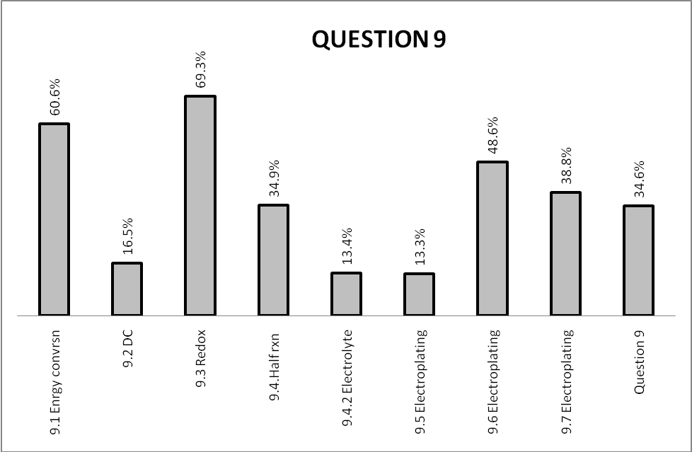

(b) Reasons why the question was poorly answered. Specific examples, common errors
and misconceptions are indicated.
(c) Suggestions for improvement in relation to teaching and learning.

Q. 9.1
- Some candidates confused chemical energy with mechanical one.

SUGGESTIONS:
- The difference between the two energies should be emphasised.

Q.9.2
- Some candidates indicated that the AC is not constant and DC is constant.
- Some wrote that the AC uses a lot of energy while DC works with batteries.

SUGGESTIONS:
- Learners should be taught the difference between the DC and AC

Q.9.3
- Some candidates failed to identify the type of the reaction at the spoon.
- Responses outside the choice were given.

SUGGESTIONS:
- Learners should be drilled on the interpretation of the diagrams.
- Learners should learn to read the questions well, particularly the ones where answers are given to choose.

Q.9.4.1
- Candidates failed to use the standard-reduction potentials table to write the half reaction.
- Aℓ and Fe were commonly used.
- Some, who used Ag; replaced the oxidation half reaction by the reduction one.

SUGGESTIONS:
- The use of the standard-reduction potentials table should be emphasised.

Q.9.4.2
- The incorrect names of the electrolyte were given. This showed a lack of understanding of the electrolytes.

SUGGESTIONS:
- Learners should be taught the selection of electrolytes for electrolysis. Reference can be made to grade 10 syllabus under the solubility rules.

Q.9.5
- Some candidates talked about the function of the catalyst, saying the electrolyte does not take part in the reaction.
- The processes of the galvanic and electrolytic cells were often confused.

SUGGESTIONS:
- The differences between the galvanic and electrolytic cells should be well explained to the learners
- It is recommended that the two cells be taught simultaneously.

Q.9.6
- Candidates could not give reasons for protection and appearances.

SUGGESTIONS:
- The functions of the salt bridge should be thoroughly explained.

Q.9.7
- Some candidates gave a DC power source as the answer, not explaining what that is. This could have been picked up from the diagram.

(d) Other specific observations relating to responses of learners.

- Candidates seemed to be only aware of the income related reasons for electroplating.
- Some candidates did not understand the difference between the electrolytic and galvanic cell.

(e) Any other comments useful to teachers, subject advisors, teacher development, etc.

- Educators should strongly emphasis use the standard-reduction potentials table during teaching.

QUESTION 10

(a) General comments on the performance of learners in the specific question.

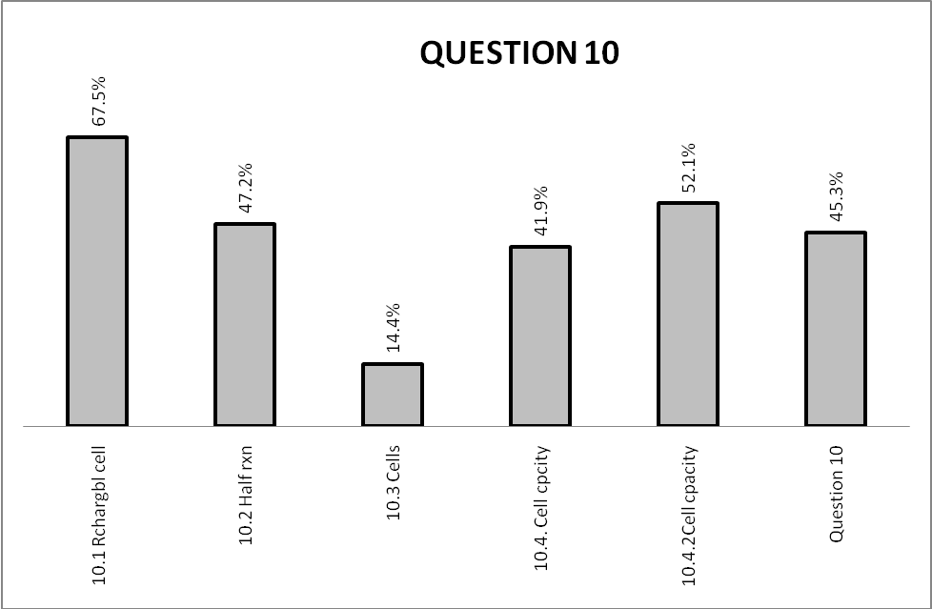

(b) Reasons why the question was poorly answered. Specific examples, common errors
and misconceptions are indicated.
(c) Suggestions for improvement in relation to teaching and learning.

Q. 10.1
- Some candidates could not distinguish between the characteristics of a primary and the secondary cell.
- Other characteristics of the cell were given e.g. dry cell

SUGGESTIONS:
- The differences between the 2 cells should be tabulated for the learners.

Q.10 .2
- Some candidates failed to interpret the equation to see the reaction that takes place at the cathode.
- They could not give the reason for their choice.

SUGGESTIONS:
- Learners should be taught in terms of reduction – cathode – gaining of electrons and vice versa.

Q.10.3
- The concept of the cell reaction reaching equilibrium was missing in most of the responses.
- Responses like “energy is lost” and “equilibrium means no more reaction” were given.

SUGGESTIONS:
- Misconceptions should be cleared at all costs.

Q.10.4.1
- Some candidates were unable to use the correct formula for calculating the cell capacity.
- The conversion of hours to seconds was forgotten by some candidates.
- The V in 1,5V was interpreted as volume, as a result the C = n/v formula was used.
- The cell capacity was confused with concentration.

SUGGESTIONS:
- When teaching batteries, learners should be exposed to the relevant formulae.

Q.10.4.2
- Units on the final answers were often omitted.
- Some candidates failed to make the correct conversions.
- Changing the subject of the formula was still a challenge for some candidates

SUGGESTIONS:

- The writing of the correct units should be emphasised.
- Some mathematical skills should be applied in Physical Sciences.

(d) Other specific observations relating to responses of learners.

- It seems as if some of the learners guessed the correct answer for Q10.2.
- It appeared that most of the schools did not give enough time to the teaching of batteries.

(e) Any other comments useful to teachers, subject advisors, teacher development, etc.

- Educators should allocate enough time to the teaching and revision of batteries

QUESTION 11

(a) General comments on the performance of learners in the specific question.

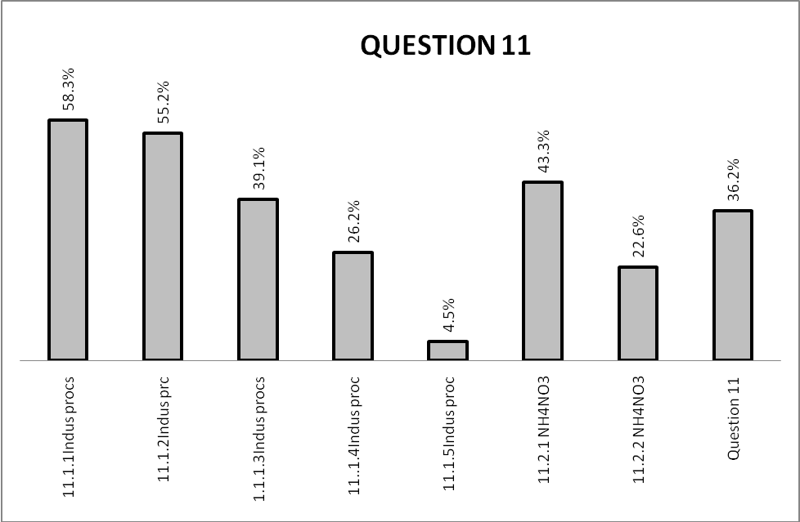
(b) Reasons why the question was poorly answered. Specific examples, common errors
and misconceptions are indicated.
(c) Suggestions for improvement in relation to teaching and learning.

Q. 11.1.1
- Some candidates were not sure of the process as some wrote Haber and contact processes.
- Others omitted the word fractional.

SUGGESTIONS:
- The differences among the industrial processes should be emphasised.

Q.11.1.2.
- Some candidates could not write the correct chemical formulae of the reactants and products.

Q. 11.1.3
- Most of the candidates were misled by the two unknowns.

SUGGESTIONS:
- Learners should be exposed to questions on flow diagrams.

Q. 11.1.4
- Some of the candidates failed to identify the acid R as a result they could not come up with the balanced equation.
- The wrong acids were used in some cases.

Q. 11.1.5
- Some of the responses indicated the reactions of organic molecules, substitution, addition, elimination etc.

SUGGESTIONS:
- Educators should explain the link between the types of reactions and the industrial processes.

Q.11.2.1.
- Some candidates still struggle to write the chemical formulae of compounds.

SUGGESTIONS:
- Learners must practice to write the chemical formulae using the periodic table.

Q.11.2.2.
- The properties of Nitrogen were given.

SUGGESTIONS:
- Revision must be done thoroughly.

(d) Other specific observations relating to responses of learners.

- It seems as if most of the schools did not give enough time to the topic of fertilizers.
- It seems as if learners are not given enough questions on flow diagrams.

(e) Any other comments useful to teachers, subject advisors, teacher development, etc.

- Educators should allocate enough time for revision.
SECTION 3
(a) GRAPH OF PROVINCIAL PERFORMANCE IN THE PAPER (summary per question)

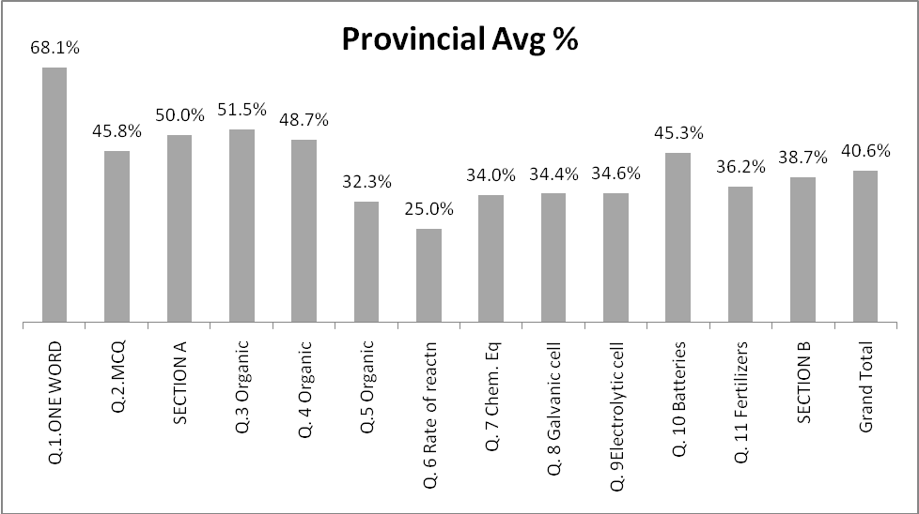

GENERAL COMMENTS
- Based on the graph above, candidates did not perform well in Q. 6

(b) GRAPHS TO COMPARE DISTRICTS' PERFORMANCES PER QUESTION

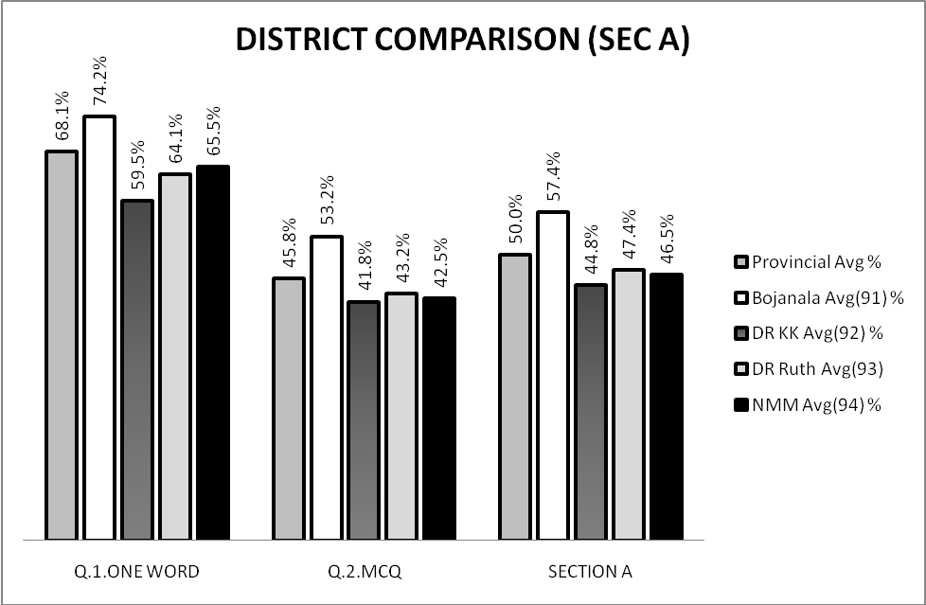

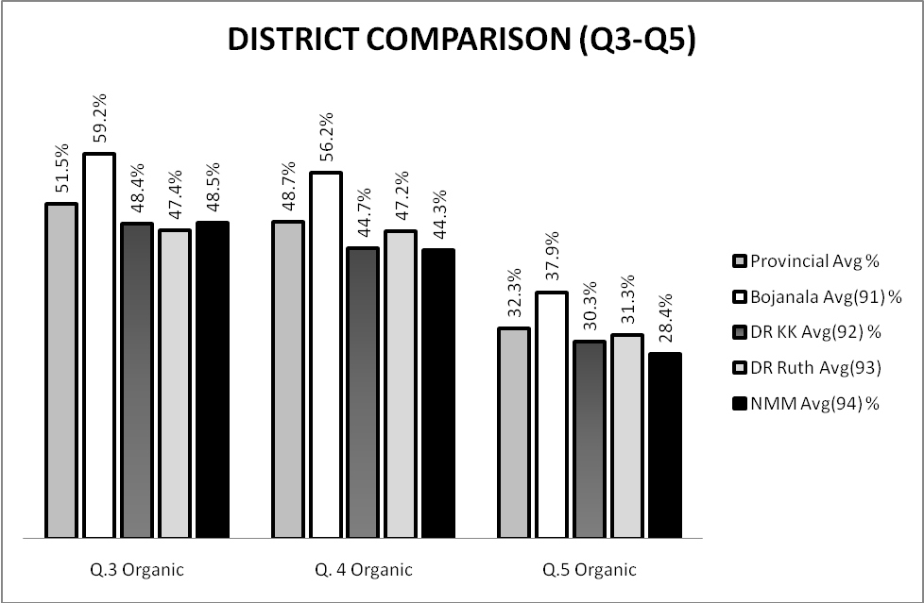

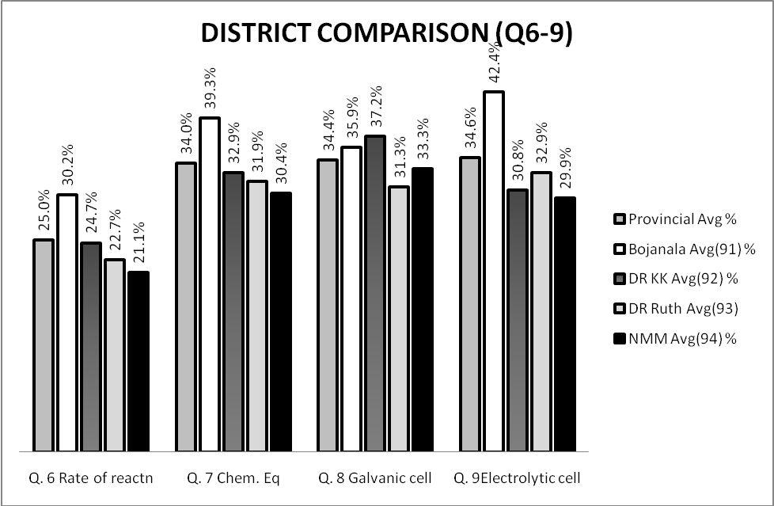

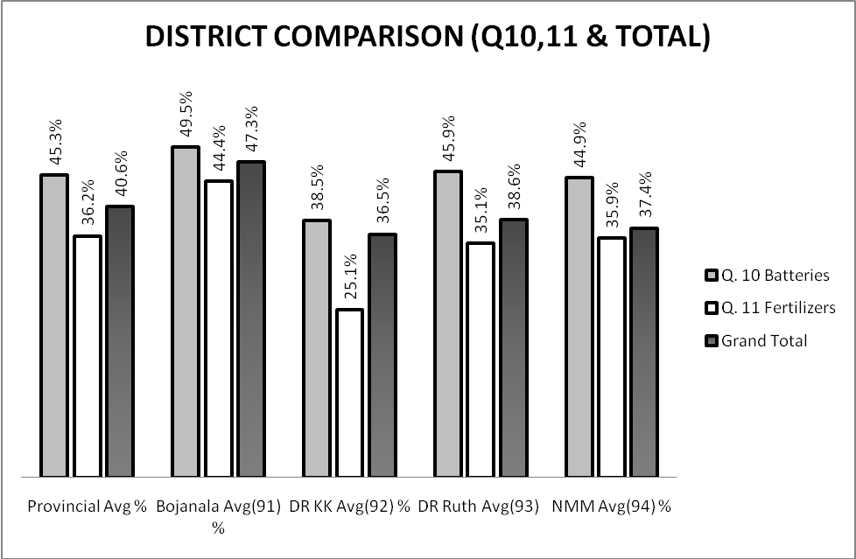

(c) GRAPH TO COMPARE OVERALL PERFORMANCE PER DISTRICT

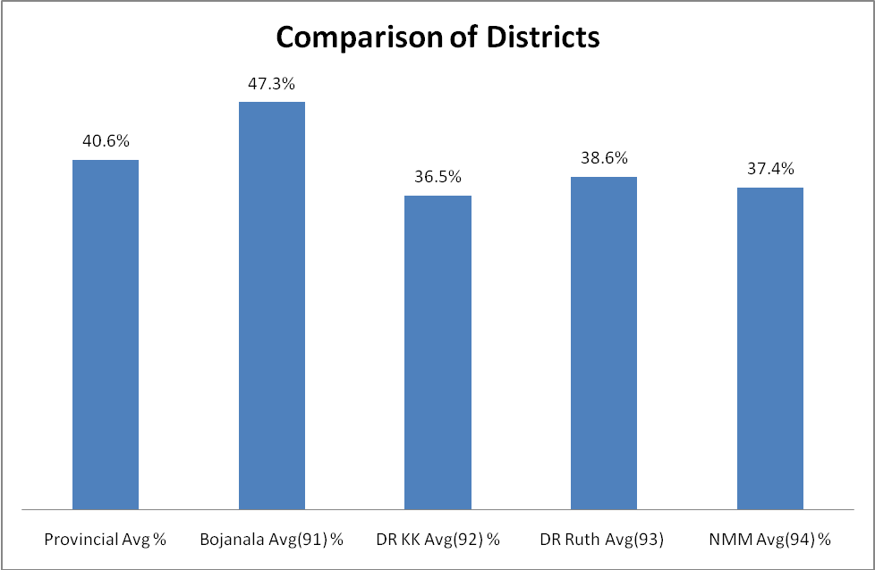

COMMENTS ON PERFORMANCE OF DISTRICTS :
[Boj = Bojanala; DrKK = Dr Kenneth Kaunda; DrRSM = Dr Ruth Segomotsi Mompati; NMM = Ngaka Modiri Molema
QUES | % IN PROV | TOPIC | DISTRICTS’ PERFORMANCE  (More than 5% difference from Province average)
Q 1 | 68 | One word | No district has problems
Q 2 | 45 | MCQ | Bojanala performed 8% better than the average
Q 3 | 51,5 | Organic molecules | Bojanala performed 7,7% better than the average
Q 4 | 48,7 | Organic molecules | Bojanala performed 7,5% better than the average
Q 5 | 32 | Organic molecules | Bojanala performed 5,9% better than the average
Q 6 | 25 | Rate of reaction | Generally all the districts did not do well, however Bojanala performed 5,2% better than the average
Q 7 | 34,0 | Chemical equilibrium | Bojanala performed 5,3% better than the average
Q 8 | 34,4 | Galvanic cell | Dr. KK performed 2,8% better than the average
Q 9 | 34,6 | Electrolytic cell | Bojanala performed 7,8% better than the average
Q 10 | 45,3 | Batteries | Bojanala and DrRS performed better than the average
Q 11 | 36,2 | Fertilizers | Bojanala performed 8,2% better than the average

- Bojanala seems to have performed above the provincial average, however other districts seem to be very close to the provincial average.
- All the districts have to give serious teacher development in the topics that were poorly performed.

(d) DISTRIBUTION OF QUESTIONS IN TERMS OF COGNITIVE LEVELS (TABLE)

Level | Q | Marks | Q | Marks | Q | Marks | Q | Marks
1 | 1.1-1.5 | 5 | 3.1.3 | 1 | 6.1 | 1
1 | 2.2 | 2 | 3.1.4 | 1 | 6.4.2 | 1 | 11.1.1 | 1
1 |  |  | 3.1.5 | 1 | 6.5 | 2 | 11.1.3 | 1
1 | 2.3 | 2 | 4.1.1 | 1 | 7.1 | 2 | 11.1.5 | 1
1 | 2.7 | 2 | 4.1.2 | 1 | 9.1 | 1 | 11.2.1 | 1
1 | 2.8 | 2 | 4.3 | 1 | 9.4.2 | 1` | 11.2.2 | 2
1 | 2.9 | 2 | 5.1.1 | 1 | 10.1 | 1
1 | 2.10 | 2 | 5.3.1 | 1
1 | 3.1.1 | 1 | 5.3.2 | 1
2 | 2.1 | 2 | 4.2.1 | 1 | 5.4 | 2 | 9.2 | 1
2 | 2.4 | 2 | 4.2.2 | 1 | 6.3 | 2 | 9.3 | 1
2 | 2.5 | 2 | 4.2.3 | 2 | 6.4.1 | 1 | 9.4.1 | 2
2 | 2.6 | 2 | 4.4 | 3 | 6.4.2 | 1 | 9.5 | 2
2 | 3.1.2 | 2 | 4.5 | 4 | 6.4.3 | 1 | 9.7 | 2
2 | 3.2.1 | 2 | 5.1.2 | 2 | 7.3 | 3 | 10.3 | 1
2 | 3.2.2 | 2 | 5.2.1 | 1 | 8.1.1 | 2 | 11.1.2 | 3
2 | 3.3.1 | 1 | 5.2.2 | 2 | 8.1.3 | 3 | 11.1.4 | 3
2 | 3.3.2 | 2 | 5.3.1 | 1 | 8.2.1 | 1
2 | 3.3.3 | 2 | 5.3.3 | 2 | 8.2.2 | 3
3 | 6.2.1 | 1 | 7.2 | 3 | 10.2 | 2
3 | 6.2.2 | 1 | 8.1.2 | 2 | 10.4.1 | 4
3 | 6.2.3 | 1 | 8.2.3 | 4 | 10.4.2 | 3
3 | 6.6 | 5 | 8.2.4 | 2
4 | 7.4 | 9

(e) COVERAGE OF LEARNING OUTCOMES AND ASSESSMENT STANDARDS
(TABLE)
LO 1 |  |  |  | LO 2 |  |  |  |  |  | LO 3
Q | Marks | Q | Marks | Q | Marks | Q | Marks | Q | Marks | Q | Marks
3.3.1 | 1 | 6.1 | 1 | 1.1-1.5 | 5 | 4.1.1 | 1 | 7.1 | 2 | 9.6 | 2
4.2.1 | 1 | 6.2.1 | 1 | 2.1-2.10 | 20 | 4.1.2 | 1 | 8.1.3 | 3 | 9.7 | 2
4.2.2 | 1 | 6.2.2 | 1 | 3.1.1 | 1 | 4.3 | 1 | 8.2.1 | 1 | 11.2.2 | 2
4.2.3 | 2 | 6.2.3 | 1 | 3.1.2 | 2 | 4.4 | 3 | 8.2.2 | 3
4.5 | 4 | 6.3 | 2 | 3.1.3 | 1 | 5.1.1 | 1 | 8.2.4 | 2
5.4 | 2 | 6.4.1 | 1 | 3.1.4 | 1 | 5.1.2 | 2 | 9.1 | 1
7.2 | 3 | 6.4.2 | 1 | 3.1.5 | 1 | 5.2.1 | 1 | 9.2 | 1
7.3 | 3 | 6.4.3 | 1 | 3.2.1 | 2 | 5.2.2 | 2 | 9.3 | 1
7.4 | 9 | 6.5 | 2 | 3.2.2 | 2 | 5.3.1 | 1 | 9.4.1 | 2
 |  | 6.6 | 5 | 3.3.2 | 2 | 5.3.2 | 1 | 9.4.2 | 1
8.1.1 | 2 | 10.4.1 | 4 | 3.3.3 | 2 | 5.3.3 | 2 | 9.5 | 2
8.1.2 | 2 | 10.4.2 | 3 | 11.1 | 1 |  |  | 10.1 | 1
8.2.3 | 4 |  |  | 11.2 | 3 |  |  | 10.2 | 2
 |  |  |  | 11.3 | 1 |  |  | 10.3 | 1
 |  |  |  | 11.5 | 1 |  |  | 11.2.1 | 1

COMMENTS:
- The spreading of weighting of the learning outcomes is as required in the SAG.

Ms. M. S Motsepe Subject Analyst

________________________ 11.12.2012

Ms. M. Nel Internal Moderator

------------------------------------------ 11.12.2012

Ms. K.M Mpye Chief Marker

--------------------------------------- 11.12.2012

