SUBJECT |  | Mathematics
PAPER |  | 3
DURATION OF PAPER : |  | 2 HOURS
PROVINCE |  | North West Province
NAME OF THE INTERNAL MODERATOR |  | Me. A. van Heerden
NAME OF THE CHIEF MARKER |  | Me. A. van Heerden
DATES OF MARKING |  | 01/12/2012 – 06/12/2012
HEAD OF EXAMINATION: |  | Dr. J.A. Myburgh

REPORT FORMAT

SECTION 1: (General overview of Learner Performance in the question paper as a whole)
1. INTRODUCTORY COMMENTS
The paper was of a good standard which was suitable for the purpose of a third paper. It consisted
of questions on all levels – real easy to difficult and challenging. There is also enough questions of a
higher cognitive level, so that only the strongest learners will be able to get results of 90% and
higher.

The type of questions varied and the instructions were clear.

The language was of a good standard (error free) and the paper was compiled professionally.

The purpose of this paper is also to develop the higher cognitive thinking and reasoning of learners,
and therefore the questions where the learners had to motivate their answers, as well as interpret
their answers, were good. The learners experienced that the time was enough and that the time
allocation was sufficient.

It is important that the content of paper 3 must be taught in depth with continuous repetition.
It is compulsory to develop learners skills, as well as their higher cognitive thinking. It is also very
important that this paper expose and prepare teachers for the content in CAPS.

In general it seems as if the paper was fair towards the average learners, but there are not many
distinctions in 2012. The overall average is 46,4% and a rate of 78%.
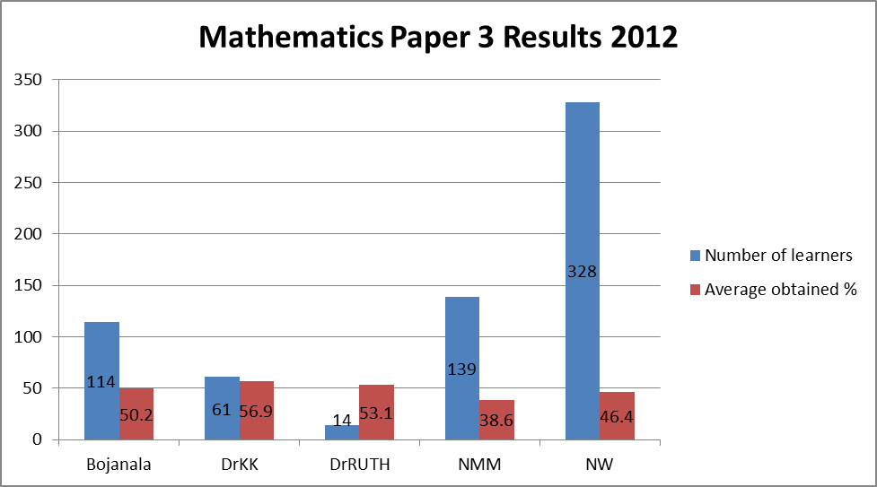

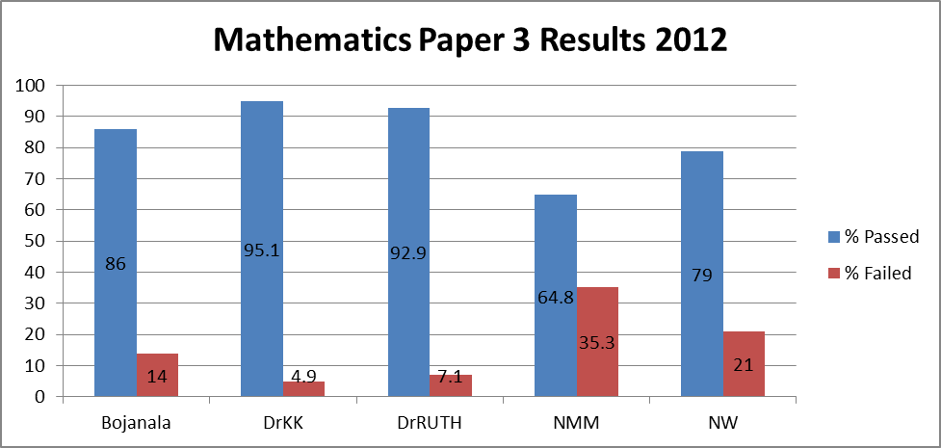

SECTION 2: Comment on candidates’ performance in individual questions
(It is expected that a comment will be provided for each question on a separate sheet).
QUESTION 1
(a) General comment on the performance of learners in the specific question. Was the question well answered or poorly answered?
Scatter Plot : Excellent, well answered. Marks allocated (13). Average obtained = 82,2%
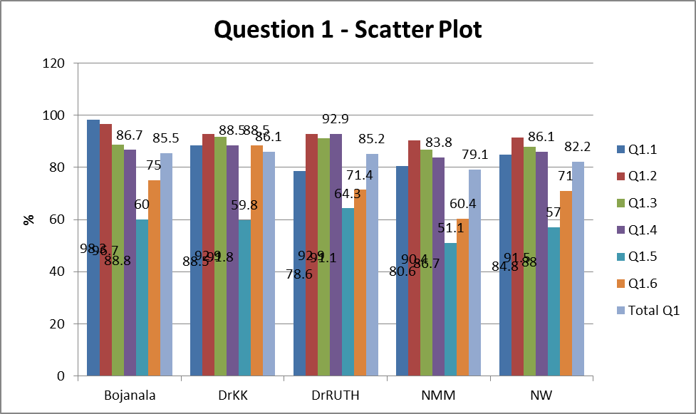

- Why was the question poorly answered? Also provide specific examples, indicate common errors committed by learners in this question, and any misconceptions.
Not applicable.

- Provide suggestions for improvement in relation to Teaching and Learning
- Learners should know the formula for the least squares regression line.
- They should know how to use the calculator to determine the values of a and b, as well as the correlation coefficient.
- They should be able to comment on the strength of the relationship. Make more use of real life examples.

(d) Describe any other specific observations relating to responses of learners
- Some learners identified the weekly sales as the independent variable (Q1.1)
- Some learners substituted the “50” in stead of the “45” into the value of x. (Q1.5)
- Some learners commented that the more time the CD is played, the higher the sales will go, which isn’t a comment on the strength of the relationship.

(e) Any other comments useful to teachers, subject advisors, teacher development etc.
- Don’t make use of the hand-method, ONLY use the CALCULATOR.
- Use substitution in the least squares regression line. The least squares regression line and the line of best fit are not the same!. Learners shouldn’t draw the line of best fit and read from that.

QUESTION 2
(a) General comment on the performance of learners in the specific question. Was the question well answered or poorly answered?
Probability : Answered from average to weak. Marks allocated (6). Average obtained = 30,3%
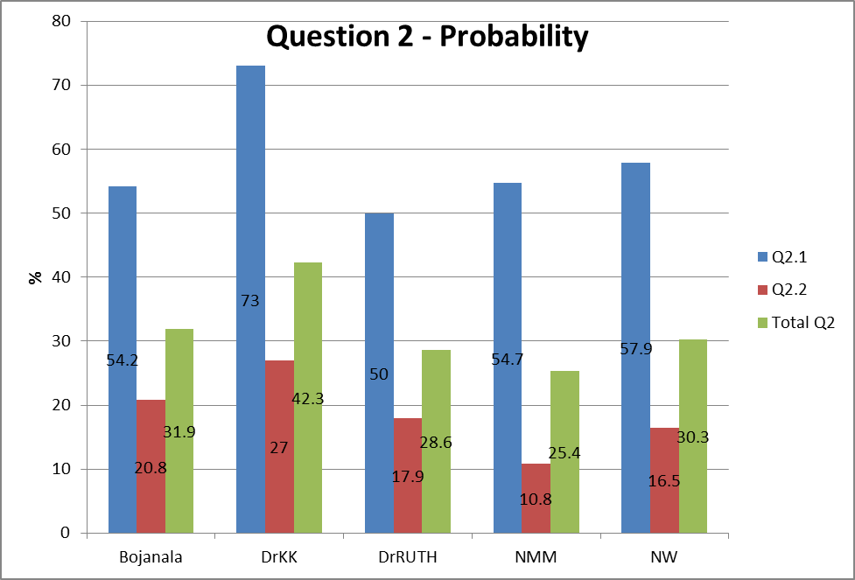

- Why was the question poorly answered? Also provide specific examples, indicate common errors committed by learners in this question, and any misconceptions.
The majority of learners did not have the knowledge of the basics and therefor how to prove that an event is mutually exclusive or independent. Lack of knowledge as well as teaching the topic.

- Provide suggestions for improvement in relation to Teaching and Learning
- Teach the learners the principles of events being – inclusive vs exclusive & dependant vs independent.
Mutually exclusive : P(A and B) = 0
Independent : P(A and B) = P(A) x P(B)
- They should also be able to prove the above … LHS
RHS
LHS = RHS
- Some learners tried something by using the general rule for 2 EVENTS :
P(A or B) = P(A) + P(B) – P(A and B)

(d) Describe any other specific observations relating to responses of learners
- Learners answered ONLY yes/no without any reasons/motivation/calculations etc.
- They did not know these concepts.

(e) Any other comments useful to teachers, subject advisors, teacher development etc.
Teacher training on this topic is needed.

QUESTION 3
(a) General comment on the performance of learners in the specific question. Was the question well answered or poorly answered?
Statistics : Q3.1 well answered, but Q3.2–3.4 were answered poorly. Marks allocated (11). Average obtained = 51.4%
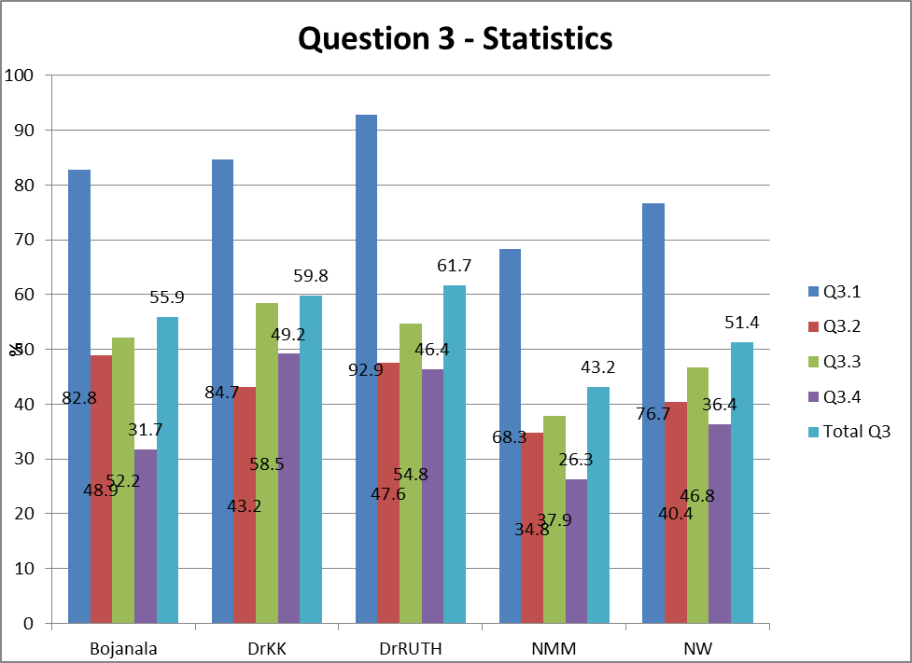

- Why was the question poorly answered? Also provide specific examples, indicate common errors committed by learners in this question, and any misconceptions.
- A number of learners drew bar graphs or frequency polygons (Q3.1)
- The learners did not know how to find the average lifespan when given in intervals.
- In Q3.3 quite a number of learners calculated 3 SD instead of 2SD.
- Most of the learners found it difficult to use the information gained from previous answers to answer Q3.4.

- Provide suggestions for improvement in relation to Teaching and Learning
- Learners should understand the usage of the normal distribution graph to improve their interpretation of data.
- Q3.1-3.2 are dealt with in Mathematics paper 2

(d) Describe any other specific observations relating to responses of learners
Some of the learners did not draw the histogram (Q3.1) clearly which made it difficult to mark.

(e) Any other comments useful to teachers, subject advisors, teacher development etc.
- Learners should understand the usage of the normal distribution graph to improve their interpretation of data.
- Practise with more real life situations and problems.

QUESTION 4
(a) General comment on the performance of learners in the specific question. Was the question well answered or poorly answered?
Probability : Varied from well answered to poor. Marks allocated (14). Average obtained = 61,6%
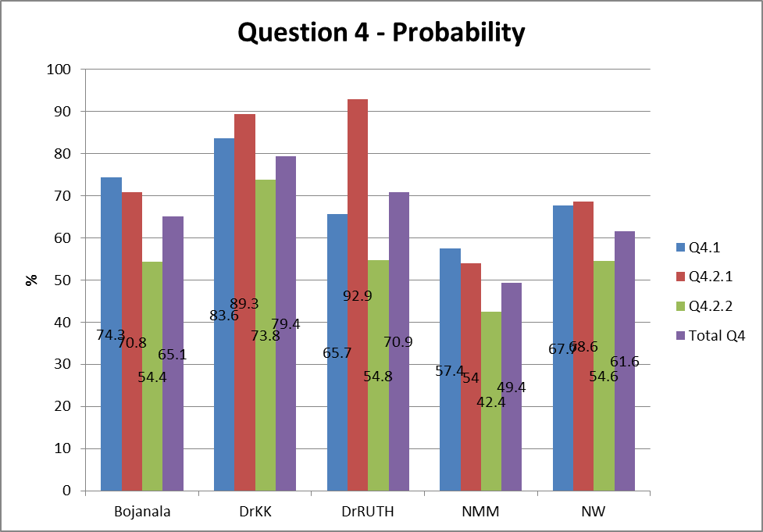

- Why was the question poorly answered? Also provide specific examples, indicate common errors committed by learners in this question, and any misconceptions.
- The learners gained either full marks for the tree diagram (Q4.1) or they did not have the slightest idea what is should look like.
- The remainder of the question was answered in the same way.

- Provide suggestions for improvement in relation to Teaching and Learning
- When learners are drawing the tree diagram, it should be emphasized that they should also write down the outcomes.
- If abbreviations are used, they should have a key to explain it.
- The learners did not know the basic principles of using the product rule and adding of the probabilities. (Q4.2 & 4.3)

(d) Describe any other specific observations relating to responses of learners
Learners are drawing actual trees?

(e) Any other comments useful to teachers, subject advisors, teacher development etc.
Teaching the topic to learners.

QUESTION 5
(a) General comment on the performance of learners in the specific question. Was the question well answered or poorly answered?
Probability Counting principles : Answered good in Q5.1, but very poor in Q5.2. Marks allocated (8). Average obtained = 26.8%
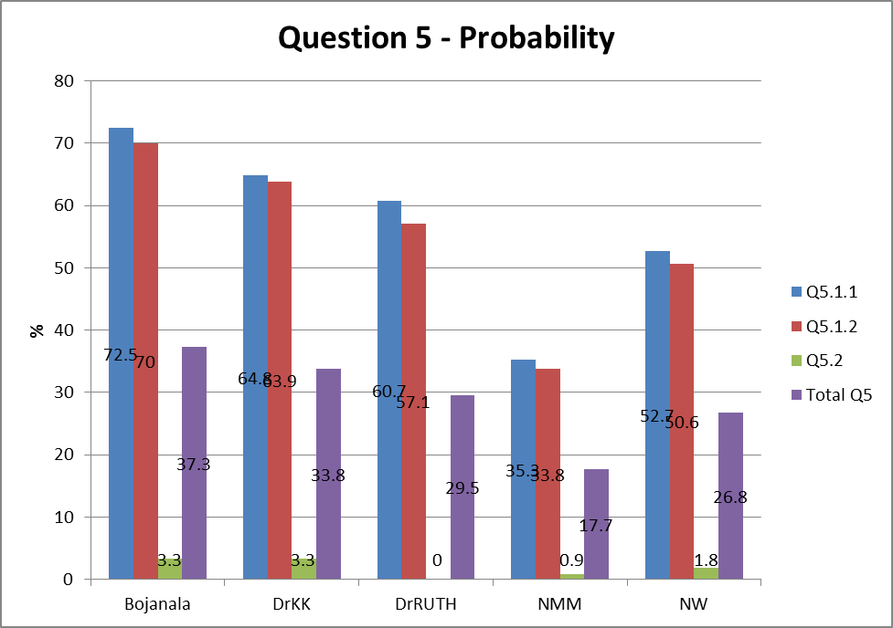

- Why was the question poorly answered? Also provide specific examples, indicate common errors committed by learners in this question, and any misconceptions.
The learners did not really have an idea what to do in Q5.2. Lack of knowledge.

- Provide suggestions for improvement in relation to Teaching and Learning
- Teaching the topic and making use of different examples even real life situations.
- Learners should know to use the complement rule when the question asks at least one…

(d) Describe any other specific observations relating to responses of learners
- Digits repeated : 10 x 10 x 10 x 10 x 10 (Q5.1.1)
- Digits can not be repeated : 10 x 9 x 8 x 7 x 6 (Q5.1.2)

(e) Any other comments useful to teachers, subject advisors, teacher development etc.
Make sure that learners know and apply the complement rule.

QUESTION 6
(a) General comment on the performance of learners in the specific question. Was the question well answered or poorly answered?
Recursive : Answered from average to very poor. Marks allocated (6). Average obtained = 26,5%
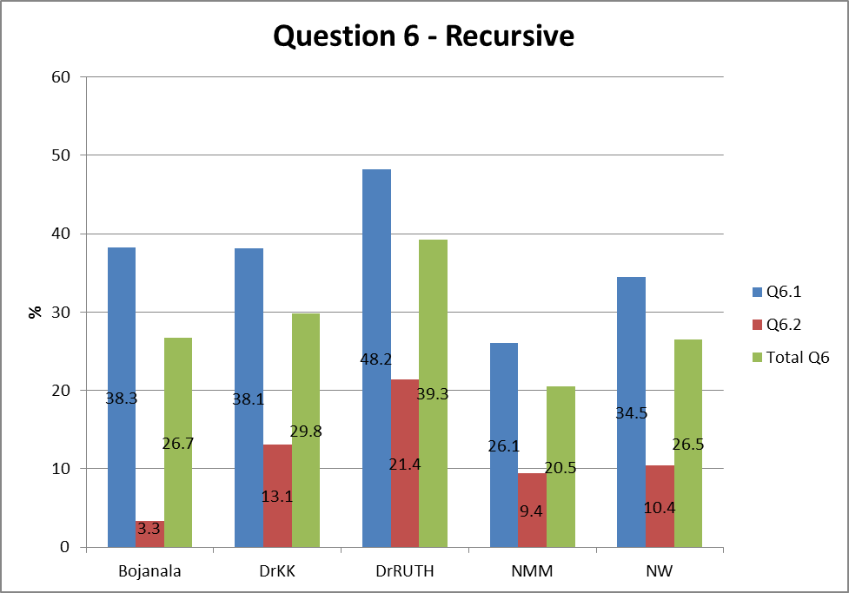

- Why was the question poorly answered? Also provide specific examples, indicate common errors committed by learners in this question, and any misconceptions.
Question 6 involved higher cognitive thinking.

- Provide suggestions for improvement in relation to Teaching and Learning
Emphasize the difference between the explicit and recursive formula.

(d) Describe any other specific observations relating to responses of learners
- The learners should take note of the correct way of using and writing with a subscript.
- They should remember to declare T₁ = … , k > …

(e) Any other comments useful to teachers, subject advisors, teacher development etc.
Teach and practise.
Questions 7 – 10 : GEOMETRY! Give attention to:
- Do all answers with complete corrext standard reasons.
- The diagram sheet should be used for:
  - The necessary constructions (only for prove of theorems)
  - Information they were given and calculated/proved
- No marks when calculations are based on assumptions. Mathematical break down.

QUESTION 7
(a) General comment on the performance of learners in the specific question. Was the question well answered or poorly answered?
Geometry : Q7.1 was answered extremely poor, while Q7.2 was answered well although the reason for the statement was omitted by many of the learners. Marks allocated (11). Average obtained = 27,1%
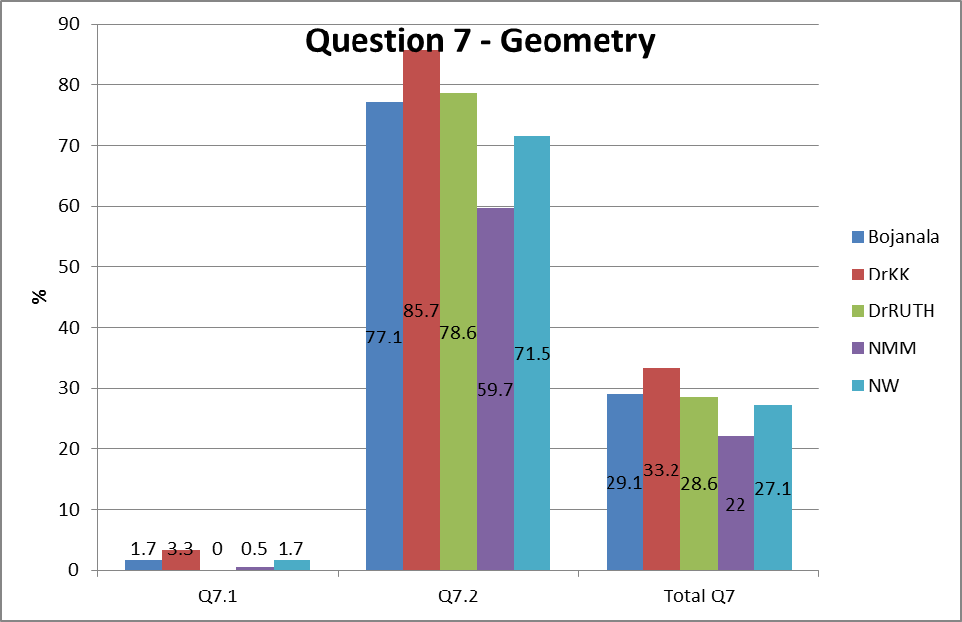

- Why was the question poorly answered? Also provide specific examples, indicate common errors committed by learners in this question, and any misconceptions.
Learners did not study how to prove the theorem.

- Provide suggestions for improvement in relation to Teaching and Learning
There is no excuse for not getting full marks for the proof of the theorem. Learners should know their work.

(d) Describe any other specific observations relating to responses of learners
Learners should know the proof of the theorem!

(e) Any other comments useful to teachers, subject advisors, teacher development etc.
Learn the proof of theorems. Know all theory. Practise!

QUESTION 8
(a) General comment on the performance of learners in the specific question. Was the question well answered or poorly answered?
Geometry : Q8.1 was answered (very) poor, while Q8.2 was answered either very well or very poor. Marks allocated (10). Average obtained = 57,7%
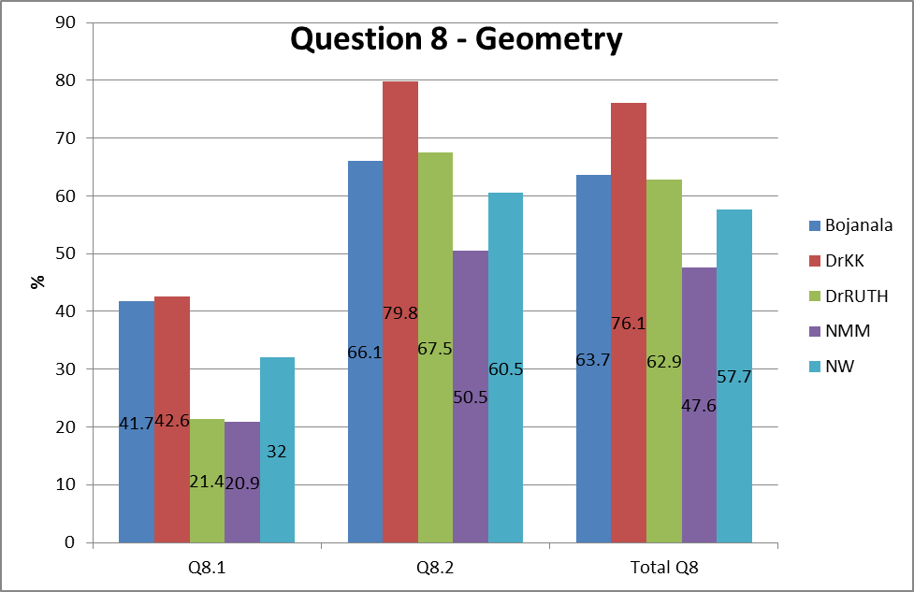

- Why was the question poorly answered? Also provide specific examples, indicate common errors committed by learners in this question, and any misconceptions.
- Learners did not know their theorems (theory).
- They tend to make assumptions like … PR or QT are diameters, therefore semicircles, 90⁰ angles, radii, etc.
- They were not able to recognize the correct angles subtended by the same chords or to apply the tangent-chord theorem correctly.

- Provide suggestions for improvement in relation to Teaching and Learning
- Learners should know their theorems (theory).
- They should do the correct construction on the diagram sheet … break down (0/7).
- They should be taught to give the (complete) correct standard reasons fot their statements.

(d) Describe any other specific observations relating to responses of learners
- Learners should not write their answers offered on the diagram sheet, but in the answer script.
- They should use the diagram sheet only for constructions when proving a theorem (theory).

(e) Any other comments useful to teachers, subject advisors, teacher development etc.
Practise makes perfect!

QUESTION 9
(a) General comment on the performance of learners in the specific question. Was the question well answered or poorly answered?
Geometry : Answered from average to poor. Marks allocated (14). Average obtained = 33,9%
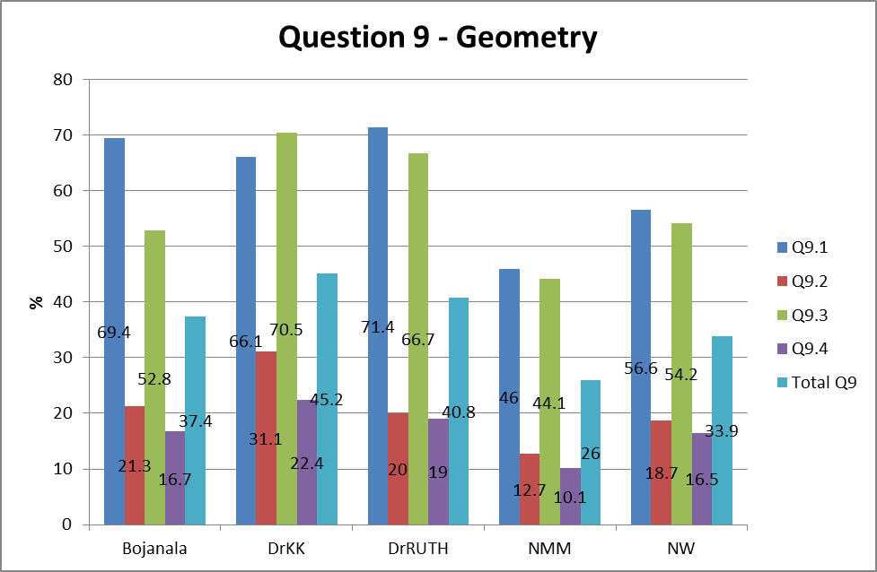

- Why was the question poorly answered? Also provide specific examples, indicate common errors committed by learners in this question, and any misconceptions.
- Learners based their answers on assumptions like ... ΔTCA is isosceles, therefore angels = x.
- Learners struggled with the correct relationship (proportionality) between the sides.

- Provide suggestions for improvement in relation to Teaching and Learning
- Teach and practise.
- Emphasize to learners to use the answers of the previous questions as if it was given (even if the learner could not do/prove it).

(d) Describe any other specific observations relating to responses of learners
- ASSUMPTIONS!

(e) Any other comments useful to teachers, subject advisors, teacher development etc.
Practise!

QUESTION 10
(a) General comment on the performance of learners in the specific question. Was the question well answered or poorly answered?
Geometry : Answered moderately to poor. Marks allocated (7). Average obtained = 34%
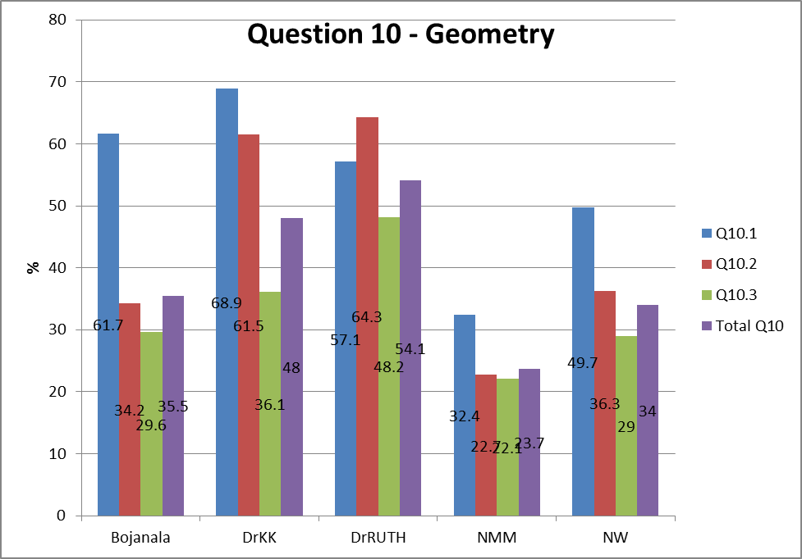

- Why was the question poorly answered? Also provide specific examples, indicate common errors committed by learners in this question, and any misconceptions.
- Lack of practise, may be time as well ... tired of struggling through the paper so that common sense was not even used … DC = 9x + 4x = 13x.
- Assumption like … OM = ½OC

- Provide suggestions for improvement in relation to Teaching and Learning
- Basics of circle geometry … a diameter goes through the centre of the circle, etc.

(d) Describe any other specific observations relating to responses of learners
- Q10.1 … DC = 9 + 4x
- OM = ½DC
- Learners used Pythagoras but did not substitute to compile an equation so that they could solve for x.

(e) Any other comments useful to teachers, subject advisors, teacher development etc.
Practise!

____________________________________ _______________________________________
NAME DESIGNATION (Subject Analyst /Moderator or Chief Marker)

_________________________________________ __________________________
SIGNATURE DATE

