

CHIEF MARKER'S / MODERATOR'S/ SUBJECT ANALYST’S REPORT FOR PUBLISHING

SUBJECT: LIFE SCIENCES PAPER: 2

INTRODUCTORY COMMENTS (How the paper was received; Papers too long/short/
balance)

The paper was well received by learners, teachers, subject advisors and examiners. The question paper covered the NCS syllabus and exam guidelines well and cognitive levels were adequately covered.
The time allocation was appropriate and the language used was on acceptable level for grade 12 First additional language candidates.
The content was covered as prescribed in the Examination Guideline document.

SECTION 1

SECTION 1: (General overview of Learner Performance in the question paper as a whole)

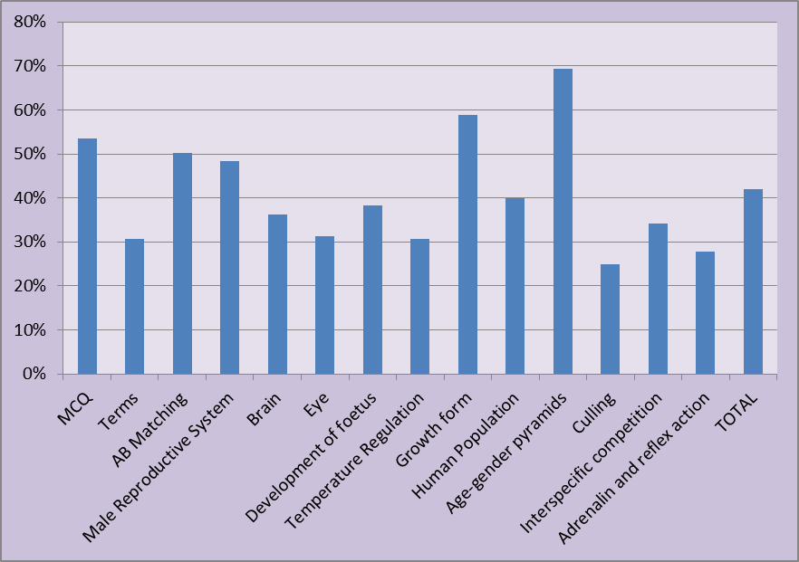

Candidates performed average, the sample of 100 scripts had an average of 42%.
Some sections were answered very well, but in other sections the performance was disappointing.
Skills of drawing a line graph improved from previous years and it was well answered.

Challenging skills are:
- Data response questions,
- application of knowledge in new situations,
- writing of a scientific essay,
- LO1(practical work) especially validity, reliability, deciding on variables, analysing data using calculations.

SECTION 2: Comment on candidates’ performance in individual questions

(It is expected that a comment will be provided for each question on a separate sheet).

QUESTION 1
(a) General comment on the performance of learners in the specific question. Was the question well answered or poorly answered?

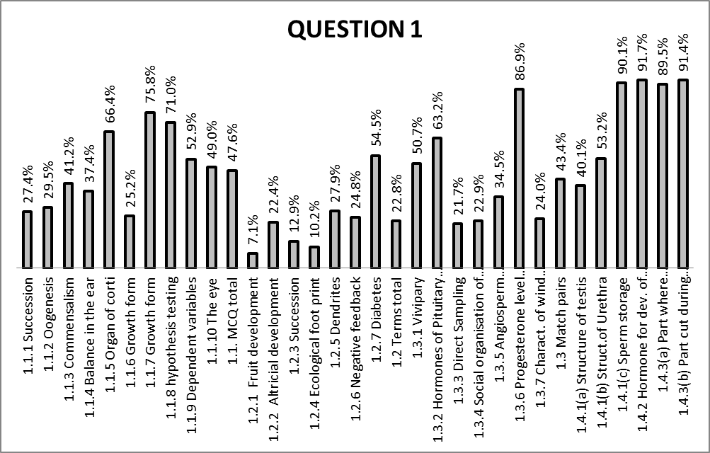

Q 1.1: Multiple choice was well answered, the average of sampled scripts is 47.6%
Q 1.2: Terminology was poorly answered, the provincial average is 22.8%
Q 1.3: matching columns was averagely answered, 43% average.
Q 1.4: short questions on male reproductive system was very well answered.

(b) Why the question poorly answered? Also provide specific examples, indicate common errors committed by learners in this question, and any misconceptions.

Q 1.2: Candidates did not know terminology well due to lack of studying.
Definitions of biological terms are not asked the same way as stated in text books.
Spelling errors are very common e.g. diabetes, dibieties, dybeties,
Epididymis; epydidmis, epiderdimus,
Testosterone; testerone, testosterone, testistreron
Altrecial; altrisial, artificial
Pioneer: pineer
Dendrite: dendron
Candidates struggle with general biological terms which may be confusing e.g.
Altrecial vs precocial, negative feedback vs antagonistic, ecological footprint vs
ecological niche, sugar diabetes vs sugar ribose, urethra vs urethre

(c) Provide suggestions for improvement in relation to Teaching and Learning

A terminology list / dictionary / glossary should be compiled for each chapter and kept at the back of learners’ note books.
Teacher should Question individual learners and not whole class / volunteers.
Teachers should encourage learners to draw flow diagrams / mind maps of long processes,
Teachers should give immediate feedback after home work or tests were marked. During this feedback session, incorrect answers should be interrogated to find out why they are wrong.
Teachers should not only give copies of memos, they must discuss memos with learners.
Teachers should Use less home language (other than LOLT) during teaching.
Teachers should be more strict on correct spelling of biological terms.

(d) Describe any other specific observations relating to responses of learners.

Q 1.1.10 This question had no correct answer, hence a compensation mechanism was
resorted to instead of crediting ALL the candidates.

The conversion of 2 marks advantaged the good candidates and not all.
Regardless of learners who left the question blank or who made a comment
that there is no correct answer.

Q 1.2.1 Only a few had ‘fruit’ correct, reproduction in plants and is neglected.
Q 1.4.1 The question required the candidates to write down the Letter (A to G) and the
NAME of ....
Many candidates gave only letters and not both letters and names (the question could have been subdivided into TWO parts namely:
a)Give letter of the following parts.....
and
b) Give the name of the part where....

(e) Any other comments useful to teachers, subject advisors, teacher development etc.

Specific training for teachers on methodology is needed.

This training should focus on GREAT teaching ideas on topics that are poorly performed in this exam. There has to be sharing of ideas by teachers across the province in this regard, where lesson plans on such great teaching ideas are done and executed in a classroom simulation for the benefit of all teachers.

Meaning and application of Principles of marking should be explained to teachers who do not generally come to the marking centres at the end of the year, especially the Grade 10 and 11.
HOD’s should be involved in memo discussions and moderation methods.
The use of teaching material on the DBE website e.g. ‘mind the gap’ material should encouraged for revision and during Winter and Spring Camp.

The Department should develop all Life Sciences teachers and not only focus on poor performing schools. It should be noted that Life Sciences is not trapped in most schools even though the school could be in a trap zone.

QUESTION 2
(a) General comment on the performance of learners in the specific question. Was the question well answered or poorly answered?

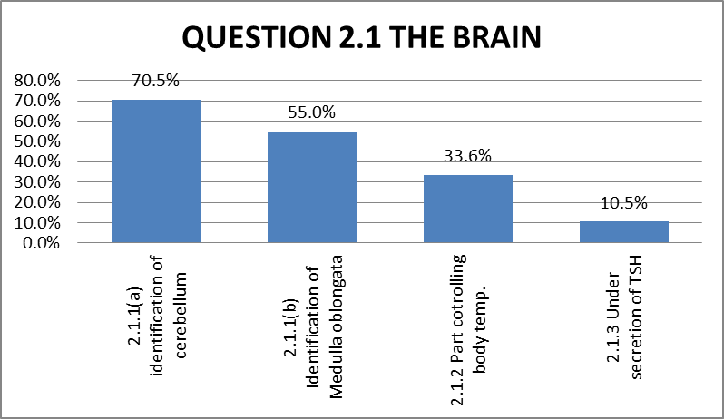

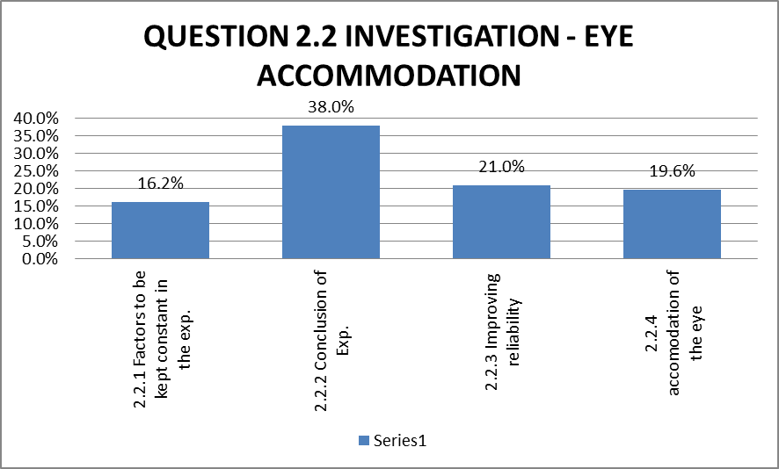

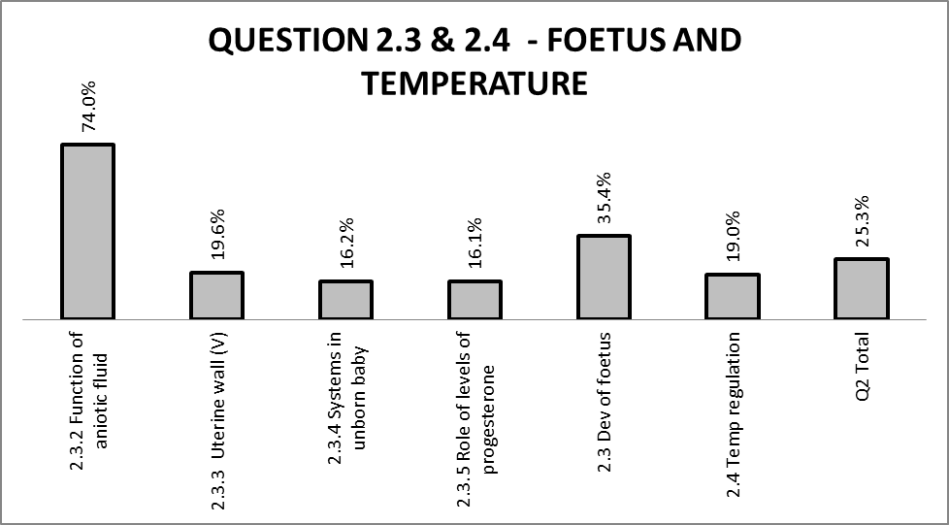

Q 2.1.3 was poorly answered, learners were unable to apply knowledge,10.5% average.
Q 2.2 , q 2.3 was poorly answered
Q 2.3.5 averagely answered.
(b) Why the question was poorly answered? Also provide specific examples, indicate common errors committed by learners in this question, and any misconceptions.

Q 2.1.1 Candidates confused cerebrum with cerebellum

Q 2.1.3 Candidates were unable to apply knowledge, they gave general functions
of TSH and not what the effect of a shortage will be.

Q 2.2.3 Candidates could not differentiate between validity and reliability,
many wrote ‘accurately’ and were not credited. This skill needs attention during
the teaching especially after conducting an experiment

Q 2.2.4 Many candidates confused pupillary mechanism and cilliary mechanism
(accommodation of the eye) Contracting, relaxing of different muscles and
ligaments in different situations is confusing.

Q 2.3.1 b) The label line was not clearly showing the correct part. Candidates confused
cervix, birth canal, uterus.

Q 2.3.3 Many candidates did not mention the structural suitability of uterus.

Q 2.3.4 Candidates do not understand which system in a new born baby takes over
the functions of the placenta.

Q 2.3.5 Many wrote just progesterone and not higher levels of progesterone.
Q 2.4 Candidates confused vasodilation and vasoconstriction.

Q 2.4 The function of the erector muscle was not credited but does relax during
high temperatures, to let the hair to be flat , increased blood supply to the
skin, sweat pores open and metabolic rate drops.

.

(c) Provide suggestions for improvement in relation to Teaching and Learning

The scientific method in any investigation should be emphasised.
Teachers must explain the following with more care: Constrict, relax, tendons, pupillary,
sweat vs more sweat, progesterone vs high levels etc.

Life Sciences Teachers should have learners coming into ther own classroom rather than them going to where learners are. This will improve the class room environment.
Relevant wall charts, posters, models, laboratories should displayed as a particular content topic is taught..

(d) Describe any other specific observations relating to responses of learners

A lack of motivation, commitment and studying skills are observed.
Huge language barriers and misconceptions are observed, e.g. Q 2.1.3; many candidates confuse temperature reduction with feeling cold.

(e) Any other comments useful to teachers, subject advisors, teacher development etc.

Teachers should be trained how to set papers, and how to allocate cognitive levels in the question paper, and how to phrase questions to eliminate wide answers on the memo.
Common exam papers should be written in June, set by examiners.
Schools/department should encourage schools to invest in projectors, charts, Models, field trips and laboratories.
Team teaching in schools and circuits could be encouraged.
Content training for teachers should be done early in the year.

QUESTION 3
(a) General comment on the performance of learners in the specific question.
Was the question well answered or poorly answered?

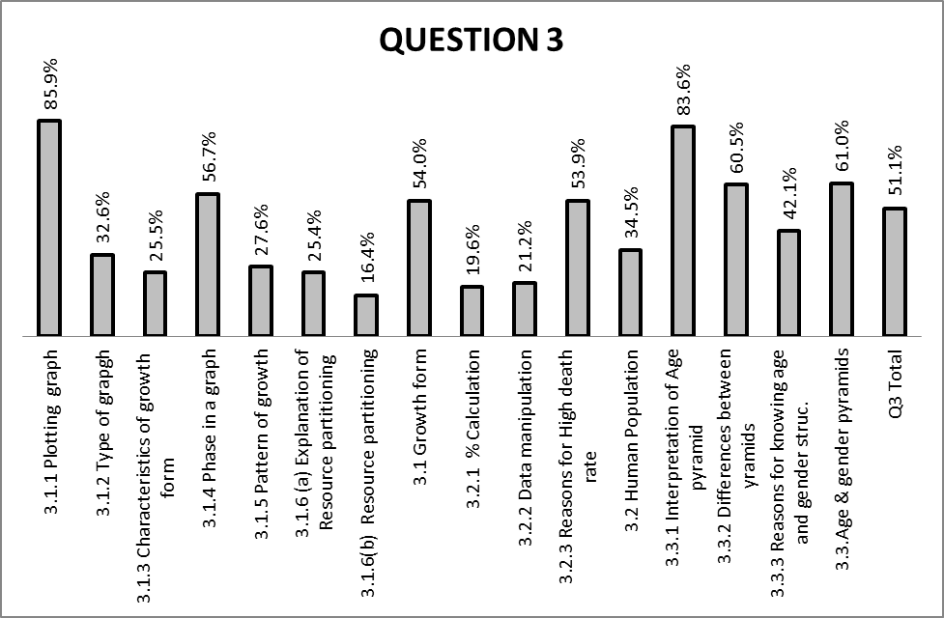

In general Q 3 was fairly well answered.
Q 3.1 was well answered, especially the graph.
Q 3.1.6 was very poorly answered, 16,4% average
Q 3.2.1 on calculations was very poorly answered 19.6% average.
(b) Why was the question poorly answered? Also provide specific examples,
indicate common errors committed by learners in this question, and any
misconceptions.

3.1.1 Most candidates lost marks for not giving both variables in the heading /
Title.

Most candidates drew incorrect scale on the y-axis or have transposed the
axes

Q 3.1.3 and 3.1.5 were poorly answered because the questions were not stated
clear enough and the mark allocation on the memo was not proper.

Q 3.1.3: Candidates were not credited when they explained population increase
And slow down of growth.

Also, those candidates that mentioned low growth, increasing population
and then fluctuating around carrying capacity were not credited,

The mark allocation should have been 3 marks so as to allow proper
marking that does not disadvantage learners

Q 3.2.1: The calculation was very poorly answered (19.6%).

The population data is given in millions while birth rate is given per 1000
people .

This got candidates confused when calculating percentages. Most
candidates had it wrong.

Q 3.2.3; The memo did not credit candidates who mentioned high levels of
Unemployment. Candidates could not categorise their responses.

.
Q 3.3.3 most candidates lost marks for not stating why the country need a census.
Candidates who wrote “for information purpose” were not credited

(c) Provide suggestions for improvement in relation to Teaching and Learning

Subject specialist should discuss this memo with Teachers at thier respective PSF at the beginning of the year. This must include the Principles of marking.
Varied Teaching media should be made available to schools: e-software, wall charts, labs.
More training on teaching methodology, at least one workshop per term
Field trips for teachers and learners should be organised to expose learners to environmental sciences /population studies.
Training on practical work and practical exams is needed.
(d) Describe any other specific observations relating to responses of learners

We have been advised by some teachers that ” impala and eland eat grass and not branches”, there is actually no resource partitioning between impala and eland in real life situation.
That been the case, learners who know this information would not think of any resource partitioning between the two animals.

Q 3.3.2: pyramid question not clear enough, some described it per age group. of 20 years or 30 years.

Q 3.1.6 many learners gave the answer that impala is smaller and eland is bigger,
and they did not link it to the height of trees.

Candidates in general did poorly in population studies. This might be that the topic was not adequately taught as teachers ran out of time.
e) Any other comments useful to teachers, subject advisors, teacher development
etc.
During teaching: Variables in graphs should be properly covered, especially in
caption of graph
Use previous question papers, give constant feedback, deal with
common mistakes and errors, misconceptions.

QUESTION 4
(a) General comment on the performance of learners in the specific question. Was the question well answered or poorly answered?

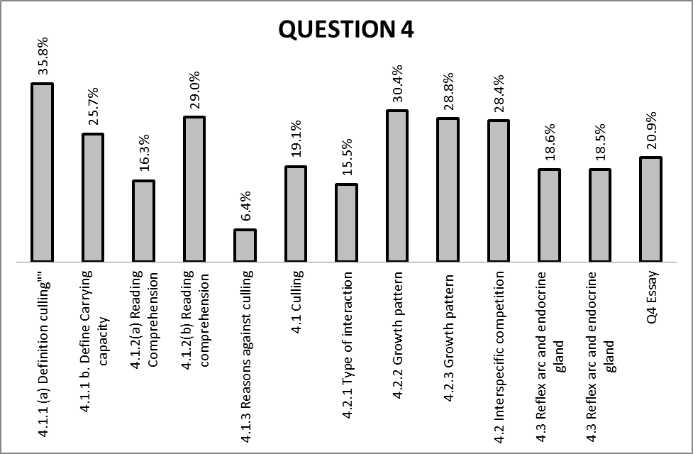

Q 4.1 was very poorly answered, underprivileged candidates lack background.
Especially Q 4.1.3 on reasons for culling with only 6.4% average.
Q 4.2 was poorly answered.
Q 4.3 was poorly answered.
(b) Why was the question poorly answered? Also provide specific examples, indicate common errors committed by learners in this question, and any misconceptions.

4.1 Candidates could not interpret the passage on elephant culling, they repeated or
copied directly from the extract.

Q 4.1.2 Most candidates could not comprehend the passage. They did not understand that
evidence meant to quote from the passage.

Candidates confused installation of artificial watering points with removal of watering points.

Q 4.1.3 Here candidates quoted from the passage while it was expected of them to use
their own words.

4.2. Candidates could not express or describe patterns of the population pyramids, it was
not well taught in class.

Q 4.2.1 Many candidates had it wrong, competitive exclusion was not well explained in schools.

Repetition of the same facts in Q 4.2.2 and 4.2.3 confused learners and markers.

4.3 Candidates did not know basic knowledge, it was a straight forward question.

- Provide suggestions for improvement in relation to Teaching and Learning

- Practice essay writing skills
- Drill definitions on population ecology, many definitions and concepts were neglected.
- Use case studies to develop population studies understanding.

(d) Describe any other specific observations relating to responses of learners

Q 4.1.1 b) many candidates wrote that carrying capacity is a ‘certain’ amount and was not credited. Many candidates repeated that it is the capacity of an environment to carry animals.
Q 4.1.2 many learners had no comprehension or understanding, they just copied from the extract.
4.3. The mark allocation could have been included on the question paper, some candidates who wrote few facts on the reflex arc but lots of detail on adrenalin were disadvantaged.

e) Any other comments useful to teachers, subject advisors, teacher development etc.
Learners should have a workbook for exercises, taking notes which are controlled by teachers!! Notes should be structured and organised with all possible questions. This will make studying easier and more structured.

SECTION 3
(a) GRAPH OF PROVINCIAL PERFORMANCE IN THE PAPER (summary per question)

GENERAL COMMENTS

(b) GRAPHS TO COMPARE DISTRICTS' PERFORMANCES PER QUESTION

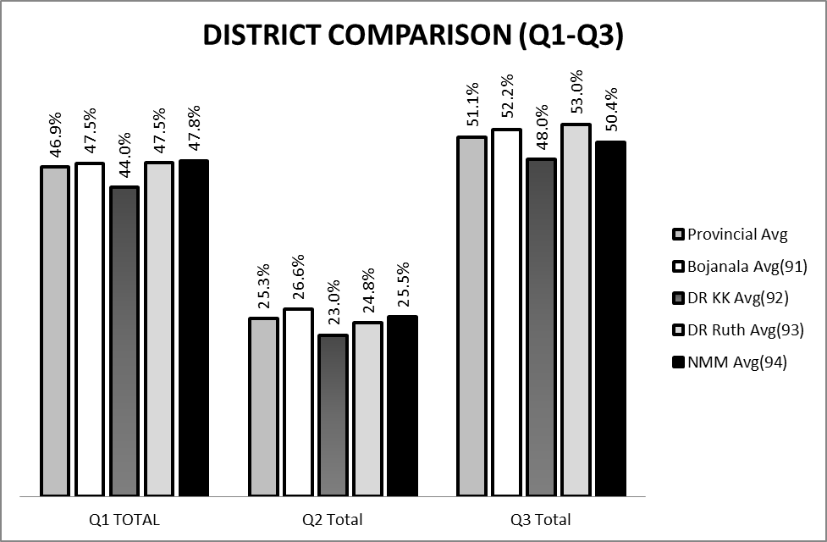

According to the graphs above,

Question 1
In this question all districts performed below 47.5%, with the lowest being Dr Kenneth Kaunda.
Bojanala average performance is depicted as higher than all districts and that of the province as well.

Question 2
All Districts performed very poorly in this question. Average performance ranges between 23 and 27%, with the lowest performing district being Dr Kenneth Kaunda and the highest being Bojanala.

Question 3

All districts performed above 50% in this question except for Dr Kenneth Kaunda that obtained an average of 48% .

Question 4

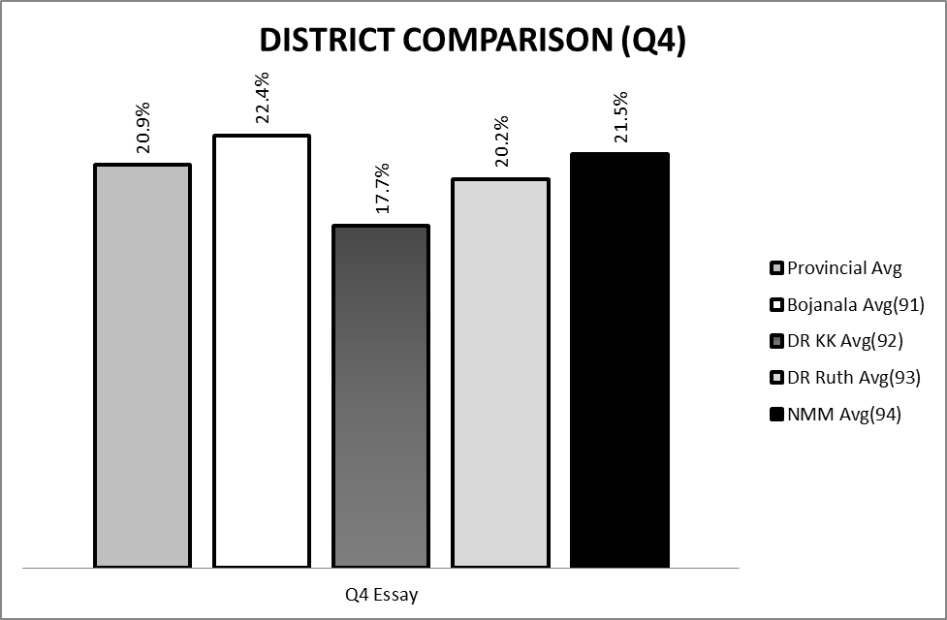

According to the graph, this question had a worst performance in all districts, with Dr Kenneth Kaunda Being the lowest and Bojanala The highest.

(c) GRAPH TO COMPARE OVERALL PERFORMANCE PER DISTRICT

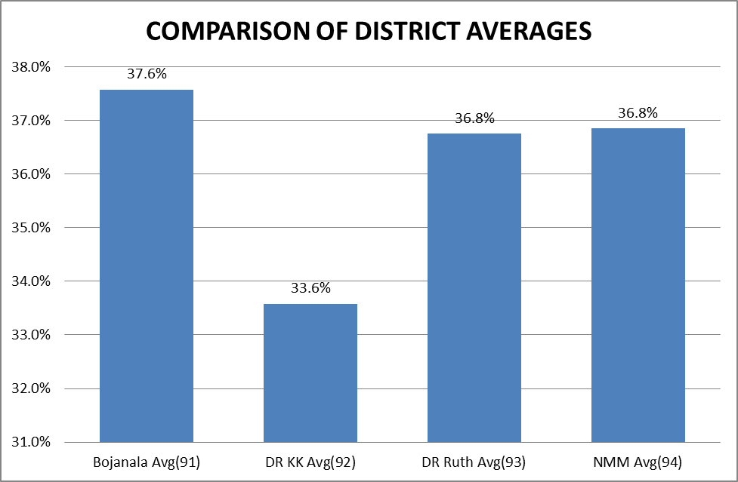

COMMENTS ON PERFORMANCE OF DISTRICTS
:
According to the graphs above, all districts are performing around 33- 37%. This should be read as average performance per district per sample of scripts taken during the marking session.

It should be acknowledged that sample size of Dr Kenneth Kaunda was by far smaller than most of the districts, as a result, this might have influenced the graph in a negative way.

If all are equal, then the performance of Dr Kenneth Kaunda should be read as the lowest in the province followed by Dr Ruth and Ngaka Modiri Molema .

(d) DISTRIBUTION OF QUESTIONS IN TERMS OF COGNITIVE LEVELS (TABLE)

The cognitive levels were adequately covered.

Cognitive levels: | A, B | C, D
MARKS | 91 | 59
% | 60.7 | 39.3
NORM:
MARKS | 90 | 60
% | 60 | 40

(e) COVERAGE OF LEARNING OUTCOMES AND ASSESSMENT STANDARDS
(TABLE)

 | LO1 | LO2 | LO3
MARKS | 46 | 94 | 10
% | 30.7 | 62.7 | 6.7
NORM
MARKS | 45 | 90 | 15
% | 30 | 60 | 10

Learning outcomes and Assessment standard were correctly covered

RG LEHOBYE 10/12/2012
_______________________ ______________ ___________
NAME OF CHIEF MARKER SIGNATURE DATE

P VAN DER WALT 10/12/2012
____________________________ ______________ ___________
NAME OF INTERNAL MODERATOR SIGNATURE DATE

NL MAUBANE 10/12/2012
_______________________________ ______________ ___________
NAME OF ANALITICAL MODERATOR SIGNATURE DATE

