

CHIEF MARKER'S / MODERATOR'S/ SUBJECT ANALYST’S REPORT FOR PUBLISHING

SUBJECT: INFORMATION TECHNOLOGY PAPER:2

INTRODUCTORY COMMENTS
(How the paper was received; Papers too long/short/ balance)

- Question paper was too long; learners wrote up to the last minute and didn’t have time to reflect on the questions.

SECTION 1
(General overview of Learner Performance in the question paper as a whole)

The average percentage obtained by the sample of 38% is 57%. It was expected that candidates should perform better in this paper, but due to unfair questions as discussed in the UMALUSI report better results could not be achieved. Another concern is that the number of candidates taking a subject of such importance is decreasing annually. Candidate numbers decreased from 219 in 2011 to 209 in 2012.

SECTION 2
(Comments on candidates’ performance in the five individual sub questions (a) – (e) will be provided below. Comments will be provided for each question on a separate sheet).

SECTION A: MULTIPLE-CHOICE [10]
QUESTION 1: MULTIPLE-CHOICE (10)

(a) General comments on the performance of learners in the specific question.

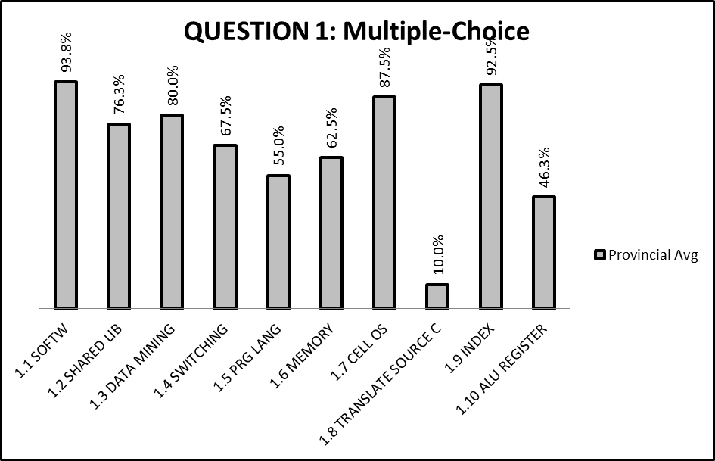

- Questions were fair and familiar to candidates.

(b) Reasons why the question was poorly answered. Specific examples, common errors
and misconceptions are indicated.
(c) Suggestions for improvement in relation to teaching and learning.

Q 1.1-Q1.10
Q1.8
SUGGESTIONS
Revision should be done on grade 10 and 11 syllabus.

(d) Other specific observations relating to responses of learners.

(e) Any other comments useful to teachers, subject advisors, teacher development, etc.

- Plan for and do thorough revision of the grade 10 & 11 syllabus.
SECTION B: HARDWARE AND SOFTWARE (50)

QUESTION 2: HARDWARE AND SOFTWARE (50)

(a) General comment on the performance of learners in the specific question.

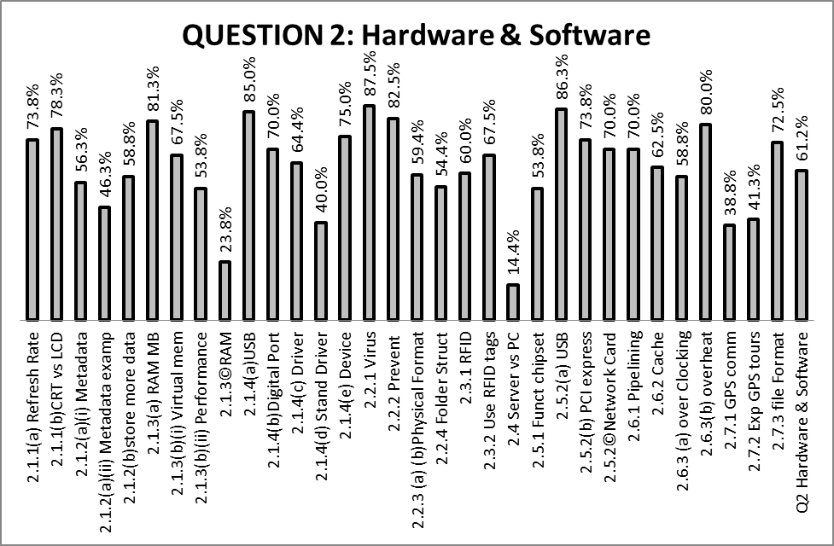

(b) Reasons why the question was poorly answered. Specific examples, common errors
and misconceptions are indicated.
(c) Suggestions for improvement in relation to teaching and learning.

Q 2.1
2.2.1(b)
2.1.3(c)
2.1.4(a)
2.1.4(d)
2.1.4(e)
SUGGESTIONS
- 2.1.1(b)
- Make sure that candidates have the background of recently used technology.
- 2.1.3(c)
- Make sure that candidates discuss every item that is referred to in the question, not only one, eg. Cache and RAM.
- The question requested reasons why the following statement is not true: Upgrading RAM means more cache memory is available.
- The proposed answer compares the two types of memory and candidates only discussed one of the two
- 2.1.4(a)USB
- Many candidates did not know what USB stand for. Make sure that candidates don’t know only abbreviations.
- 2.1.4(d)
- Candidates did not know what a standard driver is.
- Standard Driver: Already part of the OS, no need to load extra drivers
- 2.1.4(e) Devices making use of a standard driver
- Mouse, keyboard, external storage devices, printer/scanner/camera
Q 2.2
2.2.4
SUGGESTIONS
- 2.2.4
- Teach learners to label diagrams.
Q2.4
2.4 Server vs PC
SUGGESTIONS
- 2.4 (2 marks)
- Candidates did not refer to the difference in hardware between the two computers but rather referred to the advantages of a server.
Q2.5
2.5.1 Primary function of a chipset
SUGGESTIONS
- 2.5.1
- Candidates should make use of correct computer terminology. (The textbook example was not the correct answer)
Q2.6
2.6.2 (High cognitive level question)
SUGGESTIONS
- 2.6.2
- Candidates only gave the definition instead of describing the impact of the cache memory.
Q2.7
2.7.1
2.7.2
SUGGESTIONS
- 2.7.1 & 2.7.2
- Candidates should answer according to the scenario and not generalise. Candidates got confused between GPS and RFID technology

(d) Other specific observations relating to responses of learners.

- Candidates could answer questions well on the work which they had to study. Interpretation of questions from given scenario’s gave them difficulty.

(e) Any other comments useful to teachers, subject advisors, teacher development, etc.

- Make use of correct terminology while teaching the subject.

SECTION C: APPLICATIONS AND IMPLICATIONS [25]

QUESTION 3: e- COMMUNICATION (13)

(a) General comment on the performance of learners in the specific question.

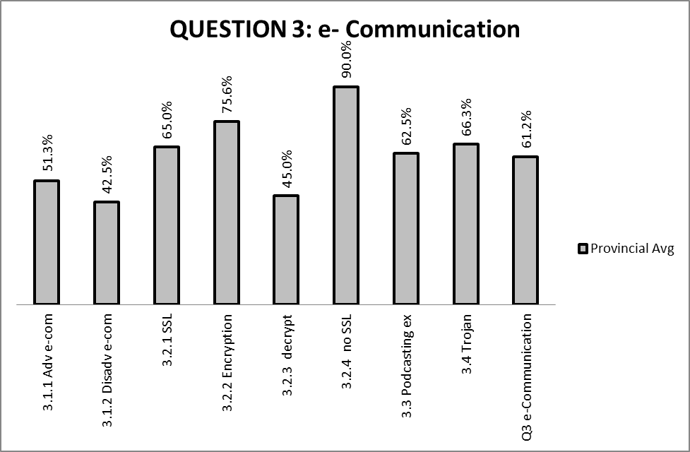

(b) Reasons why the question was poorly answered. Specific examples, common errors
and misconceptions are indicated.
(c) Suggestions for improvement in relation to teaching and learning.

Q 3.1
3.1.1
3.1.2
SUGGESTIONS
- Candidates must be exposed to insight questions.
Q 3.2
3.2.2
3.2.3
3.2.4
SUGGESTIONS
- With encryption teachers should concentrate on public key and private key
Q 3.3
3.3
SUGGESTIONS
- Make sure that answers are based on the scenario given
Q 3.4
3.4
SUGGESTIONS
- 3.3
- Candidates are under the impression that the Trojan is a virus. They should be taught that it is a program with malicious intent presenting itself as some useful program.

(d) Other specific observations relating to responses of learners.

- Candidates proofed through their answers that they are aware of the uses of technology in general life.

(e) Any other comments useful to teachers, subject advisors, teacher development, etc.
- Engage candidates in the gathering of information about trends on e-communication.
- Discuss these in class and make a list that can be updated on a regular basis.

QUESTION 4: SOCIAL AND ETHICAL ISSUES(12)

(a) General comment on the performance of learners in the specific question.

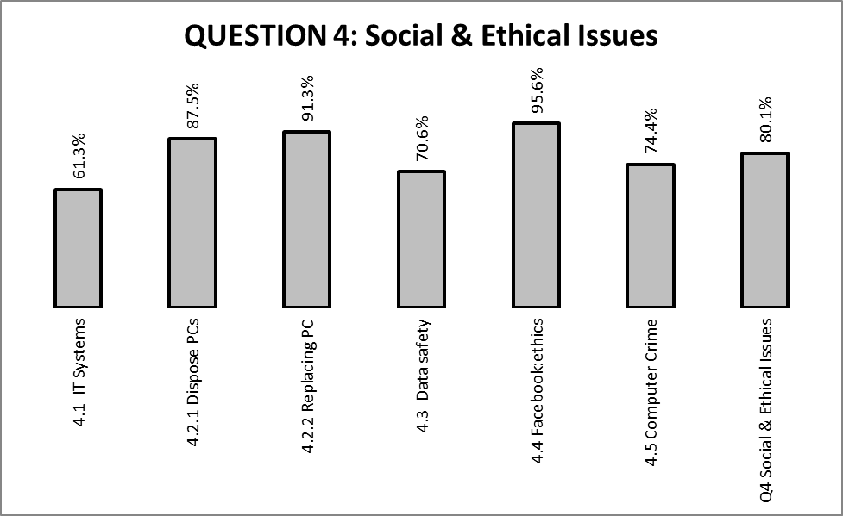

(b) Reasons why the question was poorly answered. Specific examples, common errors
and misconceptions are indicated.
(c) Suggestions for improvement in relation to teaching and learning.

Q 4.5
4.5
SUGGESTIONS
- 4.5
- Candidates should not repeat the terminology. Computer crime can happen through the internet or by the normal use of a computer.

(d) Other specific observations relating to responses of learners.

(e) Any other comments useful to teachers, subject advisors, teacher development, etc.
- Motivate candidates to know social and ethical issues of technology in the community.
- Refer them to articles in magazines and news papers.

SECTION D: PROGRAMMING AND SOFTWARE DEVELOPMENT [48]

QUESTION 5: ALGORITHMS AND PLANNING (48)

(a) General comment on the performance of learners in the specific question.

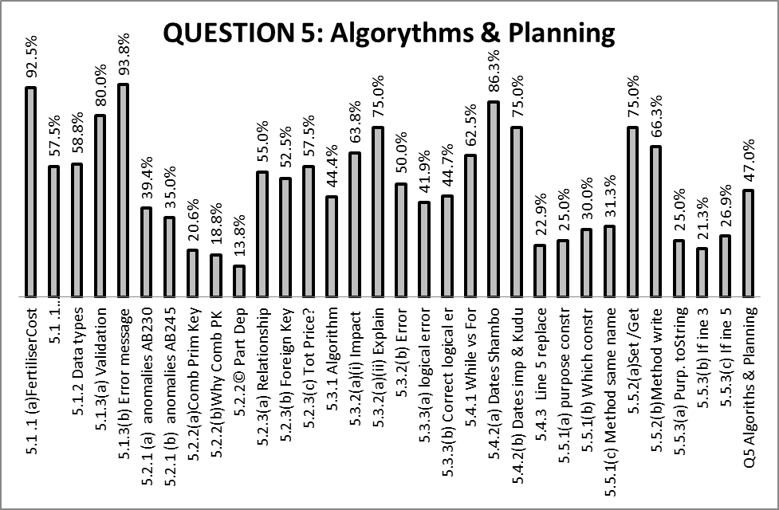

(b) Reasons why the question was poorly answered. Specific examples, common errors
and misconceptions are indicated.
(c) Suggestions for improvement in relation to teaching and learning.

Q 5.1
5.1.1
5.1.2
SUGGESTIONS
- 5.1.1
- Data type were confused between access and Delphi
- 5.1.2
- Candidates did not refer to numbers to indicate true and false
Q 5.2
5.2.1
5.2.2(a) & (b)
5.2.3 (a)
5.2.3 (b)
5.2.3 (c)
SUGGESTIONS
- 5.2.1
- Learners should get more practical exposure to these types of questions
- 5.2.2(a) & (b)
- All Access terminology should be covered. Make sure that candidates know that the table must be fully dependant on the whole single primary key.
- 5.2.3 (a)
- Teach each relationship effectively. Show examples to candidates and give relevant activities on relationships.
- 5.2.3 (b)
- Make sure candidates know what the foreign key is.
- 5.2.3 (c)
- Candidates did not apply the answer to the relevant access table and terminology. They referred to a general calculation.
Q 5.3
5.3.2 (b)
5.3.3
SUGGESTIONS
- 5.3.2 (b)
- Candidates were under the impression that it is a syntax and not a runtime error.
- 5.3.3.
- This question could either be answered by all candidates in a centre or not at all.
Q 5.4
5.4.3
SUGGESTIONS
- 5.4.3
- Make sure candidates know the order of the performance of the logical operators.
Q 5.5
5.5.1
5.5.3
SUGGESTIONS
- 5.5.1 (a)
- Lack of use of the correct terminology. Many candidates referred to the attribute of the class instead of the object.
- 5.5.1(b & c)
- Overloading should be taught thoroughly
- 5.5.3(a-c)
- Candidates did not answer the question within the context given.
- Use of the correct terminology is of utmost importance while teaching this subject.

(d) Other specific observations relating to responses of learners.

- It was clearly visible that some centers’ candidates do not have any experience on answering practical questions theoretically.

(e) Any other comments useful to teachers, subject advisors, teacher development, etc.

- Give Candidates example questions on practical questions asked theoretically.

SECTION E: INTEGRATED SCENARIO [47]

QUESTION 6: INTEGRATED SCENARIO (47)

(a) General comment on the performance of learners in the specific question.

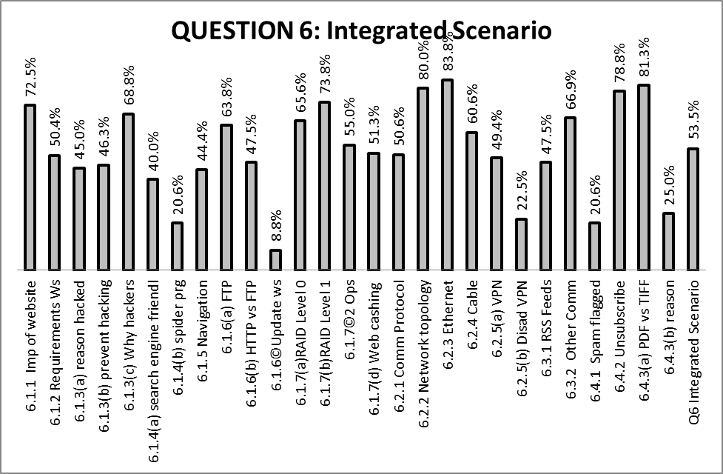

(b) Reasons why the question was poorly answered. Specific examples, common errors
and misconceptions are indicated.
(c) Suggestions for improvement in relation to teaching and learning.

Q 6.1
6.1.2
6.1.3 (a)
6.1.4 (a & b)
6.1.6
6.1.7 (d)
SUGGESTIONS
- 6.1.2
- Make sure that candidates know various requirements of a well designed website.
- 6.1.3 (a)
- Candidates had to mention changes that were made without permission.
- 6.1.4(a & b)
- Make sure candidates know the value/use of search engines and they should be able to describe a spider program.
- 6.1.6
- Differentiate clearly between the functioning of the different protocols.
- 6.1.7
- Candidates lost marks by referring to Windows instead of Windows server.
- 6.1.7(d)
- Candidates must be specific when referring that the webpage is stored on the hard drive candidates use words like on the computer and in the memory.
Q 6.2
6.2.5(a)
6.2.5(b)
SUGGESTIONS
- 6.2.5(a)
- VPN is a private network which uses the Internet to connect computers as if they are connected via a LAN
- 6.2.5(b)
- Can be slow, not available for all clients if the internet connection not available, cannot connect if the user forgot the password, specialised security measures needed.
- Candidates should not only rephrase terms.
Q 6.3
6.3.1
SUGGESTIONS
- 6.3.1 The words “faster” and “cheaper” were not accepted as right answers
Q 6.4
6.4.1
6.4.3(b)
SUGGESTIONS
- 6.4.1
- Candidates did not answer the question according to the scenario. The focus was on the author of the email.
- 6.4.3(b)
- Candidates lost the mark if question (a) was answered incorrectly.
General:
Questions were relatively wide and open ended.

(d) Other specific observations relating to responses of learners.

(e) Any other comments useful to teachers, subject advisors, teacher development, etc.
- Candidates should know the theory about websites and not only how to use it.
- Focus on issues like web design, search engines
- The functioning of different Protocols should be taught to candidates.
SECTION 3
(a) GRAPH OF PROVINCIAL PERFORMANCE IN THE PAPER (summary per question)

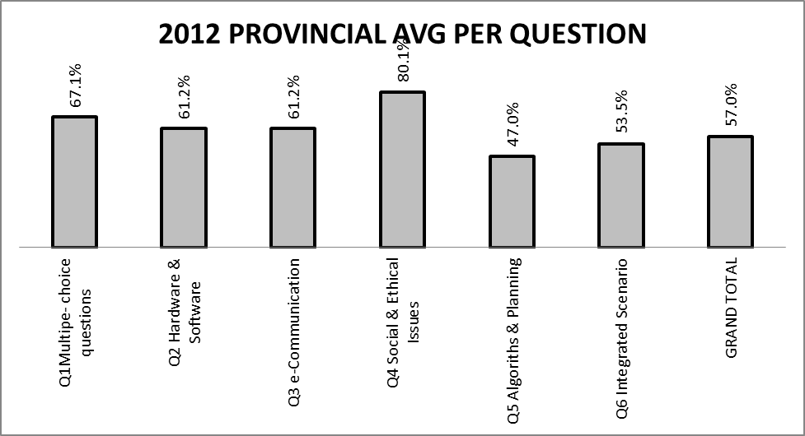

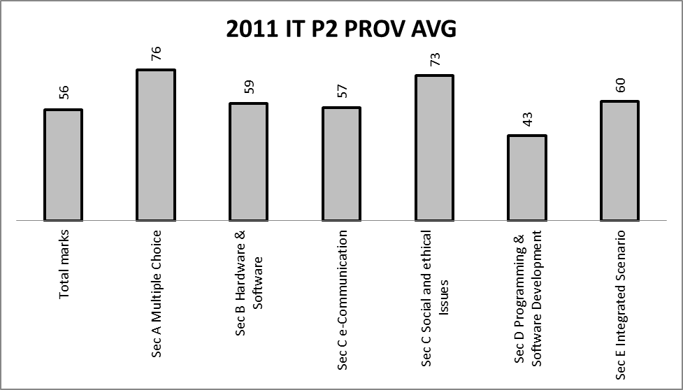

GENERAL COMMENTS
- Candidates had difficulty to finish the paper in the time allocated to the paper and a number of candidates only attempted half of question 6.
- The total average increased with 1% from 2011.

(b) GRAPHS TO COMPARE DISTRICTS' PERFORMANCES PER QUESTION

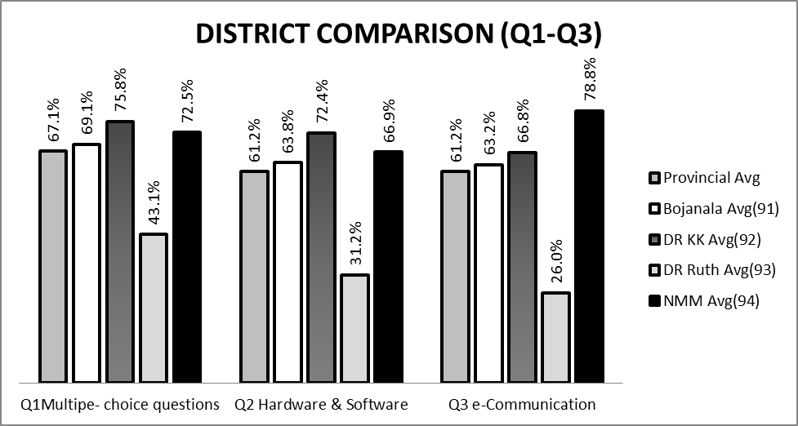

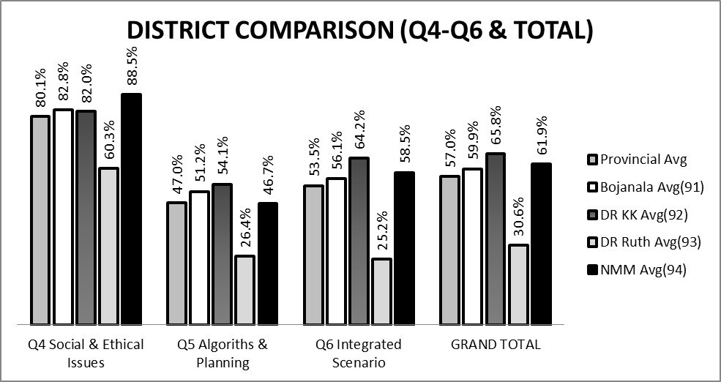
(c) GRAPH TO COMPARE OVERALL PERFORMANCE PER DISTRICT

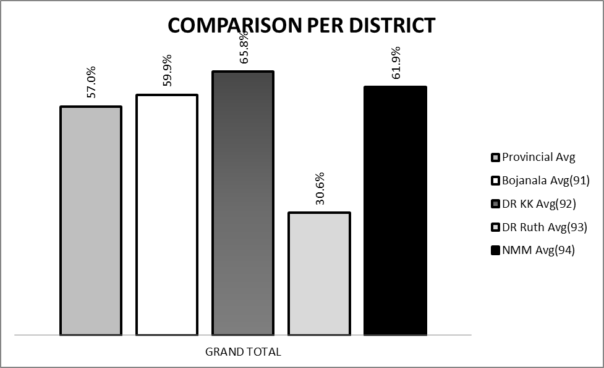

COMMENTS ON PERFORMANCE OF DISTRICTS :
- Dr KK and Bojanala are the two districts with the most schools that are offering the subject. Dr Ruth has a total of two schools offering IT. This can have a definite influence on the comparison.

(d) DISTRIBUTION OF QUESTIONS IN TERMS OF COGNITIVE LEVELS (TABLE)

Questions | Marks | CL | Questions | Marks | CL | Questions | Marks | CL | Questions | Marks | CL
1.1 SOFTW | 1 | 1 | 2.3.1 RFID | 1 | 2 | Q4 Social & Ethical Issues |  |  | 5.5.3(b) If ine 3 | 2 | 3
1.2 SHARED LIB | 1 | 1 | 2.3.2 Use RFID tags | 2 | 2 | 5.1 .1 (a)FertiliserCost | 1 | 1 | 5.5.3(c) If ine 5 | 2 | 3
1.3 DATA MINING | 1 | 1 | 2.4 Server vs PC | 2 | 2 | 5.1 .1 (b)NurseryPhoneNumber | 1 | 1 | Q5 Algoriths & Planning
1.4 SWITCHING | 1 | 1 | 2.5.1 Funct chipset | 1 | 1 | 5.1.2 Data types | 1 | 1 | 6.1.1 Imp of website | 2 | 2
1.5 PRG LANG | 1 | 1 | 2.5.2(a) USB | 1 | 1 | 5.1.3(a) Validation | 3 | 2 | 6.1.2 Requirements Ws | 3 | 2
1.6 MEMORY | 1 | 1 | 2.5.2(b) PCI express | 1 | 1 | 5.1.3(b) Error message | 1 | 1 | 6.1.3(a) reason hacked | 1 | 2
1.7 CELL OS | 1 | 1 | 2.5.2©Network Card | 1 | 1 | 5.2.1 (a) anomalies AB230 | 2 | 3 | 6.1.3(b) prevent hacking | 2 | 2
1.8 TRANSLATE SOURCE C | 1 | 2 | 2.6.1 Pipelining | 2 | 2 | 5.2.1 (b) anomalies AB245 | 2 | 3 | 6.1.3(c) Why hackers | 2 | 2
1.9 INDEX | 1 | 1 | 2.6.2 Cache | 2 | 3 | 5.2.2(a)Comb Prim Key | 2 | 2 | 6.1.4(a) search engine friendl | 1 | 2
1.10 ALU REGISTER | 1 | 1 | 2.6.3 (a) over Clocking | 1 | 2 | 5.2.2(b)Why Comb PK | 2 | 3 | 6.1.4(b) spider prg | 2 | 2
Q1Multipe- choice questions |  |  | 2.6.3(b) overheat | 2 | 2 | 5.2.2© Part Dep | 1 | 2 | 6.1.5 Navigation | 2 | 2
2.1.1(a) Refresh Rate | 2 | 1 | 2.7.1 GPS comm | 1 | 2 | 5.2.3(a) Relationship | 1 | 1 | 6.1.6(a) FTP | 2 | 1
2.1.1(b)CRT vs LCD | 3 | 2 | 2.7.2 Exp GPS tours | 2 | 3 | 5.2.3(b) Foreign Key | 1 | 1 | 6.1.6(b) HTTP vs FTP | 2 | 3
2.1.2(a)(i) Metadata | 2 | 2 | 2.7.3 file Format | 1 | 1 | 5.2.3(c) Tot Price? | 2 | 3 | 6.1.6©Update ws | 1 | 3
2.1.2(a)(ii) Metadata examp | 1 | 2 | Q2 Hardware & Software |  |  | 5.3.1 Algorithm | 2 | 2 | 6.1.7(a)RAID Level 0 | 2 | 2
2.1.2(b)store more data | 1 | 2 | 3.1.1 Adv e-com | 2 | 2 | 5.3.2(a)(i) Impact | 1 | 3 | 6.1.7(b)RAID Level 1 | 3 | 2
2.1.3(a) RAM MB | 1 | 2 | 3.1.2 Disadv e-com | 1 | 2 | 5.3.2(a)(ii) Explain | 1 | 3 | 6.1.7©2 Ops | 2 | 1
2.1.3(b)(i) Virtual mem | 2 | 2 | 3.2.1 SSL | 1 | 2 | 5.3.2(b) Error | 1 | 2 | 6.1.7(d) Web cashing | 2 | 2
2.1.3(b)(ii) Performance | 1 | 3 | 3.2.2 Encryption | 2 | 3 | 5.3.3(a) logical error | 2 | 2 | 6.2.1 Comm Protocol | 2 | 1
2.1.3©RAM | 3 | 3 | 3.2.3 decrypt | 2 | 3 | 5.3.3(b) Correct logical er | 4 | 3 | 6.2.2 Network topology | 1 | 1
2.1.4(a)USB | 1 | 3 | 3.2.4 no SSL | 1 | 1 | 5.4.1 While vs For | 1 | 2 | 6.2.3 Ethernet | 1 | 1
2.1.4(b)Digital Port | 1 | 1 | 3.3 Podcasting ex | 2 | 2 | 5.4.2(a) Dates Shambo | 1 | 2 | 6.2.4 Cable | 2 | 2
2.1.4(c) Driver | 2 | 1 | 3.4 Trojan | 2 | 2 | 5.4.2(b) Dates imp & Kudu | 1 | 2 | 6.2.5(a) VPN | 2 | 2
2.1.4(d) Stand Driver | 1 | 3 | Q3 e-Communication |  |  | 5.4.3 Line 5 replace | 3 | 3 | 6.2.5(b) Disad VPN | 1 | 1
2.1.4(e) Device | 1 | 2 | 4.1 IT Systems | 2 | 2 | 5.5.1(a) purpose constr | 1 | 2 | 6.3.1 RSS Feeds | 2 | 2
2.2.1 Virus | 2 | 2 | 4.2.1 Dispose PCs | 2 | 2 | 5.5.1(b) Which constr | 1 | 2 | 6.3.2 Other Comm | 2 | 2
2.2.2 Prevent | 2 | 2 | 4.2.2 Replacing PC | 2 | 2 | 5.5.1(c) Method same name | 1 | 2 | 6.4.1 Spam flagged | 2 | 2
2.2.3 (a) (b)Physical Format | 2 | 1 | 4.3 Data safety | 2 | 3 | 5.5.2(a)Set /Get | 1 | 1 | 6.4.2 Unsubscribe | 1 | 1
2.2.4 Folder Struct | 2 | 2 | 4.4 Facebook:ethics | 2 | 3 | 5.5.2(b)Method write | 2 | 1 | 6.4.3(a) PDF vs TIFF | 1 | 1
2.3.1 RFID | 1 | 2 | 4.5 Computer Crime | 2 | 2 | 5.5.3(a) Purp. toString | 1 | 2 | 6.4.3(b) reason | 1 | 2

(e) COVERAGE OF LEARNING OUTCOMES AND ASSESSMENT STANDARDS
(TABLE)

- Learning outcomes and assessment standards were fairly covered. This information was not provided by the national task team and neither expected of the internal moderators and chief markers to draw this grid for the subjects. Norm time should be increased if it is expected to draw this grid during the marking period.

____________________________________ _______________________________________
NAME DESIGNATION (Subject Analyst /Moderator or Chief Marker)

_________________________________________ __________________________
SIGNATURE DATE

