

CHIEF MARKER'S / MODERATOR'S/ SUBJECT ANALYST’S REPORT FOR PUBLISHING

SUBJECT: HISTORY PAPER: 1

INTRODUCTORY COMMENTS (How the paper was received; Papers too long/short/
balance)

- History Paper 1 question paper was set out of four (4) questions and candidates were required to choose ANY TWO questions from the four.
- Each question was out of 75, meaning that the paper was written out of 150 marks for 3 hours.
- Majority of candidates attempted questions 3 (Civil Rights Movement in USA) and 4 (Biko and the BCM), however, the number of candidates who attempted questions 1 (Cold War- Cuba) and 2 (Uhuru- Tanzania) has increased as compared to in 2011.
- The reason for this may be that the two topics are treated as Case Studies for question 1 and 2.
- Majority of candidates were able to complete the paper, meaning that the paper was balanced in terms of length, Los and Ass, and cognitive demands of questions.
- Generally, it was a good, fair paper. It separates weaker candidates from those with sufficient knowledge, skills and insight.

SECTION 1

(General overview of Learner Performance in the question paper as a whole)

- Generally, candidates performed well in this paper, especially those who attempted questions 3 and 4.
- In Source Based questions (all choice questions), level 2 and 3 questions on reliability, usefulness, comparison, justification and validity are still a challenge to most candidates.

- PARAGRAPH: Generally, most candidates did not perform well in paragraph questions.
- There are still candidates copying information directly from the sources without any attempt to focus on the question.
- In some questions, sources were not assisting candidates to answer the

questions, e.g, paragraph question 1.4.
- Some candidates still write the paragraph in point form.
- However, there is a slight improvement of performance in paragraph writing as compared to in 2011.

- EXTENDED WRITING:
- Majority of candidates attempted the first essay (explain, discuss) in all the choice questions. Generally, performance in this type of questions was good.
- Very few candidates attempted the second type of essay (source based essay). Those who did performed poorly.
- There is a trend that some candidates are performing well in extended writing than source based questions. This might be because candidates prepare extended writing/essays in advance.

SECTION 2

(Comments on candidates’ performance in the five individual sub questions (a) – (e) will be provided below. Comments will be provided for each question on a separate sheet).

QUESTION 1

(a) General comments on the performance of learners in the specific question.

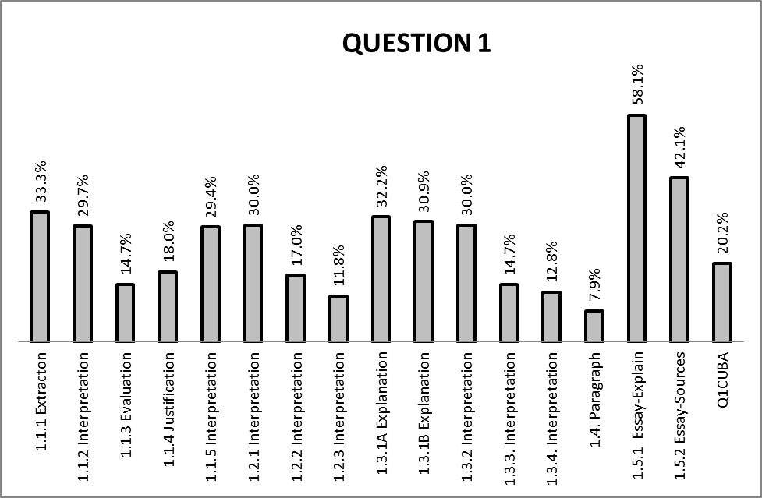

(b) Reasons why the question was poorly answered. Specific examples, common errors
and misconceptions are indicated.
(c) Suggestions for improvement in relation to teaching and learning.

Q. 1.1.1
- Though this required simple extraction of information from the source (level 1), some candidates got it wrong.
- They gave “Cuba” as an answer. They did not read the source with understanding and this also showed lack of content knowledge as Cuba was the focal point.
- Majority of candidates gave only one answer, losing the other mark.

SUGGESTIONS:
- Learners should be encouraged to fully read the source before answering the question.
- Teachers to encourage learners to always draw from their prior knowledge when answering the question.
- Learners are encouraged to be guided by the mark allocation to determine how many answers are required.

Q. 1.1.2
- The question was fairly answered.
- Some candidates could not interpret the source.
- Lack of content was evident in most candidates’ responses. They solely relied on the source to address the question.
SUGGESTIONS:
- More focus to be given to content at schools before skills can be practiced.

Q 1.1.3
- The question was poorly answered.
- Candidates could not support their choice (BIASED or NOT BIASED) with relevant facts.
- Some candidates just gave facts without stating their viewpoints.
SUGGESTIONS:
- Learners should be encouraged to always support their viewpoints with facts.

Q.1.1.4
- The question was poorly answered.
- Candidates could not support their choice (JUSTIFIED or NOT JUSTIFIED) with relevant facts.
- Some candidates just gave facts without stating their viewpoints.
- Candidates showed lack of content knowledge and the skill of ascertaining justification of evidence.
SUGGESTIONS:
- Learners should be encouraged to always support their viewpoints with facts.

Q.1.1.5
- The question was fairly answered.
- Some candidates simply extracted “a great tension, a great crisis” from the source without any interpretation. Thus scoring one mark instead of two.
SUGGESTIONS:
- Learners should be encouraged to interpret the source before answering the question.
- Simply extracting the information without understanding the question and the source should be discouraged.

Q.1.2.1
- The question was fairly answered.
- Some candidates struggled to interpret the cartoon.
SUGGESTIONS:
- Teachers should assist learners with the skill of interpreting cartoons, linking that to the topic.

Q.1.2.2
- The question was poorly answered.
- Majority of candidates were disadvantaged by the word “portray” in the question.
SUGGESTIONS:
- Teachers should familiarise learners with such questions through informal tasks and the use of previous question papers.

Q.1.2.3
- This question was poorly answered.
- Majority of candidates could not interpret the source to attach an emotion to it.
- Some candidates only gave an emotion without explaining.
SUGGESTIONS:
- Learners should be encouraged to carefully read the question. This question required an emotion/feeling with an explanation.

Q.1.3.1 A
- Most candidates failed to define the concept Cold War.
- Those who attempted the definition did not do so with reference to the Cuban Missile Crisis, as the question demanded. They gave a general definition of the concept.

SUGGESTIONS:
- Educators are advised to start the topic on Cuba by giving a brief background on the Cold war, thereby including the definition and origin of the Cold War.
- Candidates to be encouraged to always define concepts with reference to the topic, e.g, definition of the Cold War with reference to the Cuban Missile Crisis.

Q.1.3.1 B
- Majority of candidates performed well in this question, but some only extracted the word “blockade” from the source without any attempt to define.
SUGGESTIONS:
- Candidates to be encouraged to always define concepts with reference to the topic, e.g, definition of the concept Quarantine with reference to the Cuban Missile Crisis.

Q.1.3.2
- The question was fairly answered.
- Some candidates showed lack of content knowledge as the answers are not in the source.
SUGGESTIONS:
- Learners must have content knowledge to be able to interpret evidence from the source.

Q.1.3.3
- The question was poorly answered.
- Candidates displayed lack of interpretation skills.
- Lack of content knowledge also affected their interpretation skill.

SUGGESTIONS:
- Learners must have content knowledge to be able to interpret evidence from the source.
Q.1.3.4
- The question was poorly answered.
- Candidates were able to select the leader they think was responsible for the crisis in Cuba, but could not explain their choice.
- Some candidates provided explanation without stating their choice.
SUGGESTIONS:
- Learners should be encouraged to always support their choice with facts.

Q.1.4. Paragraph
- Performance in this question was extremely poor.
- The question was unfair to candidates as it required them to refer to the sources but not a single source assisted candidates to respond to the question (no source had information on the question).
- The question was also not clear. To some candidates impact only meant something negative, hence they only referred to negative impact that the Cuban Missile Crisis had on Khrushchev’s political career.
- Only those learners with content knowledge were able to score good marks.
SUGGESTIONS:
- Knowledge of content should always be encouraged to assist candidates to attempt questions of this nature.

Q.1.5.1. Essay-Explanation
- The question was well answered.
- Candidates who underperformed in this question lacked content.
SUGGESTIONS:
- Both teachers and learners must first focus on content before skills are learned. Everything in history, especially an essay question on explanation requires high content knowledge.

Q.1.5.2. Essay-Source Based
- Very few candidates attempted this question.
- Performance was poor
SUGGESTIONS:
- Teachers to train learners on how to use sources as evidence to address the question, without directly copying from the sources.
- Learners must be encouraged to fully understand the statement on the question before answering the question.

QUESTION 2

(a) General comment on the performance of learners in the specific question.

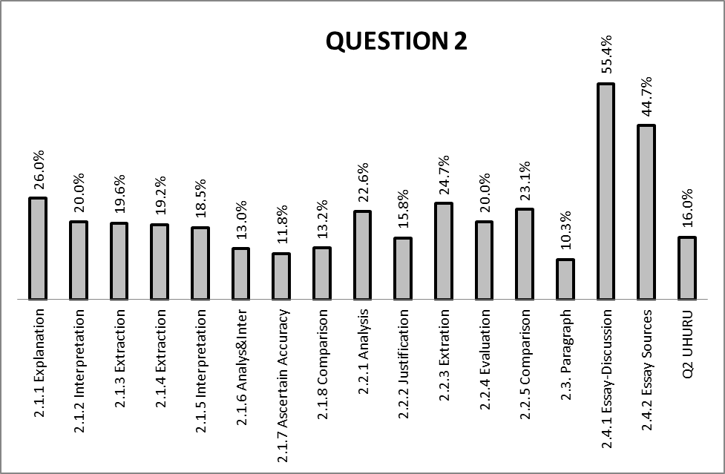

(b) Reasons why the question was poorly answered. Specific examples, common errors
and misconceptions are indicated.
(c) Suggestions for improvement in relation to teaching and learning.

Q. 2.1.1
- The question was not well answered.
- Some candidates failed to define the concept ujamaa.
- Those who attempted the definition only referred to ujamaa as family hood, which is not sufficient.
SUGGESTIONS:
- Candidates to be encouraged to always define concepts with reference to the topic.

Q.2.1.2
- The question was poorly answered.
- Majority of candidates could not understand what “land parasites” are.

SUGGESTIONS:
- Learners should be encouraged to link the information on the source with their own knowledge to be able to interpret the source.

Q.2.1.3
- The question is poorly answered.
- Majority of candidates could not understand what multiparty democracy system is.
SUGGESTIONS:
- Teachers should explain all relevant concepts in a topic studied to learners.

Q.2.1.4
- The question is poorly answered.
- Candidates did not read the written source with understanding.
- Candidates displayed lack of content.
SUGGESTIONS:
- Teachers should drill learners on content and the simple skill of extraction.

Q.2.1.5
- The question was poorly answered.
- Candidates could not associate the photograph (visual source) with ujamaa.

SUGGESTIONS:
- Learners should be encouraged to read the source in the context and content of the topic. This will make interpretation easier.

Q.2.1.6
- Candidates performed poorly in this question.
- Majority of candidates gave answers such as “happy”, “excited” and “satisfied”.
- Candidates who got Q.2.1.5 above wrong also got this one wrong as they linked.
SUGGESTIONS:
- Learners should be encouraged to read the source in the context and content of the topic. This will make interpretation and analysis easier.

Q.2.1.7
- This question was poorly answered.
- Majority of candidates could not support their choice (accurate/not accurate) with relevant evidence. In most cases, candidates could not relate the source to their own knowledge of content and the context in which the source was created.
SUGGESTIONS:
- Candidates should be encouraged to analyse the source with content (own knowledge) in mind. It is only with relevant context that the source can be analysed.

Q.2.1.8
- Majority of candidates did not show similarity between the two sources, they just wrote about the two sources without any comparison.

SUGGESTIONS:
- Educators must emphasise the skill of comparison to candidates. The use of words like “both sources”, “the two sources”, “they both”, “written and visual sources”, etc should be encouraged to show comparison two sources.

Q.2.2.1
- The question was poorly answered.
- Majority of candidates seem not to understand the word “contradiction” in the question.
SUGGESTIONS:
- Teachers should use previous question papers to train learners on such questions.

Q.2.2.2
- The question was poorly answered.
- Candidates could not support their choice (JUSTIFIED or NOT JUSTIFIED) with relevant facts.
- Some candidates just gave facts without stating their viewpoints.
- Candidates showed lack of content knowledge and the skill of justification of evidence.
SUGGESTIONS:
- Learners should be encouraged to always support their viewpoints with facts.

Q.2.2.3
- This was a simple level 1 question of extraction, but candidates performed poorly.
- The phrase “national scale” might have been a challenge to most learners.
- Lack of content knowledge by majority of candidates.
SUGGESTIONS:
- Teachers should drill learners on content and the simple skill of extraction.

Q.2.2.4
- This question on evaluation of Ujamaa in relation to viewpoint 2 was poorly answered.
- Majority of candidates showed lack of content as this question is clear and answers are in the source.
SUGGESTIONS:
- Teachers should drill learners on content and the simple skill of evaluation in reference
to the topic (ujamaa).

Q.2.2.5
- This question was poorly answered.
- Majority of candidates did not compare the two viewpoints, they just commented on the two without showing how they differ in their assessment of Ujamaa.
SUGGESTIONS:
- Educators must emphasise the skill of comparison to learners. The use of words likes “viewpoint 1 says…,” while viewpoint 2 says…”should be encouraged to show difference.

Q.2.3 PARAGRAPH
- Performance in this question was extremely poor
- The question was not clear. To some candidates, impact only meant something negative, hence they only referred to negative impact that Nyerere’s programme of Ujamaa had on ordinary Tanzanians.
- Only those learners with content knowledge were able to score good marks.
SUGGESTIONS:
- Knowledge of content should always be encouraged to assist candidates to attempt questions of this nature.
- Learners should be encouraged to refer to both negative and positive impact if the question is silent on that (if no direction on how the question is to be answered).

Q.2.4.1 Essay-Discussion
- Candidates performed well in this question.
- The question was very clear and straight forward.
- Some candidates might have performed poor in this question because of not understanding what “possibilities and constraints meant.
SUGGESTIONS:
- Teachers should use previous question papers to familiarise learners with common historical terms.

Q.2.4.2 Essay-Source Based
- Candidates performed fairly in this question.
- This was also a straightforward question.
- Some candidates could not use the information from the source as evidence to critically assess the statement given
- Some just gave facts without taking a stance (whether the statement is accurate or not).
SUGGESTIONS
- Learners should be encouraged to always take a stance and consistently support it when asked to do so.
- They also need to be taught how to use sources as evidence to support their arguments.

QUESTION 3

(a) General comment on the performance of learners in the specific question.

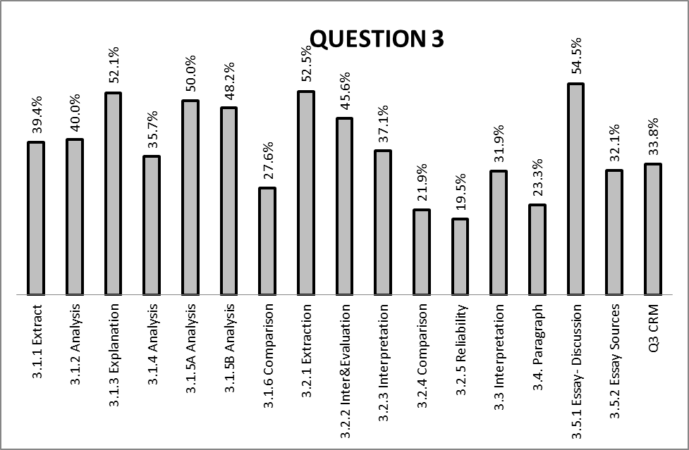

(b) Reasons why the question was poorly answered. Specific examples, common errors
and misconceptions are indicated.
(c) Suggestions for improvement in relation to teaching and learning.

Q.3.1.1
- The question was fairly answered.
- Majority of candidates provided only one answer as the source only gives one.
- Some candidates still lack the skill of extraction as the answers are on the source.
SUGGESTIONS
- Learners should be encouraged to fully read the sources before answering the questions.
- Teachers to encourage learners to always draw from their content knowledge when reading the sources.

Q.3.1.2
- Some candidates did not show similarity between the two sources, they just wrote about the two without showing any similarity.

SUGGESTIONS
- Teachers must emphasise the skill of comparison to candidates. The use of words like “both…”, “the two…”, “they both…” etc should be encouraged to show comparison, in this case similarity, of the reactions of both the cashier and the lieutenant-governor towards Ruby Doris.

Q.3.1.3
- This question was well answered.
- Some candidates could not define segregation in the context of USA Civil Society protest. They confuse it with “apartheid” in South Africa.
SUGGESTIONS
- Teachers should teach learners to always define concepts based on its context, for example, segregation in this question should be defined in the context of USA.

Q.3.1.5.A and Q.3.1.5.B
- The question was well attempted.
- Most candidates just interpreted the photograph without reading the context of the source, thereby missing some of the answers.
SUGGESTIONS
- Learners should be encouraged to read the source, starting with the caption. The caption in this source has answers for this question, which most candidates missed, and it also put the source in context.

Q.3.1.6
- Majority of candidates did not show similarity between the two sources, they just wrote about the two sources without any comparison.
SUGGESTIONS
- Educators must emphasise the skill of comparison to candidates. The use of words like “both sources”, “the two sources”, “they both”, “the written and visual sources…”, etc should be encouraged to show comparison.
Q.3.2.1
- The question was well answered.
- Candidates who could not correctly answer this question are those who lack content.
SUGGESTIONS
- Learners should be encouraged to fully read the sources before answering the questions.
- Teachers to encourage learners to always draw from their content knowledge when reading the sources.

Q.3.2.2
- The question was well answered by most candidates.
- Some candidates just copied from the source without showing the attitude of the FBI and the police.
SUGGESTIONS
- Learners should be encouraged to always identify key words in the question before answering. In this question, the key words are “comment on the attitude of…”

Q.3.2.3
- The question was fairly answered.
- Some candidates lacked the skill of interpretation to correctly answer the question.
SUGGESTIONS
- Teachers should encourage learners to study the source (photograph) having content in mind. This will help them to correctly interpret the source.

Q.3.2.4
- The question was poorly answered.
- Majority of candidates did not compare the information of the two to show how the visual source confirm what is being referred to in the written source regarding the Freedom Riders, they just commented on the two without showing how one confirm the information on the other.
SUGGESTIONS
- Educators must emphasise the skill of comparison to learners.
- Learners should be encouraged to use phrases like “the visual source confirm….as shown in the written source”, the visual source shows…as …in the written source”.

Q.3.2.5
- The question was poorly answered.
- Majority of candidates seemed not to understand the question on reliability. They just attempted to give answers without showing the reliability of the source.
SUGGESTIONS
- Teachers should prioritise the teaching of the skill of ascertaining reliability of sources as majority of candidates lost marks in this question.

Q.3.3
- The question was fairly attempted.
- Most candidates just interpreted the photograph without reading the context of the source, thereby missing some of the answers.
SUGGESTIONS
- Learners should be encouraged to read the source starting with the caption. The caption in this source has answers for this question, which most candidates missed, and it also put the source in context.

Q.3.4 PARAGRAPH
- Majority of candidates could not correctly interpret the sources to explain how the activities of the Civil Rights Movement were disrupted by the white conservative Americans.
- Candidates displayed lack of content.
SUGGESTIONS
- Mastering of content should always be encouraged to assist candidates to attempt questions of this nature.

Q.3.5.1 Essay-Discussion
- The question was well attempted.
- Some candidates only referred to only two forms of protests.
- Candidates who performed poorly in this question displayed lack of content knowledge as this question was straightforward.
SUGGESTIONS
- Everything in history, especially an essay question that requires discussion, high content knowledge is important. As a result, teachers and learners should focus on content.

Q.3.5.2 Essay-Source Based
- Not many candidates attempted this question.
- Those who attempted it performed fairly.
- Some candidates gave vague facts without answering the question; hence they could not get maximum marks.
- The leading statement; “fools that deserved to be beaten and killed” was not analysed by most candidates when answering the question.
- Some learners still copy directly from the sources without any attempt to address the question.
SUGGESTIONS
- Teachers to train learners on how to use sources as evidence to address the question, without directly copying from the sources.
- Learners must be encouraged to fully understand the statement on the question before answering the question.

QUESTION 4

(a) General comment on the performance of learners in the specific question.

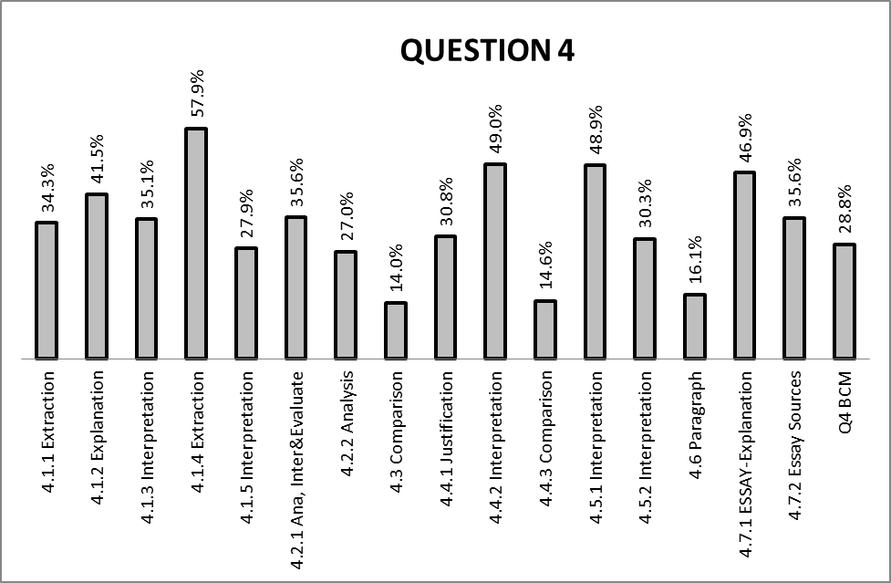

(b) Reasons why the question was poorly answered. Specific examples, common errors
and misconceptions are indicated.
(c) Suggestions for improvement in relation to teaching and learning.

Q.4.1.1
- Though this required simple extraction of information from the source (level 1), some candidates got it wrong. They gave “self confidence” as an answer. They did not read the source with understanding and this also showed lack of content knowledge (self confidence is not a philosophy).
SUGGESTIONS
- Learners should be encouraged to fully read the sources before answering the questions.
- Teachers to encourage learners to always draw from their prior knowledge when reading the sources, By doing so, they shall have recognised that the philosophy referred to in the source is Black Consciousness.

Q.4.1.2
- The question was fairly answered.
- Some candidates only gave one word without any explanation. For example, they gave words like self confidence, black pride, black pride, etc.
- Some confused Black Consciousness and Black Consciousness Movement.
SUGGESTIONS
- Teachers should teach learners how to explain historical concepts. Before teaching the topic on Biko and the BCM, the definition of Black Consciousness is a must.

Q.4.1.3
- Fairly attempted.
- Candidates who could not answer this question simply lack basic knowledge and content on the topic.
- Some candidates showed lack of interpretation skills as the answers are also in the source.
SUGGESTIONS
- Candidates must have basic content knowledge.
- Candidates need to read the source with understanding.

Q.4.1.4
- The question was well answered.
- Some candidates included NUSAS in their answer.
- Candidates who could not answer this question simply lack basic knowledge and extraction skills.
SUGGESTIONS
- Learners must have basic content knowledge.
- Candidates need to read the source with understanding as the answers are also in the source.

Q.4.1.5
- The question was fairly answered.
- Some candidates did not study source 4A with understanding as most of the answers are in the source.
SUGGESTIONS
- Learners should be encouraged to read sources with understanding before attempting to respond to questions.

Q.4.2.1
- This is a level 3 question which requires analysis, interpretation and evaluation of the source. Some candidates could not associate the word ‘skool’ (crossed) with school and the Soweto uprisings.
- Some candidates only gave 1 answer instead of 2 as required.
- The marking guide provided only one answer in different ways (rejection of Afrikaans).
SUGGESTIONS
- Candidates must interpret the source with the knowledge of content on the topic.
- Candidates to always check mark allocation per question to determine how many answers are required.

Q.4.2.2
- This question was poorly answered. Majority of candidates could not analyse the cartoon, especially the symbol of the torch/flame. Candidates who did well in this question are those who used their own knowledge, rather than the cartoon to answer the question.
SUGGESTIONS
- Learners need to be encouraged to put context into the source/cartoon when attempting questions on analysis. In this cartoon, the torch/flame must be understood in the context of the Soweto Uprising of June 1976.

Q.4.3
- This question was poorly answered.
- Majority of candidates only mentioned one source (source 4A) without comparing it to source 1B.
- Candidates had a challenge of interpreting the cartoon on source 1B to correctly compare it to source 1A.
SUGGESTIONS
- Educators must emphasise the skill of comparison to learners. The use of words like “both sources …”, “the two sources”, “they both highlight…”, “source 4A and 4B refers...” etc should be encouraged to show comparison.

Q.4.4.1
- The question was fairly answered.
- Some candidates used emotions rather than facts and the source to answer the question.
- Some candidates did not state justified or not justified in their responses, they just gave facts.
SUGGESTIONS
- Learners must be encouraged not to attach emotions to the questions, but to be guided by the question and the source, and respond as such.

- Candidates must always make a choice to direct the markers.

Q.4.4.2
- The question was fairly answered.
- Some candidates were tricked by the word circumstances, hence they could not correctly respond to the question.
SUGGESTIONS
- Teachers must expose learners to such questions during informal tasks and SBA tasks at schools.

Q.4.4.3
- The question was poorly answered. Majority of candidates only referred to one testimony to show the usefulness of the information when researching the history of the Soweto Uprising. Candidates were expected to refer to both testimonies, as a result, most ended up scoring 2 marks instead of 4.
SUGGESTIONS
- Learners should be taught and encouraged to always read the question and also look at the mark allocation.

Q.4.5.1
- The question was well answered.
- Candidates who could not answer this question are those who lack content on the Soweto Uprising of 1976.
SUGGESTIONS
- Mastering of content should always be encouraged to assist candidates to attempt questions of this nature.

Q.4.5.2
- The question was fairly attempted.
- Some candidates did not understand the question. They were not aware that the choice is given; they needed to just show how accurate this statement is.
- Some just copied from the source without any attempt to answer the question.
SUGGESTIONS
- Learners should be drilled on questions that require interpretation of sources.

Q.4.6 (Paragraph)
- Candidates could not interpret the question. Majority of candidates concentrated on the influence of BCM rather than on the various measures that the apartheid government put in place to limit the influence of the BCM.

SUGGESTIONS
- Learners should be encouraged to read the question before attempting to answer.

Q.4.7.1 Essay-Explanation
- The question was well answered.
- Some candidates gave relevant responses without answering the question; hence they could not get maximum marks.
- Some candidates focussed more on the Soweto Uprising of 1976 rather than the influence the Black Consciousness had on the uprising.
SUGGESTIONS
- Learners must be encouraged to always use facts to address the question asked, in this case, how the philosophy of Black Consciousness influenced the Soweto Uprising.

Q.4.7.2 Essay-Source Based
- Not many candidates attempted this question.
- Those who attempted it performed fairly.
- Some candidates gave vague facts without answering the question; hence they could not get maximum marks.
- The leading statement; “a new generation has grown up and these younger men and women are impatient, radical, militant, brave and proud” was not analysed by most candidates when answering the question.
- Some learners still copy directly from the sources without any attempt to address the question.
SUGGESTIONS
- Teachers to train learners on how to use sources as evidence to address the question, without directly copying from the sources.
- Learners must be encouraged to fully understand the statement on the question before answering the question.

(d) Other specific observations relating to responses of learners.

- Majority of candidates displayed lack of content in their responses, especially in question 1 and 2.
- Majority of candidates’ loose marks by not sticking to the number of answers required per question. For example, if a question requires 2 answers, they give only 1 answer, thereby loosing half the marks of a particular question.
- Majority of candidates performed poorly on questions on cartoons.
- Some candidates are performing well in extended writing than in source based questions. There are candidates who scored 30 in extended writing, but scored very low in source based questions.
- Candidates are struggling with paragraph and the second extended writing. Majority copy sources without any attempt to answer the question.

(e) Any other comments useful to teachers, subject advisors, teacher development, etc.
- Subject advisors should organize workshops for teachers focusing on content, especially question 1(Cuba) and question 2 (Uhuru). Methodology should also be part of the workshop.
- Teachers should focus on training learners to use sources as evidence to write a paragraph and the second extended writing(source based).
- Teachers should show learners how the number of answers and mark allocation are interpreted. For example, a difference between 1x3 and 3x1.
- A workshop on the interpretation and analysis of cartoons for teachers should be prioritized as a matter of urgency by the province.
- Based o candidates responses, it is highly recommended that teachers focus more on definition of concepts in all the topics. For example, Cod War, Quarantine, Ujamaa, Black Consciousness, etc.

.
SECTION 3

(a) GRAPH OF PROVINCIAL PERFORMANCE IN THE PAPER (summary per question)

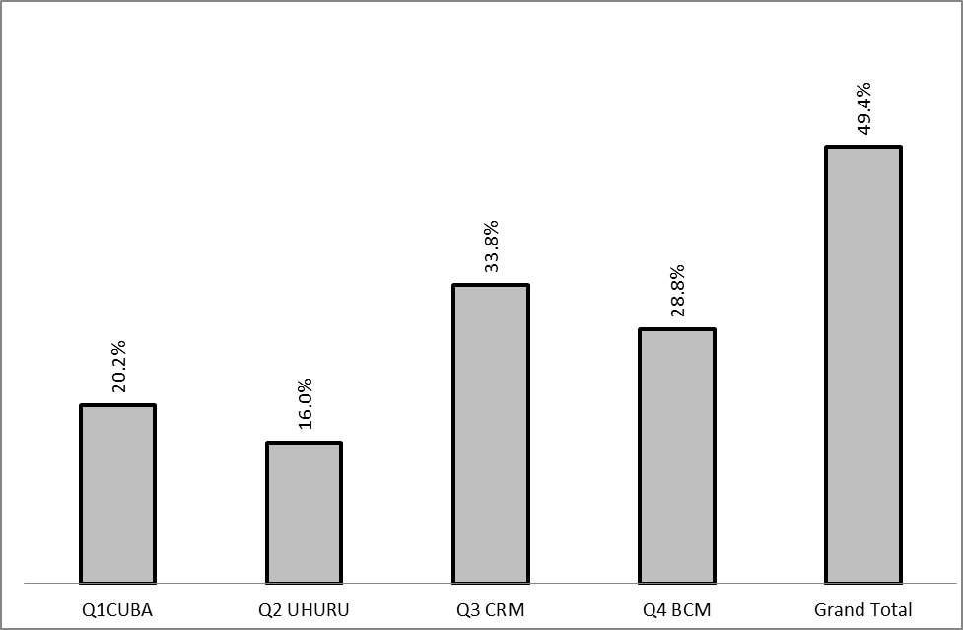

GENERAL COMMENTS

- Based on the graph above, candidates did not perform well on question 1 (Cold War-Cuba) and question 2 (Uhuru-Tanzania).
- These questions were not attempted by many candidates. The reason might be because they are both Case Studies and there is no sufficient material to teach learners.
- Question 3 (Civil Rights Movement) and Question 4 (Biko and the BCM) were popular questions and were fairly answered.
- NB: It is suggested that Subject Advisors conduct content workshops on topics for question 1 and 2 ((Cold War-Cuba and (Uhuru-Tanzania).

(b) GRAPHS TO COMPARE DISTRICTS' PERFORMANCES PER QUESTION

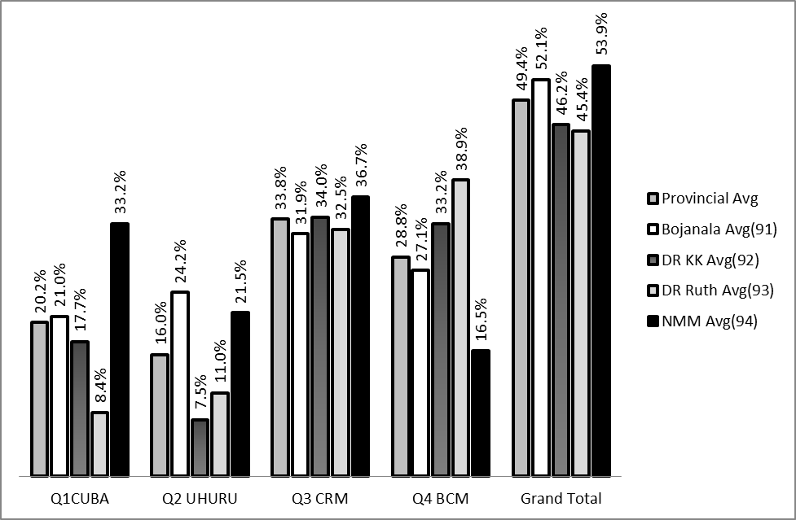

COMMENT ON PERFORMANCE OF DISTRICTS

Q.1 CUBA
- Performance in this question is not satisfactory.
- Ngaka Modiri Molema performed at 33, 2%, 13% more than the Provincial average (20, 2%).
- Ngaka Modiri Molema and Bojanala (21, 0%) performed above the provincial average.
- Dr Kenneth Kaund (17, 7%) and Dr Ruth Segomotsi Mompati (8, 4%) performed below the provincial average.

Teacher training is needed as a matter of urgency fir this question, especially in Dr Ruth Segomotsi Mompati and Dr Kenneth Kaunda.

Q.2 UHURU
- Performance in this question is also not satisfactory.
- Bojanala performed at 24, 2%, 8. 2% more than the Provincial average (16, 0%).
- Bojanala and Ngaka Modiri Molema (21, 5%) performed above the provincial average.
- Dr Kenneth Kaunda (7, 5%) and Dr Ruth Segomotsi Mompati (11, 0%) performed below the provincial average.

Teacher training is needed as a matter of urgency fir this question, especially in Dr Ruth Segomotsi Mompati and Dr Kenneth Kaunda.

Q.3 CRM
- Performance was fair.
- All districts performed above the provincial average.
- Their performance in order of best performance: Ngaka Modiri Molema (36, 7), Dr Kenneth Kaunda (34, 0%), Dr Ruth Segomotsi Mompati (32, 5%) and Bojanala (31, 9%)

Q.4 BCM
- Performance in this question is satisfactory.
- Dr Ruth Segomotsi Mompati performed at 38, 9%, 10, 1% more than the Provincial average (28, 8%).
- Dr Ruth Segomotsi Mompati and Dr Kenneth Kaunda (33, 2%) performed above the provincial average.
- Bojanala (27, 1%) and Ngaka Modiri Molema (16, 5%) performed below the provincial average.

(c) GRAPH TO COMPARE OVERALL PERFORMANCE PER DISTRICT

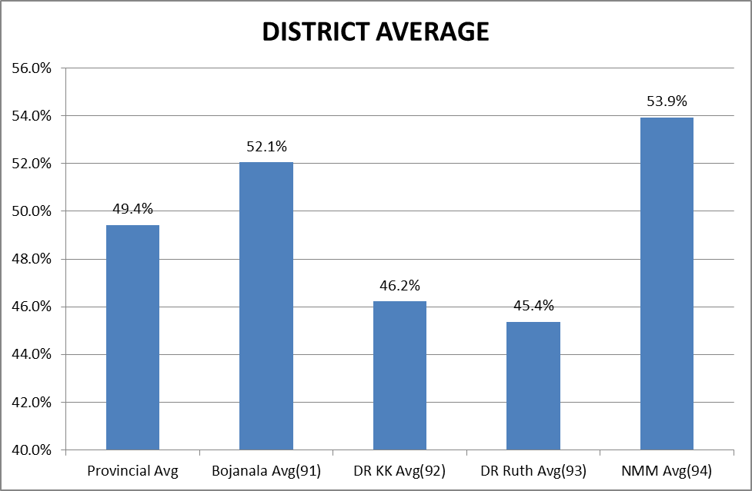
COMMENTS ON PERFORMANCE OF DISTRICTS

- Ngaka Modiri Molema performed the best in History Paper 1 in the province, at 53, 9%, followed by Bojanala (52, 1), Dr Kenneth Kaunda (46, 2) and Dr Ruth Segomotsi Mompati (45, 4).

(d) DISTRIBUTION OF QUESTIONS IN TERMS OF COGNITIVE LEVELS (TABLE)

QUESTIONS | LEVELS | MARKS PER QUESTION |  | TOTAL
QUESTION 1 | L1 | Q.1.1.1 | 2 | 6
QUESTION 1 | L1 | Q.1.1.3 A | 2 | 6
QUESTION 1 | L1 | Q.1.1.3 B | 2 | 6
 | L2 | Q.1.1.2 | 2 | 16
 | L2 | Q.1.1.5 | 2 | 16
 | L2 | Q.1.2.1 | 2 | 16
 | L2 | Q.1.2.3 | 4 | 16
 | L2 | Q.1.3.2 | 2 | 16
 | L2 | Q.1.3.3 | 4 | 16
 | L3 | Q.1.1.3 | 3 | 23
 | L3 | Q.1.1.4 | 4 | 23
 | L3 | Q.1.2.2 | 4 | 23
 | L3 | Q.1.3.4 | 4 | 23
 | L3 | Q.1.4 | 8 | 23
TOTAL |  |  |  | 45
QUESTION 2 | L1 | Q.2.1.1 | 2 | 6
QUESTION 2 | L1 | Q.2.1.3 | 1 | 6
QUESTION 2 | L1 | Q.2.1.4 | 1 | 6
QUESTION 2 | L1 | Q.2.2.3 | 2 | 6
 | L2 | Q.2.1.2 | 2 | 15
 | L2 | Q.2.1.5 | 2 | 15
 | L2 | Q.2.1.6 | 4 | 15
 | L2 | Q.2.2.1 | 3 | 15
 | L2 | Q.2.2.4 | 4 | 15
 | L3 | Q.2.1.7 | 4 | 24
 | L3 | Q.2.2.1 | 4 | 24
 | L3 | Q.2.2.2 | 4 | 24
 | L3 | Q.2.2.5 | 4 | 24
 | L3 | Q.2.3 | 8 | 24
TOTAL |  |  |  | 45

QUESTION 3 | L1 | Q.3.1.1 | 2 | 6
QUESTION 3 | L1 | Q.3.1.3 | 2 | 6
QUESTION 3 | L1 | Q.3.2.1 | 2 | 6
 | L2 | Q.3.1.2 | 2 | 18
 | L2 | Q.3.1.4 | 4 | 18
 | L2 | Q.3.1.5 A | 2 | 18
 | L2 | Q.3.1.5 B | 2 | 18
 | L2 | Q.3.2.4 | 4 | 18
 | L2 | Q.3.3 | 4 | 18
 | L3 | Q.3.1.6 | 4 | 21
 | L3 | Q.3.2.2 | 3 | 21
 | L3 | Q.3.2.3 | 2 | 21
 | L3 | Q.3.2.5 | 4 | 21
 | L3 | Q.3.4 | 8 | 21
 |  |  |  | 45
QUESTION 4 | L1 | Q.4.1.1 | 1 | 5
QUESTION 4 | L1 | Q.4.1.2 | 2 | 5
QUESTION 4 | L1 | Q.4.1.4 | 2 | 5
 | L2 | Q.4.1.3 | 2 | 16
 | L2 | Q.4.1.5 | 4 | 16
 | L2 | Q.4.2.2 | 4 | 16
 | L2 | Q.4.4.2 | 2 | 16
 | L2 | Q.4.5.1 | 2 | 16
 | L2 | Q.4.5.2 | 2 | 16
 | L3 | Q.4.2.1 | 4 | 24
 | L3 | Q.4.2.3 | 4 | 24
 | L3 | Q.4.4.1 | 4 | 24
 | L3 | Q.4.4.3 | 4 | 24
 | L3 | Q.4.6 | 8 | 24
TOTAL |  |  |  | 45

- This paper had choice questions. Candidates were to answer ANY TWO questions from the four.
- All four questions carry 75 marks each (45 marks source based questions and 30 for extended writing).
- Cognitive levels are almost equally covered in all the choice questions as per SAG (L1=10%, L2=40% and L3=50%) .
- All candidates are given equal opportunities irrespective of their choice if questions.

(e) COVERAGE OF LEARNING OUTCOMES AND ASSESSMENT STANDARDS
(TABLE)

Los | LO1 | LO2 | LO3
 | AS | AS | AS
Question 1 | 3&4 | 1,2 3 | 1,2,3,4
Question 2 | 3&4 | 1,2 3 | 1,2,3,4
Question 3 | 3&4 | 1,2 3 | 1,2,3,4
Question 4 | 3&4 | 1,2 3 | 1,2,3,4

- The paper covers the Learning Outcomes and Assessment Standards as prescribed in the NCS.
- Learning Outcomes and Assessment Standards are equally covered in all the four choice questions.
- Historical Inquiry (LO1 AS 3&4), Historical concepts LO2 AS1, 2, 3), knowledge construction and communication were equally assessed in all the questions (LO3 ASS 1, 2, 3, 4).
NB: Los and Ass in History overlaps, hence one question can assess more than one LO and AS at once, E.G. Q.1.1.2 LO1 (AS3), LO2 (AS2), Q.1.1.4 LO1 (AS3&4), Q.3.2.4 LO1 (AS4), LO2 (AS3).

It is therefore not possible to allocate marks according to Los and Ass, but it is done according to levels of questions. (SEE TABLE ON DISTRIBUTION OF QUESTIONS IN TERMS OF COGNITIVE LEVELS)

____________________________________ _______________________________________
NAME DESIGNATION (Subject Analyst /Moderator or Chief Marker)

_________________________________________ __________________________
SIGNATURE DATE

