

CHIEF MARKER'S / MODERATOR'S/ SUBJECT ANALYST’S REPORT FOR PUBLISHING

SUBJECT: ENGLISH HOME LANGUAGE PAPER: ONE

INTRODUCTORY COMMENTS (How the paper was received; Papers too long/short/
balance)

- It was evident when candidates were writing this paper that they battled to finish within the stipulated time of 2hrs.
- This delay has nothing to do with time allocation, but the impact was on the fact that there were too many complex texts, high-levelled questions, as well as the unfamiliarity of the context which needed to be interpreted.
- Too many open-ended questions with high mark allocation resulted in candidates spending a greater portion of their time on comprehension.
- Question 2 was also too metaphorical, thus impacted on time management
- In conclusion, this paper was not supposed to have been the opening paper on the examination timetable – it left the majority of candidates with mixed feelings of uncertainty, frustration, disillusionment and despair

SECTION 1

(General overview of Candidates Performance in the question paper as a whole)

- In general Question 1 and 2 texts were too difficult thus reducing the number of those candidates who are possible A’s (40 marks), however language questions (Q3 -4) were fair questions, which gave weaker candidates an opportunity to attempt to answer, although they did not manage to finish answering the paper.
- Passages in the paper were difficult for the majority of candidates, given the fact that most of them are average candidates. Most questions are of high order level ranging between levels 4-5.
- The selected passages both comprehension and summary were difficult and not accommodative for all candidates.
- Analysis of cognitive levels revealed that in the comprehension test, not a single question was of low order nature, and this was a disadvantage to the weaker candidates. The Examination Guidelines indicate that 40% of the questions should be of low order level.
- The Examination Guidelines also stipulate that the summary’s cognitive level should be 2. The summary question in this case contains ambiguity as it was difficult for candidates to distinguish and explain what “face” really means. The passage is definitely not a level 2, but a level 4 or 5.

SECTION 2:

(Comments on candidates’ performance in the five individual sub questions (a) – (e) will be provided below. Comments will be provided for each question on a separate sheet).

SECTION A:QUESTION 1

(a) General comments on the performance of candidates in the specific question.

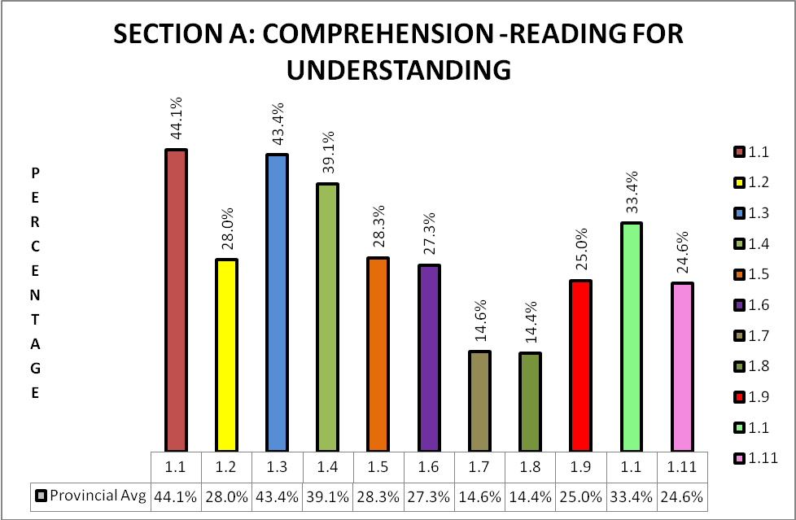

- The comprehension was challenging, both the text and the level of questioning were beyond most candidates’ understanding.
- The complexity of the text, the level of questioning, unfamiliarity of the topic as well as the open-ended questions – with high mark allocations - resulted in candidates spending too much time on the comprehension.
- The text was both intricate and at times repetitive.

(b) Reasons why the question was poorly answered. Specific examples, common errors
and misconceptions are indicated.
(c) Suggestions for improvement in relation to teaching and learning.

Q. 1.1
- Candidates answered question fairly well.
- Most candidates achieved one mark of the two marks allocated.
- Candidates did not define the term “dynamic forum”, but could identify the term in context to democracy.
- Candidates could not understand the concept of “dynamic forum”.
- Candidates could not tell whether to focus on artists, issues of democracy or the theatres.
- This was not a level 1-2 question, as one would expect the introducing question to be.

SUGGESTIONS:
- Questions should clearly outline the requirements.
- Candidates’ vocabulary is limited and this needs to be emphasised in the classroom, by the increase of language teaching at school.

Q. 1.2
- Many candidates did not get a perfect score. The 3rd mark was illusive.
- Most candidates lifted from the passage and were awarded marks.
- Candidates battled to find or deduce explanation.

SUGGESTIONS:
- Candidates need to be taught the skill of interpretation.

Q.1.3
- It was averagely answered.
- Candidates struggled with figurative interpretation, but they managed to achieve a mark.
- Many candidates misinterpreted the question.
- Many candidates did not understand the function of the ellipsis in the question.
- The word “tapestry” is not a concept many candidates understood or recognised.
- The expression “putting your differences aside” also skewed their answers and resulted in marks lost.

SUGGESTIONS
- More emphasis needs to be placed on teaching figurative language and its effectiveness.
- The phrase “putting our differences aside” was used indifferently.
- Candidates may benefit from exercises on clichés.

Q.1.4
- It was fairly answered, however not many candidates understood the connection of “sacred” meaning holy.
- Many candidates misinterpreted “sacred” for “scared”/ “scary”.
- A few candidates quoted a specific line from the passage “ Our theatres are ...struggle for liberation”
- The question was vague, candidates were uncertain on which direction they should steer their argument and the staple answer “...for democracy...” was born.
- This began to infiltrate and dominate most responses.

SUGGESTIONS
- Vocabulary skills need to be taught more extensively in the lower grades, so that candidates will be able to grasp concepts /definitions.
- Reading of diverse topics should be encouraged.
- ‘Words often confused’ is another exercise that may alleviate the problem.

Q.1.5
- It was poorly to averagely answered.
- Many candidates interpreted the literal meaning of the definition of “a mother”, they did not really relate the question to the play.
- E.g. “Mothers of the two nations – America and Africa.”
- “Only a mother will understand another mother’s pain”
- The process of being pregnant and giving birth was mentioned.
- Candidates misunderstood the concept of “powerhouses”.
- Many candidates just quoted the idea of “dry eye”.
- A few candidates interpreted the murder of the American student as a xenophobic attack or they linked it to the killing of Hector Peterson.

SUGGESTIONS
- More focus needs to be put on inference; candidates need to be taught how to answer figurative questions.

Q.1.6
- It was poorly to averagely answered
- Candidates did not read the question properly.
- Candidates were able to identify the relevant words/phrases, but the explanation of what is suggested by the audience was basic and missing.
- The question focussed on what is suggested about South African audiences, but many candidates focused on the artists instead,
- Many candidates did not understand the term “diction” or misunderstood it to refer to register.
- “Colour blind” was misinterpreted. More literal meaning was given. E.g. “that the audience was physically blind”/ “that all blind people were welcome to watch show”.
- A few candidates misinterpreted “prejudice” for “produced”.
- Many candidates lifted lines 56 -59 from the passage.

SUGGESTIONS
- Place more emphasis on language teaching.
- Expose candidates to read more to improve their comprehending skills.
- Teach candidates to analyse the question – look for (and understand) key concepts such as ‘diction’ and ‘register'
- Teach candidates to argue, evaluate, discuss, etc.

Q.1.7
- This question was poorly answered and some candidates did not attempt the question.
- Most candidates explained the meaning of subjective, they did not answer on its appropriateness.
- This question could have been split into two questions/ on two levels, this would have enabled candidates at least to score a mark.
- They were able to recognise the subjectivity.
- This was a broad based answer.
- The instruction “justify” your answer, required more than just comprehension.

SUGGESTIONS
- Candidates need to be taught basic keywords like: explain, argue, judge, compare, etc.
- Keep in mind the cognitive levels when asking questions in class in order to promote thinking and discussion (when setting tasks or worksheets).

Q1.8
- This question was poorly answered and many candidates did not attempt question.
- Candidates did not interpret the question well.
- The LO in this area stresses creative behaviour with major emphasis on the formulation of new structures, however candidates lacked skill to link the different actors and their contributions.
- Instead many candidates generalised.

SUGGESTIONS
- Emphasis must be put on questions that need a lot of explanation.
- Marks allocated must be taken into consideration when answering questions.

Q.1.9
- Candidates answered this question poorly.
- Most candidates achieved one mark out of the three marks allocated.
- Most candidates simply restated “R150m Soweto Theatre packs entertainment punch”.
- Some candidates just explained headline without looking at its figurative interpretation.

SUGGESTIONS
- Candidates cannot answer the questions, because they lack interpretation and understanding.
- The systematic unpacking of the question is a skill that can be honed.

Q.1.10
- This was a fairly easy question, but candidates did not read the question/ or interpret it accurately.
- They did not answer whether the “interior” or “exterior” is more effective, thus they answered on in general on the use of visual images.
- Many candidates answer were vague, they did not really answer question in depth.

SUGGESTIONS
- Candidates need to be taught how to interpret and analyse, and how to explain the effectiveness of language structures.

Q.1.11
- It was poor to averagely answered.
- Most candidates confused the term “contrast” with “compliment”
- The term “Giant Toy” became synonymous with the idea of play.
- Many candidates did not read question properly, therefore they did not manage to contrast “Giant Toy” to Text A.
- Some candidates’ answers were irrelevant/ incorrectly motivated.
- Some candidates focused on the two separate concepts i.e. ‘giant’ and ‘toy’.

SUGGESTIONS
- Candidates take too long to get to the point. They should be taught how to give brief answers too.
- Candidates do not understand the question, instead of giving reasons they give the explanation of some of the work and the explanation is not based on the text given.

(d) Other specific observations relating to responses of candidates.
- Very few candidates have been exposed to theatre and could not really relate to the text.
- Questions covered more high level order questioning.
- Candidates vocabulary is insufficient, thus rendering ineffective expressing of their thoughts.
- Most candidates just lifted from the passage.
- The greatest issue was the accumulative effect of the level 4-5 questions that has disregarded the suggested 20% as prescribed.
- The weighting of the questions was to the benefit of a few candidates, who could discuss, evaluate, compare and critique effortlessly.
- Candidates who lean towards concise and conceptual recognition suffered.
- Candidates cannot answer the questions, because they lack interpretation and understanding.
- Candidates do not understand the question, instead of giving reasons they give the explanation of some of the work and the explanation is not based on the text given.
- Candidates don’t read carefully.
- Candidates give vague answers that do not have sufficient depth for full marks.
- Candidates take too long to get to the point. They should be taught how to give brief answers too.
- Within the text “grapple”; “auditorium”; “endow”; “unbridled”; “raconteur” …the list goes on. Even though Para. 4 had no question set on it candidates would have grappled with one unfamiliar concept after another until the resonating panic blinded them and it was compounded the ingenious questions which dumfounded them.

(e) Any other comments useful to teachers, subject advisors, teacher development, etc.

- Teachers must give learners tasks that are challenging.
- Different cognitive level questions must be asked, based on the Barrett’s taxonomy, as prescribed by the Exam Guidelines of 2009.
- Keep in mind the cognitive levels when asking questions in class in order to promote thinking and discussion (when setting tasks or worksheets).
- Marks allocated must be taken into consideration when answering questions.
- Emphasis must be put on questions that need a lot of explanation.
- Expose learners to a large variety of texts on a regular basis.
- Give homework and promote self assessment, as well as peer assessment.
- Candidates’ responses show they do not understand questions or interpret questions – teach them the common task words so that they know what is expected from them.
- HODs must be competent enough to support and assist language educators.
- Workshops / Forums – internally in each school
- Subject advisors must be more visible and available, not only before moderations, especially regarding new schools and trapped schools.

QUESTION 2

(a) General comment on the performance of candidates in the specific question.

SECTION B: SUMMARY WRITING

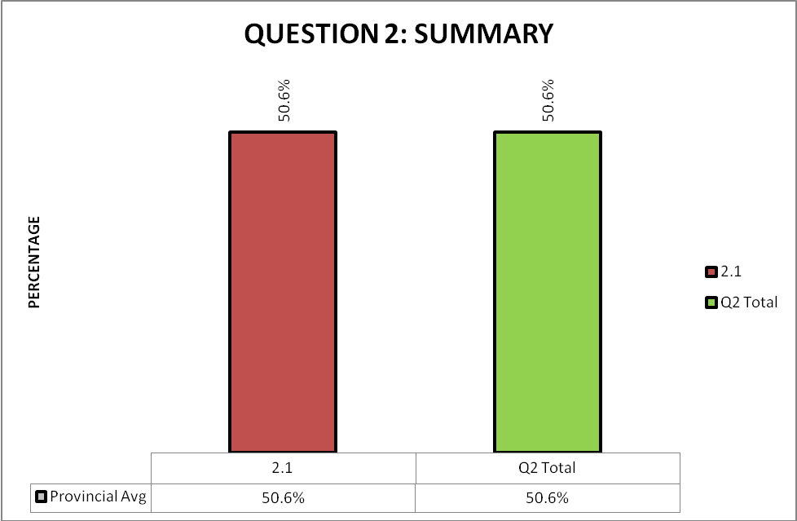

QUESTION 2
- Candidates performed averagely in this section.
- According to the exam guidelines the summary question should have been a level 2 type question, but in this question inference and interpretation were needed and this made the summary a level 3 question and not a level 2 question.
- Candidates had to interpret the passage first before they could find “the reasons why ‘Face’ is important” and this heightened the level of difficulty.
- Although a concession was given for marking the summary, candidates did not perform as expected and this could be because of the inference that was needed for candidates to locate the main ideas.
- They had difficulty in retrieving seven main points.
- Most candidates looked at the literal meaning of the word “Face”

(b) Reasons why the question was poorly answered. Specific examples, common errors
and misconceptions are indicated.
(c) Suggestions for improvement in relation to teaching and learning.

Q. 2
- It was averagely answered.
- The text was a bit too sophisticated – vocabulary too advanced and a lot of difficult figurative language used.
- They experienced difficulty to identify the main ideas because candidates the term “Face” literally.
- It covers the prescribed syllabus, however the sophistication of the language from level 2 into level 3.
- It was a fair question but the passage was difficult.
SUGGESTIONS
- LOs and Ass standards were covered but more emphasises needs to be put on summary skills in the classroom.
- Expose candidates to a large variety of texts on a regular basis.

(d) Other specific observations relating to responses of candidates.

- The text “face” was a metaphorical text, which most candidates did not get.
- Lifting benefitted weaker candidates so much, that they have achieved better in comparison to stronger candidates – who tried to synthesize the text and then they would omit a facet of the concept and actually not achieve.
- Candidates were not exposed to figurative texts and this disadvantaged many candidates.
- Candidates lack interpretation skills.
- Many candidates did not read the question.

(e) Any other comments useful to teachers, subject advisors, teacher development, etc.

- Expose candidates to a large variety of texts on a regular basis.
- Candidates must be taught how to skim and scan.
- Regular exposure to summary writing
- Expose them to figurative language in summary passage.
- Teach interpretation skills of texts.
- More informal assessment should be done and corrective measures taken.

SECTION C – LANGUAGE IN CONTEXT

QUESTION 3 – ANALYSING ADVERTISEMENTS

(a) General comment on the performance of candidates in the specific question.

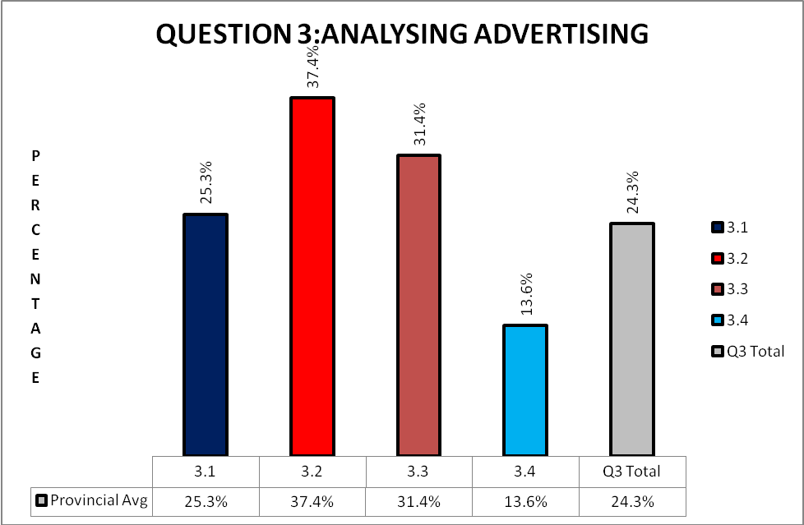

- Candidates’ performance in this section was poor to average.
- 2 out of 10 for this section was level 3, which means that 20% of this section fell in the bracket of level 3 and 80% were level 4 questions.
- There were no level 1-2 questions that were asked. This made it difficult for the underachievers to get marks.
- Candidates’ exposure to language and style in advertisements was limited.

(b). Reasons why the question was poorly answered. Specific examples, common errors
and misconceptions are indicated.
(c). Suggestions for improvement in relation to teaching and learning.

(b)
Q.3.1
- Candidates did not perform well in this question.
- The question itself is rather vague, because it does not state clearly which visual image needs to support the idea of the “upgrading of life”
- Most candidates did not actually look at the visuals but at the written text.
- Candidates looked at “tailgate” as an upgrade.
- Candidates could not identify with buildings as an upgrade, because they are not brought up in such an environment and don’t relate to the buildings as been an upgrade.

SUGGESTIONS
- Educators should teach more visual literacy.

Q.3.2
- Candidates performed fairly in this question.
- They did not understand the question that they need to make a reference to both “Mother Earth” and “Mother Nature”.
- Candidates had to link the two terms to the context of the advertisement, but many candidates were not able to do this effectively.
- Responses mostly focused on “low emissions”.

SUGGESTIONS
- Expose candidates to as many different texts, including visual literacy, as possible.
- Place more emphasis on language teaching.
Q.3.3
- It was one of the questions that was fairly answered.
- However many candidates did not give relevant motivations.
- Very few candidates scored full marks for this question, they were unable to link the visual of the car and link it to the environment.
- Many candidates just lifted the features of the car.

SUGGESTIONS
- Candidates’ responses show they do not understand questions or interpret questions – teach them the common task words so that they know what is expected from them.

Q.3.4
- This question was poorly answered.
- This question required candidates to have insight on how to link language and style to the intention of the advertiser.
- This question requires an answer with an insightful approach and many candidates were not able to justify the suitability of the language and style clearly.
- Many candidates were unable to identify that it was meant to appeal to young families instead they wrote “it was meant to protect the environment”

SUGGESTIONS
- Expose candidates to techniques used in cartoons.

(d) Other specific observations relating to responses of candidates.

- Many candidates found difficulty in linking the illustrations of the products been advertised.
- Candidates cannot answer the questions, because they lack interpretation and understanding.
- Candidates do not understand the question, instead of giving reasons they give the explanation.
- Many candidates did not actually look at both the visual and the written text, instead they focused only on the written text.

(e) Any other comments useful to teachers, subject advisors, teacher development, etc.

- Papers must be set using relevant, current texts.
- Educators must teach learners visual literacy. Let learners exercise examples from this section of the syllabus repeatedly.
- Expose learners to as many different texts, including visual literacy, as much as possible.
- Different cognitive level questions must be asked, based on the Barret’s taxonomy, as prescribed by the Exam Guidelines of 2009.
- Encourage learners to bring their favourite advert and analyse them in class
- Teach learners how to substantiate answers.

QUESTION 4

(a) General comment on the performance of candidates in the specific question.

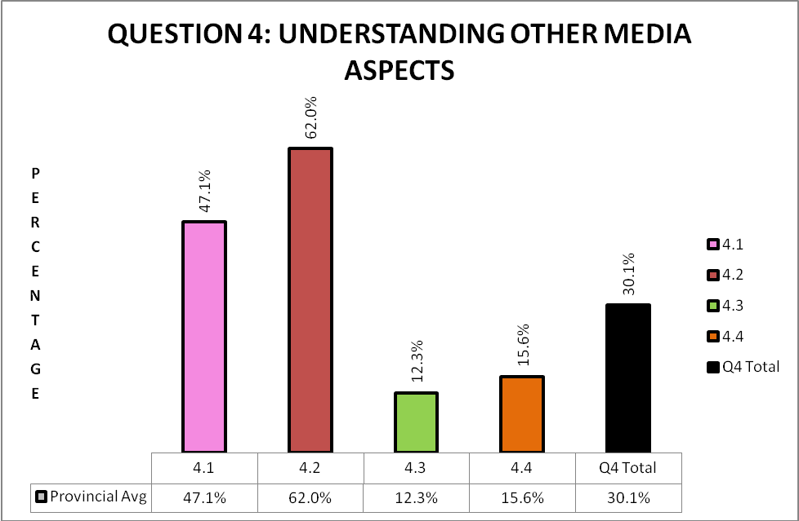
- Candidates’ performed averagely in this question.
- 40% percent of the question was at cognitive level 2, 30% was at level 3, and 30% was at level 4.
- Candidates misinterpreted the questions, because they could not link illustration with text.
- Texts were clear and many candidates’ could not identify the humour in the cartoon strip.

(b) Reasons why the question was poorly answered. Specific examples, common errors and misconceptions are indicated.
(c) Suggestions for improvement in relation to teaching and learning.

(b)
Q.4.1
- It was fairly answered.
- Majority of candidates failed to answer the entire question, they either focused on just the language or just the illustration.
- Many candidates did not link the illustration to their friendship.

SUGGESTIONS
- Teach candidates to focus on keywords in questions, explain, language, illustration.
- It should be taught that visual literacy is a combination of text and visuals.

Q.4.2
- Fairly easy. Most candidates responded well

SUGGESTION
- Teacher candidates to link frames in cartoons.
- Teach candidates not to contradict themselves when answering questions.

Q.4.3
- Candidates performed poorly in this question.
- Candidates could not identify the humour in the cartoon.(irony)
- They could not relate to the idea that a tiger and a human are friends.
- They assumed that Calvin was scared of being eaten.
- Many candidates assumed that Calvin had just woken up from a bad dream.

SUGGESTION
- Teach candidates how to identify humour in cartoons.
- Use a variety of visual texts to train candidates in identifying humour.

Q.4.4
- This question was poorly answered.
- Candidates failed to comment on the effectiveness of the techniques used by the cartoonists.
- They did not refer to specific frames in the question.
- They summarized all the frames together.
- Many candidates did not comment on techniques because they had no clue on the techniques that are used in cartoon strips.
- Candidates did not really see the technique used in this advertisement. This was another question which was extremely open ended, and most candidates usually only got no marks for this question, because they actually could not comment on the technique used.

SUGGESTIONS
- Marks allocated must be taken into consideration when answering questions
- Techniques used in cartoons need to be taught.
(d) Other specific observations relating to responses of candidates.

- Many candidates did not refer to the relevant frames that were stipulated in question 4.4.
- Most candidates have no clue what techniques are used by cartoonists.
- Many candidates misunderstood the cartoon, they thought that Calvin was going to be eaten by the tiger.
- They did not relate to the theory of a tiger and a ‘human being’ being friends.
- Candidates give vague answers that do not have enough depth for full marks.
(e) Any other comments useful to teachers, subject advisors, teacher development, etc.

- Educators must teach learners visual literacy. Let learners exercise examples from this section of the syllabus repeatedly
- Educators must give candidates feedback after each and every task. Remedial work is non-negotiable
- Papers must be set using relevant, current texts Papers must be set using relevant, current texts
- Don’t use old exam papers. Expose candidates to as many different texts, including visual literacy, as possible.
- Teachers must give candidates tasks that are challenging.

QUESTION 5

(a) General comment on the performance of candidates in the specific question.

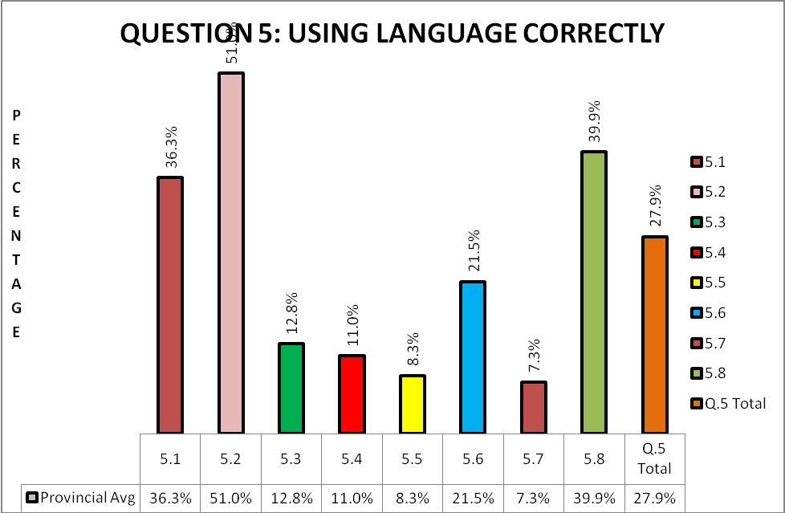
- Candidates’ performed poorly in this question.
- This could be the result that educators do not put enough emphasis on teaching and revising language skills.
- This was a fair question, as 60% of questions were at level 3 and 40% of questions were at level 2.
- Candidates did not perform as expected.

(b) Reasons why the question was poorly answered. Specific examples, common errors
and misconceptions are indicated.
(c) Suggestions for improvement in relation to teaching and learning.

Q.5.1
- They performed averagely in this question
- Candidates did not understand what formal language means.

SUGGESTIONS
- Educator should teach them the difference between formal and informal language.
- This should include slang, colloquialism, jargons, etc.

Q.5.2
- It was well answered.
- Many options to this answer were provided in the memorandum.

SUGGESTIONS
- Educators need to give candidates extensive exercises in both reported and direct speech.

Q.5.3
- It was also poorly answered.
- Many candidates were able to identify the error and thus obtained half a mark.

SUGGESTIONS
- Candidates need to be trained on correction of errors.

Q.5.4
- It was also poorly answered.
- Usually candidates are requested to change the verb when concord is asked. Here they had to change the noun and many got caught.

SUGGESTIONS
- Candidates need to be taught editing skills.

Q.5.5
- It was an easy question, but candidates did not perform as expected.
- Many candidates gave the answer “protective”

SUGGESTIONS
- Teachers should teach derivations.

Q.5.6
- Fairly easy question
- Candidates did not respond as expected.

SUGGESTIONS
- Place more emphasis on language teaching.

Q.5.7
- Candidates battled with this question, thus answering it poorly.
- Many candidates said “have always and will always”.

SUGGESTION
- Educators need to teach candidates grammatical structures.

Q.5.8
- Easy question and candidates performed well in this question.

(d) Other specific observations relating to responses of candidates.

- Many candidates did not complete this question.
- Language principles (rules) need to be taught more extensively.

(e) Any other comments useful to teachers, subject advisors, teacher development, etc.

- Give more attention to language during editing and revision of written work (essays + letters) – writing process
- Teach language principles (rules) so that learners can apply these during assessment.
- Give homework and promote self assessment, as well as peer assessment.
- Place more emphasis on language teaching.
- Motivate learners to read more.
- Learners must attempt all questions – don’t leave questions open

SECTION 3
(a) GRAPH OF PROVINCIAL PERFORMANCE IN THE PAPER (summary per question)

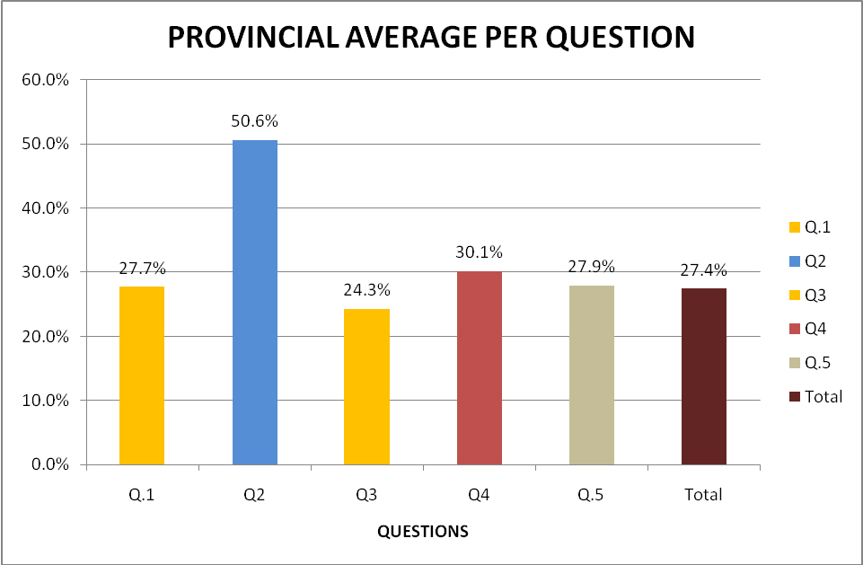

GENERAL COMMENTS
- From the graph above it is evident that candidates did not perform well in this paper. The general performance in Q.1 (comprehension) registered 27.7%, Q.3. (Advertising) 24.3%, Q.4 ( Cartoon strip) 30.1%
- Q.5. (Language Use) is poorly performed. This shows how little attention is given to language structures. It is suggested that educators should do language exercises and teach language skills repetitively as practice makes perfect.
- Although the Summary text (Q.4.) was too figurative and difficult to interpret, candidates scored better marks in this question. This was due to the fact that candidates were not penalized for several mistakes such as exceeding the number of words, wrong format, using too many quotes or language.
- The overall performance in the paper shows 27.4%

(b) GRAPHS TO COMPARE DISTRICTS' PERFORMANCES PER QUESTION

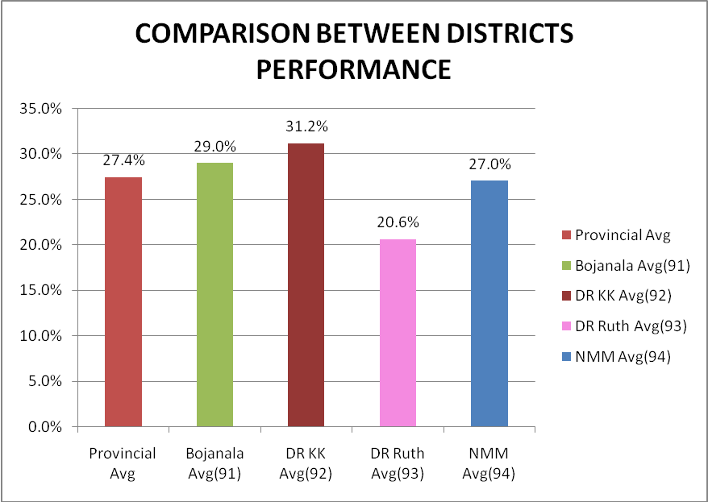

(c) GRAPH TO COMPARE OVERALL PERFORMANCE PER DISTRICT
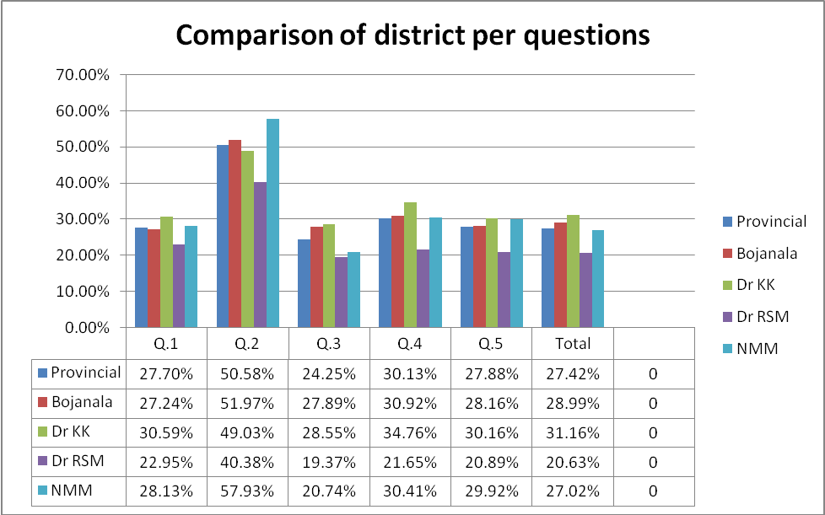

COMMENTS ON PERFORMANCE OF DISTRICTS :
- The provincial performance in Question 1 shows 27.70%. Dr K.K performed above the province by 2.89% followed by NMM which is above by 0.43%
- The provincial performance in Question 2 reveals 50.58%. NMM is above the prov. Average by 7.35% followed by Bojanala which is above by 1.39%
- In Q.3. figures above show the provincial performance of 24.25%.On the contrary Dr K.K and Bojanala scored above the prov. Average by 4.3% and 3.73% respectively
- In Q.4 NMM ( 30.41%)and Bojanala (30.92%) showed performance which is closer to that of the province which is 30.13 %
- Q.5. the provincial performance shows 27.88% ; Dr K.K, NMM and Bojanala are above the provincial performance by 2.28%, 2.04% and 0.28% respectively
- On the overall Dr K.K performed above other districts showing 31.16% which is above the provincial overall performance of 27.42%
- From the above graph it will be noted that the paper was very difficult and that almost 60% of the questions were of levels 4 and 5. There were less than the prescriptive 40% questions from level 1 & 2, as indicated in the Examination Guidelines of 2009. This is unfair to all candidates.
- An examination paper has been successfully set when there are enough lower order questions to enable a weaker candidate to pass with the prescriptive average of 40 % for a language on home language level, enough middle order questions to challenge average candidates and the 20 % higher order questions to make the top candidates distinct themselves in order to get distinctions. This paper unfortunately did not meet these requirements.
- Over the past five years the average of the home language paper has been disappointingly low. Examiners are requested to keep the candidates that offer home language in mind when setting the paper. The average learner of today does not read as much as learners of a decade ago. This is a global phenomenon. Thus the level of reading passages should not be too advanced, because candidates lack understanding.
- Many learners offering English on Home Language level are not Home Language speakers. If the level of this paper is going to stay as it is presently, it is feared that less learners will offer the subject that will be a threat to the future of the subject.

(d) DISTRIBUTION OF QUESTIONS IN TERMS OF COGNITIVE LEVELS (TABLE)
Section A: Question 1 (BARETTE ANALYSIS)
Question | Mark | Level | Question | Mark | Level
1.1. | 2 | 3
1.2 | 3 | 3
1.3 | 2 | 5
1.4 | 2 | 3
1.5 | 3 | 4
1.6 | 3 | 4
1.7 | 3 | 4
1.8 | 3 | 3
1.9 | 3 | 4
1.10 | 2 | 4
1.11 | 4 | 4
Total | 30 |  |  | SUMMARY
 |  |  |  | BARRET
Section B: Q.2 |  |  | Cognitive Level | %
Summary | 10 | 3 | 1& 2 | 17.9%
Total | 10 |  | 3 | 42.9%
 |  |  | 4 | 32.14%
Section C: Q.3
3.1 | 2 | 3
3.2 | 2 | 4
3.3 | 2 | 4
3.4 | 4 | 4
Total | 10
4.
4.1 | 2 | 2
4.2 | 2 | 2
4.3 | 3 | 3
4.4 | 3 | 4
Total | 10
5.
5.1 | 1 | 3
5.2 | 2 | 3 | 5.6 | 1 | 2
5.3 | ½ + ½ | 3 | 5.7 | 1 | 2
5.4 | 1 | 3 | 5.8 | 2 | 2
5.5 | 1 | 3 | Total | 10

(e) COVERAGE OF LEARNING OUTCOMES AND ASSESSMENT STANDARDS
(TABLE)

- The paper covered Learning Outcomes and Assessment Standards as prescribed in the Home Language National Curriculum Statement.
- The following Learning outcomes were tested throughout the question paper
LO2 (Speaking and Listening), LO3 (Writing and Presenting) as well as LO4 ( Language
Structures)
- Aspects of language that were tested included reading skills such as scanning and skimming, re-reading, summarizing key messages, denotation and connotation of meaning, contrasts, inferences, figures of speech, manipulative language, register, language use such as grammar (direct speech, tense, punctuation).
- Advertisements and cartoons (visual literacy) are also exposed to candidates as per assessment guidelines prescripts. However two adverts were rather too much as it disadvantaged some candidates who are not.
- The spread of questions, although they were challenging, was fairly distributed through-out the question paper.

Question | Los and ASs | Marks
SECTION A: Question1-Comprehension Test | LO2,3 and 4 | 30
SECTION B:Question 2- Summary | LOs. 2 and 3 | 10
SECTION C: Question 3-Analysing Advertising  Question 4-  Understanding aspects of Media  Question 5-Using language correctly | LO 3 and 4 | 30
Total Mark |  | 70

____________________________________ _______________________________________
NAME DESIGNATION (SUBJECT ANALYST) Signature

------------------------------------------------------------------------------- ----------------------------------------------------------------------
NAME DESIGNATION (INTERNAL MODERATOR) Signature

------------------------------------------------------------------------ -----------------------------------------------------------------------
NAME DESIGNATION (CHIEF MARKER) Signature

__________________________

DATE

