

CHIEF MARKER'S / MODERATOR'S/ SUBJECT ANALYST’S REPORT FOR PUBLISHING

SUBJECT: ENGLISH FAL PAPER: 1

INTRODUCTORY COMMENTS (How the paper was received; Papers too long/short/
balance)

- The question paper is well presented, fair, balanced and catering for different ability groups. It is of a sufficient length and there is no evidence that suggests that the paper could not be completed within the allocated duration of time.
- There is a balanced distribution for low, medium and high order questions catering for a variety of cognitive levels. It provides opportunities for candidates who have been taught basic language skills to respond appropriately to the set questions.
- A variety of texts that include prose and visual materials have been used to ensure that the paper adheres to a text based approach currently in practice.
- The paper conforms to standards set in the 2012 Amendment to Examination Guidelines for Languages.

SECTION 1

(General overview of Learner Performance in the question paper as a whole)

- Candidates performed fairly well in the question paper as a whole and were able to meet various cognitive levels assessed as per determined taxonomy.
- The paper presented a wide variety and thereby affording candidates multiple opportunities to display their knowledge and skills acquired in the subject.
- The paper was of a good standard and the average learner would perform fairly well whilst the above average candidate is also presented with the necessary challenges.

SECTION 2

(Comments on candidates’ performance in individual questions.

The graphs included in the report illustrate the performance of candidates and the average percentages obtained in each question.

QUESTION 1

(a) General comments on the performance of learners in the specific question.

QUESTION 1: Comprehension

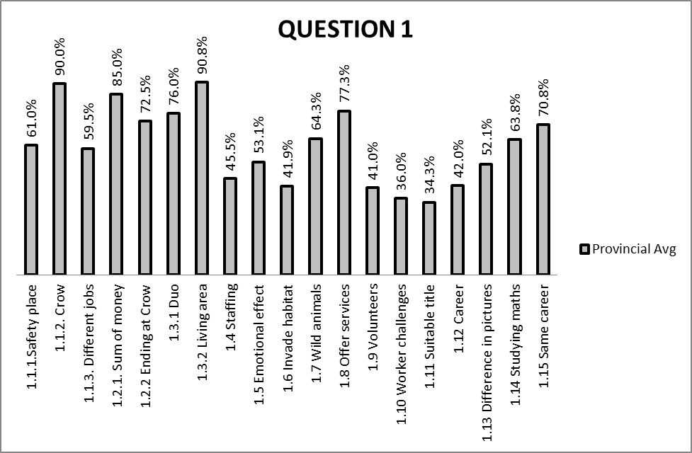

(b) Reasons why the question was poorly answered. Specific examples, common errors
and misconceptions are indicated.
(c) Suggestions for improvement in relation to teaching and learning.

Q. 1.1.1
- Candidates performed fairly well in this question. Most resorted to describing the word “sanctuary” instead of reading the instruction accurately which requires a one word answer.
- Candidates display limited vocabulary as there is alternative answers to be found in paragraph 1 relating to the answer.
SUGGESTIONS:
- Candidates’ vocabulary needs to be enriched, and instructions be followed as required.
- Candidates need to make use of the contextualisation approach, which suggests finding the meaning of words by looking at clues that surround the context in which words are being used.
Q. 1.1.2
- The performance of candidates is very good in this question. The question was well answered, though candidates need to make use of their own words to show understanding of the text.
- Candidates were able to provide a valid reason that indicates motivation for Brian Pieterse working at CROW.
SUGGESTIONS:
- Candidates need to learn to make use of their own words to show a clear understanding of the text.
- Each candidate needs to be provided with a dictionary to ensure that vocabulary is improved.

Q.1.1.3
- Candidates performed fairly well in this question as they were able to differentiate Brian and Monique’s job from office-based jobs.
- Candidates did not adhere to instructions which required reference information of paragraph 1; however, candidates opted to refer to other paragraphs.
SUGGESTIONS:
- Candidates need to be taught to infer differences within the context of the text, and follow instructions relating to reference information to be used in the text.

Q.1.2.1
- Candidates performed exceptionally well in this question. They are required to infer the answer from the given text and substantiate the option chosen.
- Candidates tended to use quotations instead of own words.
SUGGESTIONS:
- Candidates need to be taught to follow instructions as indicated in the question.

Q.1.2.2
- T0he performance for the question is satisfactory as most candidates were able to provide reasons why some animals end up at CROW.
- Candidates failed to adhere to instructions that required reference to paragraph 2.
SUGGESTIONS:
- Candidates need to read the whole text with understanding and use appropriate reference information in order to respond to the stated question.

Q.1.3.1
- Most candidates performed very well in the question as candidates were able to choose the most appropriate answer with the same meaning as the word “duo” in the context of the passage.
- The incorrect response of some candidates in this question is due to limited vocabulary.
SUGGESTION:
- Candidates need to make use of the contextualisation approach in which the meanings of words are found by looking at clues that surround the context used.
- Learners need to read more texts in order to gain vocabulary.

Q.1.3.2
- Candidates performed exceptionally well in this question. However, some quoted an entire paragraph instead of answering the question correctly.
- Candidates did not make use of their own words.

SUGGESTION:
- Candidates need to be taught the skill to summarise given text and using own words to express ideas freely and appropriately.

Q.1.4
- Candidates performed poorly in this question as they depended more on quotations to substantiate their answers.
- Instructions clearly required candidates to answer the question by providing motivation in their own words but could not adhere to the instruction given.
- The question provides for fair, evenly distributed marks for the option given and substantiation thereof.

SUGGESTION:
- Candidates need to follow instructions as stated in the question paper.
- Candidates should be taught use their own words when required.

Q.1.5
- Candidates performed fairly well in this question. It is an open-ended question that requires of candidates to express their view openly on the reader’s emotional response to the text.
- Candidates tended to discuss views beyond the content and context of the article.
- Candidates could not substantiate their answers through a discussion but opted to provide quotations.

SUGGESTION:
- High order questions need to be provided and candidates urged to discuss their views openly within the context of selected articles.

Q.1.6
- The performance of candidates was very poor in this question as they could only respond to one part of the question that refers to describing the ‘invasion by human beings’ whilst the ‘natural habitat’ or living space for animals was either repeated or not explained.
- The question posed challenges to learner responses as it required an implicit explanation of two ideas within the selected phrase.
SUGGESTIONS:
- The candidates need to be taught to infer main ideas which are not explicitly stated in the selected text but implied.
- Candidates are expected to use interpretation skills in order to show understanding of the text.

Q.1.7
- Candidates performed fairly well in this question though they found it difficult to express the state of animals’ ‘dependency on human beings’.
- Candidates would indicate that animals ‘...will come back wanting more.’, but the answer still seems inadequate as it does not fully address the dependency syndrome and expectations created when wild animals are fed like pets.

SUGGESTIONS:
- Candidates need to be able to make use of inferring techniques that include inferring cause and effect relationships that prevail in the text, seeking respondents’ own opinions on the validity of comments made by the writer.
- Candidates need to be taught to express their thoughts, clearly and coherently in order to support their assumptions and validity of their opinions.

Q.1.8
- Candidates performed very well in this question.
- Most candidates though, tended to quote the whole of paragraph 10, instead of just mentioning a relevant fact in respect to the question.

SUGGESTIONS:
- Candidates should be able to make use of their own words in response to such questions, in order to avoid quoting the whole paragraph.
- Most candidates show lack of confidence in answering questions that require use of own words.

Q.1.9
- Candidates performed poorly in this question.
- Expected answers are not explicitly stated in the text but inferred.
- Candidates could not motivate fully why persons under the age of 16 would not be allowed to volunteer at CROW.
- The question does not have reference information compared to other questions.

SUGGESTIONS:
- Reference information needs to be included in questions, though not all answers will be derived explicitly from referred paragraphs.

Q.1.10
- Candidates performed very poorly in this question but most could be partially appropriate in their responses.
- Candidates were not provided with reference information but had to refer to the whole passage.
- Candidates were faced with multitudes of alternative answers from which to choose the most appropriate and required answer.

SUGGESTIONS:
- Reference information needs to be included in questions, though not all answers will be derived explicitly from referred paragraphs.
- Candidates need to be taught to read texts with understanding, in order to answer questions correctly and clearly.
- Candidates should not be depended on guess-work by quoting whole paragraphs and hoping to get correct answers within these long extracts.

Q.1.11
- Candidates performed poorly in this question.
- Candidates could not justify or motivate the appropriateness of the title for the passage.
- Candidates fail to make an evaluative judgement through their responses, as they could not interpret ‘hands and feet of crow’ nor explain the role of volunteers in CROW.
- Candidates failed to link the title with the relative adequacy of the text.

SUGGESTIONS:
Candidates need to be able to evaluate the appropriateness of titles for each piece of writing and determine if adequate support for the writer’s conclusion towards completeness or incompleteness is provided.

Q.1.12
- Candidates performed fairly in this question and were provided with a picture in the advertisement in which questions referring to details of the text were asked.
- Candidates could not state the career depicting the man in the picture, and thereby indicating that they did not understand the main visual material of the text.
- Emphasis on the visual text has previously been on the language element and register, but in this question, candidates were required to show understanding of visual elements in the text.

SUGGESTIONS:
- Emphasis on visual texts needs to cover both the visual and language element of the text.

Q.1.13
- Candidates performed fairly in this question.
- Candidates found it difficult to interpret visuals in the text and show a clear distinction between the pictures presented.

SUGGESTIONS:
- Learners need to be taught how to interpret the visual materials in the text.

Q.1.14
- Candidates performed fairly well in this question.
- Candidates were required to state the importance of mathematics based on the text presented but some made generalisations outside the context provided.

SUGGESTIONS:
- Candidates need to follow instructions as stated. They are required to respond to the text in the context provided.

Q.1.15
- Candidates performed very well in the open-ended question.
- Most candidates were able to express their opinions that are in line with their personal views.
- Some candidates though, had limited options as they offered quotations from the passage instead of answering the question.

SUGGESTIONS:
- Candidates need to be encouraged to express their own opinions commensurate with their evaluative judgements, openly and freely.
- Candidates need to be taught to adhere to instructions.

(d) Other specific observations relating to responses of learners.
- Question 1.3.2 required a longer answer and should have been allocated two marks as learners were expected to give reasons in their responses.
- Due to learners’ limited vocabulary, questions 1.5 and 1.6 were misinterpreted and proved to be very difficult to adequately respond to what was required.

(e) Any other comments useful to teachers, subject advisors, teacher development, etc.
- Learners need to be exposed to a variety of texts in order to build their vocabulary.
- Learners need to be taught other ways of providing motivation to a question rather than starting each answer with ‘because’.

QUESTION 2

(a) General comment on the performance of learners in the specific question.

Question 2: Summary

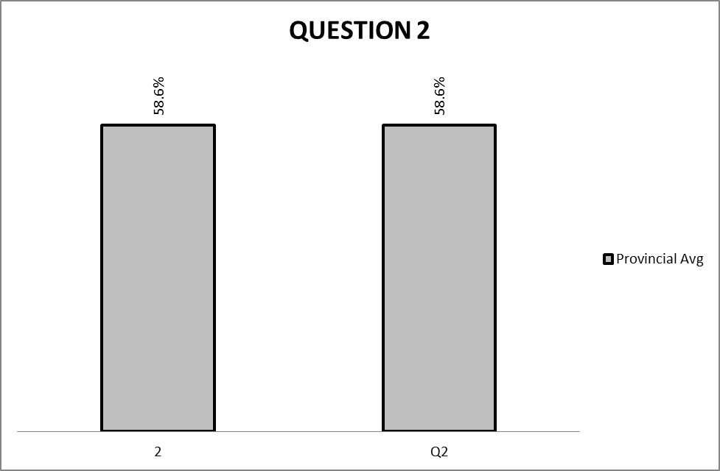

(b) Reasons why the question was poorly answered. Specific examples, common errors
and misconceptions are indicated.
(c) Suggestions for improvement in relation to teaching and learning.

Q. 2.
- Candidates performed fairly well in the question as they could identify relevant facts required for a list of safety tips.
- Candidates experienced difficulties with language structures and as such were hampered to make use of their own words as per instruction.
- Candidates prefer to use direct quotations which are not paraphrased.
- Candidates do not observe grammar rules, punctuations, and commit many spelling errors.
- Most candidates were able to adhere to the format required, however some used paragraphs and would summarise out of the context of the text.
- Due to the relaxation of various sorts of penalties, candidates performed better than it would be the case in this section.

SUGGESTIONS:
- Candidates should avoid excessive use of direct quotations.
- Candidates need to practice using their own words in responding to the question.
- Candidates need to apply the process of writing, in order to edit their pieces of summary writing.
- Punctuation should be observed and properly used, in order to make meaning of the summary.
- Most of the instructions that include word-counting have been adhered to.

(d) Other specific observations relating to responses of learners.

- Candidates were required to make use of their own words when writing a summary but even though they used quotations, applicable penalties were not used.

(e) Any other comments useful to teachers, subject advisors, teacher development, etc.

- Teachers need to teach candidates summary writing skills, as some could not use the required format and instead used paragraphs.
- Learners need to be taught language structures in order to ensure that they are grounded in writing a good summary.

QUESTION 3

(a) General comment on the performance of learners in the specific question.

QUESTION 3: Analysing an advertisement

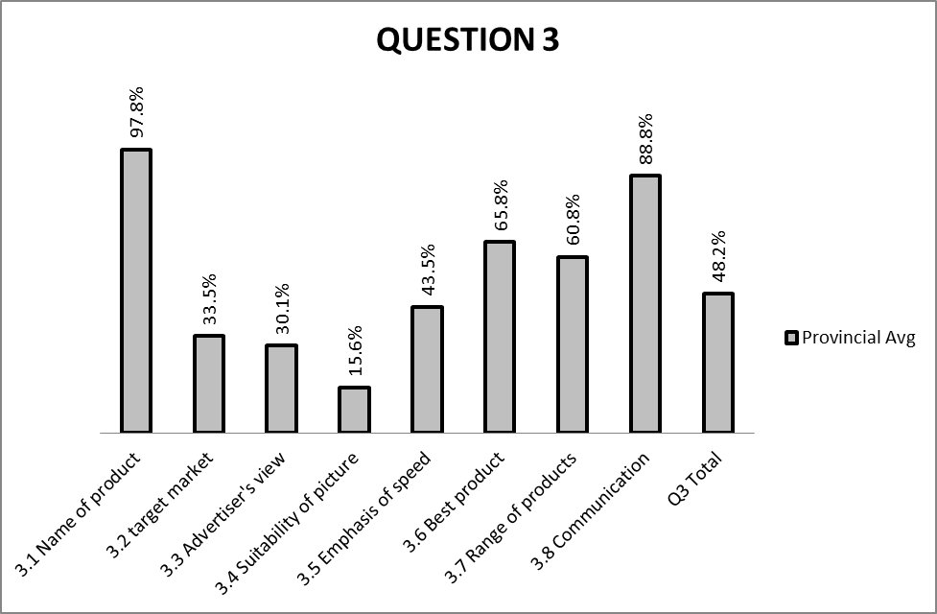

(b) Reasons why the question was poorly answered. Specific examples, common errors
and misconceptions are indicated.
(c) Suggestions for improvement in relation to teaching and learning.

Q.3.1
- The performance is very good in this question, as candidates could recognise the name of the product advertised.

SUGGESTIONS:
- If the pictures are clearly visible in the advertisement, candidates should be able to respond appropriately to visual elements required.

Q.3.2
- Candidates performed poorly in this question as they could not associate the advertised product with the target market.
- Candidates personalised the product and wrote ‘teenagers’ as the target market, whilst the question required a broader answer in the context of the text.

SUGGESTIONS:
- Candidates need to read questions on advertisement clearly and with understanding.
- Candidates should be able to recognise that a clearer understanding of visuals contribute to interpretation of the advertisement as a whole.
Q.3.3
- Candidates performed poorly in this question as they could not explain the effect of the words ‘guaranteed’ and ‘money back’ in describing the feeling of the advertiser about the product.
- Candidates are not able to distinguish nor do they understand linguistic techniques used by advertisers in marketing their products.

SUGGESTIONS:
- The analysis of an advertisement should be taught fully, including the integration of both the visual and language element in the advertisement.
- The general purpose for advertisements and linguistic techniques that advertisers use should be taught in the classroom.

Q.3.4
- Candidates performed very poorly in the question as they could not place the picture of the dog in the context of the advertisement.
- Candidates could not interpret the effect of the picture in the advertisement.
- Very few candidates recognised the main aim of the picture, which relates to catching the attention of the viewer and illustrating the effectiveness of the product in removing spots.

SUGGESTION:
- Candidates should be able to make judgements about the relative adequacy of the advertisement and be aware of the effectiveness of pictures in conveying the main aim of any advertisement.
- Candidates should determine if the advertisement appeals to the target market by analysing the visual element of the text as well.

Q.3.5
- The question was not well answered.
- Candidates could not make use of verbs to indicate the action by which the advertiser emphasises the speed at which the product works.

SUGGESTION:
- Candidates need to be taught to observe question words in order to respond appropriately to set questions.

Q.3.6
- The question was well answered by candidates.
- Candidates were able to quote a word which justifies that the product is the best of its kind in the market.
- Some candidates failed to adhere to the instruction that only required a single word.

SUGGESTION:
- Candidates need to adhere to instructions given.
- Learners should be taught question words used in the paper, in order to ensure appropriate responses to questions.
Q.3.7
- Candidates performed fairly well in this question.
- While candidates were able to locate pictures of other products of the same brand in the advertisement, others had difficulties of recognising a whole range of products placed in the advertisement.

SUGGESTION:
- Candidates should be able to recognise the placing of all pictures in the advertisement.
- All pictures should be viewed as contributing to the effectiveness of the advertisement.

Q.3.8
- The performance of candidates was exceptionally well in this question.
- Most candidates could recognise the willingness of the advertiser to communicate with customers through the provision of contact details in the advertisement, invitations to make comments and to make enquiries.

SUGGESTION:
- Learners should be able to view and study the advertisement as a whole since details included serve a variety of reasons.

(d) Other specific observations relating to responses of learners.
- Candidates are not exposed to the visual literacy genre in schools.

(e) Any other comments useful to teachers, subject advisors, teacher development, etc.
- Materials that include newspapers, magazines, radio and television need to be used in the classroom to teach visual literacy.

QUESTION 4

(a) General comment on the performance of learners in the specific question

QUESTION 4: Analysing a Cartoon

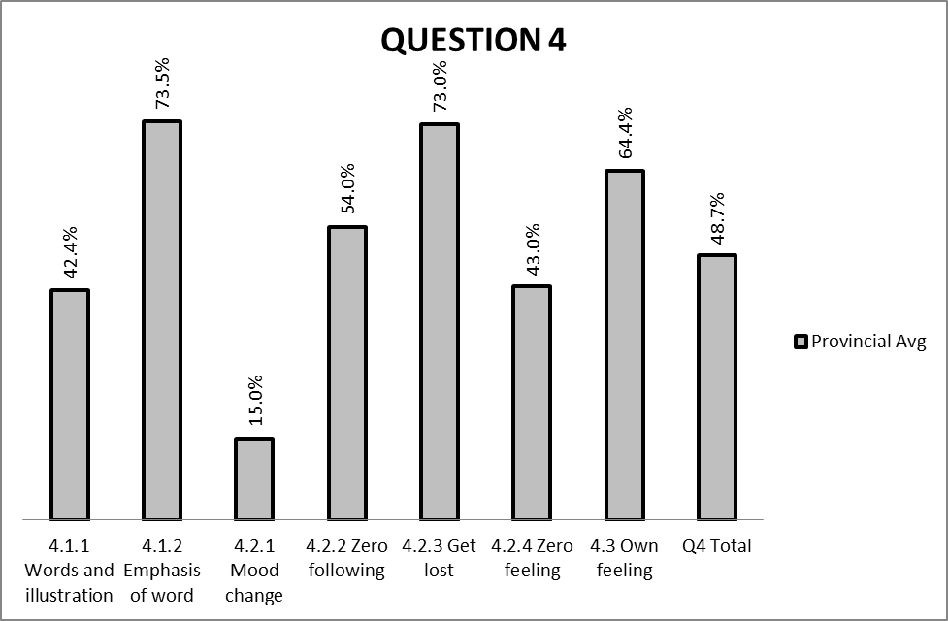

(b) Reasons why the question was poorly answered. Specific examples, common errors
and misconceptions are indicated.
(c) Suggestions for improvement in relation to teaching and learning.

Q.4.1.1
- Candidates did not perform well in this question.
- Many candidates have not yet mastered a response to double-sided questions that require the use of words and illustrations and in the cartoon.
- Candidates could not interpret the question correctly and opted for direct quotations of the text.
- Candidates further wrote long paragraphs which are not addressing the question on use of words and illustration to show that the sergeant does not want to be followed.

SUGGESTION:
- Basic features and conventions of the visual literacy genre should be taught in order to ensure more appropriate interpretation of the cartoon.
- Candidates should be sensitised to the use of punctuation to create meaning in the text, and body language.

Q.4.1.2
- Candidates performed very well in this question.
- Candidates were able to recognise change of typeface to show emphasis.

SUGGESTION:
- Candidates need to recognise the effect of change of typeface in the text.
- Candidates need to be taught literary techniques, forms and different styles of writing.
- The use of symbols, punctuation marks and words in the text should be clearly identified and their effect analysed.

Q.4.2.1
- The question was poorly answered as candidates could not demonstrate change of mood from frame 1 to frame 2.
- Candidates did not consider the situation that prevailed in frame 1, in order to answer the mood changes in the next frame.
- Candidates could not apply degrees of comparison

SUGGESTION:
- Candidates need to follow references to specific frames set in the question.
- Candidates further need to be taught the interpretation of body language and facial expressions.

Q.4.2.2
- The question was fairly answered but most candidates confused their answers with question 4.1.1.
- Candidates could not link progression from frame 1 to frame 2 and as such repeated the same answer provided in question 4.1.1.
- Candidates failed to distinguish miscommunication of instructions or commands due to literal interpretations by Zero.

SUGGESTION:
- Candidates need to be taught literal and figurative language.
- Progression of the story line from one frame to the other needs to be clearly understood in order to make meaning of the text.

Q.4.2.3
- Candidates performed very well in this question.
- Candidates were able to make meaning of the expression ‘...get lost’.

SUGGESTION:
- Candidates need to be taught the effects of emotive language in visual literacy.
- Candidates need to be taught how to recognise and evaluate emotive language within context.
- The use of figurative and literal language further needs to be emphasised.

Q.4.2.4
- Candidates performed fairly in the question.
- Most candidates opted to answer option B, which was further adopted for a personal opinion on question 4.3.
- Candidates confused their personal feeling with what was actually happening to Zero in frame 2.
- Candidates made use of frame 3 to answer a question relating to frame 2, and as such misinterpreted the body language in question.

SUGGESTION:
- Candidates need to be able to interpret Zero’s body language which is clearly depicted and inferred in frame 2.
- Candidates should be able to answer questions based on the text, and not only on personal feelings about characters in the visuals.

Q.4.3
- Candidates performed very well in the question.
- Most candidates were able to express their feelings about Zero but could not provide reasons for their answers.
- Candidates did not present motivations in line with their personal views on the text.

SUGGESTION:
- Open-ended questions that require candidates’ opinions need to be emphasised.
- Candidates’ substantiated responses need to be in line with personal views of characters in the cartoon within the context of the text.
- Candidates further need to be exposed to stereotype, which is often based on bias of a certain type of person in the text.
(d) Other specific observations relating to responses of learners.
- Candidates did not understand the humour in the cartoon presented.

(e) Any other comments useful to teachers, subject advisors, teacher development, etc.
- A number of popular cartoons need to be used in the classroom, in order to ensure that learners get exposed to the genre and its features.

QUESTION 5

(a) General comment on the performance of learners in the specific question.

QUESTION 5: Language and Editing

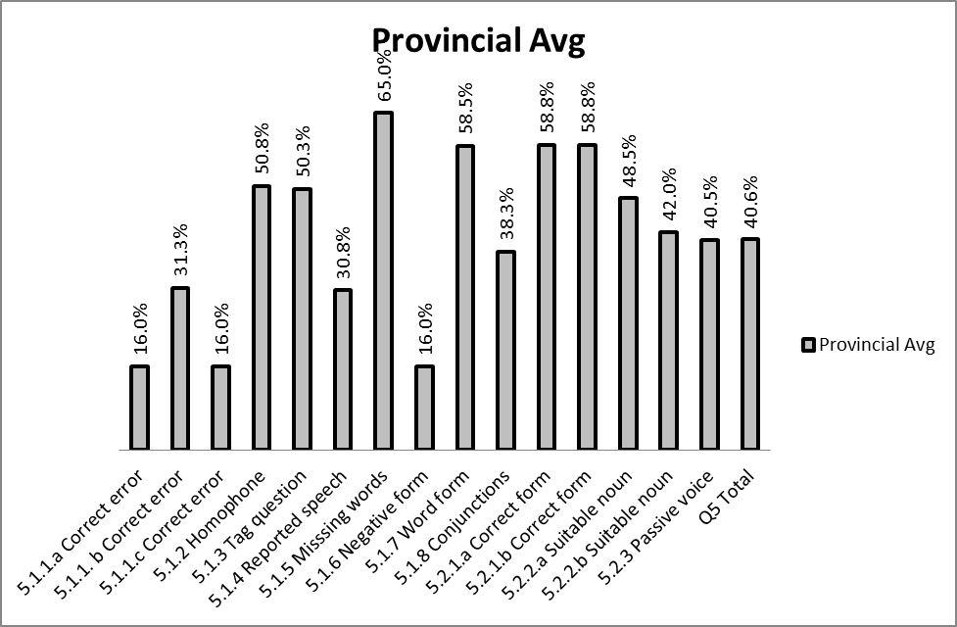

(b) Reasons why the question was poorly answered. Specific examples, common errors
and misconceptions are indicated.
(c) Suggestions for improvement in relation to teaching and learning.

Q.5.1.1 (a)
- Candidates performed very poorly in the question as they could not identify an error in the sentence.
- Candidates do not recognise that pronouns don’t use apostrophe but only omission and possession.
Q.5.1.1 (b)
- Candidates performed poorly in this question.
- Candidates could not correct the word ‘hole’ by using a homophone, ‘whole’.
Q.5.1.1 (c)
- Candidates could not recognise a spelling error in the word ‘sandwitches’ and thereby performed poorly in the question.

SUGGESTION: 5.1.1 (a) - 5.1.1 (c)
- Candidates need to be taught to show an understanding of the use of an apostrophe.
- Vocabulary enrichment exercises are necessary in order to ensure that candidates are equipped to respond to such questions that include homophones and application of correct words to convey meaning in sentences.
- Spelling exercises are necessary in order to provide the correct form of words.

Q.5.1.2
- Candidates performed fairly well in the question as candidates could distinguish the difference between ‘meat’ and ‘meet’.
- Candidates were able to construct sentences using a homophone for the word ‘meat’.
- Some candidates could not construct sentences that use a homophone ‘meet’ as a verb in the sentence.

SUGGESTION:
- Vocabulary building exercises could improve the critical language awareness of candidates and in that regard learners will be able to construct complete and correct sentences.

Q.5.1.3
- Candidates performed fairly well in the question.
- Candidates confused the statement with a question and rewrote the statement instead of only supplying the tag.

SUGGESTION:
- Candidates need to note that in order to affect a question tag successfully, a positive statement needs to be followed by a negative tag and a negative statement by a positive tag.
- Question tags need to be taught in their entirety with all the rules that apply.

Q.5.1.4
- Candidates performed very poorly in this question.
- Candidates could not apply pronouns and tense changes as required.
- Punctuation changes that included removing inverted commas, commas and capital letters were not applied.
- A connector ‘that’ was also not inserted while the tense should have been converted to the past. Most candidates could not change ‘took’ to ‘had taken’.
- A demonstrative pronoun ‘this’ should also be changed to ‘that’.
- Only a few candidates could succeed in effecting all required changes.
- Candidates were partially credited for any correct changes applied.

SUGGESTION:
- Candidates should be taught reported speech.
- It should further be emphasised that when the speech is reported, the conversation is placed in the past and all the necessary changes are applied.

Q.5.1.5
- Candidates performed very well in the question and were able to supply the correct preposition ‘with’.

SUGGESTION:
- Candidates should be taught the use of correct prepositions.

Q.5.1.6
- Candidates performed very poorly in this question.
- Candidates could not change the sentence from the positive to the negative by adding the auxiliary verb ‘does not’ or its contracted form doesn’t.
- Candidates attempted to change ‘exclude’ to ‘include’ in order to convert the sentence in the negative form.

SUGGESTION:
Candidates need to be able to recognise the use of auxiliary verbs and verb changes when changing the sentence in the negative form.

Q.5.1.7
- Candidates performed fairly well in the question.
- The answer requires an understanding of the word ‘quite’ which falls within the category of words easily confused.
- Candidates failed to select the correct word for the sentence given.

SUGGESTION:
- Vocabulary building exercises is required to ensure that learners are made aware of such words easily confused.

Q.5.1.8
- Candidates performed poorly in the question.
- Candidates could not use conjunctions correctly.
- Candidates could not make use of conditionals by combining sentences into a single sentence.
- Candidates failed to make the necessary substitutes and thus continue to repeat nouns.

SUGGESTION:
- Candidates need to be taught to use conditionals and eliminate repetitions.
- The correct form of the verb should be maintained.

Q.5.2.1 (a)- (b)
- Candidates performed very well in both questions.
- The correct use of the noun was tested wherein knowledge on parts of speech was required.
- Candidates failed to correct the form of the verb.
- Spelling errors were common
- Not all candidates could apply the correct degree of comparison.

SUGGESTION:
- Parts of speech need to be taught with special focus on the function of each.
- Learners need to be able to identify parts of speech and understand their functions in sentences.

Q.5.2.2 (a)- (b).
- Candidates performed fairly well in both questions.
- Candidates though, could not form suitable nouns in the context of the sentence.

SUGGESTION:
- Candidates need to be able to differentiate parts of speech that include; noun, verb, adjectives, adverb, pronoun, preposition, conjunction, interjection and articles.
- Candidates should be taught basics that relate to correct form of verbs.

Q.5.2.3
- Candidates performed poorly in the question.
- Verb changes could not be effected in the required present tense.
- Candidates could not affect the verb phrase an additional auxiliary verb ‘is plus the 3rd column of the verb provided’ correctly.
- Candidates could further not observe that in the passive voice, the active subject becomes the passive subject and is then moved to the end of the sentence where it is introduced by the preposition; ‘by’.

SUGGESTION:
- Candidates should start the sentence with words given.
- The transformation of sentences from the active to the passive voice should be taught along with standard rules that apply within the context of the sentence.

(d) Other specific observations relating to responses of learners.
- Candidates are performing poorly in the language and editing component of the language.

(e) Any other comments useful to teachers, subject advisors, teacher development, etc.
- Learners should not only be taught communicative language, but basic language structures and conventions in context.
SECTION 3
(a) GRAPH OF PROVINCIAL PERFORMANCE IN THE PAPER (summary per question)

PROVINCIAL PERFORMANCE FOR ENGLISH PAPER 1 DEC 2012

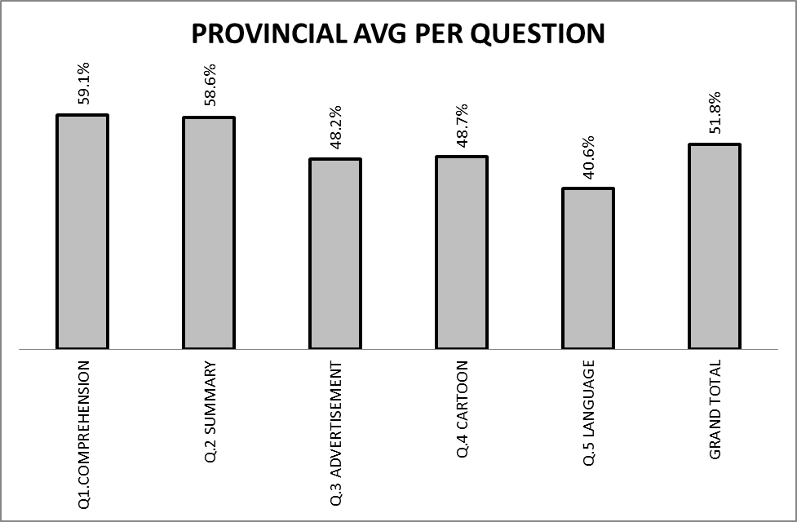

- Based on the graph above, candidates did not perform well in Questions 5, 4 and 3.
- It is evident that more attention should be paid to teaching Language and Editing.
- Teachers should also pay focus on Analysing a Cartoon and an Advertisement.
- Candidates are performing fairly well in Summary writing and Compehension Questions.

(b) GRAPHS TO COMPARE DISTRICTS' PERFORMANCES PER QUESTION
QUESTION 1-3 ENGLISH P1 DEC 2012

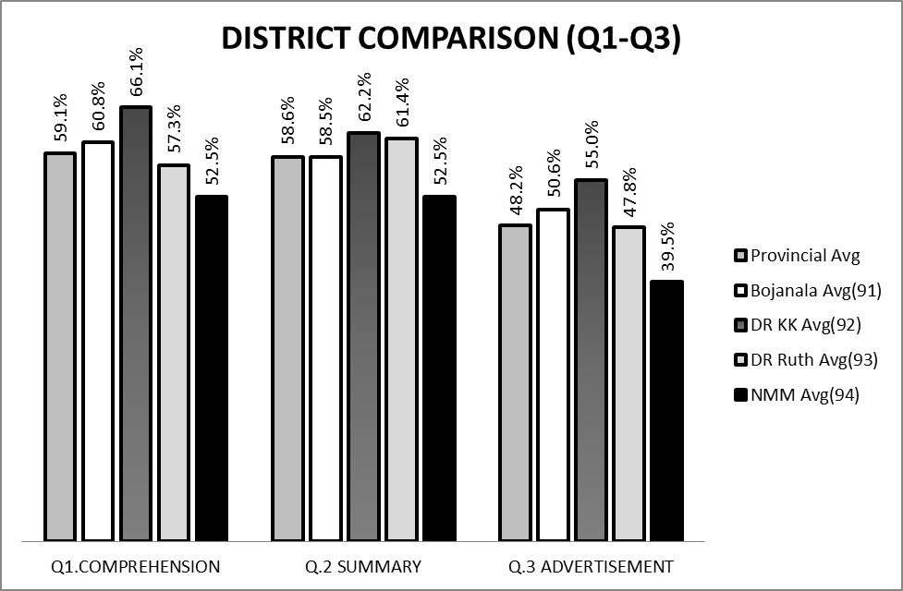

QUESTION 4-5 ENGLISH P1-DEC 2012

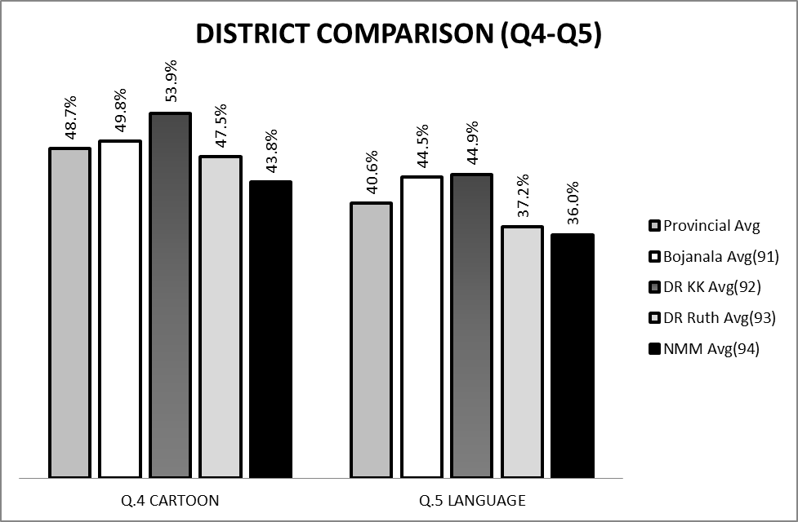

(c) GRAPH TO COMPARE OVERALL PERFORMANCE PER DISTRICT
PERFORMANCE IN QUESTION PAPER PER DISTRICT-ENGLISH P1 DEC 2012

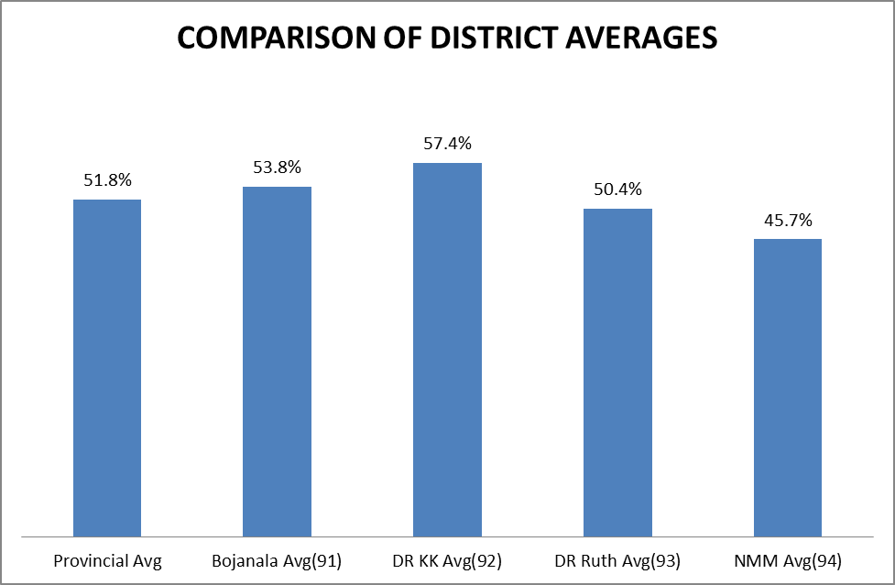

COMMENTS ON PERFORMANCE OF DISTRICTS
:
Boj=Bojanala; Dr KK=Dr Kenneth Kaunda; DrRSM=Dr Ruth Segomotso Mompati; NMM=Ngaka Modidi Molema

QUESTIONS | % in Province | Topic | District Performance
Q.1 | 59.1 | Comprehension | Dr KK performed more than 5% above average and NMM 5% below average.
Q.2 | 58.6 | Summary | NMM performed 5% below average
Q.3 | 48.2 | Analysing an Advertisement | NMM performed 5% below average
Q.4 | 48.7 | Analysing a Cartoon | NMM performed 5% below average
Q.5 | 40.6 | Language and Editing | Boj and Dr KK performed above average while DrRSM and NMM below average

CONCLUSION
- Dr Kenneth Kaunda performed best in English Paper 1 in the Province
- Ngaka Modiri Molema performed below the Provincial average
- All the districts need to give special attention to the Language and Editing component of the subject.

(d) DISTRIBUTION OF QUESTIONS IN TERMS OF COGNITIVE LEVELS (TABLE)

QUEST | MARKS | LEVEL | QUEST | MARKS | LEVEL
1.1.1 | 1 | 1 | 3.1 | 1 | 1
1.1.2 | 1 | 1 | 3.2 | 1 | 1
1.1.3 | 2 | 2 | 3.3 | 2 | 3
1.2.1 | 2 | 3 | 3.4 | 2 | 5
1.2.2 | 3 | 2 | 3.5 | 1 | 1
1.3.1 | 1 | 3 | 3.6 | 1 | 1
1.3.2 | 1 | 1 | 3.7 | 1 | 3
1.4 | 2 | 3 | 3.8 | 1 | 2
1.5 | 2 | 4 | Total | 10
1.6 | 2 | 3 | 4.1.1 | 2 | 3
1.7 | 2 | 1 | 4.1.2 | 1 | 2
1.8 | 1 | 3 | 4.2.1 | 2 | 2
1.9 | 1 | 4 | 4.2.2 | 1 | 1
1.10 | 2 | 3 | 4.2.3 | 1 | 1
1.11 | 2 | 5 | 4.2.4 | 1 | 1
1.12 | 1 | 1 | 4.3 | 2 | 5
1.13 | 2 | 3 | Total | 10
1.14 | 1 | 3 | 5.1.1 | 3 | 1
1.15 | 1 | 5 | 5.1.2 | 2 | 1
Total | 30 |  | 5.1.3 | 1 | 1
2 | 10 | 2 | 5.1.4 | 3 | 2
 |  |  | 5.1.5 | 1 | 1
 |  |  | 5.1.6 | 1 | 1
 |  |  | 5.1.7 | 1 | 1
 |  |  | 5.1.8 | 2 | 2
 |  |  | 5.2.1 | 2 | 1
 |  |  | 5.2.2 | 2 | 1
 |  |  | 5.2.3 | 2 | 2
 |  |  | Total | 20
 |  |  | Cognitive Lev | Marks | Req
 |  |  | Literal | 24 | 20
 |  |  | Reorganisation | 26 | 20
 |  |  | Inference | 18 | 40
 |  |  | Evaluation | 5 | 10
 |  |  | Appreciation | 7 | 10
 |  |  | Total | 80 | 100

(e) COVERAGE OF LEARNING OUTCOMES AND ASSESSMENT STANDARDS
- The Paper assessed covered relevant learning outcomes for the subject that include;
- LO 2-Reading and Viewing
- LO3-Writing and Presenting; and
- Language structures and conventions.
- Related Assessment Standards are also covered as per 2009 Examination Guidelines as amended (2012)

NAME DESIGNATION (Subject Analyst /Moderator or Chief Marker)

SEFAKO M.E SUBJECT ANALYST
SIGNATURE DATE

_________________________________________ __________________________

