

CHIEF MARKER'S / MODERATOR'S/ SUBJECT ANALYST’S REPORT FOR PUBLISHING

SUBJECT: AGRICLUTURAL SCIENCES PAPER: 2

INTRODUCTORY COMMENTS (How the paper was received; Papers too long/short/
balance)

- The paper was well balanced in terms of the required cognitive levels as per assessment guide line. The length of the paper was standard and all learners manage to complete the paper on time, the general feeling was that it was a good paper.
- The paper is well balanced in terms of the different LO’s ASS’s and topics in the Examination Guideline.
- Different level of questions was asked with the most of the questions at level 1 and 2.
- The candidates finished the paper in time.

SECTION 1

(General overview of Learner Performance in the question paper as a whole)

- Learners managed to score 32.7% average for the paper as a whole with ballad questions scoring the highest marks. Learner did not perform well in Agric management and genetics with 23% and 26% average respectively. Question 1.3 which required learners to supply one word for the given description was the lowest in average with 21.9%.
- Again there was a Question on the description of gene modification (cloning) – Question 4.5. Again we ask why artificial insemination can be asked that is in the scope of the learners.
- There are still too many learners in the lower performance bracket i.e. 0 – 44 (0 – 29%) and 45 – 60 (30 – 40%).
- Reading and interpretation of questions is a general problem that must be addressed.
- Candidates do not know their terminology. This problem will be explained in the discussions that follow.
- Candidates read the first part of a question and then started to answer the question instead of reading the full question.
- As in all the previous papers, genetics is answered very poorly.

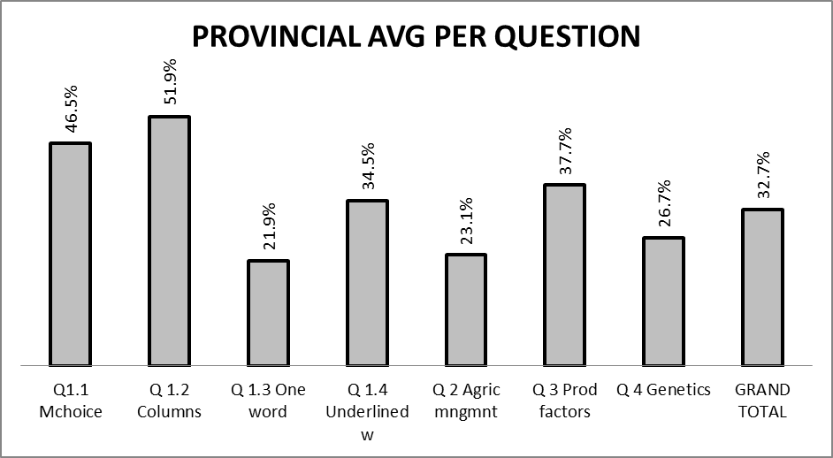

SECTION 2

Comments on candidates’ performance in the five individual sub questions (a) – (e) will be provided below. Comments will be provided for each question on a separate sheet).

QUESTION 1

(a) General comments on the performance of learners in the specific question.

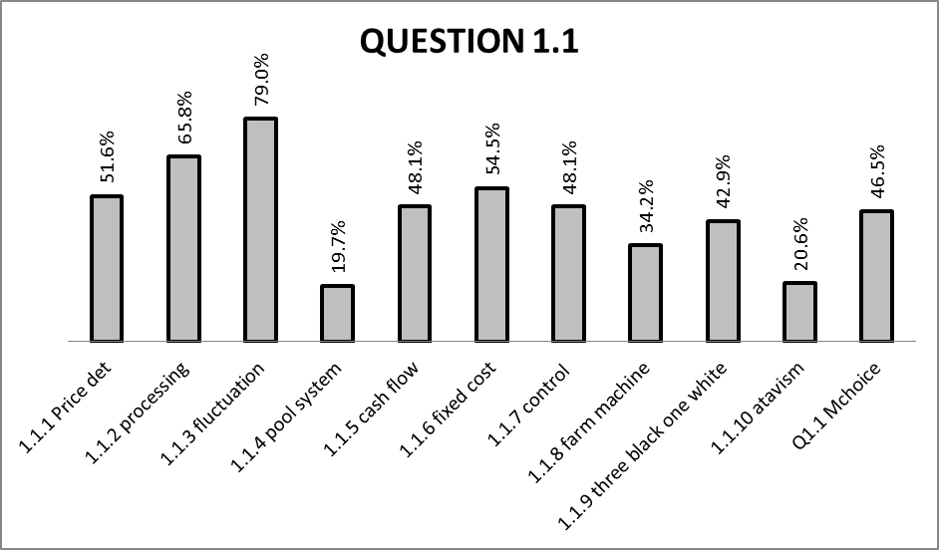
- Some of the questions are of higher order. If the knowledge of the candidate is not op to standard, they will not be able to distinguish between the answers to get the correct answer.
- With only a part of a description or definition it can be difficult to identify the term. Knowledge plays a very important part.
- To answer this question it is important that the knowledge of the learner is on a very high level.
- Although the candidate was led by the underlined word, the learner must know the definitions very well to answer this question.
Average = 46,5%.
This is multiple choice questions and candidates can guess the answers correct.

Questions answered poorly are:
1.1.4 19,7% Marketing systems. Same problem occur in Section B
1.1.8 34,2% Under capitalisation
1.1.10 20,6% Genetics. Same problem occur in Section B

Best answered questions:
1.1.1 Price establishing
1.1.2 Definition of processing
1.1.3 Fluctuation. Scope of learners

(b) Reasons why the question was poorly answered. Specific examples, common errors
and misconceptions are indicated.
(c) Suggestions for improvement in relation to teaching and learning.

Q. 1.1.4
- Learners did not know the meaning of the word “pool” in context and therefore were not able to link pool system to the cooperative marketing system.
SUGGESTIONS:
- It is recommended that the word “pool” be explained in the context of gathering similar products together standardise and grade them to determine the price.

1.1.10
- Learners were “probably” seeing the term for the first time
SUGGESTIONS
- It is suggested that learner be taught genetic concepts prior to teaching Mendel’s laws

Q. 1.2.1

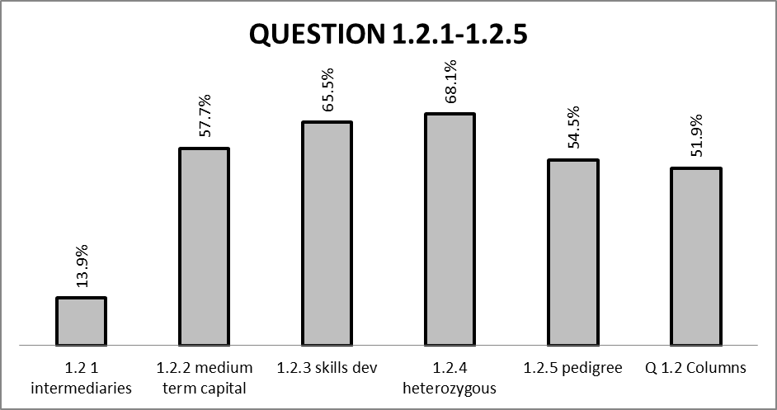

Average = 51,9%
Column A Column B question and guesswork can obtain a lot of marks.

Question poorly answered is:
1.2.1 13,9% Marketing

Best answered questions:
1.2.4 Mendel’s laws
1.2.3 Skills developement

- Learners are familiar with “agents” or “middlemen” as opposed to “intermediaries”
SUGGESTIONS:
- It is suggested that learner should be exposed to as many marketing terminologies as possible, with an improved vocabulary; learners will be able to tackle marketing questions.

Q 1.3.1

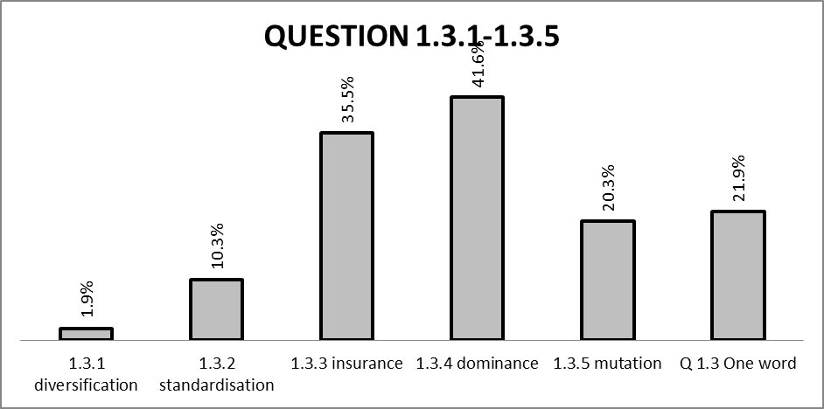

Average = 21,9%
Give one word question. Not answered well.

Questions answered poorly are:
1.3.1 1,9% Farming systems
1.3.2 10,3% Marketing
1.3.3 – 1.3.5 not answered so well.

Best answered questions:
1.3.4 Mendell’s laws
1.3.3 Insurance. Scope of leaners

- Question 1.3.1 was the worst answered question in the whole paper. Learners did not know risk management strategies because educators confine their teaching to management principles, namely planning, organising guiding and control and ignore management skills.
- Question 1.3.2 on “standardisation” was poorly answered due to its confusion with “grading”
SUGGESTIONS
- Management principles should be linked to management skills including production and operational skills as well as risk management skills.
- It is suggested that a clear distinction between grading and standardisation be drawn for learners to understand. Learners should be taught that standardisation is a set of rules while grading is process.

Q 1.4
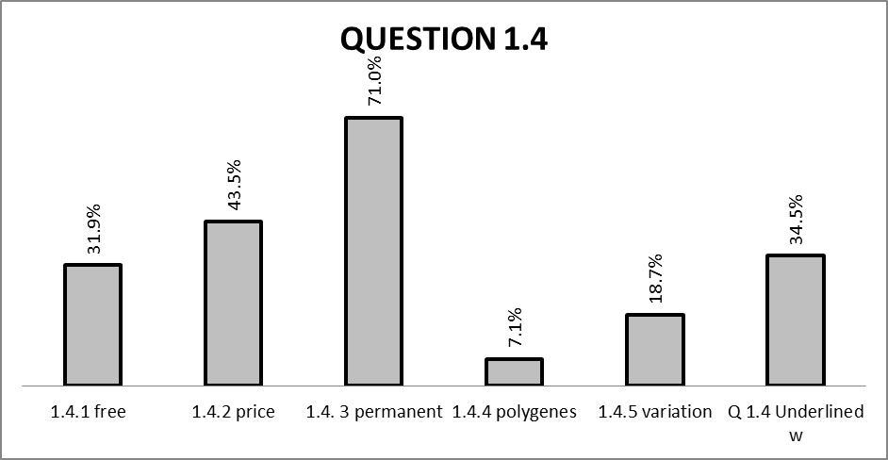

Average = 34,5%
Change the underlined word. the word that is underlined leads the candidate to the correct word and is sometimes just the opposite.

Questions answered poorly are:
1.4.4 7,1% Genetics
1.4.5 18,7% Genetics

Best answered questions:
1.4.3 Labour
1.4.2 Price establishing

- Questions 1.4.4.and 1.4.5 were poorly answered due to a lack of knowledge in genetics particularly genetic concepts or terminology.
SUGGESTIONS
- It is suggested that learners be taught genetic concepts with practical examples from Mendel’s laws

(d) Other specific observations relating to responses of learners.

- Some of the questions are of higher order. If the knowledge of the candidate is not op to standard, they will not be able to distinguish between the answers to get the correct answer.
- Question 1.4 is characterized mostly by concepts in agriculture and learners are not familiar with agricultural concepts.
- A very well organised study plan is essential to obtain better marks.
- Knowledge is very important in Section A for most of the questions are of a level 1 question and some on level 2.
- Reading and interpretation of e questions in full to answer these type of questions and not only the first part.

(e) Any other comments useful to teachers, subject advisors, teacher development, etc.

- Learners should be encouraged to compile glossary of agric science concepts per topic in order to familiarize themselves with terminology.

QUESTION 2

(a) General comment on the performance of learners in the specific question.

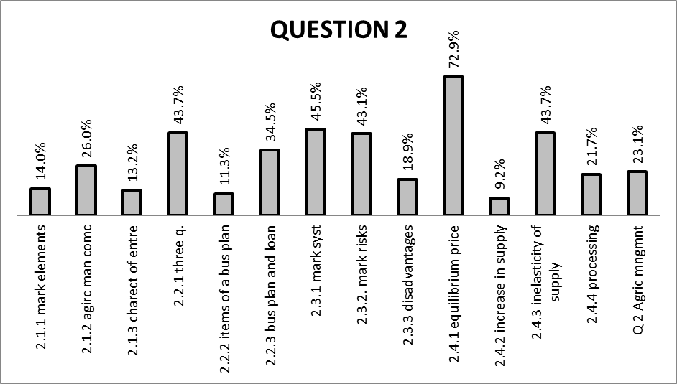

- The learners don’t know the difference between concepts and elements of marketing strategies – knowledge.
- Learners do not read the questions carefully and just start to answer.
- Question stated “from data above” and learners simply give any answer.

- 2.2 Reading and interpretation plays an important role in the answering of this question. It was asked for the main questions, main items and learners simply write anything that came to mind.

- 2.3 The problem is that learners write the same answers of 2.3.2 to 2.3.3. The knowledge of the disadvantages was asked and they only write what they see in the picture. This is a knowledge question – level 1 and the knowledge failed them.

- 2.4 This is a higher order question – level 3. It will be only the more advanced learners that will obtain high marks in this question.

Question 2 in general was answered very poorly.
Average = 23,1%

The averages for the different questions are:
2.1 Marketing and entrepreneurship
2.1.1 14,0%
2.1.2 26,0%
2.1.3 13,2%

2.2 Business plan
2.2.1 43,7%
2.2.2 11,3%
2.2.3 34,5%

2.3 Marketing systems
2.3.1 45,5%
2.3.2 43,1%
2.3.3 18,9%

2.4 Graph of supply and demand
2.4.1 72,9%
2.4.2 9,2%
2.4.3 43,7%
2.4.4 21,7%

1.2

(b) Reasons why the question was poorly answered. Specific examples, common errors
and misconceptions are indicated.
(c) Suggestions for improvement in relation to teaching and learning.

Q. 2.1.1
- This question was poorly performed though it was verbatim from page 192 of focus textbook.
SUGGESTIONS:
- It is suggested that learners be taught marketing strategy and how marketing elements influence the attitude of buyers towards buying the product. The importance of the “marketing mix” should be emphasised.
Q. 2.1.3
- Most learners did not have a clue about what makes a good entrepreneur despite qualities of a good entrepreneur clearly stated on page 198 activity 7.10.
SUGGESTIONS
- Learners should be given case studies and real life scenarios of successful entrepreneurs in their communities to relate qualities of business acumen.
Q 2.2.2
- This question was poorly answered because learners are not familiar with the structure of a business plan.
SUGGESTIONS
- Learners should be given sub items of a business plan at random and classify the under main items, namely executive summary, history, market research operations, financial projections and business control.
Q 2.3.3
- Learners could not name disadvantages of marketing system if they did not know or could not identify marketing systems.
SUGGESTIONS
- It is suggested that learners be taught to identify types of marketing with their unique elements and supply their own view with regard to advantages or disadvantages.
Q 2.4
- This question was confusing because of the general statement which did not relate to
the graph

(d) Other specific observations relating to responses of learners.

- Question 2 is the most poorly answered of the four main questions with 23% average.
- More emphasis must be placed on business plan and marketing
- The topic of price fluctuation, elasticity and inelasticity must be included in training of teachers for this is difficult to explain to learners.

(e) Any other comments useful to teachers, subject advisors, teacher development, etc.

- It is suggested that learners must be taught to apply graphs and scenarios to real life situations.

QUESTION 3

(a) General comments on the performance of learners in the specific question.

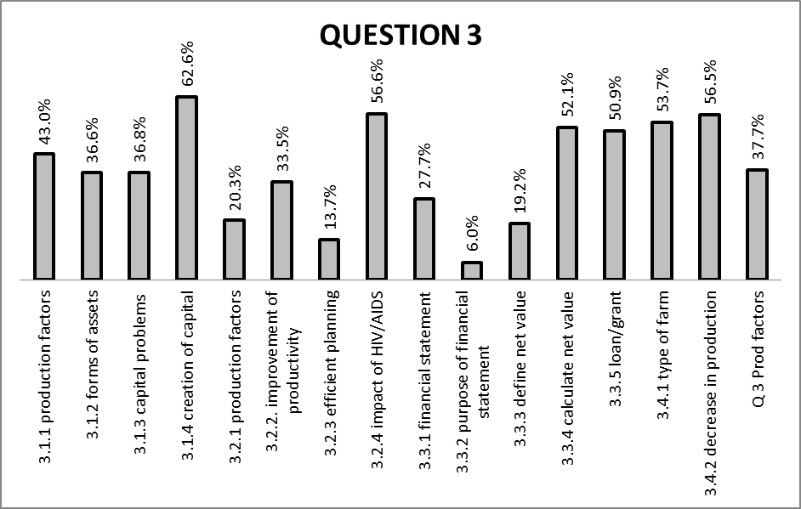

- Reading and interpretation of the question is a problem.
- Learners do not know the problems related to capital – knowledge.
- Knowledge plays an important role in answering this question. Application of this question is based on knowledge.
- Reading the question (3.2.3) and interpretation of the question determine the answer. Most learners misinterpreted this question.
- The first three questions (3.3.1 – 3.3.3) are pure knowledge and definitions. Learners perform very badly in these knowledge questions.
- The calculations were better answered.
- The moment that questions is of higher order, the learners perform poorly. To answer these types of questions, it is important that learners do have the basic knowledge.

Of Section B, question 3 was the best answered question but still not good enough.
Average = 37,7%

3.1 Production factors and capital.
3.1.1 43,0%
3.1.2 36,6%
3.1.3 36,8%
3.1.4 62,6%

3.2 Farm management
3.2.1 20,3%
3.2.2 33,5%
3.2.3 13,7%
3.2.4 56,6%

3.3 Financial statements
3.3.1 27,7%
3.3.2 6,0%
3.3.3 19,2%
3.3.4 53,1%
3.3.5 50,9%

3.4 Application of knowledge on production
3.4.1 53,7%
3.4.2 56,5%
3.4.3 37,7%

(b) Reasons why the question was poorly answered. Specific examples, common errors
and misconceptions are indicated.
(c) Suggestions for improvement in relation to teaching and learning.

Q 3.2.1
- Learners could not link farm owner to management as a production factor.
SUGGESTIONS
Q 3.2.3
- Learners might have not been conversant with “mechanization” and as a result were not able to apply their minds on the efficacy of machinery.
SUGGESTIONS

Q 3.3.2/ Q 3.3.3
- Learners are not familiar with financial management concepts namely cash flows, balance sheets, budget etc
SUGGESTIONS
- Learners should be taught financial management in a nut shell to include other concepts not in the text books for enrichment. More examples of budgets, cash flows and other financial records should be given to learners.

(d) Other specific observations relating to responses of learners.

- Questions on agric management were mostly application questions, though learners performance was averagely good, learners still struggle to apply concepts to real agric life situation.
- More emphasis on capital and production factors is necessary.
- Give learners more homework on level 2 and level 3 type of questions and not only level 1 type of questions.
- Teach learners the different type of financial statements.
- Interpretation of graphs and tables causes still a problem. This is every year a problem despite the fact that all learners have mathematics or mathematical literacy.

(e) Any other comments useful to teachers, subject advisors, teacher development, etc.

- Learners should be given more practical situation within their immediate environment to relate to.

QUESTION 4

(a) General comments on the performance of learners in the specific question.

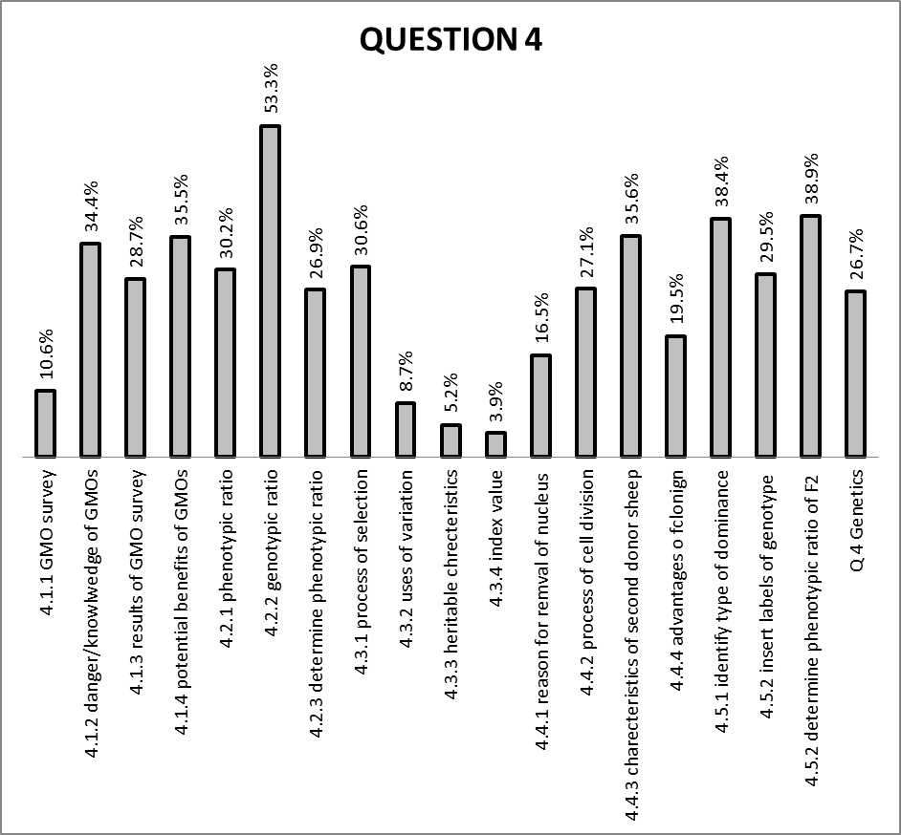

- Interpretation of graphs is still a problem.
- The graphs weren’t clear enough.
- Learners read part of the question and then start to answer this question. They do not look at the graph but answer what they know about this topic. Most learners get the answers the wrong way round.

- There were a lot of learners that were confused and draw a Pearson square instead of a Punnett square.
- Ratio must be indicated clearly.
- Knowledge on breeding and selection are very low.
- Knowledge on index values is more or less non existing.
- 4.3.3 on heritability was answered poorly. Interpretation of the question was clearly a problem.
- Learners do not know anything on cloning. It is a topic outside the scope of their normal frame of reference.

4.5 This question is the application of knowledge. If the learners do not have the knowledge, they can’t apply it.

(b) Reasons why the question was poorly answered. Specific examples, common errors
and misconceptions are indicated.
(c) Suggestions for improvement in relation to teaching and learning.

Q 4.1.1/ Q 4.3.2/ Q 4.3.3/
- Learners under performed in this question because they were unable to deduce the type of selection from the case study.
SUGGESTIONS
- Learners should be taught principles of selection in relation to variation, heritable characteristics and index value
Q 4.4
- This question was poorly answered and unfair because even though it is part of the National Curriculum Statement, it does not form part of the Subject Assessment Guideline.

(d) Other specific observations relating to responses of learners.

- Learners’ responses to genetics questions indicate a lack of in basic knowledge of genetics.
- Reading and interpretation of the statements and graphs must be emphasised.
- Genetic modification and cloning needs more explanations in the class.
- Include these topics in teacher training and even try to visit institutions were teachers cab learn more about these topics.
- Breeding and selection needs more attention. These concepts must be explain in a better way to learners.

(e) Any other comments useful to teachers, subject advisors, teacher development, etc.

- With regard to topics on genetics, educators should start with the basics, namely cell structure and cell division (mitosis/meiosis). Educators should then proceed to genetic concepts.

(a) GRAPH OF PROVINCIAL PERFORMANCE IN THE PAPER (summary per question)
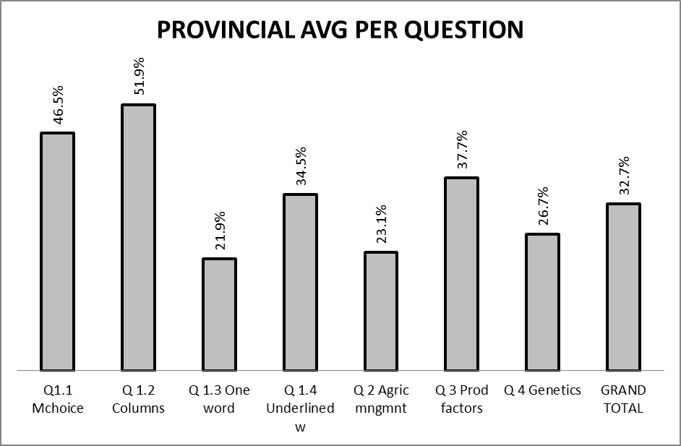

(b) GRAPHS TO COMPARE DISTRICTS' PERFORMANCES PER QUESTION
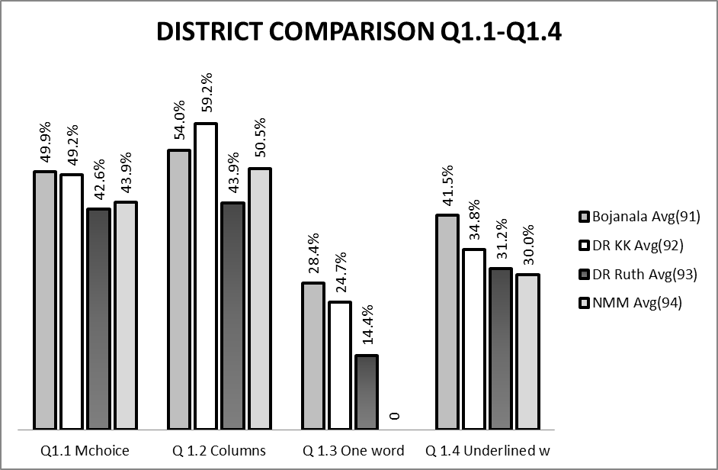

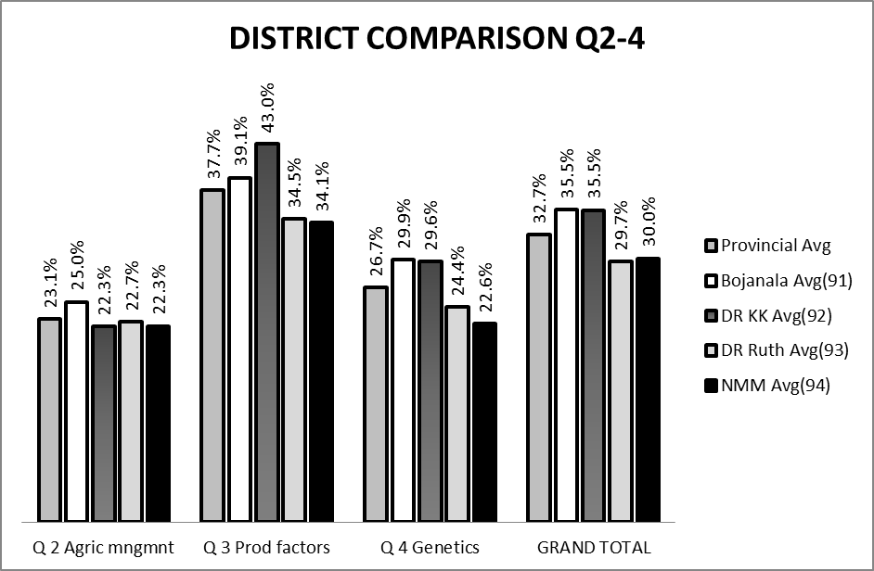

(c) GRAPH TO COMPARE OVERALL PERFORMANCE PER DISTRICT
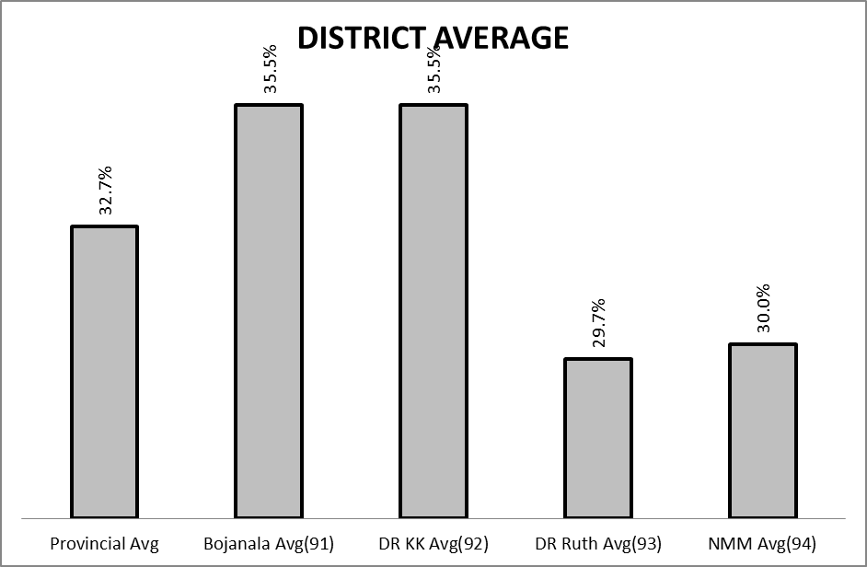

(d) DISTRIBUTION OF QUESTIONS IN TERMS OF COGNITIVE LEVELS (TABLE)

QUEST | MARKS/LO | LEVEL | QUEST | MARKS/LO | LEVEL | QUEST | MARKS/LO | LEVEL
Q1  1.1.1 | 2 LO3 |  | Q2/3 |  |  | Q4
1.1.2 | 2 LO3 |  | 2.1.1 LO3 | 4 |  | 4.1.1 LO2 | 2
1.1.3 | 2 LO3 |  | 2.1.2 LO3 | 4 |  | 4.1.2 LO2 | 2
1.1.4 | 2 LO3 |  | 2.1.3 LO4 | 3 |  | 4.1.3 LO2 | 2
1.1.5 | 2 LO3 |  | 2.2.1 LO3 | 2 |  | 4.1.4 LO2 | 2
1.1.6 | 2 LO3 |  | 2.2.2 LO3 | 4 |  | 4.2.1 LO2 | 2
1.1.7 | 2 LO3 |  | 2.2.3 LO3 | 2 |  | 4.2.2 LO2 | 3
1.1.8 | 2 LO3 |  | 2.3.1 LO3 | 2 |  | 4.2.3 LO2 | 2
1.1.9 | 2 LO2 |  | 2.3.2 LO3 | 2 |  | 4.3.1 LO2 | 1
1.1.10 | 2 LO2 |  | 2.3.3 LO3 | 3 |  | 4.3.2 LO2 | 2
TOTAL | 20 |  | 2.4.1 LO3 | 1 |  | 4.3.3 LO2 | 2
1.2.1 | 2 LO3 |  | 2.4.2 LO3 | 3 |  | 4.3.4 LO2 | 2
1.2.2 | 2 LO3 |  | 2.4.3 LO3 | 2 |  | 4.4.1 LO2 | 2
1.2.3 | 2 LO3 |  | 2.4.4 LO3 | 3 |  | 4.4.2 LO2 | 1
1.2.4 | 2 LO2 |  | TOTAL | 35 |  | 4.4.3 LO2 | 2
1.2.5 | 2 LO2 |  | 3.1.1 LO3 | 3 |  | 4.4.4 LO2 | 2
TOTAL | 10 |  | 3.1.2. LO3 | 3 |  | 4.5.1 LO2 | 1
1.3.1 | 2 LO3 |  | 3.1.3 LO3 | 2 |  | 4.5.2 LO2 | 3
1.3.2 | 2 LO3 |  | 3.1.4 LO3 | 2 |  | 4.5.3 LO2 | 2
1.3.3 | 2 LO3 |  | 3.2.1 LO3 | 2
1.3.4 | 2 LO2 |  | 3.2.2 LO3 | 2 |  | TOTAL | 35
1.3.5 | 2 LO2 |  | 3.2.3 LO3 | 4
TOTAL | 10 |  | 3.2.4 LO3 | 2 |  | MARKS | NOV 11 | REQ
1.4.1 | 1 LO3 |  | 3.3.1 LO3 | 2 | COGN LEVEL
1.4.2 | 1 LO3 |  | 3.3.2 LO3 | 1 | KNOWLEDGE | 45 |  | 45
1.4.3 | 1 LO3 |  | 3.3.3 LO3 | 2 | COMPREHENSION | 35 |  | 30
1.4.4 | 1 LO2 |  | 3.3.4 LO3 | 2 | APPLICATION | 35 |  | 45
1.4.5 | 1LO2 |  | 3.3.5 LO3 | 2 | ANALYSIS,EVAL,SYNTH | 35 |  | 30
TOTAL | 5 |  | 3.4.1 LO3 | 4 |  | 150 |  | 150
G. TOTAL | 45 |  | 3.4.2 LO3 | 2
 |  |  | TOTAL | 35

COMMENTS:

____________________________________ _______________________________________
NAME DESIGNATION (Subject Analyst /Moderator or Chief Marker)

_________________________________________ __________________________
SIGNATURE DATE

