

CHIEF MARKER'S / MODERATOR'S/ SUBJECT ANALYST’S REPORT FOR PUBLISHING

SUBJECT: AGRICULTURAL SCIENCES PAPER: 1

INTRODUCTORY COMMENTS (How the paper was received; Papers too long/short/
balance)

In general, we think, this paper was well received and the overall standard was appropriate. It was well balanced and the knowledge component well represented between the different types of questions (section A and B - short and longer questions). The composition of the different types of questions was fair, reasonable, on standard and within the scope of the Agricultural content

It had a fair representation of the various/different cognitive levels with a good distribution of the different and specific outcomes and assessment criteria. The overall impression is that all the cognitive levels and skills were well covered

Most of the LO‘s and AS‘s were adequately addressed as stipulated in the policy document, it was well structured and set according to the examination guidelines
The diagrams, illustrations and graphs were clear, visible and easy to access. The case studies provide were current, relevant and appropriate providing the necessary balance and variety to the paper
Time allocation was in order and candidates should finish in time. No evidence could actually be found of candidates not vanishing within the given time frame
This paper also provided scope for some candidates to perform well. But for the candidates that struggle, there were still not enough easer questions, to pass. For the stronger candidate the higher order questions were difficult but still inside their ability to perform well and in some cases obtain a distinction
There were a few problems in regard to the construction/structuring of some of the questions, there were some double barrel questions, some were just too difficult, unfair and maybe outside the examination guidelines
In a few questions it was not clear exactly what the examiner wanted and it also did not correspond with the memo
In most cases the marking guidelines was straight forward, clearly and accurately set and provide the necessary minimum standards. Some corrections, additions, alterations made to the marking guidelines are a problem for it is trying to rectify a poor question or to accommodate learners’ responses and this it is not always scientific and agriculturally correct. In other instances it is too scientific and although it is correct, somewhat outside the reach of a Grade 12 learner. But overall, these marking guidelines/memo were trying to benefit candidates and were marker friendly
The use of language is still a problem as candidates, in some instances, were not able to understand exactly what to do. It must also be pointed out that for most candidates English is their second language and it will have an impact on their performance. In the Afrikaans paper there was one erratum (spelling mistake) but of more problematic concern is an undetected error in one of the case studied (Q 3.3 p12). This is a national paper and the image and reputation of the National Department is at risk here
As indicated in the above mentioned sections the overall impression is that this is a good and an acceptable paper but it is still too difficult for the average learners if you look at the performance in the sections below. A matter of catastrophic concern is that with the performance of candidates as set out in the following sections, the marks will again be adjusted downwards, the same as last year, even with an average of less than 40%, leaving us back to square one, again. Nobody understand the rationale behind this various/different cognitive levels with a good distribution of the different and s
SECTION 1

(General overview of Learner Performance in the question paper as a whole)

According to the average hovering around 38 to 40% it is evident that something is seriously wrong. The answer to this question is actually very easy - the paper is just too difficult for the learners. The question is, for how long are we still going to persist in this same manner and playing with the future of Agriculture and the future of our learners

SECTION 2

(Comments on candidates’ performance in the five individual sub questions (a) – (e) will be provided below. Comments will be provided for each question on a separate sheet).

QUESTION 1

(a) General comments on the performance of learners in the specific question.

The average for question 1 was 36,2% and corresponds with the rest of the questions. This is a serious concern

(b) Reasons why the question was poorly answered. Specific examples, common errors
and misconceptions are indicated.
(c) Suggestions for improvement in relation to teaching and learning.

Q. 1.1.1
- 71,6% of learners got this question right, easy question, level 1 recall
SUGGESTIONS:
- None
Q. 1.1.2
- 62,1% of learners got this question right, easy question, level 1 recall
SUGGESTIONS:
- None
Q. 1.1.3
- 41,3% of learners got this question right, question more difficult with 2 variables
SUGGESTIONS:
- Bubble barrel question with palatability and digestibility. Learners were unable to make this connection
Q. 1.1.4
- 55,9% of learners got this question right, easy question, level 1 recall
SUGGESTIONS:
- None
Q. 1.1.5
- 37,4% of learners got this question right, actually this was easy, level 1 recall
SUGGESTIONS:
- None
Q. 1.1.6
- 60,1% of learners got this question right, easy question, level 1 recall
SUGGESTIONS:
- None
Q. 1.1.7
- 49,2% of learners got this question right, learners got confuse with the letters
SUGGESTIONS:
- Learners struggle with reproduction
Q. 1.1.8
- 84,3% of learners got this question right, easy question, level 1 recall
SUGGESTIONS:
- None
Q. 1.1.9
- 40,2% of learners got this question right, easy question, level 1 recall
SUGGESTIONS:
- There are too many diseases to study so learners go for the obvious or they don’t study them at all
Q. 1.1.10
- 35,1% of learners got this question right, easy question, level 1 recall
SUGGESTIONS:
- There are too many diseases to study so learners go for the obvious or they don’t study them at all (With CAPS it is more structured)

The average for question 1.1 was 53,7% the highest for any question in this paper

Q. 1.2.1
- 60,1% of learners got this question right, easy question, level 1 recall
SUGGESTIONS:
- None
Q. 1.2.2
- 22,8% of learners got this question right
SUGGESTIONS:
- To difficult, learners cannot handle this type of interpretation questions
Q. 1.2.3
- 19,4% of learners got this question right
SUGGESTIONS:
- To difficult, learners cannot handle this type of questions on reproduction
Q. 1.2.4
- 86.0% of learners got this question right, easy question, level 1 recall, outside their frame of reference
SUGGESTIONS:
- None
Q. 1.2.5
- 17,1% of learners got this question right
SUGGESTIONS:
- To difficult, learners cannot handle this type of questions, outside their frame of reference

The average for question 1.2 was 40,8%, in line with the average of the paper. Learners are struggling with this higher order question as some of them do not know how to answer this type of question. In some of the scripts learners answer only A or B for they are not familiar with the other options

Q. 1.3.1
- 16,9% of learners got this question right

SUGGESTIONS:
- There are too many mineral and vitamin deficiencies and diseases to study so learners go for the obvious ones or they don’t study them at all (With CAPS it is more structured)
Q. 1.3.2
- 9,0% of learners got this question right
SUGGESTIONS:
- Most learners answered “villi” as the real answer were outside their frame of reference
Q. 1.3.3
- 3,9% of learners got this question right
SUGGESTIONS:
- This question was outside their frame of reference
Q. 1.3.4
- 45,6% of learners got this question right, easy question, level 1 recall
SUGGESTIONS:
- Best answered question in this section
Q. 1.3.5
- 34,8% of learners got this question right, easy question, level 1 recall
SUGGESTIONS:
- There are too many mineral and vitamin deficiencies and diseases to study so learners go for the obvious or they don’t study them at all (With CAPPS it is more structured) This was one of the more obvious ones
- Teachers must start explaining terminology whenever he present a lesson

The average for question 1.3 was 21,8%. Meaning that learners do not know their theory especially terms, definitions and descriptions

Q. 1.4.1
- 50,8% of learners got this question right, easy question, level 1 recall
SUGGESTIONS:
- None
Q. 1.4.2
- 25,3% of learners got this question right, easy question, level 1 recall
SUGGESTIONS:
- None
Q. 1.4.3
- 32,6% of learners got this question right,
SUGGESTIONS:
- Learners struggle with reproduction
Q. 1.4.4
- 11,0% of learners got this question right
SUGGESTIONS:
- This question is outside their frame of reference

Q. 1.4.5
- 22,8% of learners got this question right, easy question
SUGGESTIONS:
- None

The average for question 1.4 was 28,5%. Meaning that learners do not know their theory especially terms, definitions and descriptions

(d) Other specific observations relating to responses of learners.

The section on hormones and reproduction are of problematic concern. It is difficult and learners do not understand and study these sections. Some of the textbooks used do not address these topics adequately enough and some educators do not pay enough attention to it

(e) Any other comments useful to teachers, subject advisors, teacher development, etc.

Refer to more than one textbook or a textbook that addresses these topics according to the specified guidelines. More emphases should be put on these topics

QUESTION 2

(a) General comment on the performance of learners in the specific question.

The average for question 2 was 35, 8%. This is a serious concern for animal nutrition is a fundamental aspect in any animal production system and it seems that learners do not understand the basic concepts of nutrition

(b) Reasons why the question was poorly answered. Specific examples, common errors
and misconceptions are indicated.
(c) Suggestions for improvement in relation to teaching and learning.

Q. 2.1.1
- 63,6% of learners got this question right, easy question, level 1 recall
SUGGESTIONS:
- None

Q. 2.1.2
- 22,2% of learners got this question right, easy question, level 1 recall
SUGGESTIONS:
- Some learners swapped it around with question 2.1.3, once again indicating there lack of content knowledge

Q. 2.1.3
- 19,5% of learners got this question right, easy question, level 1 recall
SUGGESTIONS:
- Some learners swapped it around with question 2.1.3, once again indicating there lack of content knowledge
Q. 2.1.4
- 16,2% of learners got this question right, easy question, level 1 recall
SUGGESTIONS:
- None
Q. 2.1.5
- 20,5% of learners got this question right, easy question, level 1 recall
SUGGESTIONS:
- None
Q. 2.2.1
- 39,0% of learners got this question right, easy question, level 1 recall
SUGGESTIONS:
- None
Q. 2.2.2
- 25,6% of learners got this question right, may be on a too high level
SUGGESTIONS:
- None
Q. 2.2.3
- 8,8% of learners got this question right, easy question, level 1 recall
SUGGESTIONS:
- None
Q. 2.3.1
- 57,3% of learners got this question right, easy question, level 1 recall
- Others are still struggling about making interpretations .
SUGGESTIONS:
- Every case study contain some passage that need interpretation
Q. 2.3.2
- 42,4% of learners got this question right, easy question, level 1 recall
SUGGESTIONS:
- None
Q. 2.4.1
- 40,0% of learners got this question right, easy question, level 1 recall (calculations)
SUGGESTIONS:
- Learners are progressing in the manner they do the calculations, but there are still centres where the calculations are very badly answered.
Q. 2.4.2
- 16.3% of learners got this question right, a higher order question, and learners struggled

SUGGESTIONS:
- None
Q. 2.5.1
- 41,0% of learners got this question right ,(calculations)
SUGGESTIONS:
- Learners are progressing in the manner they do the calculations, but there are still centres where the calculations are very badly answered.
Q. 2.5.2
- 44,9% of learners got this question right, (calculations)
SUGGESTIONS:
- Learners are progressing in the manner they do the calculations, but there are still centres where the calculations are very badly answered.
Q. 2.6.1
- 61,2% of learners got this question right, (calculations)
SUGGESTIONS:
- Learners are progressing in the manner they do the calculations, but there are still centres where the calculations are very badly answered. There is also some confusion between the ratio, amount and the percentage in the Pearson square. Learners must practically do these calculation over and over again
Q. 2.6.2
- 23,2% of learners got this question right, higher order question, progression on Q 2.6.1
with application (calculations)
SUGGESTIONS:
- Learners must practically do these calculations over and over again. Starting with the
easer part and progressing to the more difficult and complicated parts. Calculations will
always form part of any paper so how can learners still struggle with it if they know there
will be calculations in the paper

QUESTION 3

(a) General comment on the performance of learners in the specific question.

The average for question 3 was 41,3% and corresponds with the rest of the questions. This is a also a serious concern as animal nutrition as mentioned earlier together with animal production forms the fundamental aspects in any animal production system and it seems that learners do not understand the basic concepts of production

(b) Reasons why the question was poorly answered. Specific examples, common errors
and misconceptions are indicated.
(c) Suggestions for improvement in relation to teaching and learning.

Q. 3.1.1
- 36,3% of learners got this question right, but most of them couldn’t see the connection. They are also not familiar with Angoras or know where Rietbron is situated. This type of application is difficult for our learners
SUGGESTIONS:
- Teach them how to interpret this type of question
Q. 3.1.2
- 25,5% of learners got this question right, but were outside their frame of reference
SUGGESTIONS:
- Set the question more appropriate
Q. 3.1.3
- 35,7% of learners got this question right, but were outside their frame of reference.
Subsidies forms part of the economic factors in paper 2
SUGGESTIONS:
- Refer to paper 2
Q. 3.2.1
- 78,8% of learners got this question right, easy question, strait forward level 1 recall
SUGGESTIONS:
- None
Q. 3.2.2
- 15.5% of learners got this question right, learners were unable to handle this type of
interpretation/implementation question
SUGGESTIONS:
- Expose them to these type of questions during the tests and examinations
Q. 3.2.3
- 9,0% of learners got this question right, learners were unable to handle this type of
interpretation/implementation question
comparison question deals with the differences and similarities in this case learners gave only the differences and not both.
SUGGESTIONS:
- Expose them to these type of questions during the tests and examinations
- Learners should be familiarised with comparison questions
Q. 3.3.1
- 56,6% of learners got this question right,
SUGGESTIONS:
- Expose them to these type of questions during the tests and examinations
Q. 3.3.2
- 40,7% of learners got this question right,
SUGGESTIONS:
- Learners struggle with the interpretation/implementation
Q. 3.4.1
- 23,6% of learners got this question right,
SUGGESTIONS:
- Learners struggle with the interpretation/implementation
Q. 3.4.2
- 80,6% of learners got this question right. It must be noted that learners are much better
prepared for drawing graphs than in the past
SUGGESTIONS:
- Keep up the good work
Q. 3.4.3
- 65,9% of learners got this question right. It must be noted that learners are much better
prepared for the interpretation/implementation of graphs than in the past
SUGGESTIONS:
- Keep up the good work

QUESTION 4

(a) General comment on the performance of learners in the specific question.

The average for question 4 was 28,0% and is the question with the lowest mark in the paper. This a serious a huge concern that needs to be addressed very urgently

(b) Reasons why the question was poorly answered. Specific examples, common errors
and misconceptions are indicated.
(c) Suggestions for improvement in relation to teaching and learning.

Q. 4.1.1
- 24,2% of learners got this question right, easy question, level 1 recall. Meaning that
learners do not know their theory especially terms, diagrams and sketches
Learners were confusing the male reproductive organ with the female one. e.g. parts
identification (vagina, ovum, vulva etc.) also confused the reproductory parts of cow and chicken(fowl)
SUGGESTIONS:
- Study. When teaching this topic the educator must put all the three alimentary canals so that learners could see the differences and similarities
Q. 4.1.2
- 33,7% of learners got this question right, easy question, level 1 recall. Meaning that learners do not know their theory especially terms, diagrams and sketches
SUGGESTIONS:
- Study
Q. 4. 1.3
- 40,2% of learners got this question right, easy question, level 1 recall. Learners do not
know their theory especially terms, diagrams and sketches
SUGGESTIONS:
- Study
Q. 4.1.4
- 9,4% of learners got this question right, Learners do not know their theory
SUGGESTIONS:
- Study
Q. 4.1.5
- 23,0% of learners got this question right, Learners do not know their theory especially terms, diagrams and sketches
SUGGESTIONS:
- Study
Q. 4.2.1
- 45,8% of learners got this question right. It must be noted that learners are much better
prepared for the interpretation/implementation of graphs than in the past
SUGGESTIONS:
- None
Q. 4.2.2
- 53,1% of learners got this question right. It must be noted that learners are much better
prepared for the interpretation/implementation of graphs than in the past
SUGGESTIONS:
- None
Q. 4.2.3
- 33,3% of learners got this question right, learners are struggling with reproduction
SUGGESTIONS:
- Special emphases should be put on reproduction
Q. 4.2.4
- 16,9% of learners got this question right, learners are struggling with hormones and
reproduction
SUGGESTIONS:
- Special emphases should be put on reproduction
Q. 4.2.5
- 31,2% of learners got this question right, learners are struggling with hormones and
reproduction
SUGGESTIONS:
- Special emphases should be put on reproduction
Q. 4.3.1
- 67,8% of learners got this question right. Learners could not give reasons as outlined in
the Case study in order for them to answer the question ( language is a problem)
SUGGESTIONS:
- Let us encourage teaching, reading and writing in English
Q. 4.3.2
- learners are struggling with hormones and reproduction

- Most of the learners could not classify the Bont tick life cycle. They just copied what is written in the passage without giving their own interpretation.

SUGGESTIONS:
- They must know that case study carries some questions that need their interpretation skills

Q. 4.3.3
- 7.3% of learners got this question right. Learners could not give a reason for outbreak
e.g. relating coastal regions with humid or unfavourable climate
SUGGESTIONS:
- There are too many pests/diseases to study so learners go for the obvious or they don’t study them at all (With CAPS it is more structured). Study and sometimes apply general knowledge
Q. 4.3.4
- 30,3% of learners got this question right. Here learners purely did not know the answer
- There are too many pests/diseases to study so learners go for the obvious or they don’t study them at all (With CAPS it is more structured). Study and sometimes apply general knowledge
SUGGESTIONS:
- There are too many pests/diseases to study so learners go for the obvious or they don’t study them at all (With CAPS it is more structured). Study and sometimes apply general knowledge
- Study
Q. 4.3.5
- 3,9% of learners got this question right. Here learners purely did not know the answer
- Learners showed lack of knowledge and only a few learners could answer a question on biological method of controlling ticks
SUGGESTIONS:
- For some learners this seems like a foreign concept
- Study
Q. 4.4.1
- 38,8% of learners got this question right. Here learners purely did not know. There is a
lack knowledge of vaccination for Pulp kidney.
- There are too many pests/diseases to study so learners go for the obvious or they don’t study them at all (With CAPS it is more structured).
- Study and sometimes apply general knowledge
SUGGESTIONS:
- Study
Q. 4.4.2
- 47.8% of learners got this question right. Here learners lack the knowledge about
weaning lambs
- Learners were unable to handle this type of interpretation/implementation question
SUGGESTIONS:
- More exposure
- Study
Q. 4.4.3
- 27,4% of learners got this question right. Here most learners did not provide the reason,
or they simply didn’t know

- Here learners lack the knowledge or were unable to handle this type of
interpretation/implementation question
SUGGESTIONS:
- Study
- More exposure
Q. 4.4.4
- 23,6% of learners got this question right.
- Here learners lack the knowledge or were unable to handle this type of
interpretation/implementation question
- Some learners had no idea about quarantine services and veterinary research

SUGGESTIONS:
- Lack of basic knowledge
- Study
- More exposure

(d) Other specific observations relating to responses of learners.

- The Memo for question 4.2.2 was not accurate by giving 30 as the answer. The level of oestrogen on the graph is above 30 marks. Some learners read the graph well
- Almost all learners struggled with 3.2.2 the’ space requirement’ was not clear to the learners, others thought of space in the picture. Teachers should explain the expectation of this question to the learners
- Question 2.2.3 which deals with the absorption zones of the villi as shown in the diagram does not fall within the confines of the examination guideline or work schedule. The learner is expected to know that the villi helps with the absorption of nutrients in the small intestine
- Most learners are still struggling about how to make correct substitution and calculate the required percentage.

(e) Any other comments useful to teachers, subject advisors, teacher development, etc.

We are concern as 4 scripts were marked without any section A (45 marks) as they were misplaced/lost during the examination period. The suggestion is that we do away with a loose answer sheet and print the answer sheet on the flip side of the script or let candidates write it on the first page of the script. All 4 these learners failed because of this

Learners must be coached, confronted and skilled in the art of answering a question paper especially the manner in which the different types of questions should be answered and to a level of examination and work rate that they are not used to, but are in line, on the same level and standard as the examination at the end of the year. They must therefore be skilled in the type, format and style of examination that will be expected from them. This type of repetition or rehearsal can only benefit the learners. The only way to accomplish this is too expose learners to the same types of questioning and level of examination as during the final examination so that they are ready and prepared for what is to come. At this stage the state of readiness for most of Grade 12 learners are unsatisfactory, and this can be seen in the results.

Please do away with double barrel questions as they are just confusing the learners and markers

Most questions are set where one mark is allocated for one fact. (name 2 or identify 2 for 2 marks) but some questions stated for example one reason (Q 2.1.4) for 2 marks. (Q 3.1.1) Name the production system and give a reason for 3 marks. This is confusing for learners and markers

Understanding the terms and terminology of Agricultural Sciences is still a concern. By reading some of the answer it is clear that the leaner has no idea of what is expected from them. In some cases the answer does not even remotely correspond with the question. A perfect example of their state of unpreparedness
It must also be remembered that for most of these learners English is their second and even third language making critical reading, implementation and interpretation of the different types of questions an enormous challenge and problem, learners need therefore to be coached in these aspects.
If this can be achieved learners will feel more positive, comfortable and at ease now that they are more familiar with the above mentioned aspects. They will also be more confident as they now realize that they can perform well at this level.
There is also a concern that the culture of learning and study does not exist in our schools anymore and learners are just dependent on handouts. This culminates in the biggest problem at this point in time. Learners do not know their theory, (the basic knowledge at level 1) therefore it is impossible for them to answer the interpretation/implementation type of questions (level 2 and 3, higher order question). Unfortunately for the learners the only way to accomplished this, is to STUDY
SECTION 3
- GRAPH OF PROVINCIAL PERFORMANCE IN THE PAPER (summary per question)

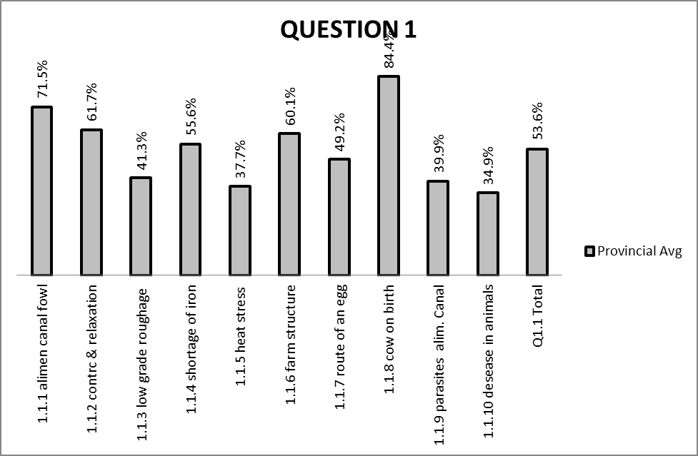

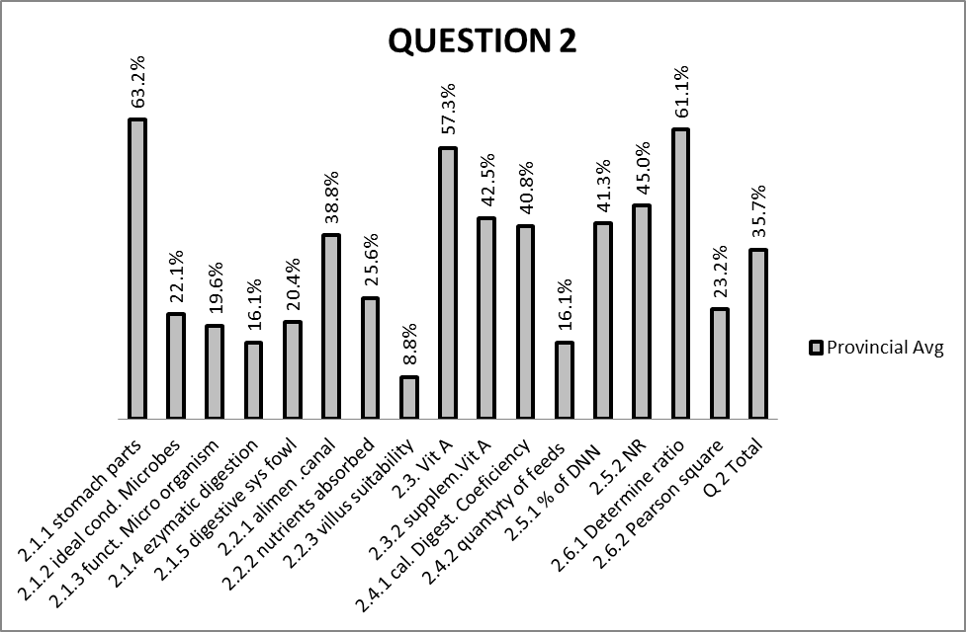

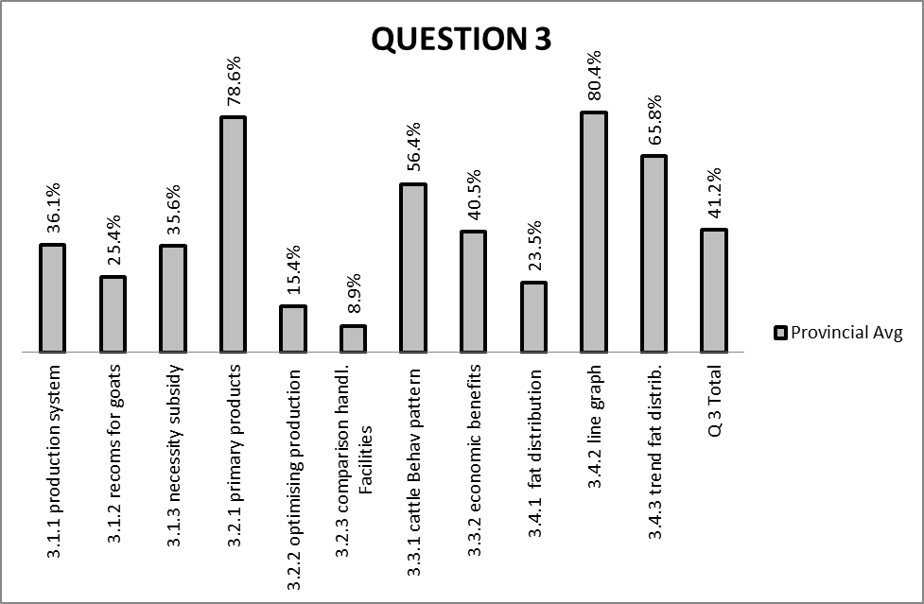

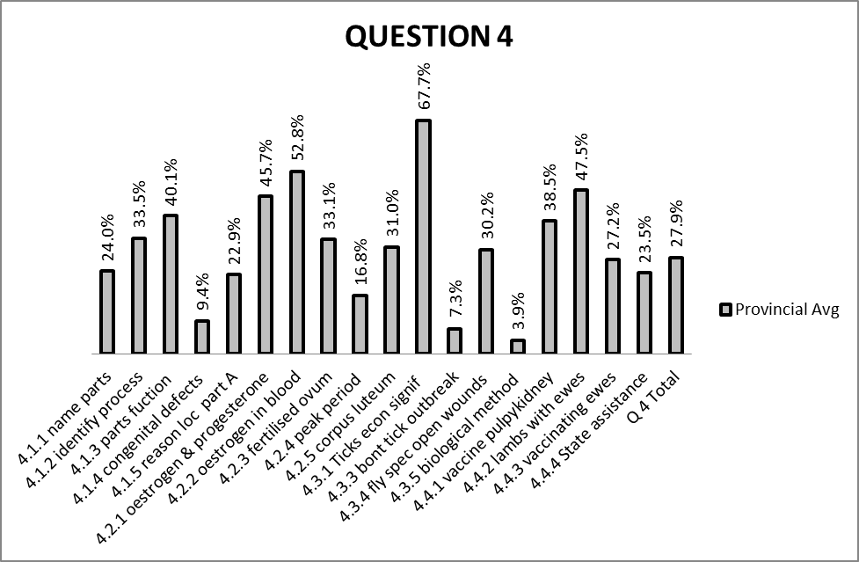

GENERAL COMMENTS

The above mentioned graphs shows the mark distribution for each section of the question paper

(b) GRAPHS TO COMPARE DISTRICTS' PERFORMANCES PER QUESTION

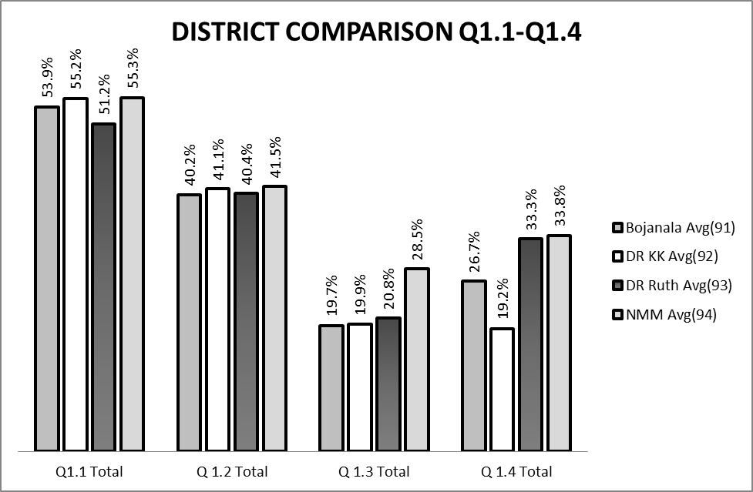

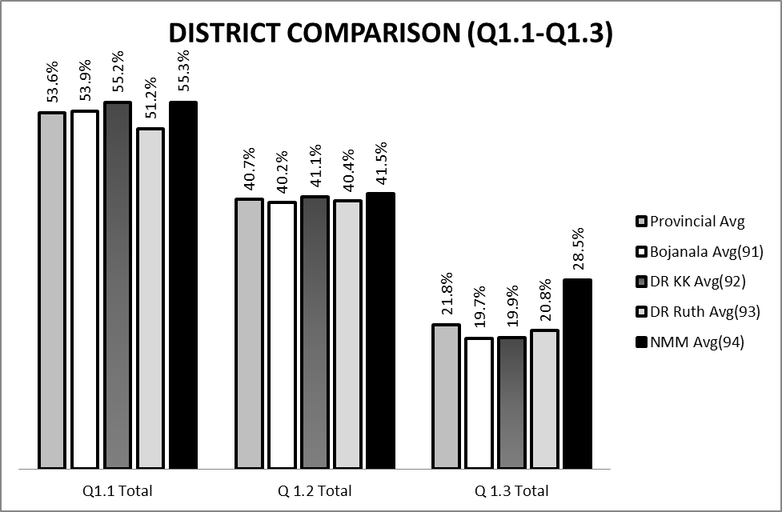

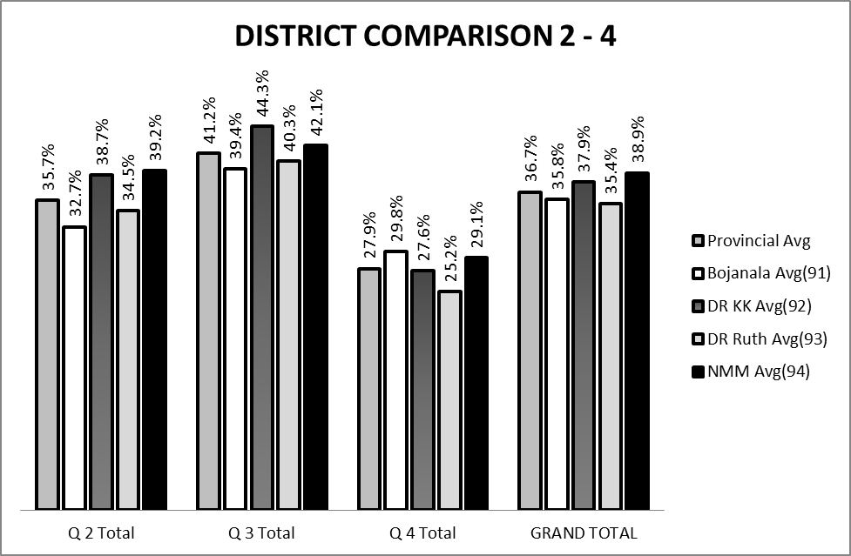

(c) GRAPH TO COMPARE OVERALL PERFORMANCE PER DISTRICT
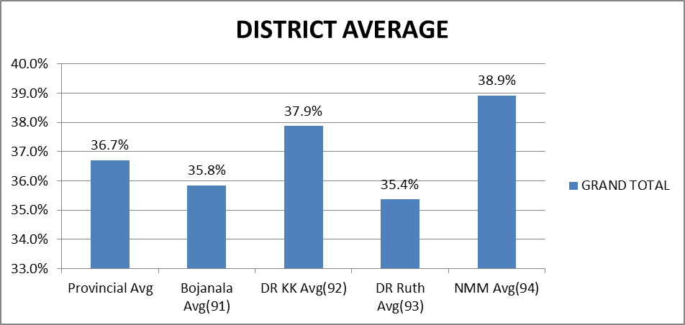

COMMENTS ON PERFORMANCE OF DISTRICTS :

(d) DISTRIBUTION OF QUESTIONS IN TERMS OF COGNITIVE LEVELS (TABLE)

QUEST | MARKS/LO | LEVEL | QUEST | MARKS/LO | LEVEL
1.1.1 | 2 LO 1 | 1 | 2.1.1 | 3 LO1 | 2
1.1.2 | 2 LO1 | 1 | 2.1.2 | 2 LO1 | 1
1.1.3 | 2 LO 2 | 1 | 2.1.3 | 2 LO2 | 2
1.1.4 | 2 LO2 | 1 | 2.1.4 | 2 LO2 | 3
1.1.5 | 2 LO3 | 1 | 2.1.5 | 1 LO1 | 1
1.1.6 | 2 LO 2 | 1 | 2.2.1. | 1 LO1 | 1
1.1.7 | 2 LO1 | 1 | 2.2.2 | 2 LO2 | 1
1.1.8 | 2 LO2 | 1 | 2.2.3 | 2 LO2 | 2
1.1.9 | 2 LO1 | 1 | 2.3.1 | 2 LO2 | 3
1.1.10 | 2 LO2 | 1 | 2.3.2 | 2 LO1 | 1
TOTAL | 20 |  | 2.4.1 | 5 LO3 | 3+4
1.2.1 | 2 LO1 | 1 | 2.4.2 | 3 LO2 | 3
1.2.2 | 2 LO2 | 1 | 2.5.1 | 1 LO2 | 3
1.2.3 | 2 LO2 | 1 | 2.5.2 | 2 LO2 | 3
1.2.4 | 2 LO1 | 1 | 2.6.1 | 3 LO2 | 3
1.2.5 | 2 LO3 | 1 | 2.6.2 | 3 LO2 | 3
TOTAL | 10 |  | TOTAL | 35
1.3.1 | 2 LO2 | 1 | 3.1.1 | 3 LO2 | 1
1.3.2 | 2 LO1 | 1 | 3.1.2 | 6 LO2 | 2
1.3.3 | 2 LO2 | 1 | 3.1.3 | 2 LO3 | 3+4
1.3.4 | 2 LO2 | 1 | 3.2.1 | 2 LO2 | 2
1.3.5 | 2 LO3 | 1 | 3.2.2 | 2 LO2 | 3
TOTAL | 10 |  | 3.2.3 | 4 LO2 | 3
1.4.1 | 1 LO1 | 1 | 3.3.1 | 2 LO2 | 2
1.4.2 | 1 LO2 | 1 | 3.3.2 | 2 LO3 | 1+4
1.4.3 | 1 LO2 | 1 | 3.4.1 | 2 LO2 | 2
1.4.4 | 1 LO3 | 1 | 3.4.2 | 6 LO2 | 3+4
1.4.5 | 1 LO1 | 1 | 3.4.3 | 2 LO2 | 3
TOTAL | 5 |  | TOTAL | 35
 |  |  | 4.1.1 | 4 LO1 | 1
 |  |  | 4.1.2 | 1 LO1 | 1
 |  |  | 4.1.3 | 2 LO2 | 1
 |  |  | 4.1.4 | 2 LO2 | 3
 |  |  | 4.1.5 | 1 LO2 | 3
 |  |  | 4.2.1 | 2 LO2 | 2
 |  |  | 4.2.2 | 1 LO2 | 2
 |  |  | 4.2.3 | 2 LO2 | 3
 |  |  | 4.2.4 | 2 LO2 | 3+4
 |  |  | 4.2.5 | 1 LO2 | 2
 |  |  | 4.3.1 | 2 LO3 | 2
 |  |  | 4.3.2 | 2 LO3 | 3+4
 |  |  | 4.3.3 | 2 LO3 | 3
 |  |  | 4.3.4 | 1 LO3 | 1
 |  |  | 4.3.5 | 2 LO3 | 2
 |  |  | 4.4.1 | 1 LO2 | 2
 |  |  | 4.4.2 | 1 LO2 | 2
 |  |  | 4.4.3 | 2 LO2 | 2+4
 |  |  | 4.4.4 | 4 LO3 | 3+4
 |  |  | TOTAL | 35
 |  |  | MARKS | DEC 2012 | REQ
 |  | COGNITIVE LEVEL
 |  | KNOWLEDGE | 45 |  | 30%
 |  | COMPREHENSION | 35 |  | 20%
 |  | APPLICATION | 35 |  | 30%
 |  | ANALYSIS,EVALUATION  &SYNTHESIS | 35 |  | 20%

(e) COVERAGE OF LEARNING OUTCOMES AND ASSESSMENT STANDARDS
(TABLE)

LO | TOPIC | QUESTION | MARKS
12.1.1 | Nutrition: Digestion
1 & 2 | Alimentary canals | 1.1.1-1.1.2 -1.1.9  2.1.1 – 2.1.5 | 6  10
1 & 2 | Digestion in Ruminants and Non ruminants | 1.4.1  2.2.1 - 2.2.3 | 1  5
1& 2 | Nutrition : components, digestibility, quality of feed & energy value | 1.1.3-1.3.2-1.3.3-1.4.2  2.3.1 – 2.3.2  2.4.1 – 2.4.2 | 7  1  4  7
1,2+3 | Nutrition:  types of feed, supplement to ration & feeding programmes | 1.1.4- 1.2.1-1.2.5-1.3.1-1.4.5  2.6.1 – 2.6.2 | 10  6
1,2+3 | Production:  Increasing production, shelter, handling of farm animals and production management | 1.1.5-1.1.6  3.1.1 – 3.1.3  3.4.1 – 3.4.3 | 4  11  10
1,2+3 | Reproduction :  Reproductive systems of cattle, mating and fertilization, AI, Dev of embryo, Parturition & milk production | 1.1.7-1.1.8-1.2.3-1.2.4-1.3.4-1.4.3  4.1.1 – 4.1.5  4.2.1 – 4.2.5 | 11  10  8
1,2+3 | Protection and control:  Gen signs & disease, types of animal disease, Pests and parasites & gov. control | 1.1.10-1.2.2-1.3.5-1.4.4  3.2.1 – 3.2.3  3.3.1 – 3.3.2  4.3.1 – 4.3.5  4.4.1 – 4.4.4 | 8  10  4  9  8
TOTAL SPREADING
LO1 |  |  | 45
LO2 |  |  | 70
LO3 |  |  | 35
TOTAL |  |  | 150

____________________________________ _______________________________________
NAME DESIGNATION (Subject Analyst /Moderator or Chief Marker)

_________________________________________ __________________________
SIGNATURE DATE

